White Cane Safety Day
Resource Toolkit

This resource was developed to help local groups and organizations educate the general public about the importance of White Cane Safety Day, which takes place annually on October 15th.
The financial resources necessary to create and develop this toolkit were made possible by an anonymous charitable grant.
Distribution made possible through the Shopko Foundation.

Thank you for your participation!

Each year, White Cane Safety Day, otherwise known as Blind American Equality Day, is celebrated on October 15th. The Wisconsin Council of the Blind & Visually Impaired is reaching out to organizations and groups such as yours throughout the state to encourage you to develop your own grassroots promotion of this very important day.

By equipping you with this resource toolkit, our goal is to help create more widespread impact by helping you articulate your voice around this important observance and to educate more people about the importance of understanding White Cane laws.

Within the pages of this booklet you will find ideas and suggestions for developing a plan and how to reach out to leaders within your community to spread the word about the White Cane law in Wisconsin.

Help us help those who have vision loss travel safely by being vocal about White Cane Safety.

On behalf of the Wisconsin Council of the Blind & Visually Impaired I would like to thank you for taking the time to review this resource toolkit. Thank you in advance for your support of White Cane Safety Day!

Sincerely,

Denise Jess
CEO/Executive Director

What is White Cane Safety Day?

From the Wisconsin State Statutes
White Cane Safety Day acknowledges the law that is enforced year around and is based on the following state statute 346.26 entitled Blind Pedestrian on Highway.

(1) An operator of a vehicle shall stop the vehicle before approaching closer than 10 feet to a pedestrian who is carrying a cane or walking stick which is white in color or white trimmed with red and which is held in an extended or raised position or who is using a service animal, as defined in s. 106.52 (1) (fm), and shall take such precautions as may be necessary to avoid accident or injury to the pedestrian. The fact that the pedestrian may be violating any of the laws applicable to pedestrians does not relieve the operator of a vehicle from the duties imposed by this subsection.

From Wikipedia.com
White Cane Safety Day is a national observance in the United States, celebrated on October 15 of each year since 1964. The date is set aside to celebrate the achievements of people who are blind or visually impaired and the important symbol of blindness and tool of independence, the white cane.

On October 6, 1964, a joint resolution of the U.S. Congress, H.R. 753, was signed into law as Pub.L. 88–628, and codified at 36 U.S.C. § 142. This resolution authorized the President of the United States to proclaim October 15 of each year as "White Cane Safety Day".

President Lyndon B. Johnson signed the first White Cane Safety Day proclamation within hours of the passage of the joint resolution.

In 2011, White Cane Safety Day was also named Blind Americans Equality Day by President Barack Obama.

What can you do to help promote White Cane Safety Day?
Send a news article to your local newspaper
Do you or someone in your group or organization have a passion for writing? Have you personally experienced using a white cane out and about in the community? Submitting a pre-written newspaper article to your local newspaper is a great way to receive visibility for White Cane Safety Day, especially if you are able to provide a first-hand account of someone’s experience using a white cane in your local community.
If you do not know someone who has personally experienced using a white cane, your article can focus on the importance of the White Cane Law. A sample news article from this perspective is located on page 8.
When creating your news article, it will be important to keep it to less than 500 words in length. When submitting your article to your local newspaper, make sure to include an introduction letter or email explaining why you are submitting the story and that you are promoting White Cane Safety Day, which takes place on October 15th each year. Sharing these details should help give news editors more motivation to potentially publish your piece.

Send a Press Release to local law enforcement
Sending out a press release to your local police department is a helpful way to remind law enforcement about the importance of the White Cane Law in Wisconsin.
In 2014, the Wisconsin Council of the Blind & Visually Impaired worked with the Madison Police Department to conduct a pedestrian safety enforcement operation. Police officers enforced motorist crosswalk violations in an effort to educate drivers about Wisconsin’s White Cane Law and general safety precautions to use when pedestrians are in the crosswalk.
To enact a similar operation, it is recommended to reach out to your local police department 1-2 months prior to October 15th. Find out if there is an officer or a team of officers that would be interested in working on this project with you by calling the police department’s non-emergency number. Work together to develop a plan prior to October 15th. Consider contacting your local news media to cover this event to help spread the word. A sample press release is located on page 10.
Send a letter to your Mayor seeking a formal proclamation
A letter to your community’s mayor is another great way to help garner publicity for White Cane Safety Day.
If your mayor issues a formal proclamation for “White Cane Safety Day in [Your Community]” you have a wonderful opportunity to set up a photo session with the mayor, city council, etc. You can then send this photograph to your local newspaper to get additional publicity for White Cane Safety Day.
It is recommended that you send your letter to the mayor 4-6 weeks prior to White Cane Safety Day. After sending your letter, call your mayor’s office to confirm that the letter was received and to ask a second time if the mayor would be interested in issuing a formal proclamation. A sample letter to the mayor is located on page 11.

Develop a social media plan and share on your social media platforms
Does your group or organization have a Facebook or Twitter page? Do you use Instagram, Pinterest or YouTube?
There are many options in terms of social media. The important thing is to figure out which ones are best for your audience. At the Wisconsin Council of the Blind & Visually Impaired, we have found that Facebook and Twitter are the best resources for us to consistently reach our clients and followers. To make sure that you are engaging with your audience on a regular basis, it is important to pre-plan when you are going to place a post on your social media pages and what you want the content to be.
It is highly recommended that you develop a social media calendar when promoting specific events. You don’t necessarily want to flood your social media channels with the same messages every day so writing your posts in advance and creating different messages for each day helps create balance – and won’t agitate your followers by flooding them with too much of the same information.

A sample social media calendar, as well as recommended social media posts, begin on page 12.
Another popular element of social media is the use of hashtags. A hashtag (“#” - otherwise known as the number symbol or pound symbol) is placed in front of a word or series of words to make a statement searchable on different social media platforms. The hashtag is then associated with any other conversations using that particular phrase.
For White Cane Safety Day, it is recommended that you use #WhiteCaneSafetyDay and #WhiteCaneLaw with all of your social media posts.

Host a special event
Hosting a special event is a wonderful way to build awareness about White Cane Safety Day in your community. By gathering a large group of people in one place, you have the opportunity to build awareness of the White Cane Safety laws and can provide items such as hand-outs or education through public speakers.
Some successful special events that have taken place throughout the country on or promoting White Cane Safety Day include:
- A “flash mob”
  - Milwaukee, WI - https://sites.google.com/site/wisconsinwhitecaneday/

- A march/walk
  - Austin, TX - http://www.whitecaneday.org/events/
  - Sacramento, CA - http://societyfortheblind.org/events/white-cane-awareness-day/
  - Des Moines, IA - http://www.idbonline.org/celebrate-white-cane-safety-day-des-moines
  - Baton Rouge, LA - http://www.lsvi.org/content.cfm?id=118

- A fair featuring informational exhibits, an educational program and entertainment
  - Oklahoma City, OK - http://www.okrehab.org/mr/2015/whitecaneokc

- A gathering at a unique location or local hot spot
  - Fort Worth Stockyards National Historic District, Fort Worth, TX - http://www.whitecanesafetyday.info/ https://www.smugmug.com/gallery/n-SXJ6KF/
These are only a few ideas and examples of successful events around the country. Keep in mind that special events do take quite a bit of pre-planning and manpower to execute. Having a detailed plan, as well as a team of volunteers or ambassadors will really help in the coordination of hosting a successful event. Some of the larger scale events begin preparation 6 months before the event is to take place. Other smaller events can be planned 1-2 months in advance. Don’t be afraid to start small and grow from year to year!

Develop a team of ambassadors
What is an ambassador? Merriam Webster’s dictionary defines “ambassador” as “an authorized representative or messenger; an unofficial representative.” An ambassador is someone who is willing to help carry out a mission, vision or message for an organization or cause one is passionate about.
Building a team of ambassadors, especially for promoting White Cane Safety Day, is an effective way to bring people together who want to spread the word about this cause. The goal is to create a team of people that believe in your message and are willing to share it with others.
Where can you find ambassadors? Consider reaching out to the following community groups and people:
- Rotary, Lions Club or other civic organizations
- Local churches
- AARP
- Aging and Disability Resource Centers
- Schools
- Universities
- Public Officials
- Friends and Family

What can an ambassador do? Lots of things! Ultimately, it is up to your organization to determine what it is you would like your ambassadors to do. Your ambassadors are volunteers that will need directions. Maybe you simply would like your ambassadors to share your social media messages on their personal social media pages. Maybe you would like them to help you host an event. Maybe you have limited staff and you’d like them to help you execute your communications strategy to local law enforcement and mayors. And maybe it’s a combination of all these things.
The best way to maximize your ambassadors is to clearly define what tasks it is you would like them to do and then stay in touch with them to make sure they are doing it! They will have ideas to offer as well. Remember to include them in your plans and invite them to share their ideas.

Samples

News Article
This is a sample news article, meant to serve as inspiration for creating your own original article to be submitted to your local newspaper. Should you wish to use this exact news article, we kindly request that you contact the WCBVI office at 1-800-783-5213 for permission.

Remember Equality and Safety on White Cane Safety Day
By Loretta Himmelsbach, Executive Director
Wisconsin Council of the Blind & Visually Impaired

It’s devastating to read that a child or an adult is killed due to an automobile accident. It’s even worse when the victim is using a white cane because of visual impairment or blindness.
Unfortunately, this happens far too often in our state. However, sighted individuals can help make crosswalks and roadways safer for pedestrians who are blind or visually impaired by following the White Cane Safety Law and being alert and aware of their surroundings.
White Cane Safety Day, also known as Blind Americans Equality Day, is commemorated every year on October 15. This date was officially proclaimed White Cane Safety Day in 1964 to gain recognition for the growing independence and self-sufficiency of blind or visually impaired people in the U.S., and also to gain recognition of the white cane as the symbol of reliance and self-sufficiency.
The purpose of White Cane Safety Day is to alert everyone on the importance of a white cane to a person who has a vision impairment. A white cane provides valuable independence for those with vision loss to be contributing members of our society through their employment, volunteer opportunities, faith communities or recreational activities.
However, we need sighted people to be aware of this and to know Wisconsin state law, which states: “An operator of a vehicle shall stop the vehicle before approaching closer than 10 feet to a pedestrian who is carrying a cane or walking stick which is white in color or white trimmed with red and which is held in an extended or raised position or who is using a dog guide and shall take such precautions as may be necessary to avoid accident or injury to the pedestrian.”
As the population ages and the greatest demographic experiencing vision loss are those 65 years and older, we will be seeing a larger group of people using white canes or dog guides. Educating the general public on the importance of recognizing this is critical. What can you do? Pay attention when driving or walking. Be aware of your surroundings. If you see a person using a white cane, give them space.
If you inadvertently bump into a person who is blind or visually impaired, offer an apology and ask if they are alright. Ask if they need assistance. Remember, they can’t see you. If the person is using a dog guide, do not pet or talk to the dog; the dog is working and needs to keep its concentration on being sure his owner is safe.
These are simple common sense steps and an easy call to action. We urge all, especially drivers, to be alert and respectful of people utilizing a white cane or a dog guide. Will you be one of them?

Press Release to local law enforcement

[Your organization name]
[Your organization address]
[Your organization phone number]
White Cane Safety Day is October 15th
[Insert Send Date] – October 15 is White Cane Safety Day in Wisconsin and nationwide. In honor of White Cane Safety Day, various groups throughout Wisconsin and the nation will be organizing events in their communities to bring safety awareness and its significance for people with vision loss or blindness.

White Cane Safety Day acknowledges the law that is enforced year around and is based on state statute 346.26 entitled Blind Pedestrian on Highway.

(1) An operator of a vehicle shall stop the vehicle before approaching closer than 10 feet to a pedestrian who is carrying a cane or walking stick which is white in color or white trimmed with red and which is held in an extended or raised position or who is using a service animal, as defined in s. 106.52(1) (fm), and shall take such precautions as may be necessary to avoid accident or injury to the pedestrian. The fact that the pedestrian may be violating any of the laws applicable to pedestrians does not relieve the operator of a vehicle from the duties imposed by this subsection.

On the 50th anniversary of White Cane Safety Day, the Madison Police Department’s Traffic Enforcement Safety Team conducted a pedestrian safety operation, enforcing motorist crosswalk violations and educating drivers about Wisconsin’s laws to protect the visually impaired. This was an ideal way to inform motorists of Wisconsin’s White Cane Traffic law, enforced since 1947. Please consider marking White Cane Safety Day as an opportunity to carry out a similar operation in your community.

[Insert a brief paragraph that describes the mission and vision of your group, as well as contact information for your group’s event coordinator. This contact information should include the person’s name, title, phone number and email address]

Letter to Mayor
[Insert your organization’s logo here]
[Your organization address]
[Your organization phone number]
[Your organization website]
[Your organization phone number]

[Date]

Mayor [First and Last Name]
[Office Address]
[City, State Zip code]

Dear Mayor [Last Name],
White Cane Safety Day is nationally recognized on October 15 every year. This date and the weeks surrounding it offer opportunities to educate the driving public of the challenges the blind and visually impaired community faces on a daily basis just by doing something as ordinary as crossing a street.
The Wisconsin Council of the Blind & Visually Impaired is asking mayors across Wisconsin to set this day and the weeks ahead to raise awareness of the safety law that protects the rights of pedestrians who are blind or visually impaired.
It states:
“An Operator of a vehicle shall stop the vehicle before approaching closer than 10 feet to a pedestrian who is carrying a cane or walking stick which is white in color or white trimmed with red and which is held in an extended or raised position or who is using a service animal, as defined in s.106.52 (1)(fm), and shall take such precautions as may be necessary to avoid accident or injury to the pedestrian.”
Help us help those who have vision loss travel safely by being vocal about White Cane Safety. Help reduce the number of accidents involving those who are visually impaired. Please consider issuing a formal proclamation recognizing October 15th as “White Cane Safety Day” in your local community.
Thank you in advance for your support of White Cane Safety Day.
Sincerely,
[Signature]
[First and Last Name]
[Title, Organization Name]

Social media plan
September
Sunday | Monday | Tuesday | Wednesday | Thursday | Friday | Saturday
11 | 12 | 13 | 14 | 15 | 16 | 17
 |  |  |  | FB & Twitter: WCSD one month away!
18 | 19 | 20 | 21 | 22 | 23 | 24
FB & Twitter:
Why recognize WCSD
25 | 26 | 27 | 28 | 29 | 30
 |  | FB & Twitter: Mark your calendar |  |  | FB & Twitter:  Looking for volunteers

October
Monday | Tuesday | Wednesday | Thursday | Friday | Saturday | Sunday
 |  |  |  |  | 1 | 2
3 | 4 | 5 | 6 | 7 | 8 | 9
FB & Twitter:  White Cane Law |  | FB & Twitter: Have you shared news? |  |  | FB & Twitter: One week until WCSD!
10 | 11 | 12 | 13 | 14 | 15 | 16
 | FB & Twitter: Event details |  |  | FB & Twitter: Tomorrow is the day! | FB & Twitter Post: WHITE CANE SAFETY DAY!

Social media posts
Some tips for creating quality social media posts:
- Write posts in a way that educate, inform, inspire or entertain
- Include hyperlinks to videos
- Include photos, especially if they help enhance your message

Sample text:
Did you know that White Cane Safety Day was originally established in 1964? In 2011, President Barack Obama also recognized the day as Blind Americans Equality Day. #WhiteCaneSafetyDay

Join us for our special White Cane Safety Day event! <Include event details> #WhiteCaneSafetyDay

Did you know that #WhiteCaneSafetyDay is taking place on October 15th? The purpose of White Cane Safety Day is to help educate the public about the white cane law. You can read more about the Wisconsin State Statute here: https://www.dhs.wisconsin.gov/blind/whitecane/law.htm

Have you shared the news? Our White Cane Safety Day walk is taking place on Saturday, October 15th starting at 1pm on the Capitol Square. Bring all your family and friends! Contact <name> at <email address> if you plan on joining us!

We are looking for volunteers for our White Cane Safety Day event on Saturday, October 15th. Can you join us? Contact <name> at <email address> for more details!

Tomorrow is #WhiteCaneSafetyDay! What are you doing to spread the word?

Examples from Facebook:
Wisconsin Council of the Blind & Visually Impaired shared Lions Clubs International's photo.
Published by · October 15, 2015 ·
Today is White Cane Safety Day! How has the White Cane made a difference in your life?

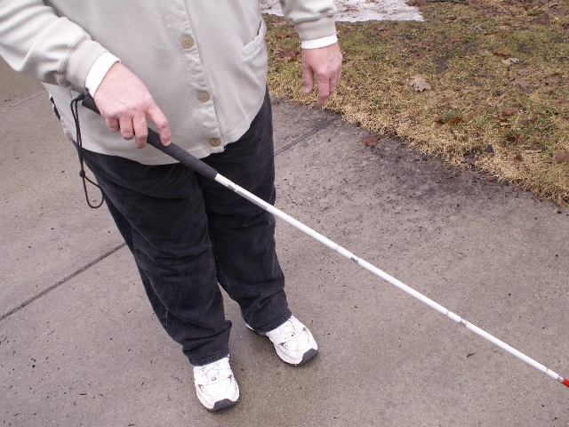

October 15, 2015 ·

Blinded Veterans Association
October 14, 2015 ·
Tomorrow is White Cane Safety Day! The white cane is both an important mobility tool for blind and low vision people and serves as a signifier to motorists to take care around white cane users. Many local BVA groups and members participate in events to raise awareness of the White Cane and the challenges of life with little or no vision.

White Cane Safety Day is Thursday
Gerard Boucher of Haverhill, a blind war veteran, wants to remind the public about people who are blind and visually impaired and how many of them use white canes when walking on sidewalks and crossing streets.
EAGLETRIBUNE.COM

Examples from Twitter:

Miami Lighthouse ‏@Miamilighthouse 29 Oct 2015
#TBT to the unforgettable National White Cane Day walk to raise awareness for White Cane Safety Laws!

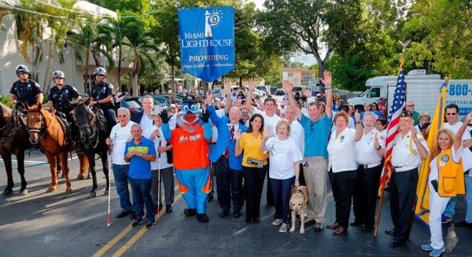
Reply

Retweet

Like

More

Cincy Blind ‏@CABVICincy 22 Oct 2015
Our Blind American Equality Day/ White Cane Safety Day Celebration was a success!

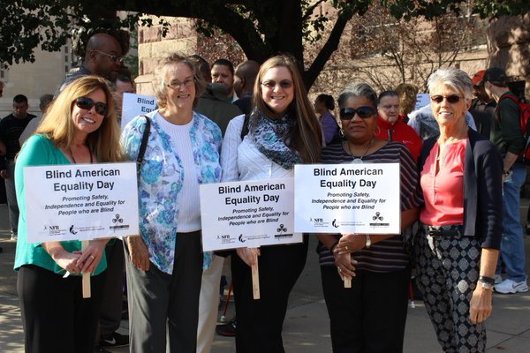

If you have suggestions to add to this toolkit, please let us know!

Contact information for the Wisconsin Council of the Blind & Visually Impaired
Phone: (608)255-1166
Toll free phone: (800)783-5213
Fax: (608)255-3301
Mailing address: 754 Williamson Street, Madison, WI 53703
Website: www.wcblind.org
Email: info@wcblind.org

