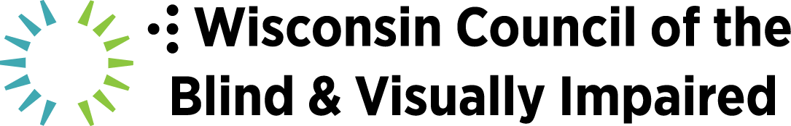

SOCIAL MEDIA FOR ALL OF US:
MAKING CONTENT ACCESSIBLE AND INCLUSIVE

Hashtags to use when you start doing accessible posts:
#AccessibleSocialMedia and #Accessibility

5 Tips to Make Your Social Media Accessible by Fashioneyesta:
1) Add alt text and/or image descriptions
2) Capitalize the first letter of each word in hashtag; voiceover pronounces it really weird otherwise! Demonstration: #InclusiveActivity inclusiveactivity
3) Add transcriptions to your videos (YouTube automatically adds it now; make sure it’s right) add a script using a tool like Cliptomatic; add captions to Instagram Stories
4) Add hyperlinks to your content
5) Don’t overuse GIFs - not accessible for people who use voiceover

Writing Alt Text:
HubSpot - Image Alt Text: What It Is, How to Write It, and Why It Matters to SEO https://blog.hubspot.com/marketing/image-alt-text
Axess Lab - How Does Alt Text Work? https://axesslab.com/alt-texts/

University of Minnesota tutorial blog post on accessible social media
https://accessibility.umn.edu/tutorials/accessible-social-media

6 ways to make your social media posts accessible for people with a visual impairment - Life of a Blind Girl blog
https://lifeofablindgirl.com/2018/10/31/6-ways-to-make-your-social-media-posts-accessible-for-people-with-a-visual-impairment/

Marketing Land article
https://marketingland.com/how-to-make-your-content-more-accessible-to-the-visually-impaired-255553

6 Actionable Tips for Accessible Emails:
https://www.webdesignerdepot.com/2019/04/6-actionable-tips-for-accessible-emails/

Influencers:
Molly Burke
IG: @MollyBurkeOfficial

Emily Davison
FB: @FashionEyesta
IG: @FashionEyesta2012
Ink Davidson
IG: @InkDavidson
Pippa Leigh
IG: @PippaLeigh13
The Disability Collective
IG:@TheDisabilityCollective

Twitter example:
Braille Works World Braille Day tweet with image description
https://twitter.com/BrailleWorks/status/1081188538350215169

Clips with descriptive video:
Disability Vote Coalition: http://www.disabilityvote.org/videos

Star Wars: https://www.youtube.com/watch?v=qeL1H2ILiNM

Lion King (dramatic! 2:22): https://www.youtube.com/watch?v=jT5AsjzgIC4&feature=youtu.be

The Hunger Games (dramatic! 0:56)
https://www.youtube.com/watch?v=B8BD9txkGL4

Frozen trailer (funny! 1:31): https://www.youtube.com/watch?v=O7j4_aP8dWA

Microsoft apps (business/ad example of integrated description 1:17)
https://www.youtube.com/watch?v=v79wg45-_ys

Example of an inaccessible video on YouTube:
IKEA hacks https://m.youtube.com/watch?v=OqfJGOuX1Jk

