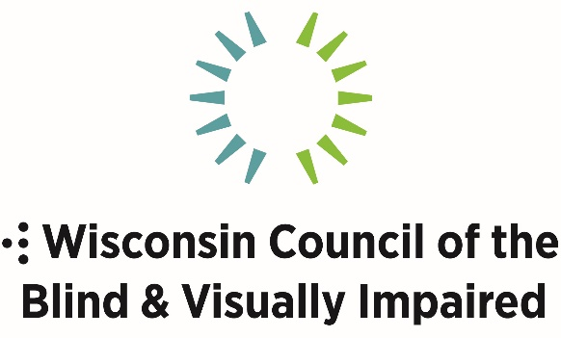

754 Williamson Street
Madison, WI 53703
800-783-5213
WCBlind.org

February 2019

Hello!

I am pleased to send you an application for scholarships given by the Wisconsin Council of the Blind & Visually Impaired. This year we are providing up to ten $2,000 post-secondary scholarships for full and part-time students enrolled or accepted in university/college, community or technical college programs. May 18, 2019 the Council will host our annual scholarship and awards luncheon. Scholarship winners are expected to attend this event. The details of place and exact time will be announced in the award letter. Additionally, the Council will ask recipients to update us periodically on your educational and career progress and be interviewed for Council publications.

A committee reviews applications considering grades, interests, answers to the essay questions and extra-curricular activities, both at school and in the community. This is a highly competitive process and you have the opportunity to market yourself to the committee through the application process. All students must include a letter of recommendation from an instructor. Previous applicants are invited to apply again, with an expectation of original responses to the essay questions.

A “Verification of Vision Impairment” form (attached) must also be included for all first-time applicants or if you do not have one already on file with us. Deadline for applications is Friday, April 5, 2019. Incomplete applications or applications received after the deadline will not be considered.

We will contact you by April 19, 2019 of the committee’s decision. Recipients and up to two family members are invited to attend the Saturday, May 18, 2019 scholarship and awards luncheon.

Thank you for your interest in the Council. If you have further questions or would like scholarship information in another format, please contact our office at 800-783-5213.

Sincerely,

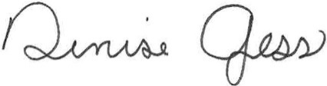
CEO/Executive Director

Wisconsin Council of the Blind & Visually Impaired
Scholarship Requirements

- Applicants must have established residency in Wisconsin by providing a photocopy of a valid state ID.

- Maintain at least a 3.0 Grade Point Average, and provide at least one letter of recommendation from an instructor.

- Have a visual acuity of 20/70 or less in the better eye with the best conventional correction OR have a visual field of 20 degrees or less.

- Attendance in a technical/community college or university program carrying at least enough credits for part time or full time status, as defined by the institution. The committee has the right to make exception to this requirement if there are extenuating circumstances. Please provide information or documentation.

- Incoming freshman must provide verification of high school grade point average.

- Participants in the Business Enterprise Program must submit a letter of recommendation by an instructor or supervisor.

- A copy of the current semester schedule and grade transcript OR an acceptance letter to the institution must be included with the application.

Important Note

Please be sure that all requirements above are enclosed with your application. This is your responsibility. Application deadline is Friday, April 5, 2019. Incomplete or late applications will not be considered. Thank you for your attention to this note!

Instructions

- Fill out the application. If handwritten, please be sure your writing is legible and easy to read. Be sure your application contains all information required. (Use the checklist to be sure!)

- Make a photocopy of your valid Wisconsin State ID and include it with your application. If you’ve applied in the past, you do not need to re-submit a copy of your ID, unless something has changed on it. You are responsible for making sure that your previous year file contains the ID and indicating this on your application.

- A) If you are a first-time applicant, have the attached “Verification of Vision Impairment” form completed by a qualified physician (ophthalmologist or optometrist), DVR counselor, teacher of the visually impaired, school nurse or counselor from college disabilities services department and signed within one year of the application date. You may also submit a Wisconsin Department of Public Instruction Ocular Report.

B) If you have previously applied for a Wisconsin Council of the Blind & Visually Impaired scholarship and submitted verification, please indicate this on the application. It is your responsibility to make sure your previous application contained the verification form.

- In order to act on your application, we must have a complete legible transcript bearing the Registrar’s Seal. The Grade Point Average should be included using the 4.0 scale. If you are in high school, please include an official transcript from your school.

- All applicants must have one letter of recommendation, written by an instructor, and mailed directly to the Scholarship Committee (address below).

- Application material must be postmarked no later than April 5, 2019, in order to be considered and sent in one envelope to:

Wisconsin Council of the Blind & Visually Impaired
Scholarship Committee
754 Williamson Street
Madison, WI 53703-3546

In addition, the answers to all essay questions must be sent electronically in Word to rcubberly@WCBlind.org

Wisconsin Council of the Blind & Visually Impaired
Scholarship Application

Please Print Clearly or Complete Using a Word Processor

- Name:

- Date of Birth:

- Present Address:

- Permanent Address:

- E-mail Address:

- Telephone Number, including area code:

- How have you heard about the Wisconsin Council of the Blind & Visually Impaired? Check all that apply.

___ Family member ___ Teacher or other educator
___ Eye doctor ___ Friend
___ Council’s webpage ___ Council’s social media
___ Sharper Vision Store visit ___ Other - specify

- How did you hear about this scholarship?

- How are you currently financing your education?

- What is your vocational goal?

Please list your major and/or minor (if declared):

- Are you involved in any extracurricular activities, either at school or in the community or both? Yes No

If yes, please list the organizations and your role with them:

- In the future, how do you see yourself becoming involved with the Council?

- In a maximum of 400 words, describe a special attribute or accomplishment that sets you apart. Explain why you believe this would make you an excellent candidate for this scholarship. If you have applied for this scholarship in the past, please author a new response to this essay question.

- Please respond to ONE of the three prompts below, keeping your response to a maximum of 400 words.
  - Describe your visual impairment and how it affects your life. As above, if you’ve answered this question on a past application with the Council, please author a new original response.
  - How does your continued education help you cope with your vision impairment?
  - Please share an example(s) of your leadership in advocating for the needs of people who are blind and visually impaired.

NOTE: If you have applied for a Council scholarship in the past, please choose a new prompt for question 14.

- What college or technical/community colleges have you attended (or into which college or technical school have you been accepted)? _________________

Be Sure to Send Complete Transcripts

School attended Dates attended Degree or Diploma

- If I am chosen as a recipient, I will come to receive this award at the May 18 event in Madison. Yes
If ‘No’ please explain:

If ‘Yes’, describe any special accommodation, you may need:

Award recipients may bring up to two guests to the May 18 luncheon.

I solemnly affirm that to the best of my belief the information given herein is correct.

________________________________ _______________
APPLICANT’S SIGNATURE DATE

Completed, signed form must be postmarked by April 5, 2019
Wisconsin Council of the Blind & Visually Impaired
Scholarship Committee
754 Williamson Street
Madison, WI 53703-3546
1-800-783-5213

Wisconsin Council of the Blind & Visually Impaired
Verification of Vision Impairment

Please Note: This Verification of Vision Impairment is required for all new scholarship applicants as well as any applicant who does not already have one on file with the Wisconsin Council of the Blind & Visually Impaired. It is the candidate’s responsibility to confirm that WCBVI has a copy of the verification.

Applicant’s Name______________________________________________

I, ___________________________________ (Please Print Name)

certify that I have examined the above applicant and that he or she is visually impaired as defined below.

A best corrected visual acuity of 20/70 or less, or a visual field of 20
degrees or less, in the better eye.

I certify that the information I have provided is true to the best of my knowledge.

_____________________________________ ____________________
Authorized Signature Date

____________________________________________________________
Address (Street, City, State, Zip)

Telephone Number (______)______________________________________

Completed, signed form must be postmarked by April 5, 2019
Wisconsin Council of the Blind & Visually Impaired
Scholarship Committee
754 Williamson Street
Madison, WI 53703-3546
1-800-783-5213

Visit our website for more information on services or programs!
WCBlind.org

Wisconsin Council of the Blind & Visually Impaired
Scholarship Application Requirements Checklist

Answers to the essay questions (13 & 14) must be sent electronically in Word to rcubberly@wcblind.org by April 5, 2019.

Please use the following checklist to insure you have ALL required items and information. If you cannot check it off, do not mail your application – it must be complete and received on time!

□ Applicants must have established residency in Wisconsin by providing a photocopy of a valid state ID. If you have applied in the past and have a copy of your ID on file, you do not need to re-submit it. It is your responsibility to make sure that your previous file contains a copy of the ID card.
□ Maintain at least a 3.0 Grade Point Average and provide one letter of recommendation from a supervisor or instructor.
□ Have a visual acuity of 20/70 or less in the better eye with the best conventional correction OR have a visual field of 20 degrees or less.
a) New applicants must submit the enclosed “Verification of Vision Impairment” form, signed by an appropriate agent.
b) Returning applicants are responsible for checking with the Wisconsin Council of the Blind & Visually Impaired to be sure that we have a copy on file.
□ Full-time or part-time attendance in a technical/community college or university program carrying at least a full load or part time load, as defined by the institution. The committee has the right to make exception to this requirement if there are extenuating circumstances. Please provide information or documentation.
□ Incoming freshman must provide verification of high school grade point average.
□ Letter of recommendation by an instructor to be sent directly to the Scholarship Committee.
□ If applicable, a copy of the current semester schedule and grade transcript must be included OR a copy of the acceptance letter of the institution to which you are attending in the fall.

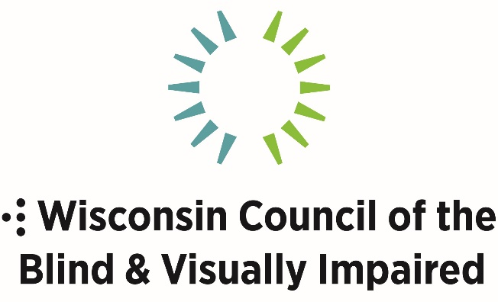

Promoting the dignity and empowerment of the people in Wisconsin who are blind and visually impaired by providing services, advocating legislation and educating the general public.

The Wisconsin Council of the Blind & Visually Impaired has been serving the needs of people in Wisconsin who are blind or visually impaired once 1952.

We are committed to empowering and assisting the growing number of people who must make lifestyle changes and adjustments due to vision impairment.

We provide:
• one-on-one low vision exams • free white canes
• assistive technology • rehabilitation training
• the Sharper Vision Store • outreach and advocacy
• educational conferences • information and referral
• scholarships

Why is our work so important?
Every seven minutes, someone in America will become blind or visually impaired. By 2030, the estimated number of visually impaired Americans 65 and older will double to seven million.

Vision impairment is one of the main causes of loss of independence. By providing powerful tools for independence and empowerment, the Council helps improve the quality of life for people of all ages who are blind or visually impaired, and this in turn enhances and enriches the larger community.

To learn more about the programs, services, outreach and advocacy of the Council, please contact us.

Wisconsin Council of the Blind & Visually Impaired
754 Williamson Street • Madison, WI 53703-3546
608-255-1166 • 800-783-5213 • WCBlind.org • info@wcblind.org
Visit our social media channels on Facebook, Twitter,
Instagram, YouTube and LinkedIn

