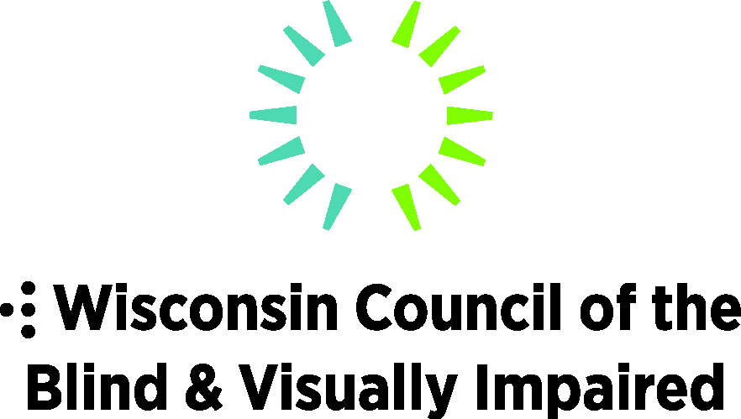
754 Williamson Street, Madison, WI 53703
WCBlind.org, info@WCBlind.org
608-255-1166

Legislative Priorities: Education
Support increased educational opportunities, including access to specialized educational services, for the 511 Wisconsin students who are blind or visually impaired.

Budget Items
- Increase funding for special education in alignment with Governor Evers’ proposed $600 million. State funding for special education has been flat for the past 10 years, creating unmet needs for students with disabilities.
- Create a dedicated funding stream for students who are blind or visually impaired. Currently, there is no specific funding category for students who are blind or visually impaired. A dedicated funding stream for students with visual impairments would help ensure there is appropriate specialized technology and staff to meet their needs.
- Maintain the current level of funding for the Wisconsin Center for the Blind and Visually Impaired (Janesville), which has dedicated programs, outreach, and specially trained professionals serving the needs of students with visual disabilities throughout the state.

Legislative Items
- Recruit and train additional vision services professionals to provide services in educational settings. There is a severe shortage of vision professionals in Wisconsin schools. These professionals are highly educated -- often with a Master’s degree or specialized certification—to provide training and education in assistive technology, adaptive techniques and orientation and mobility to people experiencing vision loss.
- Promote loan and loan forgiveness programs, facilitated by the Higher Education Aids Board, for teachers of the visually impaired and orientation and mobility specialists.

