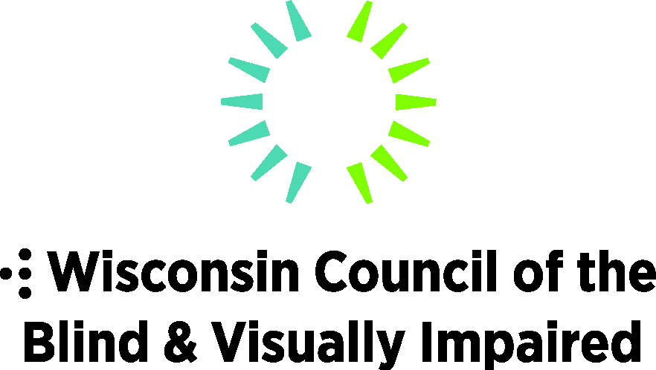
754 Williamson Street, Madison, WI 53703
WCBlind.org, info@WCBlind.org
608-255-1166

Legislative Priorities:
Health & Long-term Care Priorities
Protect and strengthen health coverage for people who are blind or visually impaired. People with vision-related disabilities, whether purchasing their own health insurance or accessing Medicaid, are vulnerable to changes in these systems. Those who are income-limited, suffer from a traumatic eye injury or disease, require surgery or medication, or have other health conditions are especially impacted.
Budget Items
- Increase state funding for the DHS Office of the Blind and Visually Impaired (OBVI) to $500,000 to match the federal grant from the Independent Living for Older Blind Grant annual award. Funding is needed to maintain the necessary level and number of professionals to effectively serve the increasing population of adults with significantly changing vision. OBVI staff instruct individuals with low vision on techniques and technologies for use in daily living (home management, personal care, Orientation & Mobility, and communications). The state’s share of funding for OBVI has been flat in recent years, which has impacted recruitment and retention of vision service professionals. At the same time, the numbers of people with significantly changing vision is increasing as individuals live longer and Baby Boomers age.

- Create and fund a residential-based adjustment skills training program for adults experiencing significantly changing vision. Wisconsin is among a handful of states that do not provide a residential-based adjustment skills training program for adults experiencing significantly changing vision.

- Expand the types of certified professionals who can bill Medicaid for vision services. Currently, Medicaid will pay for vision rehabilitation if the services are performed by a licensed occupational therapist (OT). Other highly qualified vision rehabilitation specialists, such as a certified low vision therapist, certified orientation and mobility specialist, certified vision rehabilitation specialist or a certified assistive technology trainer cannot be reimbursed by Medicaid. While the services of an OT are billable, there are few OTs with the proper training in low vision. Vulnerable Wisconsin residents, ranging from infants to elders, would be better able to receive the necessary training and skills to reduce injuries and live a healthier quality of life. Additionally, agencies like the Department of Vocational Rehabilitation would also be able to better utilize their funding for direct job training, rather than needing to fund support services like orientation and mobility and vision rehabilitation.

