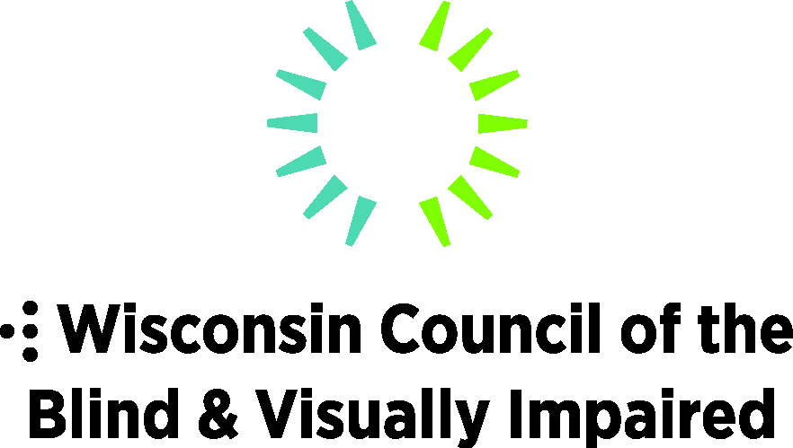
754 Williamson Street, Madison, WI 53703
WCBlind.org, info@WCBlind.org
608-255-1166

Legislative Priorities: Transportation
Alternatives & Accessibility
Strengthen transit and transportation services to ensure people with disabilities across Wisconsin can get where they need to go. Transportation is among the greatest challenges for people who are blind or visually impaired.
Because they are transit dependent, access to employment, healthcare, and community are limited due to inadequate transportation services. State transit aid is $4.8 million below the 2011 funding level and has led to a decline in services and increased fares.
Budget Items
- Increase funding for the specialized transit program for Seniors and Individuals with Disabilities (85.21) by $3 million per year and (85.215 to the tribes) by $50,000 to account for accelerating growth in the future.
- Increase the transit budget by $36.3 million per year to support increased transit and paratransit funding as well as necessary infrastructure improvements.
- Increase paratransit funding by $3 million per year. Paratransit funding has been flat since 2013.
- Create a shared-use transportation council to develop a strategic plan to increase transportation coordination across the state and between state agencies.
- Provide $200,000 to the Department of Transportation to administer a grant program designed to help municipalities install accessible pedestrian signals.

Legislative Items
- Increase public awareness of Wisconsin’s Pedestrian Right of Way laws to ensure drivers understand the White Cane Law. This will protect the rights of pedestrians with visual impairments. WCBVI supports the following:
- Enhanced public awareness regarding drivers' responsibilities to preserve the safety of persons using white canes or guide dogs, through the mechanisms of the Department of Transportation.
- Greater enforcement of pedestrian safety laws to guarantee the safety of pedestrians who are visually impaired or blind.
- Increased penalties for the violation of laws designed to enhance the safety of pedestrians who are visually impaired or blind.

