STAY ON TRACK OF YOUR DIABETES
According to the National Eye Health Education Program (NEHEP), about 10% of the U.S. population has diabetes and at least 1 in 3 are pre-diabetic. Kaiser Permanente reports blurry vision is often an early warning sign of diabetes. Elevated glucose levels in the blood can damage vessels by narrowing them. While blood vessels all over the body are impacted, damage to the fragile blood vessels of the eye can lead to vision changes.

Diabetic Retinopathy

Diabetic retinopathy is the leading cause of vision loss among working-age adults, according to the National Institutes of Health.
Several factors influence whether you get diabetic retinopathy:
- blood sugar control
- blood pressure levels
- how long you have had diabetes
- genes

According to the American Diabetes Association, the longer you have had diabetes, the more likely you are to have some form of retinopathy. People who keep their blood sugar levels closer to normal are less likely to have retinopathy or will have milder forms.

Glaucoma
People with diabetes are 40% more likely to suffer
from glaucoma than people without diabetes. The longer someone has had diabetes the more at risk they are for developing glaucoma. Risk also increases with age.

Did you know? With cataracts, the eye’s clear lens
clouds, blocking light.

Cataracts

Many people get cataracts, but people with diabetes are 60% more likely to develop this eye condition. Excess blood sugar can cause cataracts. People with diabetes also tend to get cataracts at a younger age and they progress faster.

1

Tools to Help

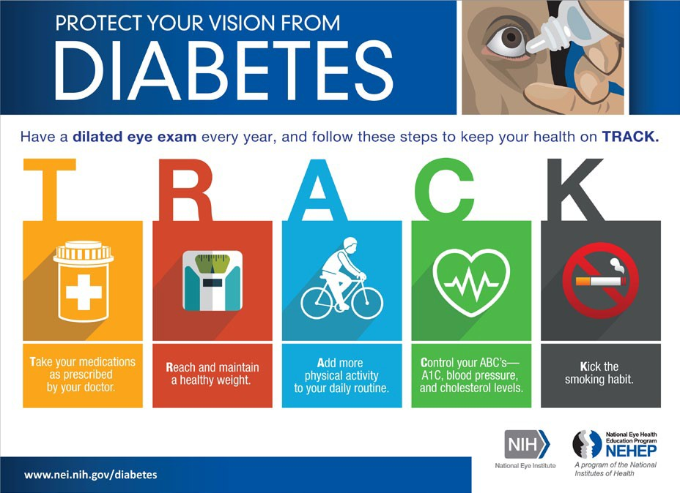
Annual dilated eye checkups can reduce complications due to the conditions above or help you avoid them altogether. There are many strategies and tools to help you stay on top of your diabetes with low vision. NEHEP developed a tool using the word “TRACK” to help you remember how to stay on track with your diabetes:
T: take medications as prescribed
R: reach and maintain a healthy weight A: add physical activity to daily life
C: control A1C, blood pressure and cholesterol K: kick smoking

If you have diabetes, work with a certified diabetes educator who will educate, support and advocate for you. If you also have a vision impairment, consider meeting with a vision
rehabilitation specialist to get help with routine tasks associated with medication management, meal preparation, participation in enjoyable physical activities, and measuring blood glucose levels.

Materials for Measuring Blood Glucose

Discuss with the diabetic educator the features that different meters offer. If you have usable vision, ask your diabetic educator to recommend a meter with large numbers and a high contrast screen. If needed, ask about a talking meter, making sure you can hear the audio output.

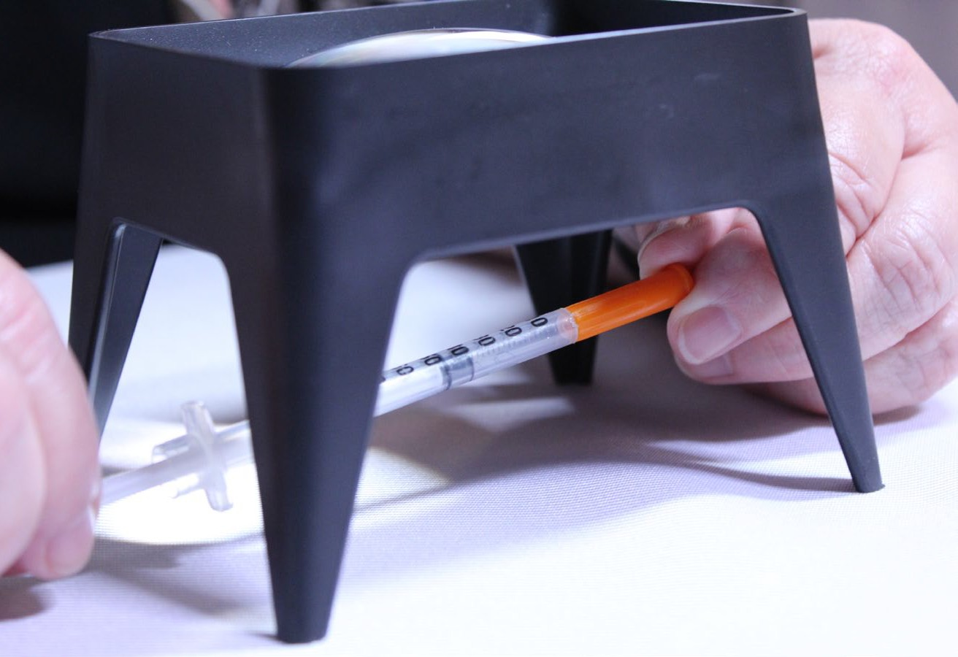Other useful features include meters that can be managed independently by a person who is blind, meters that give blood glucose averages over a 30- or 60-day span, and talking meters with a repeat button.

Create a consistent location for the testing set-up. A solid surface is preferable to stabilize the meter or the finger being
If you have low vision, make the surface high contrast in relation to the testing items. This can be any color that works for you. Add a task lamp that is movable because it will need to be placed to best enhance the blood drop’s location and not cast a shadow on the lanced finger. Sometimes, an optical aid may be useful. This might be a head-worn device like the Optivisor or a stand magnifier. If you have a CCTV, consider using it to help find the blood drop. Magnifiers can be ordered through the Sharper Vision Store at WCBlind. org/store, or by calling 608-255-1166.

Getting the Most Accurate Blood Glucose Reading

To increase the blood flow to the fingers, wash your hands in warm water to remove any substance that might alter the meter’s reading if the substance mixed with the blood drop. Use soap when washing hands, as hand sanitizer can alter the reading. Vigorously shake your hands at your side, like shaking a mercury thermometer. Milk the finger that will be lanced by gently squeezing the finger from its base toward the fingertip. A final suggestion to increase the blood in the tip of a finger is to use a rubber band tourniquet or pinch-type clothespin. Place the rubber band or clothespin next to the first joint from the fingertip. Lance the fingertip and release the rubber band or clothespin. For detailed instructions and pictures, go to static.diabetesselfmanagement.com/ pdfs/DSM2337_3714.pdf.

Getting the blood onto the test strip can be a challenge. Work with your diabetic educator to discover a solution that
will work for you. One suggestion is to turn the meter sideways as the strip meets the fingertip. This is more effective when the hand that has been lanced is stabilized on the surface and only the meter is being moved. For detailed instructions with pictures, go to nfb.org. Some hold their thumb nail next to the spot to be lanced, and leave the thumb in that position as a landmark for the location of the blood drop.

Hold thumbnail next to lanced area.

Magnifier with syringe.
2
lanced. A tray with raised sides prevents testing items from
getting away. 3

Physical Activity for Well-Being

Increasing physical activity can be challenging with vision impairment. Check the local community recreation programs for chair exercise classes.
These classes can increase your heart rate without leaving the chair. If a gym or physical fitness center is available, schedule a meeting with a trainer. Have the trainer work with you to find machines that meet your comfort level. Ask someone to work with you until you are able to
independently set up the machine for your needs and you can orient within the facility.

If you prefer being out and about, try to get mobility training from a Certified Orientation and Mobility Specialist and learn to use a long white mobility cane. With training, you can walk in your neighborhood or around the mall to get in physical activity. If you are concerned about falling, Stepping On classes may be helpful.

Tips to Start or Continue an Exercise Program

- Create a schedule with your smart speaker or smart phone. The Amazon Echo, Google Home, watch, FitBit or smart phone can provide you with daily reminders to move and stay on TRACK.
- Pick an exercise buddy – someone you can share your successes and challenges with!

Additional Resources

Contact your healthcare system or the Aging and Disability Resource Center for diabetes education classes in your area.
VisionAware’s How Can I Manage My Diabetes
Centers for Disease Control and Prevention’s Living with Diabetes
Find a Diabetes Educator at the National Certification Board for Diabetes
Educators or American Association of Diabetes Educators.

4

