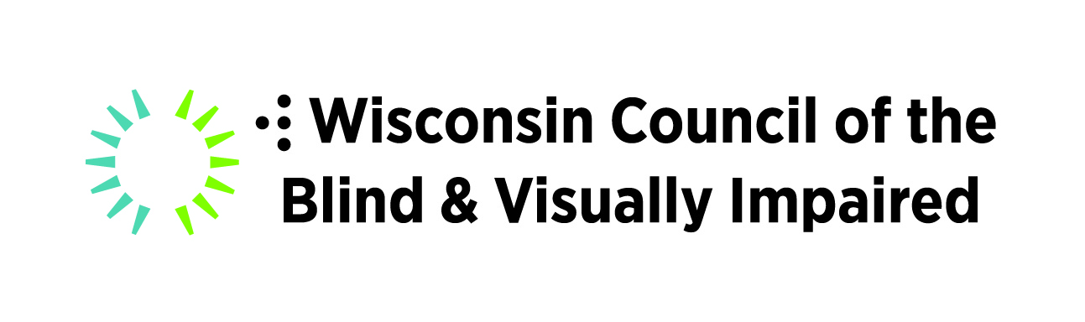

Eleven Amazing iPhone and Android Apps

Presented by:
Jim Denham
Wisconsin Council of the Blind & Visually Impaired
http://www.wcblind.org

Presented: May, 2020

General Overview

Apps allow users of smart phones to perform a wide variety of tasks. For individuals who are blind or visually impaired, the accessibility features which are built-in to modern smart phones, including screen magnifiers and screen readers, make many of these apps accessible. For example, Apple products contain a screen reader called Voiceover and a screen magnifier called Zoom. Users of Android phones can take advantage of a screen reader called Talkback and a magnification system called Magnifier.

To learn more about the accessibility of Apple products, including iPhones and iPads, you can visit:
https://www.apple.com/accessibility/iphone/

To learn more about the accessibility of Android phones, check out:
https://support.google.com/accessibility/android/answer/6006564?hl=en

Apps for both iPhone and Android

bard mobile
Price: Free
Description: Allows users to download and play books and magazines from the National Library Service for the Blind and Print Disabled’s BARD Service. Individuals who are blind or visually impaired must register with the National Library Service before they can access this content.
Learn more about NLS Bard, including links to download the Bard mobile app for both iOS and Android at:
http://nlsbard.loc.gov

audible
Price: Free, but users must purchase books or subscribe to a monthly membership
Description: Audible, which is part of Amazon, contains a vast collection of audio books recorded by professional narrators. The app allows users to browse, download and play these titles.
Link to Audible:
http://www.audible.com

NFB Newsline
Price: Free
Description: NFB Newsline Mobile, available to individuals who are blind or who have print disabilities, can be used to read electronic newspapers, magazines and television listings. This is a service of the National Federation of the Blind.
Apple App Store link:
https://apps.apple.com/us/app/nfb-newsline-mobile/id530470425
Google Play Store link:
https://play.google.com/store/apps/details?id=com.nfb.android&hl=en_US

Smart News
Price: Free
Description: A very easy to use app which provides local, national and world news.
Apple App Store link:
https://apps.apple.com/us/app/smartnews-local-breaking-news/id579581125

Google Play Store link:
https://play.google.com/store/apps/details?id=jp.gocro.smartnews.android&hl=en_US

Google Maps
Cost: free
Description: An accessible mainstream GPS app for navigating to and finding information about local businesses. Google maps can provide spoken directions for navigating by car, bus or walking.
Apple App Store link:
https://apps.apple.com/us/app/google-maps-transit-food/id585027354

Google Play Store link:
https://play.google.com/store/apps/details?id=com.google.android.apps.maps&hl=en_US

Uber
Cost: The Uber App is free, but there is a cost to use the service
Description: Connect to a driver in your area who can provide a ride to your desired destination. Payment can be handled using a credit card and you will get information about your driver and there arrival status.
Apple App Store link:
https://apps.apple.com/us/app/uber-request-a-ride/id368677368

Google Play Store link:
https://play.google.com/store/apps/details?id=com.ubercab&hl=en_US

Lyft
Cost: The Lyft App is free, but there is a cost to use the service
Description: Connect to a driver in your area who can provide a ride to your desired destination. Payment can be handled using a credit card and you will get information about your driver and there arrival status.

Apple App Store link:
https://apps.apple.com/us/app/lyft/id529379082

Google Play Store link:
https://play.google.com/store/apps/details?id=me.lyft.android&hl=en_US

Aira
Cost: App and first five minutes of every call is free, but extended service may require a monthly subscription
Description: Gain on-demand access to the visual world by contacting a trained Aira agent who can assist with a wide variety of tasks.
Link to Aira homepage:
http://aira.io

Be My Eyes
Cost: Free
Description: Connects an individual who is blind to a sighted volunteer who can then see through the users camera to answer questions about the surrounding environment. Also allows individuals who are blind to connect with several different companies to get product assistance.
Apple App Store link:
https://apps.apple.com/us/app/be-my-eyes/id905177575

Google Play Store link:
https://play.google.com/store/apps/details?id=com.bemyeyes.bemyeyes&hl=en_US

Just Press Record,
Cost: $6.99
Description: Instantly start recording to save important information. The app also allows users to save recordings to the cloud and play them back when needed.
Apple App Store link:
https://apps.apple.com/ca/app/just-press-record/id1033342465

Google Play Store link:
https://play.google.com/store/apps/details?id=quick.memo.song.voice.recorder&hl=en_US

iPhone/iPad Apps

OOTunes,
Cost: $4.99
Description: Listen to and record hundreds of radio stations from around the world in a wide variety of genres.
Apple App Store link:
https://apps.apple.com/us/app/ootunes-radio-record-alarm/id302782364

Seeing AI
Cost: Free
Description: Read printed documents, determine the denomination of currency and identify household products using the camera on your iPhone.
Apple App Store link:
https://apps.apple.com/us/app/seeing-ai/id999062298

Spectrum Access
Cost: Free
Description: Download and Listen to the audio description track or read the closed captions of hundreds of movies. This app does not require a subscription to Charter or Spectrum, but it does require you have the movie playing on television or through a streaming service.
Apple App Store link:
https://apps.apple.com/us/app/spectrum-access-enabled-media/id1492182876

Vintage Radio
Cost: Free, but monthly subscription of $2 for access to entire library of shows
Description: Listen to hundreds of hours of old time radio classic shows in a wide variety of genres.
Apple App Store link:
https://apps.apple.com/us/app/vintage-radio/id455577974

Android Only Apps

MyTuner Radio

LookOut
Cost: Free
Description: This app allows Android users to read printed materials, identify currency and hear the location of nearby objects using the camera on a phone.
Link to app in Google Play Store:
https://play.google.com/store/apps/details?id=com.google.android.apps.accessibility.reveal&hl=en_US

This document was prepared by:
Jim Denham
Assistive Technology Specialist
Wisconsin Council of the Blind & Visually Impaired
754 Williamson Street
Madison, WI 53703
Phone: (608) 255-1166
email: jdenham@wcblind.org
www.wcblind.org

