A Welcoming Main Street!

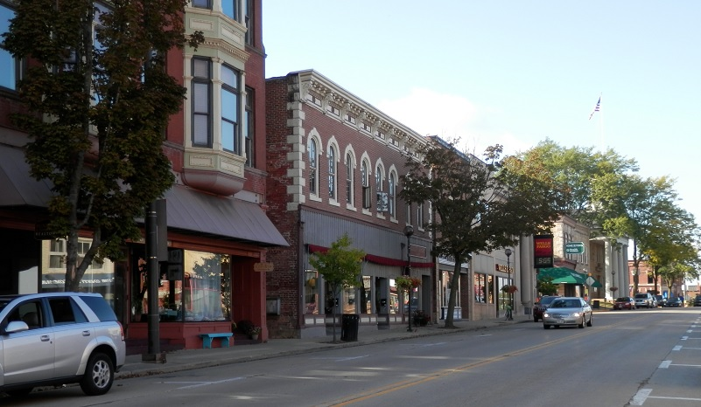

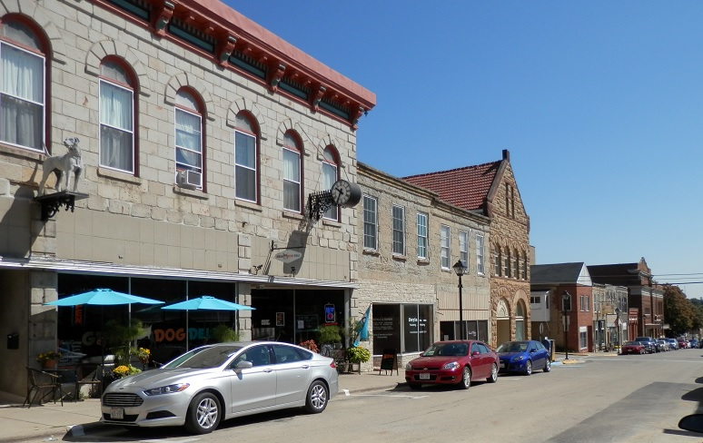

A guide for providing a quality customer service experience for those with vision impairments.

Produced by Wisconsin Council of the Blind & Visually Impaired
WCBlind.org

Introductions

Meet Kaitlyn and Emily.

They are two of the over 90,000 Wisconsin residents who are blind or have low vision (PreventBlindness.org). Kaitlyn and Emily enjoy their independence and being out and about. Kaitlyn loves trying new recipes. Emily loves to travel to family events and gatherings. Kaitlyn enjoys coffee shop visits with work colleagues. Emily enjoys casual restaurants to share a meal with lifelong friends. Kaitlyn is planning to buy a house and has been visiting banks and credit unions in preparation for a mortgage. Emily is gathering genealogy records and writing a family memoir.
(pics of headshots)

Kaitlyn is blind and sees only shadows. Emily has low vision with blurry central vision. Low vision means that glasses, surgery or medication cannot correct the vision loss. The experience of low vision varies by person, eye condition, environment, and lighting. Persons with low vision have usable vision, but may experience blurry vision, dark spots, loss of peripheral vision, partial visual fields, or sensitivity to light and glare. Low vision is not always obvious.

Here are examples of the Iowa County courthouse as seen by persons with different low vision conditions.

 | 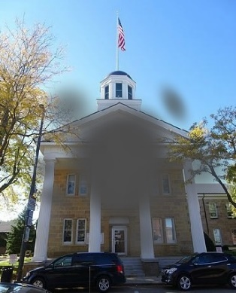 |  | 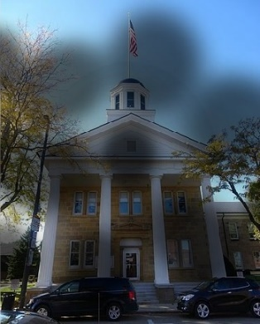
Blurry | Central Vision Loss | Loss of Peripheral Vision | Dark Spots in Visual Field

Kaitlyn and Emily want to shop in their communities and support local businesses. They want to have access to services. They want be involved in their places of worship and to be fully engaged in their communities!

How can Main Street businesses welcome Kaitlyn, Emily and others with blindness or low vision?

By creating work practices and making small changes in the environment, your business, service or agency will accommodate most customers with vision loss and make them feel comfortable.

INTERACTIONS WITH PERSONS WITH VISION IMPAIRMENT

Welcome all customers.
The first impression a business makes with customers is the staff member who greets them as they come in the door. Welcome all customers, “do you need any assistance?” If a customer says “yes,” ask, “How can I help?” Customers can request help to find a product, room number, etc. Go one-step further and ask the customer “do you need any help locating that room?” Let the customer tell you the kind of assistance needed. If there is doubt, ask for clarification.

Address all customers directly.
Position yourself in front of customers. If the person tips her/his head to see you, stay where you are. If you move around too quickly, you might be moving in and out of the customer’s visual field. Speak directly to the customer, not the person who is accompanying them. An example is a restaurant with two people at a table. One of the people is using a white cane and listening to the other person read the menu. The server looks directly at the person with the white cane and asks for the order, then looks at the other person and takes the order. Expect customers to speak for themselves.

Speak up.
When addressing customers, speak up and do not shout. Speak at an even pace. Look at the customer when speaking. If you turn your head away, your voice will trail off in that direction and it may not be heard. Use common words and phrases. Avoid jargon understood only by others in your business. An example is an older person buying a cell phone and not understanding terms like smart phone and data plan.

Give descriptive information.
When giving directions, be specific. Directions like “follow the hallway to the second door on the left” are more descriptive than “down this hallway.” “Over there” or “straight ahead” mean little to a person with vision impairment. If the customer seems confused, try adding descriptive detail and ask if additional assistance is needed.

Offer human guide.
Persons who are blind or have low vision may need a human guide to move safely and efficiently through an environment. To guide a person with vision impairment, have the customer take your arm, just above the elbow. You walk ahead of the customer, who follows about one step behind. The sighted person gives verbal information and cautions as they walk. The human guide will tell about doors that need to be managed (“door opens on your right”) or steps (“there are 3 steps going up and the railing is on your left”). | 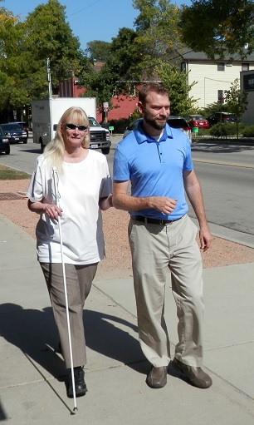
An example is a customer at a bank where there is a lot of open space. Human guide may assist the person from the lobby to the counter or to a private meeting room. Another example is a restaurant host guiding a person through a complex environment of tables and chairs.

Attend to the customer, not the guide dog.
Some customers may have a guide dog. The dog’s job is to guide the person with vision impairment through the environment. The dog will be in harness, indicating it is working. Do not pet, feed or distract a working dog. If the dog is in the way of others, ask the owner to position the dog to be out of the way. | 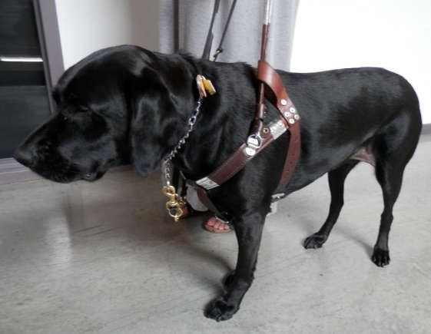

Environment Concepts

Lighting
Persons with low vision need good lighting to navigate easily and safely your business. Older people also require good lighting. Check for darker areas, such as the pathway to restrooms, over stairs or changes in levels. Check for well-lit entrances and parking areas. Consider adding light where needed.

Task lighting is essential for persons with low vision when reading or writing at a table or counter, such as reading papers at a bank or signing a credit slip in a retail shop. Have cordless lights available to help a person with vision impairment read a menu. Book lights may assist a person with low vision to follow along during a worship service.

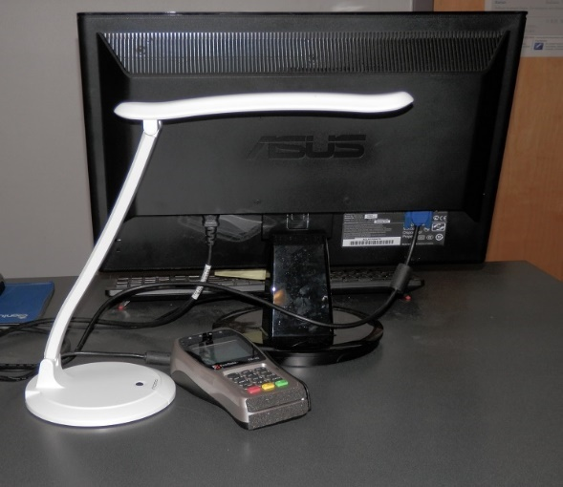 | Position a task light about 10-inches from the work surface with the light directly on the task-at-hand. A cordless LED light may be a good addition at the front counter where customers sign credit slips or put in a pin number.

Glare
Persons with vision impairment are often sensitive to glare as it reduces vision and causes visual confusion. They may prefer sitting with their backs to a brightly window or squint when walking down a hallway with light reflecting off wall pictures. Check your business environment for glare. Check windows when the sun is low.

Check if ceiling or wall light bounces off the glass front of pictures or off the tops of polished tables and counters. Control glare by using adjustable window treatments, non-reflective glass, angling light away from reflective surfaces, or matte finishes or coverings to eliminate glare on tables and counters.

Contrast
High, sharp contrast improves visibility. Any written information is easier to see when text edges are sharp and the text color pops from the background. Examples of low contrast in businesses include forms printed on pastel paper, light grey form fields on a white background, text inside colored fields on a sign, and large, hanging signs that blend into the background.

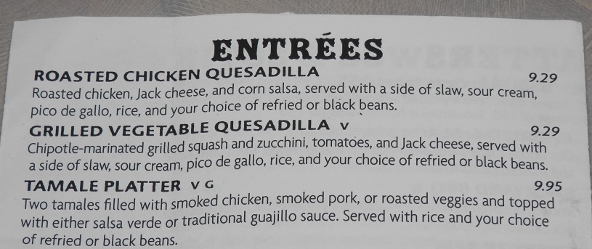 | This menu’s sharp contrast between text and background makes reading easier.
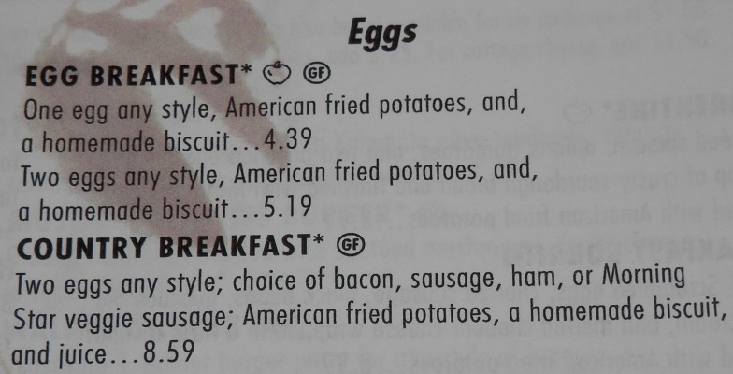 | This menu’s background image, visibility of “shadow” text from the next page, and the off-white background can reduce readability.

High contrast can improve safety when navigating your business. A yellow strip on a step makes it easy to see the edge. Yellow markings on outdoor walkways can help a person stay on the path. A railing on steps in a contrasting color encourages people to use it. | 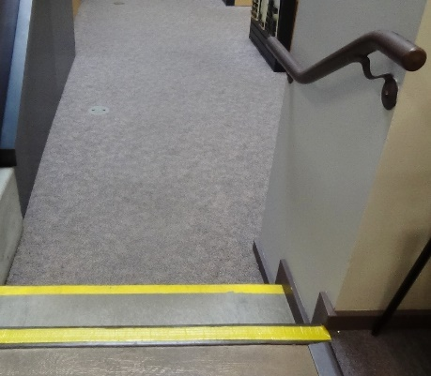

Written Information
Plan for customers who may need alternate formats for written information. Consider having large print (14-point font minimum; 18-point font preferred) and braille materials available. Staff may also offer to read paperwork or to act as a scribe to complete forms.

Have digital copies of forms that are routinely used. Adjust text with a smart phone, tablet or laptop to make the forms easier to manage by persons with vision impairments. Accessibility is available on most operating systems.

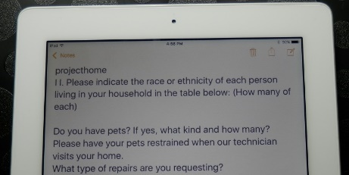 | Standard size document text (left).  Text and background inverted (right). | 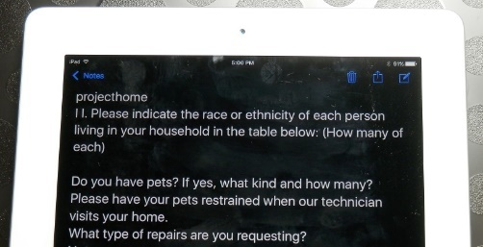
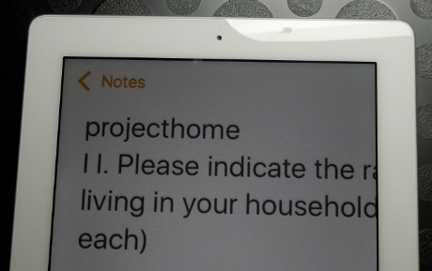 | Text magnified (left).  Text being read with iOS reader (right). | 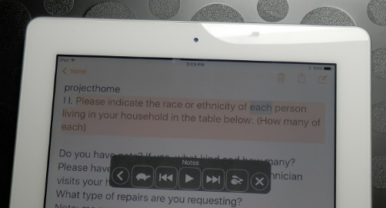

Applying the Concepts

On your web site…
Design web sites to be accessible to persons who use magnification or screen reading software. Use high contrast colors for text against a colored background. Include alt tags with all pictures, as they provide an audio description of images for persons using a screen reader. Have a mobile version of your web site to make it easier to manage on a mobile device.

In a restaurant…
Offer large print or verbal descriptions of the menu. When reading a menu, start broad and then narrow the detail when the diner indicates interest in a certain part of the menu. Tell the diner when placing items on the table and the location of items. For example, “the water glass is above and to the right of your plate.” You can also use a clock analogy. For example, “the chicken is at 6 o’clock, the baked potato is at 10 o’clock and the green beans on at 3 o’clock.” Contrasting place mats and dishware make it easier for diners with low vision to see the edge of the plate or the food that is on the plate.

In a retail store…
Guide customers to items of interest. Identify what is on the shelf. Offer to read packaging information or the price tags. State the cost of items when ringing them up. Reduce clutter in the checkout area, aisles and walkways.

When a customer is using a credit or debit card machine, offer verbal guidance. Tell the customer that the insertion slot is on the right or along the bottom edge. State the location of the submit button, such as in lower right corner of screen. If a digital signature is needed, put your finger on the line at the starting point.

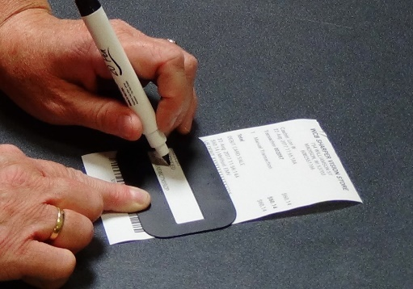 | When signing a paper, place the sales slip on a black mat, making it easier to locate. Put a signature guide along the signature line.

When exchanging cash, tell the amount given to you and count back any change. Offer similar denominations together. Give the person a moment to put away one denomination before giving another. For example, an item costs $2.42 and the customer gives you a $10 bill. State, “$2.42 out of $10.” Gather the change and say, “that’s $7.58 in change. Here’s a $5 bill.” Put the $5 in the person’s hand. “Here are 2-$1 bills.” Give them to the person. “Here’s the 58 cents.”

In a house of worship…
Look for creative ways to offer rides to services and other events for persons who do not drive. Use human guide to assist persons with vision loss to a seat. Let people know the readings and hymns that will be used at the next service. The person with vision impairment can use at-home resources to prepare. Large print bulletins and newsletters or audio versions of the services or classes may increase inclusion of persons with vision loss.

In an office or agency…
Use human guide to assist a person with vision to waiting areas, offices, and chairs. Be descriptive of any procedures that are done. Tell the person when you leave the room or when others come and go. Offer alternatives for all print materials. Be sure staff know to the location of alternative materials. If the alternative is on an electronic device, be sure staff how to manage the device. Do not assume that the person with vision loss can operate your device. Have a private area available when using audio information or a scribe.

Next Steps

An accessible business includes an accommodating physical environment and staff members whose attitudes and behaviors are welcoming and inclusive regardless of disability. Consider which suggestions we have given would work in your business. Share your ideas with staff and let them offer suggestions. Begin implementing the changes to the physical environment. Support your staff to be comfortable asking, “If you need help, please let me know how I can assist you.”

Make customers aware of any changes you have made to increase accessibility and ease of use when in your business. Shine a light on your efforts to make your Main Street business welcoming to those with vision impairments. Caitlyn and Emily will appreciate it!

