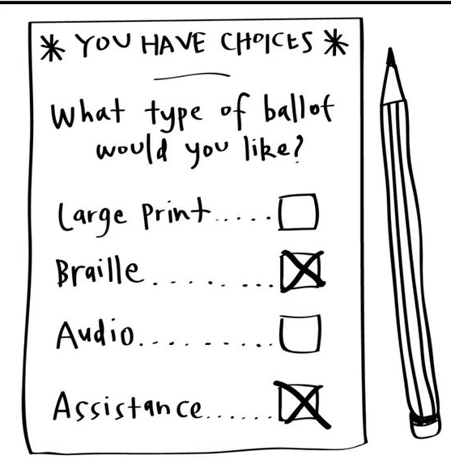
Federal law requires people with disabilities have equitable access to voting, including the right to vote privately and independently.
ACCESSIBLE ABSENTEE VOTING
BACKGROUND
Currently, Wisconsin does not have an Americans with Disabilities (ADA) compliant absentee ballot. Under Wisconsin statute, absentee ballots may not be transmitted electronically, except to overseas and military voters. Voters with blindness, vision impairment, intellectual or other disabilities who cannot see, read, or physically mark the ballot are unable to vote absentee in a private, secure, and independent way.
ABSENTEE VOTING BARRIERS
Photo I.D.: Wisconsin allows people to vote using a voting I.D. which can be picked up at the Department of Motor Vehicles (DMV). However, many have difficulty physically getting to the DMV because of transportation issues.

Inaccurate ballot-marking: People who cannot mark their ballot independently have no method of verifying how their ballot has been marked by a caregiver.
Inability to find an assistant: Many people with disabilities have limited support networks. If the voter lives alone, they may struggle to find a trusted assistant to mark their ballot.
Disempowerment of the voter: Since the voter cannot control their own ballot or be unable to access an assistant, they may be unable to vote.
Continued on page 2

IN-PERSON VOTING BARRIERS
While voters with disabilities can vote in-person at polls or absentee voting locations, there are barriers that prevent them from doing so:
Transportation: Since these voters are primarily non-drivers, they must rely on paratransit, family members or other ways to get to the polls.
Lack of accessible voting equipment: Even though state law requires it, there are barriers to getting the machines deployed for people with disabilities to vote.
Prior negative experiences at the polling place: Accessible equipment might not be set up, wayfinding in the polling place not clearly marked and/or poll workers could display bias towards a person with a disability.

“A screen reader-accessible ballot that could be filled out online offers the most access regardless of format. While it doesn’t address all issues, it increases the circle of accessibility.”
- Denise Jess,
Council CEO/Executive Director

PROPOSED SOLUTION
To assure all voters with disabilities fulfill the right to vote privately, securely, and independently, Wisconsin needs a ballot which can be electronically sent to the voter. The voter can then complete the ballot using appropriate assistive technology and electronically securely submit the ballot to the municipal clerk.
The call for a fully electronic voting process that complies with the ADA Title II has been adopted by many states. For example, West Virginia, New Hampshire, New Mexico, New Jersey and Delaware offer accessible absentee voting.

WCBlind.org • 800-783-5213
Info@WCBlind.org

