EDUCATION

Support educational opportunities for the 1,500 Wisconsin students who are blind or visually impaired.
BUDGET ITEMS
- Increase funding for special education by $500 million to help close the funding gap faced by Wisconsin schools. Prior to the $100 million increase approved by the Legislature and Governor in the 2019-21 state budget, funding for special education had been flat for over a decade, creating unmet needs for students with disabilities.
- Support funding for the Wisconsin Center for the Blind and Visually Impaired in Janesville. This school has dedicated programs, outreach, and specially trained professionals serving needs of students with visual disabilities throughout the state.
LEGISLATIVE ITEMS
- Promote loan and loan forgiveness programs, facilitated by the Higher Education Aids Board, for teachers of the visually impaired and orientation and mobility specialists.
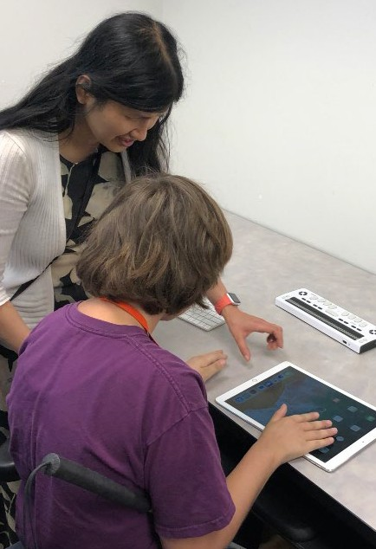
Exploring an iPad’s access technology options.
- The only program in the state that provides training for Teachers of the Visually Impaired is currently inactive. This has led to a severe shortage of vision professionals in Wisconsin schools. Students with visual disabilities are not receiving the supports they need to be successful, such as orientation and mobility training, access technology, and adaptive techniques.

WCBlind.org • 800-783-5213 Info@WCBlind.org

