

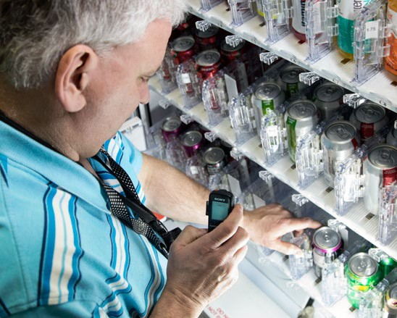

EMPLOYMENT
Support initiatives to increase competitive integrated employment for people who are blind or visually impaired.
Individuals with visual impairments have a 70% unemployment rate and a 22% underemployment rate – meaning almost the entire population has an unfavorable employment status.
People experiencing vision loss have unique needs related to obtaining and sustaining living wage employment. These include access technology training, workplace accommodations, transportation, and employer bias toward persons with visual disabilities.
LEGISLATIVE ITEMS
Repeal a 2013 state law that prevents people receiving Social Security Disability Insurance (SSDI) benefits from getting unemployment benefits or pandemic unemployment assistance. This law has made it difficult for people whose jobs have been impacted by the pandemic to get assistance.

WCBlind.org • 800-783-5213 Info@WCBlind.org

A vendor in the Wisconsin BEP program.
BUDGET ITEMS
Increase resources in the Department of Workforce Development’s Division of Vocational Rehabilitation (DVR). This proposal would boost the state match for Title 1B grant (a reading program for young children) and create a position to support vocational rehabilitation services.
Provide greater funding to Project SEARCH through a $250,000 transfer from the Fast Forward jobs training program. Project SEARCH provides training and career services to young people with disabilities in and just out of high school. This program should be expanded to include a specialist to meet needs of people with vision loss.

