TRANSPORTATION
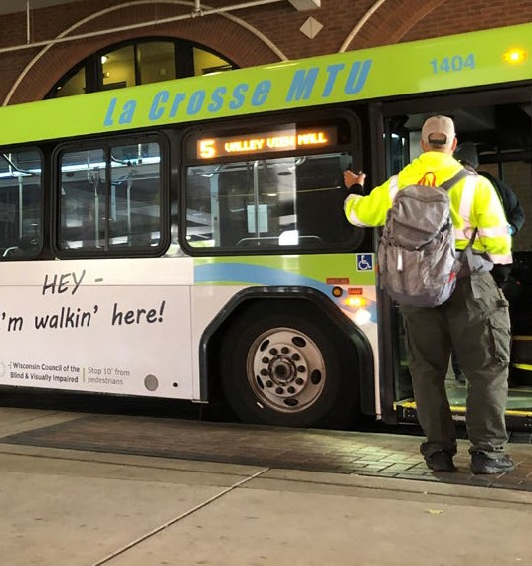

Getting where you need to go reliably on schedule is key to having a job, accessing healthcare and getting to a store for necessities. Reliable transportation can also link you to family and friends.
Legislators may not know that nondrivers face many barriers to accessing transportation. About 65 percent of people who are blind or visually impaired are unemployed, and a comprehensive public transportation system is critical to the ability to start and keep a job.
BUDGET ITEMS
A bus at the transit center in La Crosse.

Grants for Pedestrian Signals: Provide $200,000 to the Department of Transportation to administer a grant program designed to help municipalities install accessible pedestrian signals.
Streamline Agency Services: Direct state agencies to do an evaluation of which services can be provided online or virtually instead of requiring a trip to an in-person office. This will create efficiencies within government programs and increase access for Wisconsin’s estimated 1.2 million non-drivers.

Specialized Transit: Increase funding for the specialized transit program for Seniors and Individuals with Disabilities (85.21) by 10% per year.
Mass Transit: Increase mass transit funding to keep up with inflation and to increase services for non-drivers.
Funding for DMV Customer Service Centers: WCBVI supports the Department of Transportation’s request to provide $2.1 million in funding over the 2021-23 biennium to additional DMV customer service centers in Madison and Green Bay.
Continued on page 2

LEGISLATIVE ITEMS
“Public transportation in our county is lacking. There is nothing after workday hours or on weekends. I am not able to go out for dinner, to church or to my kids’ school activities without help/rides from others. It is very frustrating.”
-Survey Participant
We currently serve on the Wisconsin Non-Driver Advisory Council and the City of Madison Transportation Commission.
40% of Survival Coalition of Wisconsin Disability Organizations’ survey respondents said they do not have access
to public
transportation in their communities.
We support cross-municipal transportation options.
We continue to increase awareness of Wisconsin’s Pedestrian Right of Way laws to ensure drivers understand the White Cane Law and the rights of pedestrians with visual impairment.
WCBVI supports the following:
- Increased education and public awareness regarding drivers’ responsibilities to enhance the safety of persons using white canes or guide dogs.
- Increased enforcement of pedestrian safety laws to guarantee the safety of pedestrians who are visually impaired or blind.
WCBlind.org • 800-783-5213
Info@WCBlind.org

- Increase penalties for the violation of laws designed to enhance the safety of pedestrians who are visually impaired or blind.

