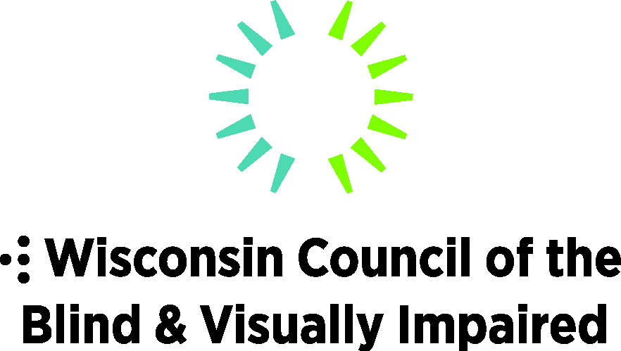
754 Williamson Street
Madison, WI 53703
608-255-1166
WCBlind.org
Info@WCBlind.org

February 2022

Dear Scholarship Applicant,

The Wisconsin Council of the Blind & Visually Impaired is pleased that you are interested in applying for one of our annual scholarships. Thanks to generous gifts from Steve Johnson and the Priess family, we will offer ten scholarships of $2,000 each this year to qualified students.

Please carefully review all the materials in the scholarship kit:
- Application and essay prompts.
- Verification of Visual Impairment
- Request for Wisconsin identification card
- Request for letter of recommendation
- Photo release

To be eligible for a scholarship, the following criteria are required:
- Complete application and supporting materials submitted by Friday, April 8, 2022
- GPA of 3.0 or higher (4.0 scale)
- Wisconsin resident
- Blind, legally blind or visually impaired
- Accepted into a post-secondary institution, vocational, technical or community college, university at the undergraduate or graduate level or the Business Enterprise Program.

Instructions for submitting application:
- All materials must be presented in MS Word compatible format and submitted electronically to Info@WCBlind.org.
- All essay responses should be in a separate document in MS Word compatible format, using 14 pt. Verdana or Arial font and should use 1.5 line spacing.
- All new applicants must submit verification of vision impairment and proof of residency.
- If you’ve applied for a scholarship in the past, it is your responsibility to verify that we have copies of your verification of vision impairment and proof of residency on file. You may call Kathleen Callen at 608-255-1166 or email at Info@WCblind.org.

If you have questions, please contact Denise Jess, Council Executive Director at DJess@WCBlind.org or 608-255-1166.

We are excited to review your application and wish you the best of luck in the process.

Denise
Executive Director
Wisconsin Council of the Blind and Visually Impaired

Wisconsin Council of the Blind & Visually Impaired
Scholarship Application

Please Complete Using MS Word Compatible Program

Contact Information
Name:
Date of Birth:
Present Address:
Permanent Address, if different from present address:
E-mail Address:
Phone Number (including area code):

How did you hear about the Wisconsin Council of the Blind & Visually Impaired Scholarship? Check all that apply.
___ Family member
___ Teacher or another educator
___ Eye doctor
___ Friend
___ Council’s webpage
___ Council’s social media
___ DVR
___ Council staff member/board member
___ Sharper Vision Store visit
___ Council visit
___ Other - specify

Your Education
- What is your vocational goal?

- Please list your major and/or minor (if declared):

- What is your GPA? If not based on a 4:0 scale, please indicate the grading scale.

- Are you considered a full-time student? What is considered a full-time credit load at your school/in your program?

- Please list schools attended and include transcripts.
School Attended Dates Attended Degree or Diploma

Extracurricular and Community Involvement
- Describe extracurricular activities, either at school or in the community or both within the last two years with which you’ve been involved. List the organizations, their purpose, your role with them, and duration of participation.
- Describe any part- or full-time employment that you’ve held in the past two years. List the business/organization, your role and primary responsibilities and duration of employment.

Essay Responses
Please respond to the two essay questions below. If you’ve previously applied for a Council scholarship, either craft new responses that reflect your current experience, or choose new questions.

Essay responses should be in a separate document, using MS Word compatible program, in 14 pt. Arial or Verdana font and with 1.5 line spacing.

- In a maximum of 400 words please respond to both parts of this question.
- What is a special attribute or accomplishment that sets you apart from your peers?
- Explain why you believe this would make you an excellent candidate for this scholarship.

- Please respond to ONE of the three prompts below. If you’ve applied for a Council scholarship in the past, please choose a new prompt.
A) In a maximum of 400 words describe your visual impairment and how it affects your life. As above, if you’ve answered this question on a past application, please author a new original response.
B) In a maximum of 400 words how does your continued education help you cope with your vision impairment?
C) In a maximum of 400 words please share an example(s) of your leadership in advocating for the needs of people who are blind or visually impaired.

Scholarship Recognition
The Council will host a scholarship recognition event in late May or early June. It is our expectation that all scholarship recipients plan to attend the recognition event. To assist in our planning, please respond to the following question.
Would you prefer to attend a virtual event that would be broadcast to YouTube so that your family could attend or would you and two family members prefer to attend an in-person event in Madison?

I solemnly affirm that to the best of my knowledge the information given herein is correct.

________________________________ ________
Applicant’s Signature Date

Completed, signed form must be received by
Friday, April 8, 2022 to Info@WCBlind.org
Wisconsin Council of the Blind & Visually Impaired
Verification of Vision Impairment

Please Note: This Verification of Vision Impairment is required for all new scholarship applicants as well as any applicant who does not already have one on file with the Wisconsin Council of the Blind & Visually Impaired. It is the candidate’s responsibility to confirm that the Council has a copy of the verification.

Applicant’s Name _____________________________________

I, ___________________________________ certify that I

(Please Type/Print Name)
examined the above applicant and that he or she is visually impaired as defined below.

A best corrected visual acuity of 20/70 or less, or a visual field of 20 degrees or less, in the better eye.

I certify that the information I have provided is true to the best of my knowledge.

_____________________________________ ____________
Authorized Signature Date

____________________________________________________
Address (Street, City, State, Zip)

______________________________________
Phone Number (Including Area Code)

Completed, signed form must be postmarked by
Friday, April 8, 2022
Wisconsin Council of the Blind & Visually Impaired
Scholarship Committee
754 Williamson Street
Madison, WI 53703-3546
1-800-783-5213
Or submitted electronically to Info@WCBlind.org

Visit our website for more information on services or programs!
WCBlind.org

Wisconsin Council of the Blind & Visually Impaired
Verification of Residency and Letter of Recommendation

All applicants must be Wisconsin residents. Please include a photocopy of your Wisconsin State Identification Card or your Passport. If you’ve applied in the past, please verify that we have your verification of residency on file.

You will also need a letter of recommendation to accompany your application. This letter can be from a teacher, counselor, professor, employer, volunteer supervisor. The recommendation should be from someone who knows you well and can speak to your qualifications to be awarded the scholarship. Letters should be in MS Word compatible program and on the letterhead of the writer’s organization (school district, college, organization, etc.)

Send the photocopy of your identification by Friday, April 8, 2022 to Info@WCBlind.org.
Please have the writer of your recommendation send the letter to the same address.

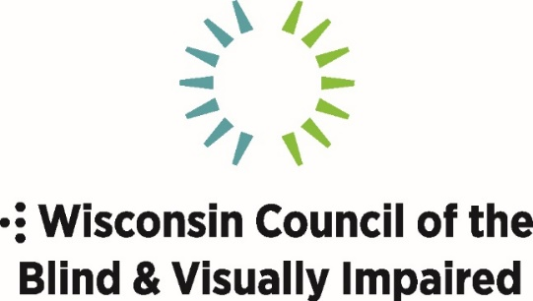
754 Williamson Street
Madison, WI 53703
608-255-1166
Info@WCBlind.org
WCBlind.org
PHOTO & VIDEO RELEASE FORM
I give permission to the Wisconsin Council of the Blind & Visually Impaired to take and use photos of me for publications, public relations, community education, training and any other purposes as it sees fit, without further consideration from me. I also give permission to use information about my relationship to the Council, and it is my choice if the name is changed or my real name is used.

______________________________________

Signature (If under age 18, signature of parent/legal guardian)

_________________________ _____________

Name Date
___________________________________________________

Address (Street, City, State, Zip)
________________ _______________________
Phone Number Email

