Council Courier, Spring 2022

70th Anniversary Spotlight: Sharper Vision Store’s Evolution is a Story of Growth and Adaptation
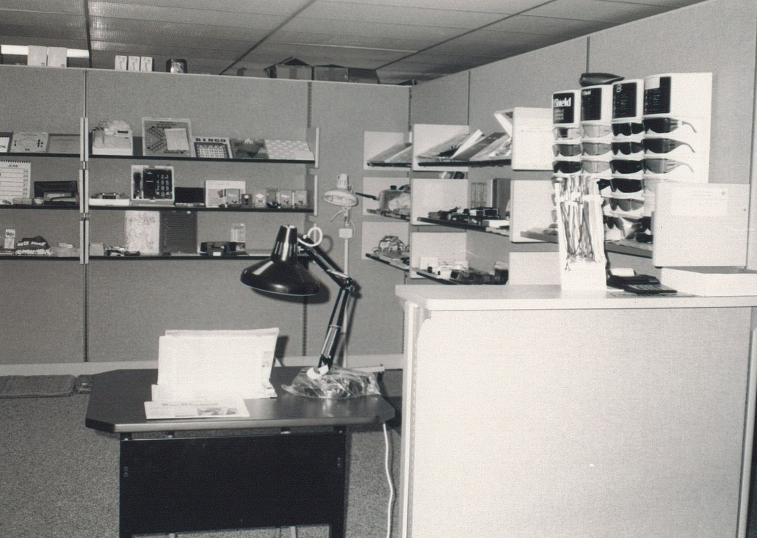
Caption: An early version of the Sharper Vision Store
Alt text: Store items on shelves and a desk.
There are a lot of specialty retail stores scattered across Wisconsin, each catering to the specific needs of a particular group of people. But within that varied landscape, the Council’s Sharper Vision Store stands out as one of the most unique. The Sharper Vision Store carries products designed expressly for people who are blind and visually impaired as well as items that may also be useful to those who do not have vision impairment.
The notion of a full-blown retail store dedicated to technology and household items for people with vision loss took time to blossom. In the 1960s and ‘70s, the Council had a pegboard display of that era’s magnifiers and other adaptive items. As more specialized products were developed, it became clear that the store would need more space. The 2001 purchase of our current home at 754 Williamson St. in Madison enabled the Council to greatly expand the store's footprint and improve the organization of its wares. It was christened the Sharper Vision Store in 2006.
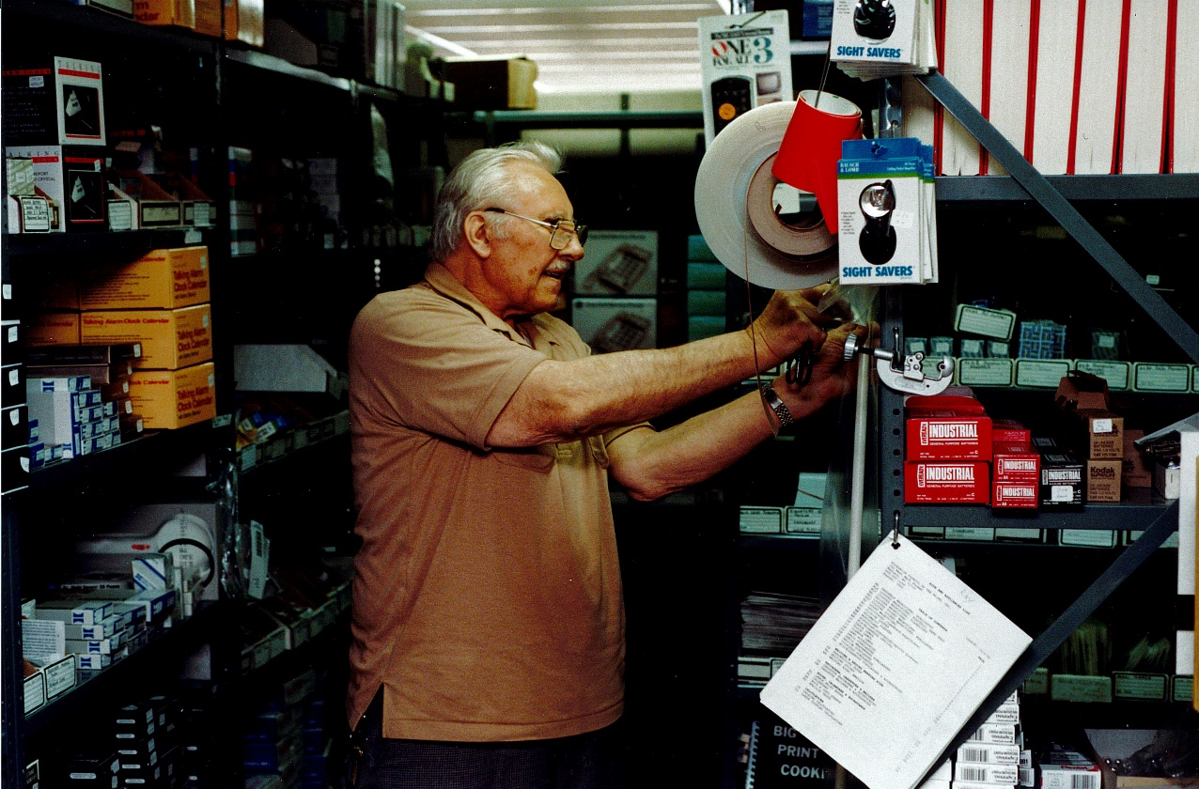
Caption: The back storeroom of the ‘60s-era Council store.
Alt text: A man standing between cramped stockroom shelves.
Since then, the Sharper Vision Store has continued to evolve in ways designed to make it easier for clients to discover and purchase what they need. Shoppers can now browse aisles dedicated to personal health, kitchen aids, household items, personal and health aids, games, clocks and watches, office needs and sunglasses. We created a catalog so customers could make purchases by phone in addition to visiting the store in person.
With the emergence of internet shopping, the Sharper Vision Store created on online storefront. These days, the store serves several thousand customers each year, and about three-quarters of purchases take place online or by phone.
“The website has made the store more accessible to those who can’t make the trip to Madison, are unable to visit us during our store hours, or have been uncomfortable with in-store shopping during the pandemic,” says Store Customer Care Specialist Greg Schmidt.
Brent Perzentka, now a Certified Vision Rehabilitation Therapist with the Council, managed the store for about a dozen years, seeing it through many of its most significant developments. In addition to the creation of the online store, Brent points to making the physical store accessible as one of the most important transformations that took place during his tenure. That included labelling items in a range of formats, including large print, braille, and audio that could be accessed using a PenFriend voice labelling system.
Another key change, Brent says, was to restructure the store to make it more hands-on. “Instead of just shelves, we divided it into different living environments so people could sit down and try out a product as if they were using it at home,” Brent says. That transformation was celebrated with a grand re-opening event in 2017.
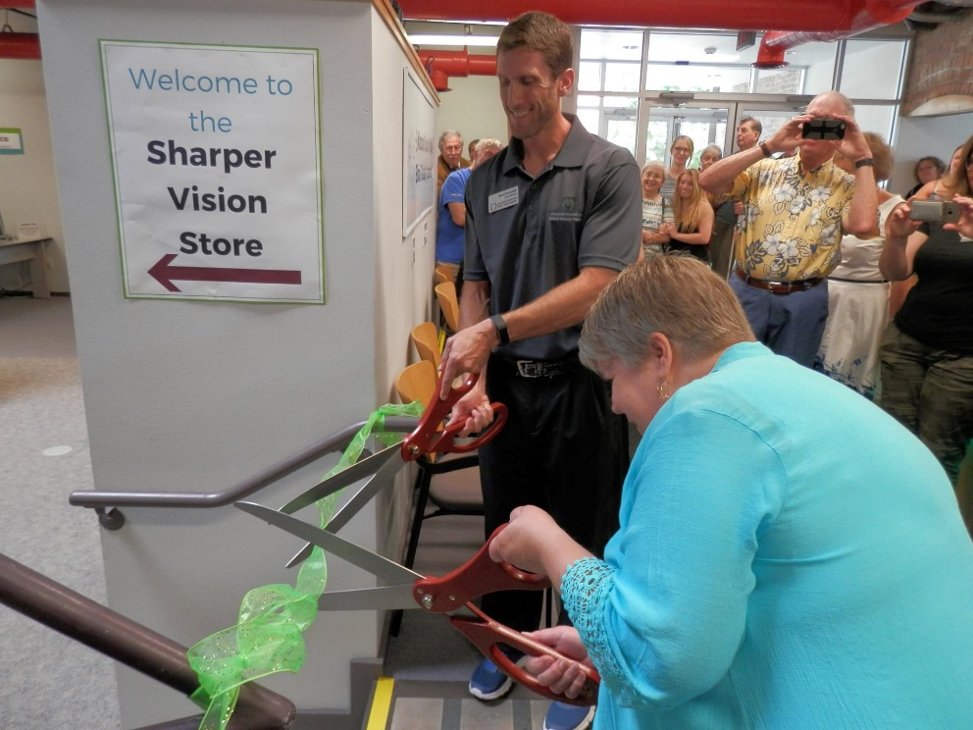
Caption: Denise and Brent cutting the ribbon at the 2017 grand re-opening event
Alt text: Denise Jess and Brent Perzentka cutting a ribbon with giant scissors as people take pictures.
As the store has expanded, it has taken on an important role beyond what was envisioned back when it consisted of a handful of items hanging on a wall. The Sharper Vision Store serves as the front door through which many newcomers are introduced to the full range of services the Council provides.
“The Sharper Vision Store is the first exposure a lot of people have to the Council,” Brent says. “Often somebody will come in looking for a magnifier, and then once they are here, they discover that we have a lot more to offer beyond selling them products. We can support our clients’ independence in a lot of different ways.”
Certain items have remained popular over the years. Raised rubber bump dots that have a lot of applications, including identifying appliance buttons, are perennial favorites. Magnifiers, ranging from simple handheld optical devices to large, high-tech video magnifiers are also in steady demand. As the technology has advanced, the store has kept pace.
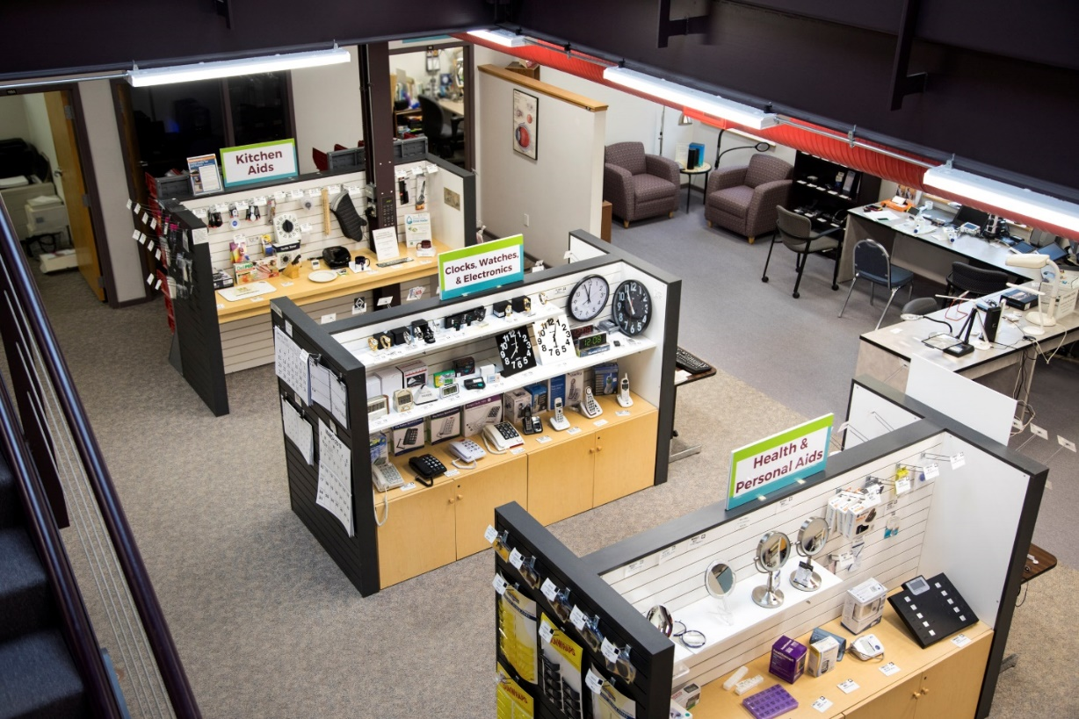
Caption: The Sharper Vision Store today.
Alt text: View from above of Sharper Vision Store aisles
As the Sharper Vision store has evolved, one thing has remained constant: the personalized service. That’s part of what makes the store unique.
Patricia Stage of Richland Center discovered the Sharper Vision store about ten years ago after her vision had deteriorated severely due to a congenital retinal disease.
“When I started out, I didn’t know anything,” she says. Initially, she used a standard magnifying glass to identify objects, but she found it wasn’t strong enough for her needs. The Sharper Vision Store and the trained staff who demonstrate the items became a valuable resource.
Over the past decade, Patricia has purchased many products from the store: a white cane, a talking calculator, bump dots and multiple magnifiers. “I like how no matter what your vision is, they will work with you and help you find what works for you.”
Many first-time visitors to the store are surprised to learn about the sheer range of products that can make their lives easier, whether it’s a health necessity like a talking blood pressure monitor or something recreational like braille Uno cards.
“We’re here to provide access to items hard to find anywhere else that will help customers with daily activities and bolster their sense of independence,” Greg says. “That’s how the store contributes to the Council’s overall mission to promote dignity and empowerment.”
We invite you to visit the store online at https://store.wcblind.org/store; or if you’re in Madison, stop by the brick-and-mortar store during business hours Monday through Friday, 8:30 a.m. to 4:30 p.m.

Letter from Executive Director Denise Jess
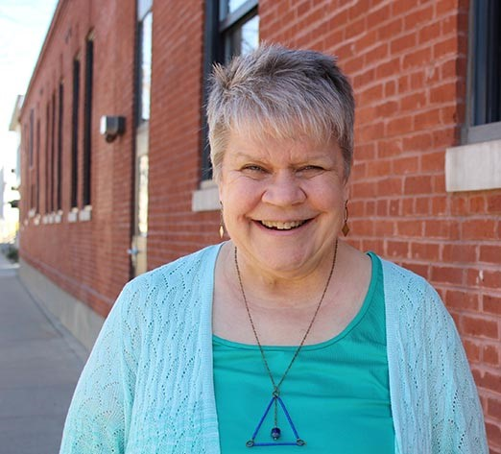
Alt text: Denise Jess smiling, standing in front of brick building.
Every three years, the Council sets new strategic goals to respond to the changing needs of people living with vision loss, align with current research and practices, and further our mission to promote the dignity and empowerment of Wisconsinites who are visually impaired. We are excited to hit the ground running on these goals this year in our key mission areas of advocacy, education and vision services, as well as in our work related to financial sustainability; board development; and diversity, equity and inclusion.

Wellness is a theme that is braided into these goals, and you’ll find it woven into our publications, events and advocacy efforts. Wellness has everything to do with a person’s overall quality of life. It covers access to healthy food and medical care, community involvement, social interaction with friends and family, exercise and movement, recreation outside in nature, and attention to our mental and emotional wellness.

Research is showing us what many have known for a long time: Tending to our wellness is critically important for those of us living with vision loss. We are statistically more likely to experience arthritis, obesity, diabetes, high blood pressure, anxiety and depression than our sighted peers. The negative impacts of social isolation and loneliness further complicate the situation. It is why the Council is compelled to heighten awareness of the value of attending to our wellness.

As the Council strives to achieve our strategic goals and offer ways to enhance your wellness, I want to invite you to make your own wellness plan. As the weather warms, get outside even just to sit in the sun, go for a walk, listen to the birds or dig in the garden. Reconnect with an old hobby or take up something new. As COVID restrictions loosen, arrange visits with friends and family or volunteer in your community. Seek behavioral or mental health services, make an appointment with your primary care provider for a physical and see your eye doctor. Eye health is important no matter your level of vision loss. Reach out to us or the Office for the Blind & Visually Impaired to connect with a vision rehabilitation therapist to brush up on those all-important daily living skills or strengthen your access technology skills so you can stay connected with the world around you.

Your wellness matters. What is the next step on your healthy journey?

Non-Driver Advisory Committee is Already Making Inroads on Transportation Equity

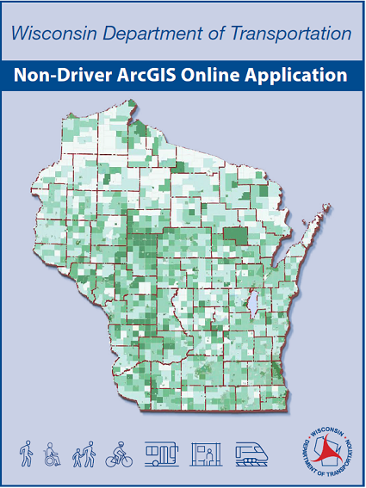
Caption: WiNDAC drove the creation of a new mapping tool called the Non-Driver ArcGIS Online Application.
Alt text: Map of Wisconsin with the words Wisconsin Department of Transportation Non-Driver ArcGIS Online Application and icons representing different modes of transportation.
Nondrivers in Wisconsin have been waiting a long time for better transportation options to help them get from Point A to Point B. A simple 20-minute trip for someone who drives can easily become a multiple-hour excursion for an individual who relies on other forms of transit and must carefully plan every step of the journey.
Council Executive Director Denise Jess hears this question frequently: “Why can’t we get transportation to work in this state?”
The short answer is that it’s a much more complicated challenge than many people realize. But after decades of limited progress, Denise believes that a new collaborative effort she is helping lead has the potential to make a meaningful difference.
The barriers facing nondrivers are numerous. One is a lack of adequate funding, especially for specialized transportation for people with disabilities and older adults. Another is a state statute that prohibits regional transportation authorities, which limits options for increasing funding for local transit systems. And a third impediment is the patchwork nature of the state’s existing transportation systems that do exist, leaving gaps that are hard for users to navigate.
To address these and other challenges, the Wisconsin Department of Transportation (WisDOT) in 2020 formed the Wisconsin Non-Driver Advisory Committee (WiNDAC), a diverse body consisting of key advocacy groups, legislators, local officials, transportation providers, mobility managers and relevant state agencies. Denise is one of the committee’s co-chairs, along with Tami Jackson, a public policy analyst with the Wisconsin Board for People with Developmental Disabilities; and Aileen Switzer, a WisDOT administrator.
In the very beginning, the three co-chairs agreed on several key goals. The first and most critical was to present the reality of living as a nondriver in Wisconsin, which was outside the experience of many committee members.
“My co-chairs and I knew that if we didn’t get this group centered on the everyday experience of the nondriver, we weren’t going to get off the dime,” Denise says. The best way to accomplish this, they decided, was to tell stories.
As it happened, the first meeting in 2020 took place via a Zoom video call due to the pandemic. Denise, who is legally blind, detailed how complicated her travel plans would have been if the meeting had been in person.
Her presentation was followed by six case studies of the predicaments faced by other nondrivers. One story involved a young single mother who was offered a new, higher-paying job. But the job was in a different city with very limited bus service, giving her little leeway to manage unforeseen problems, such as picking up a sick child from school.
Those stories had a major impact on committee members, including Secretary Thompson. “People were blown away,” Denise says. “They realized we aren’t talking about just a couple of marginalized people.” They were, in fact, talking about one-third of Wisconsin residents. This collective understanding of the scope of the problem set the stage for the tangible steps forward that have followed.
One big achievement was to formally prioritize criteria for measuring how well public transportation serves nondrivers. One criterion, for example, is that it shouldn’t take longer for a nondriver to get to a destination than it takes a person driving a car. A pilot program is now underway across Wisconsin to gauge the criteria’s value in supporting policy changes.
The committee’s most visible achievement to date, which has garnered considerable attention even outside of Wisconsin, was the creation of the Non-Driver ArcGIS Online Application, an interactive online mapping tool that illustrates where Wisconsin’s nondrivers are located in the state. That information can then be compared with the locations of existing transportation systems, concentrations of poverty, and other data. This tool has the potential to inform transit managers, urban and rural planners, and others as they make decisions about public policy, economic development and land use.
Unlike many advisory committees, WiNDAC has successfully gone beyond discussion and rehashing of problems. It is advancing concrete solutions. “I’m extremely proud of the committee’s work,” Denise says. “It’s rare to find this level of collaboration among stakeholders that bring such disparate perspectives to the table.
“And we’re just getting started.”

From White Cane to Wings
Caption: Becky Fraire
Alt text: Headshot of Becky Fraire
It was that lengthy flight of historic marble steps at Chicago’s Union Station that finally convinced Madison resident Becky Fraire that she needed a white cane.
A few years earlier, Becky had been diagnosed with retinitis pigmentosa, an irreversible condition that caused her to lose most of her vision. She tried to adjust. She stopped driving and outfitted her house with new lighting, bump dots and tactile tape. To travel, she’d call an Uber. Walking became difficult due to uneven sidewalks. But she didn’t want a white cane.
At Union Station that day, Becky knew she was short on time to catch the Amtrak train to Lansing, Michigan, where her elderly parents live. But Union Station is big, and there were all those steps to descend, steps crafted long before modern building codes existed. And they were nearly invisible to her eyes. “Of course, I grabbed the rail, but it took me forever to get down the staircase,” Becky says.
She rushed to the gate from which her train was departing, but just as she arrived, the ticket collector barred her entrance. “She told me the gate is closed. And then she turned away,” Becky says. “I missed the train by one minute.”
Luckily, her husband hadn’t left Chicago yet, so they ended up driving to Lansing instead. “My husband was shaking his finger at me,” she says. He said ’If you’d had a cane, she might’ve realized and been more helpful.’”
Back in Madison, Becky visited the Council’s Sharper Vision Store and talked to Vision Services staff. First, she got an identification cane—one that served as a signal to others that Becky had vision loss. Later, she received orientation and mobility training to learn how to use a mobility cane effectively.
“When I started to use the cane, the switch just flipped,” she says. "Suddenly it was more like having wings. Now, I can walk outside and down the sidewalk and not be worried I’m going to step off the curb and break my ankle. I can get on the bus and go downtown and come back to my house all by myself, safely. It was an amazing, amazing feeling of freedom.”
Becky’s story is unique to her, but similar to those of countless people with vision loss. Many people who could benefit from a white cane do not have one because they don’t yet understand what an empowering tool it can be.
The Council can help in that regard. We provide a free white cane to nearly 500 people every year. And we can connect new users with somebody who can teach them how to wield their cane safely and effectively.
Please consider making a meaningful gift to the Council so that more people can gain wings the way Becky did. An envelope is enclosed for your convenience. A $35 gift will put a white cane into the hands of someone who needs it for mobility or identification.
You can find more examples of what your gift can do at WCBlind.org/Donate.
Pull quote: Please consider making a meaningful gift to the Council so that more people can gain wings the way Becky did. An envelope is enclosed for your convenience. A $35 gift will put a white cane into the hands of someone who needs it for mobility or identification.

Staff Changes Bring One Farewell and One Welcome
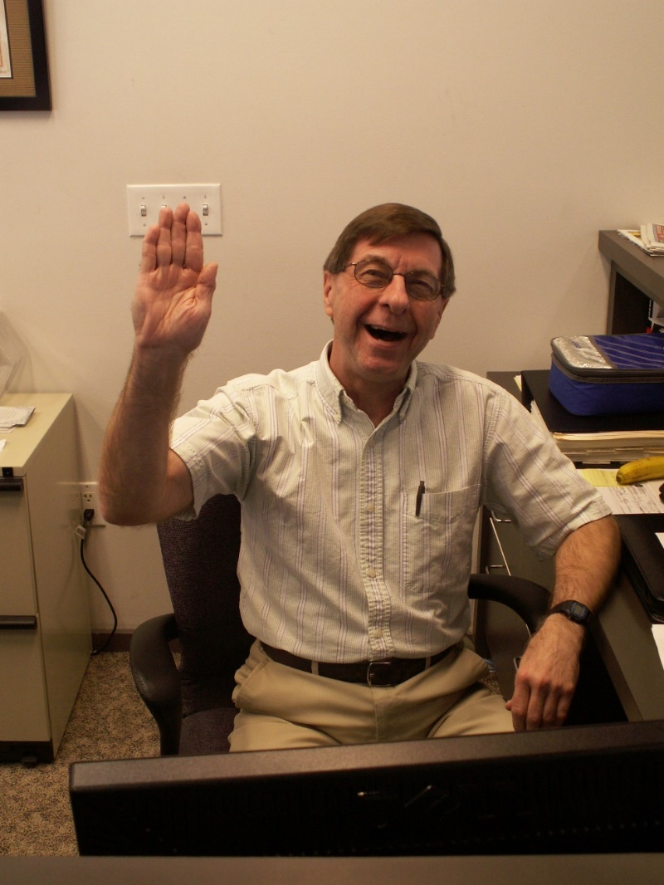
Caption: Ray Cubberly
Alt text: Ray Cubberly sitting at a desk waving goodbye
Caption: Dan Torres
Alt text: Dan Torres standing in a brick wall corner.
After 15 years at the Council, Database Manager Ray Cubberly has called it a career at the end of March. We are grateful to Ray for all his excellent work as a member of the fund development team.
Ray came to the Council in 2007, after his position at another nonprofit was eliminated. After initially managing the donor database as a half-time volunteer for six months, he was hired as a full-time staff member.
Ray later added several other duties to his workload: creating thank you letters to donors, producing donor reports, generating mailing lists for Council communications and helping process scholarship applications. Less well-known is that for a while, Ray was a driver and helper for one of the Council’s vision services specialists who was blind, meeting with clients in their homes. “It was an interesting and rewarding experience, calling on some of the clients the Council was serving,” Ray says.
Ray was eligible for retirement in 2012, but instead chose to stay on with the Council part time.
One thing that has helped keep Ray around has been his relationship with his coworkers. “Working at the Council has been like spending my workdays with one big happy family,” he says. “All of my colleagues here have been both highly competent workers and very friendly people.”
Certified Vision Rehabilitation Therapist Brent Perzentka was already on staff when Ray arrived. “Ray is somebody you could always trust to do whatever task he was assigned, and do it thoroughly,” Brent says. Nearly as important, according to Brent, is Ray’s sense of humor. “And he’s a big Paul Simon fan.”
Ray’s short-term plans include catching up with home projects and traveling in Wisconsin and beyond to see new sights. “I plan to have as much fun as I can in however many good years I have left,” Ray says.
As we bid Ray adieu and wish him well, we’re pleased to welcome Dan Torres as the newest member of the Council staff. Dan joined the Council as a Program Associate in February. That role comes with a lot of hats to wear. Dan helps update the Council website, helps put together our e-newsletters, assists callers and Sharper Vision Store visitors, and pitches in as needed with various other tasks.

Dan has a B.A. in economics from the University of Wisconsin-Madison. Before working at the Council, he helped manage the office of a small event photography company.

A Wisconsin native, Dan is an avid Brewers fan and a lover of cheese. He enjoys writing fiction, watching movies, and listening to music and podcasts. Dan also has a competitive streak that shows up during his frequent card, board and video game activities.

“It’s a nice feeling to be able to contribute to an organization that supports and advocates for so many people,” Dan says.

And we say it’s a nice feeling to have Dan on board. Welcome!

Price Changes in the Sharper Vision Store
Keeping prices affordable in the Sharper Vision Store has always been a top priority for the Council. To that end, we operate at the slimmest of margins possible.
Unfortunately, our costs have been climbing as our suppliers have increased their prices. In order to continue offering the range of products our customers need and continue providing the level of service they deserve and expect, we have increased prices on store items by 10 percent across the board. The new prices are reflected in the store and on our website. If you have a print catalog, please be aware that the prices listed in it are not up to date.
This is not an easy decision for us. But while we are driven by our mission rather than by profit, we are at the mercy of the same economic forces as all other retailers. Thank you for understanding.

Upcoming Events
Birding by Ear
Identifying birds by their song is an exciting activity and skill, and any experienced bird watcher will tell you that most birding is done without actually seeing the bird, but by hearing it. Birding by Ear, hosted in collaboration with Madison Audubon, teaches the techniques for identifying birds by close listening. Participants can attend the virtual class session either Thursday, April 28 or Saturday, April 30; and take part in an in-person field trip in Madison either Thursday, May 5 or Saturday, May 7. For registration information, visit https://wcblind.org/council-events/birding-by-ear.

Back cover:
The Council publishes four monthly e-newsletters: Upcoming Events, Advocacy Update, On Sight and News You Can Use. Each has important information to help empower readers with vision loss to live vibrant, independent lives. Subscribe to any or all of them at https://wcblind.org/who-we-are/contact/newsletter-signup.
Did you know that the Council Courier is also available in braille and audio formats? To request an alternative format or update your mailing address, call us at 608-255-1166.

