EDUCATION

Support educational opportunities for the 1,500 Wisconsin students who are blind or visually impaired.
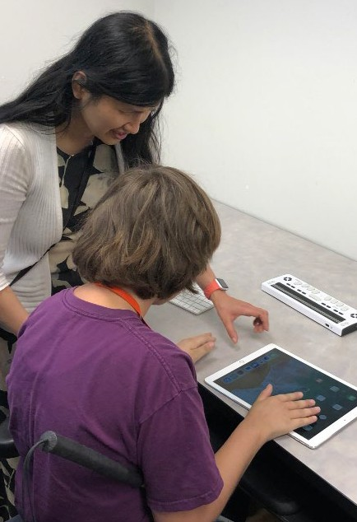
BUDGET ITEMS
- Provide adequate funding for special education to help close the funding gap faced by Wisconsin schools. Prior to increases of $100 million in the 2019-21 state budget and $85 million in the 2021-23 budget, funding for special education had been flat for over a decade, creating unmet needs for students with disabilities.
- Provide funding to support the statewide outreach efforts of the Wisconsin Center for the Blind and Visually Impaired.
Exploring an iPad’s access technology options.
LEGISLATIVE ITEMS
- Promote loan and loan forgiveness programs, facilitated by the Higher Education Aids Board, for all vision services professionals, including teachers of the visually impaired, vision rehabilitation therapists, low vision therapists, orientation and mobility specialists, etc.
- Currently, opportunities in Wisconsin to receive training to become a teacher of the visually impaired are extremely limited. This has led to a severe shortage of vision professionals in Wisconsin schools. Students with visual disabilities are not receiving the supports they need to be successful, such as orientation and mobility training, access technology, braille instruction and adaptive techniques.
WCBlind.org • 800-783-5213
Info@WCBlind.org

