EMPLOYMENT


Individuals with visual impairments have a 70% unemployment rate and a 22% underemployment rate – meaning almost the entire population has an unfavorable employment status.
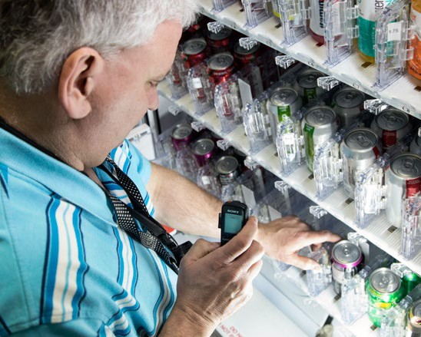
People experiencing vision loss have unique needs related to obtaining and sustaining living wage employment. These include access technology training, workplace accommodations, transportation and overcoming employer bias toward persons with visual disabilities.
For those reasons, we support initiatives to expand integrated employment opportunities for people who are blind or visually impaired.
A vendor in the Wisconsin BEP program.

LEGISLATIVE ITEMS
Repeal a 2013 state law that prevents people receiving Social Security Disability Insurance (SSDI) benefits from getting unemployment benefits or pandemic unemployment assistance. This law has made it difficult for people whose jobs have been impacted by the pandemic to get assistance.
BUDGET ITEMS
Increase resources in the Department of Workforce Development’s Division of Vocational Rehabilitation (DVR). This proposal would boost the state match for Title 1B grant (a reading program for young children) and create a position to support vocational rehabilitation services.
ADMINISTRATIVE ITEMS
Ensure that agencies allocate adequate resources for key support services like career counseling and access technology training.
WCBlind.org • 800-783-5213
Info@WCBlind.org

