White Cane Safety Day Toolkit – 2022
Resources to Support Your Grassroots Advocacy

October 15 is recognized nationally as White Cane Safety Day. Its purpose is to promote the independence of people with vision loss by increasing awareness of the White Cane Law, which protects the right-of-way of pedestrians who use white canes and guide dogs. Every state has its own version of the White Cane Law. Wisconsin’s White Cane Law states that a person operating a vehicle must stop at least 10 feet from someone who is using a white cane or guide dog.

The Council seeks to expand that goal to promote pedestrian safety in general, understanding that everybody is a pedestrian at times, and therefore greater driver awareness benefits the entire community.

Below are sample resources you can adapt and use to help spread the word about White Cane Safety Day in your community.

Sample Letter to Elected Official
Dear Mayor/Town Chairperson/City Administrator:
﻿
Every Wisconsin community needs to pay greater attention to pedestrian safety. Pedestrian injuries and fatalities have increased over the past couple of years, and it’s important to take steps to reverse this disturbing trend. This is a critical issue for those of us living with vision loss, but the reality is that nearly a third of Wisconsinites are nondrivers, and EVERYBODY is a pedestrian some of the time.

One of the most basic actions you can take is to officially proclaim October 15 White Cane Safety Day in our community, as 23 Wisconsin municipalities did last year. White Cane Safety Day has been recognized nationally on that date each year since 1964.

There are many other actions you can take to make our streets safer for pedestrians. One of the most meaningful things our community can do is create a “Vision Zero” plan. Vision Zero is a movement aimed at eliminating traffic fatalities through comprehensive, cross-disciplinary local planning and cooperation. Many U.S. cities are already on board, and more are joining the network each year. More information is available at VisionZeroNetwork.org.

Here are a few easier, less intensive ideas to consider as well:

- Join a community member on a “walk audit” to evaluate how accessible our streets are for pedestrians.
- Initiate plans to make a troublesome intersection safer by installing pedestrian safety features such as crossing signals.
- Check out the Wisconsin Department of Transportation’s Non-Driver ArcGIS Online Application and encourage city planners to use this valuable tool to gauge transit needs and allocate pedestrian resources.

The Wisconsin Council of the Blind & Visually Impaired is available as a resource. I encourage you to contact the Council if you would like to learn more about these actions.

Thank you for considering becoming a local champion for pedestrian safety.

Sincerely,
[Your Name Here]

Sample Letter to the Editor
To the editor,

Last year in Wisconsin, 54 pedestrians lost their lives, a number that has been growing steadily in recent years. It’s important that communities take steps to reverse this alarming trend. Pedestrian safety is a particularly critical issue for people living with vision loss. Everybody is a pedestrian at times, but those of us who do not drive, whether because of vision impairment or another reason, are especially vulnerable to inattentive motorists.

Since 1964, October 15 has been recognized nationally as White Cane Safety Day. This day is an opportunity to raise awareness of Wisconsin’s White Cane Law, which requires drivers to stop at least 10 feet from a pedestrian using a white cane or service dog. Last year, 23 Wisconsin municipalities and the State of Wisconsin issued proclamations officially recognizing White Cane Safety Day.

Knowledge of the White Cane Law is important in itself, but White Cane Safety Day can also be a springboard to a much more ambitious campaign to improve pedestrian safety in our community. Greater driver awareness is a key first step, but there are many other actions we can take: Conducting a “walk audit” to evaluate how pedestrian-friendly our streets are; installing and maintaining sidewalks; improving crosswalk design; and adding pedestrian signals at problem intersections are just a few of the strategies that can make our community safer for pedestrians.

Please join me in helping spread the word about White Cane Safety Day on October 15 and building on the momentum to create a safer community for everyone!

[Your Name and city]

Social Media Posts

Help educate your online audience about White Cane Safety Day and pedestrian safety by using your social media channels.

Tips for accessible social media:

1) Add alt text and/or image descriptions to all images.
2) Capitalize the first letter of each word (this is called “camel case”) in hashtags so that screen readers will pronounce them correctly. Examples: #CamelCase; #PedestrianSafety; #WhiteCaneLaw.
3) Add audio descriptions to your videos.
4) Use descriptive hyperlink text instead of “click here.”
5) Don’t overuse GIFs. They are not accessible for many users.

Sample Posts:

Facebook

October 15 is #WhiteCaneSafetyDay nationwide! This day celebrates independence and mobility for people with vision loss. In Wisconsin, the #WhiteCaneLaw states that drivers must stop 10 feet or more from pedestrians using white canes or service dogs. By promoting greater driver awareness, the White Cane Law helps make our streets safer for everybody. Help spread the word about White Cane Safety Day by sharing this post and reminding your friends and family to stop at least 10 feet from crosswalks.

Graphic: The #WhiteCaneLaw states that drivers must stop 10 feet or more from a pedestrian with a white cane or service dog. Learn more at WCBlind.org.

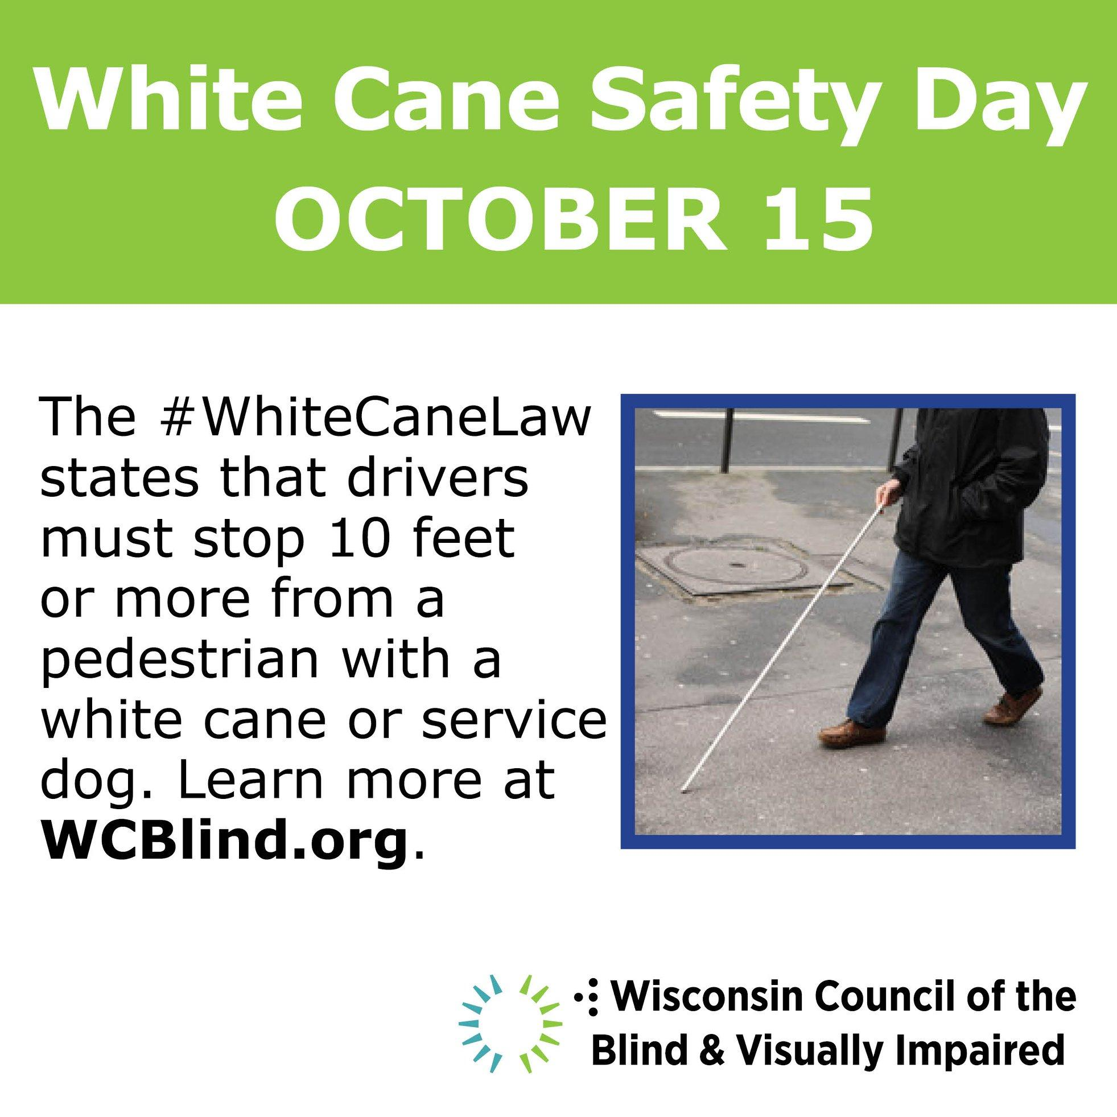

Twitter

October 15 is White Cane Safety Day! Wisconsin’s White Cane Law states that a person operating a vehicle must stop at least ten feet from someone who is using a white cane or guide dog. Help spread the word and make our streets safer! #WhiteCaneSafetyDay #WhiteCaneLaw

Instagram

Wisconsin municipalities are promoting pedestrian safety by officially proclaiming October 15 White Cane Safety Day! These proclamations highlight the importance of the White Cane Law, which protects the right-of-way for people with vision loss. Contact your community leaders and ask them to get on board! #WhiteCaneLaw #WhiteCaneDayProclamation

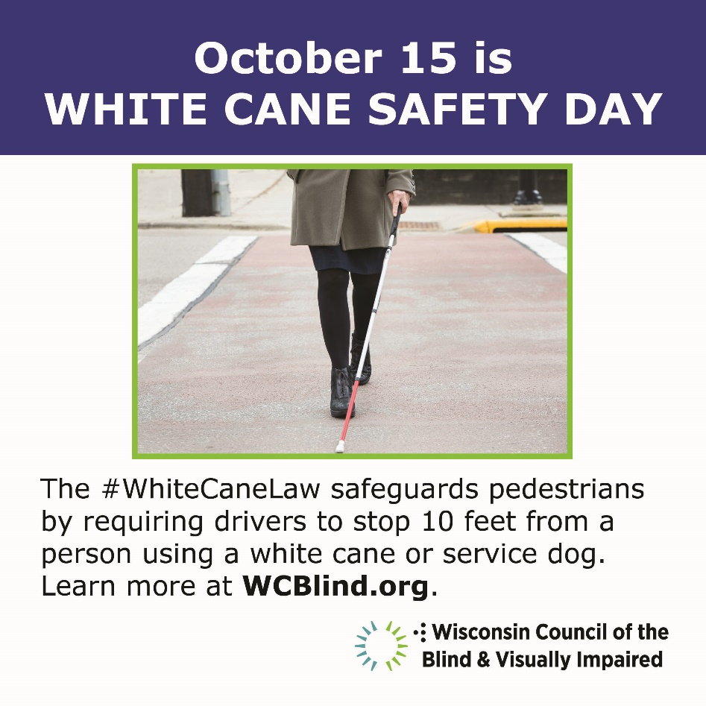

Newsletter Articles
Below are links to a couple of newsletter articles the Council has published in recent years around White Cane Safety Day and pedestrian safety. Feel free to adapt parts of them for your own newsletter article.

“White Cane Safety Day is a Great Opportunity to be a Pedestrian Safety Advocate”
https://wcblind.org/2021/09/white-cane-safety-day-is-a-great-opportunity-to-be-a-pedestrian-safety-advocate/

“White Cane Safety Day is October 15: Spread the Word About the White Cane Law”
https://wcblind.org/2019/09/white-cane-safety-day-is-october-15-spread-the-word-about-the-white-cane-law/

White Cane Safety Day Facts

- On October 6, 1964, a joint resolution of the U.S. Congress, H.R. 753, was signed into law as 36 U.S.C. § 142. This resolution authorized the President of the United States to proclaim October 15 of each year as "White Cane Safety Day". President Lyndon B. Johnson signed the first White Cane Safety Day proclamation within hours of the passage of the joint resolution.
- Each state has its own White Cane Law. Wisconsin’s requires drivers to stop 10 feet from a person using a white cane or service dog.
- Last year 23 Wisconsin municipalities and the State of Wisconsin issued White Cane Safety Day proclamations.
- Pedestrian fatalities and injuries have increased dramatically both nationwide and in Wisconsin in recent years. An estimated 7,485 pedestrians in the United States were struck and killed by drivers in 2021. That’s the largest number in four decades.
- In Wisconsin, preliminary data show that 54 pedestrians were killed during 2021, 4 more than the previous year. These statistics underscore the importance of active measures to improve pedestrian safety, such as better-designed intersections, more crosswalk signals, greater emphasis on pedestrian safety in drivers’ training courses, and more public education about relevant laws, including the White Cane Law.

