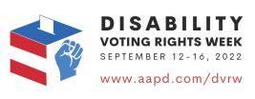
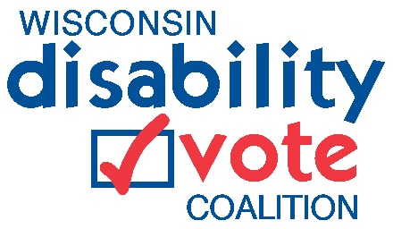
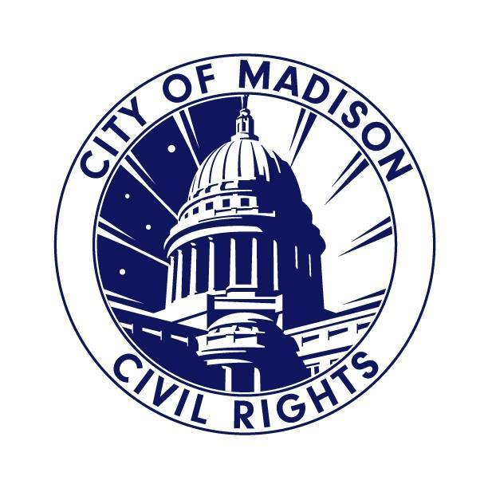
For immediate release September 15, 2022
Contacts:
Rebecca Hoyt, City of Madison Department of Civil Rights, 608-266-6511, RHoyt@cityofmadison.com
Jennifer Neugart, Disability Vote Coalition Co-Lead, 608-266-7707, Jennifer.neugart@wisconsin.gov
Denise Jess, Wisconsin Council of the Blind & Visually Impaired, 608-237-8103, DJess@WCBlind.org

Advocates, City of Madison Promote Accessible Voting in Celebration of Disability Voting Rights Week, Sept. 12-16
This week, advocates and city Civil Rights agencies are calling for greater awareness of voting rights and barriers facing people with disabilities during Disability Voting Rights Week. These issues were discussed at a press event at the City County Building in Madison.

Spearheaded by the American Association of People with Disabilities (AAPD), Disability Voting Rights Week is a national, nonpartisan initiative to amplify the voice and presence of the disability vote across the United States.

“People with disabilities are a powerful voting bloc. This week is all about raising awareness about that, getting people with disabilities registered to vote, and ensure voters with disabilities have access to the ballot.” said Jenny Neugart, Disability Vote Coalition Co-Lead. “Today we focus on helping voters with disabilities understand their rights and empower them to show up at the polls because their voice matters more than they think.”

Historically, the disabilities community has been left out of policy discussions that directly affect their ability to participate in our

democracy. Voting rights for people with disabilities are guaranteed by state and federal laws, including the Voting Rights Act and the
Americans with Disabilities Act. However, discrimination, inaccessible voting processes and other forms of exclusion—both intentional and unintended—have led to a huge turnout gap between voters with and without disabilities. A 2021 report from the Program for Disability Research at Rutgers University and the U.S. Election Assistance Commission indicated that despite improvements in voting accessibility in recent years, an estimated 1.95 million people with disabilities had trouble voting in 2020.

“It is critical that people with disabilities understand our rights to ensure we can cast our ballots and have them counted,” said Denise Jess, Executive Director of the Wisconsin Council of the Blind & Visually Impaired. “Rights like assistance to complete the ballot and deliver it to the clerk, dependable access to curbside voting, and the use of accessible voting equipment all reduce barriers and pave a path to greater equity.”

The law requires every polling place to have available accessible voting equipment that enables people with disabilities to cast their ballot independently. Unfortunately, poll workers are often not well trained in use of the equipment, and frequently it is not set up and ready to use prior to the polls opening on Election Day.

​“The City of Madison is committed to making the November elections accessible to our residents with disabilities,” said Mayor Rhodes-Conway. “Before opening the polls, Madison chief inspectors walk through the Disability Rights Wisconsin Election Day Accessibility Checklist. The ExpressVote makes voting more accessible at all absentee voting sites and polling locations. I urge our disability community to register to vote and vote in the manner accessible to you.”

More information about Disability Voting Rights Week is available on the AAPD website at https://www.aapd.com/advocacy/voting/dvrw/ and information about voting equity in Wisconsin is available on the Disability Vote Coalition website at https://disabilityvote.org/.

Today’s press event was sponsored by sponsored by the Wisconsin Disability Vote Coalition, Wisconsin Council of the Blind & Visually Impaired, City of Madison Department of Civil Rights, Wisconsin Board for People with Developmental Disabilities, Disability Rights Wisconsin, Access to Independence, and the League of Women Voters of Wisconsin.

Further information and resources:

Our Voices Our Votes: Disabled Voters Speak Out on Voting Rights and Ballot Return Assistance

Know Your Voting Rights Fact Sheet

Know Your Rights Video (with audio descriptions)

National Disability Voting Rights Week website

###

