Wisconsin Council of the Blind and Visually Impaired Council Courier, Winter 2023
In the Winter 2023 issue of the Council Courier:
- What’s on the Menu? Council’s Vision Services Offerings Continue to Grow
- Letter from Executive Director Denise Jess: Raise Your Voice to Help Improve the State of Vision Services in Wisconsin
- State Budget Priorities Taking Center Stage in Council’s Advocacy
- Gallery Night was a Fall Highlight for Artists and Art Lovers Alike
- New Year Brings Changes to Board of Directors
- Support the Council in a Lasting Way Through Planned Giving
- Upcoming Events
  - The Big Share
  - Scholarship applications
  - Advocacy Days
- About Us

What’s on the Menu? Council’s Vision Services Offerings Continue to Grow
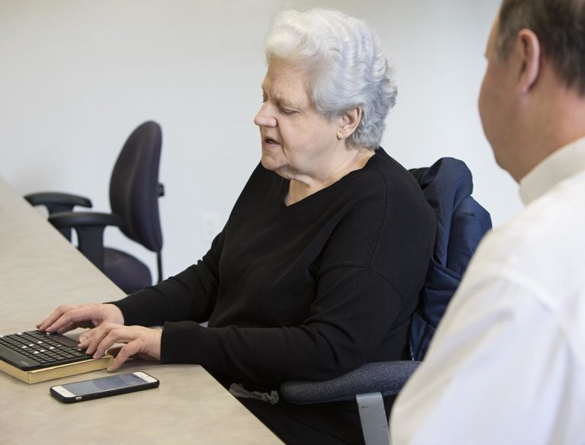
Photo: Access Technology Specialist Jim Denham working with a client.
Whether it’s during a home visit, at a job site, at our own office or in a virtual remote session, the Council’s Vision Services staff can help determine the impact of vision loss on an individual’s daily activities and work with them to develop strategies for living safely and independently. They teach, troubleshoot and problem solve to help people adapt and cope with changing vision using adaptive skills, assistive devices and new approaches to common tasks.
All programs are led by qualified, certified professionals who individualize a learning plan for each client. Specific goals are identified. Staff collaborates with the individual seeking assistance to determine an action plan. Referrals may also come from eye care providers, social services and DVR counselors.
Our menu of available vision services has expanded over the past year! Here’s a summary of the types of services people who have vision loss can access through the Council:
Orientation and Mobility (O&M) sessions are led by Certified Vision Rehabilitation Therapist and Certified O&M Specialist Brent Perzentka. O&M provides skills for getting around safely and independently. That could be anything from white cane skills to get to a baseball game across town, to navigating one’s own home, to moving safely from the basement laundry room to the second story bedroom. It’s all about independence. Learning to instruct people in cane skills was one of the centerpieces of Brent’s training. He provides an assessment to discover the client’s needs and goals for mobility, then provides training at their residence, in the community, or at their workplace. Brent notes that getting a person to trust the cane over their vision can be a tough sell. “There’s a building of confidence,” he says. Confidence in both the cane and in the instructor. “You take baby steps,” Brent says. “Building a rapport is important. They need to build trust to take your word and take that leap of faith.”
Access Technology Services at the Council are provided by Access Technology Specialist Jim Denham. Whether clients are trying to use a smart phone (such as an iPhone), tablet (such as an iPad), or a personal computer, an access technology specialist can assist an individual experiencing vision loss utilize technology effectively at home, in school or at the office. During the assessment, a client's current abilities, needs and technology-related goals are discussed, and features of current hardware and software applications are demonstrated. Each one-on-one training session is customized to provide what the client needs to meet their individual training goals. Training can occur at the Council's access technology classroom, at home or via online remote instruction. The goal of access technology services is to assist individuals with vision loss to gain access to information as efficiently and easily as possible.
Low Vision Evaluations are provided by Certified Low Vision Therapist Amy Wurf. She works with clients to find ways to maximize remaining vision using color, contrast, lighting and magnification. Amy describes the evaluation as a “guided tour of magnification options.” It can be frustrating trying to find a strong magnifier at regular stores, and online shopping does not offer a chance to try the magnifier before buying it. The low vision evaluation, provided onsite at Council offices, includes a conversation about the specific things a client wants to see again or see better.
Changing lighting or using a different color background can often make a significant difference in seeing details for things like taking medications, working on crafts, etc. Magnifiers come in many sizes and strengths and a client should learn what works best for them before making a purchase. The low vision evaluation can help a client find the right tool for the task, whether it is a magnifier or a non-optical aid, and understand how to use that tool most efficiently and effectively.
Vision Rehabilitation Services are provided by both Brent Perzentka and Certified Vision Rehabilitation Therapist Rachel Pavone. Vision rehabilitation services help people who have vision loss regain independence and confidence as they learn adaptive ways and safe skills to manage day-to-day tasks. A preliminary conversation seeks to discover the areas of daily living that the client would like to address. Assessment and training in the Council’s recently opened Vision Rehabilitation Classroom, staffed primarily by Rachel, is related to a wide range of daily living activities, such as medication management, smart speaker and TV remote operation, timekeeping, notetaking, labeling and much more. Rachel also provides braille instruction. In-home training may also include organization around the home, meal preparation and safe cooking.
To learn more about the range of Vision Services offered by the Council, you can fill out the Vision Services Request Form at https://wcblind.org/who-we-are/vision-services-requests or call us at 800 783-5213.

Letter from Executive Director Denise Jess
Raise Your Voice to Help Improve the State of Vision Services in Wisconsin
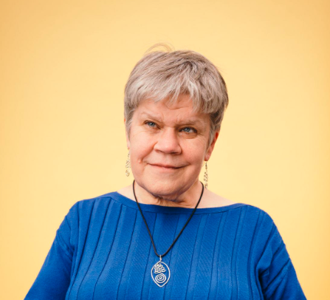
Photo: Denise Jess
Vision loss is often described as a “low incidence” disability, and over the decades it has ranked low in priority for public officials at the local, state and federal levels. That is why the Council’s statewide public policy work has been so vital throughout our history and remains critical today. Our advocacy strives to enhance equitable access to key rights and services for all people with blindness and vision impairment.
By 2050, the number of Wisconsinites with significant vision loss is expected to double from today’s estimated total of 109,000. Older adults are the fastest growing group of people with blindness and vision loss, due to age-related diseases. With a large baby boomer population, we know a “silver tsunami” is on the way. This trend is not unique to Wisconsin; it is happening nationwide.
Wisconsin, along with other states across the country, must be better prepared to address the needs of this growing population. We know that vision rehabilitation services delivered by specially trained and qualified professionals can make all the difference in someone’s ability to age in place with dignity, reduce the risk of injuries, stay connected with loved ones and the community, engage in hobbies and favorite leisure time activities, and in general maintain a high quality of life. However, even at present, there are insufficient services available to assist people in learning these invaluable skills. Further, many people do not know that these services are available. As a result, only about 3% of older adults receive vision rehabilitation services that would enable them to develop skills in cooking, medication management, household maintenance, reading, communicating online, safe navigation in the community and other daily living activities.
While private nonprofit organizations like the Council and Vision Forward do extensive outreach and education and offer high quality vision rehabilitation services by trained professionals, we cannot fill the increasing need on our own. We need our public partners, such as the Office for the Blind and Visually Impaired (OBVI) to step up to connect with this growing number of individuals. Over the past approximately 15 years, we’ve seen state services decrease, with vision rehabilitation specialists covering larger areas of the state, often stretched to serve their consumers. If more people were to seek out services at rates more indicative of the need, it would be well beyond the ability of OBVI and its nonprofit partners to provide those services.
The Council is doing several things to raise awareness of these issues with policymakers. We’ve banded together with other leaders across the country to form the Aging and Vision Loss National Coalition (AVLNC) to strategize about productive actions we can take both nationally and state by state. I was also recently appointed to the board of VisionServe Alliance, a national consortium of organizations like the Council, to work with my peers to wrestle with these critical issues of availability and access.
A recent large-scale project of the AVLNC has been a state-by-state analysis of older adults living with vision loss, breaking down this population by race, gender and income level. The studies also look at social determinants of health and the impact of vision loss on quality of life. The Council, along with other vision serving organizations in Wisconsin, commissioned our state study. We are anxiously awaiting the results, as we believe the data will provide a critical missing piece in our advocacy efforts.
You can be a strong advocate in promoting access to publicly available vision services. Here’s how:
- Reach out to your state elected officials to help them learn about the needs of people with vision loss. With the November elections, there were many changes in our elected bodies. Many legislators are new to their roles, and constituents play an important role in educating lawmakers.
- Advocate for state services during the budget process. This spring the legislature will be building the 2023-25 state budget. There will be several opportunities throughout the process for you to give feedback and offer ideas.
- Stay informed. Follow the Council’s advocacy emails and alerts and consider attending our Advocacy Days later this spring.
- Apply for a seat on the Statutory Council on Blindness. The SCOB is housed within the WI Department of Health Services and has an explicit mission to advise state government on issues important to the blindness community.
- Educate your healthcare professionals about the value of vision rehabilitation services and encourage them to refer their clients/patients for services.
As people with vision loss, we have the right to live our lives to the fullest. The lack of available services interferes with that right for many people, especially Wisconsin’s most vulnerable residents. We need to raise all our voices to call attention to this very real issue. I’m excited for you to join us in this effort.

State Budget Priorities Taking Center Stage in Council’s Advocacy
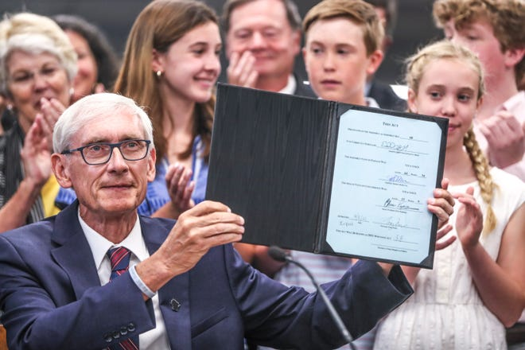
Photo: Wisconsin Gov. Tony Evers right after signing the 2021-23 state budget bill.
As Governor Evers and the state legislators dig into the new legislative session, one of their first orders of business will be to start constructing Wisconsin’s 2023-25 biennial budget, which takes effect on July 1. As always, the Council’s advocacy will shift into high gear to communicate our priorities to policymakers and make the case for investing in programs and infrastructure that meet the needs of Wisconsinites living with vision loss.
Council Executive Director Denise Jess says the Council’s number one priority during this budget cycle is transportation, specifically for nondrivers.
“It’s huge,” Denise says. “We really need to focus major attention on this issue because so many other issues are tied to it.” Denise notes that transportation matters for everybody in the state, but is particularly critical for people with disabilities. Access to reliable transit goes a long way in reducing family stress. People stay healthier when they have dependable transportation to medical appointments and to the pharmacy. Employers and employees both benefit when workers can get to work consistently and on time.
“It’s a critical infrastructure issue,” Denise says.
A stubborn challenge in advocating for nondrivers is that the system itself works against them. Most transportation systems are designed primarily with drivers in mind, at the expense of the modes of transit nondrivers rely on. Denise provided context in a recent update to the Council Board of Directors based on her work with the Wisconsin Non-Driver Advisory Committee. Denise urges people to refer to these facts when talking with elected officials during the state budget process.
- 31% of Wisconsin residents are non-drivers. That’s nearly one in three people. This debunks the idea that non-drivers are a small, comparatively insignificant portion of the population.
- 97% of the state’s land is rural and 30% of the state’s population lives in communities smaller than 10,000 residents. Rural nondrivers are particularly disadvantaged by our lack of transit options.
- 17% of Wisconsin’s population is 65 or older. In general, older adults are two to four times as likely to have a disability, depending on age, and a larger percentage are unable to drive compared to younger residents.
- Lack of transportation options is a systemic issue, but it creates individual barriers. It leads to fewer employment opportunities, poorer health outcomes and increased isolation.
Denise Jess says another top priority for the Council is voting equity. People with disabilities are one of the largest, most marginalized populations in the country. But collectively, it’s a huge voting bloc. Data from the Rutgers University School of Management and Labor Relations indicates:

- Nearly 62% of people with disabilities voted in 2020, up from 56% in 2016.
- That 6-point increase outpaces the historic increase of 5 points among people without disabilities.
- Higher turnout was reported across all disability types and demographic groups.

“The Council’s work on voting tries to clear the path so people with disabilities can exercise their right to vote,” Denise says. The voting access issue is thoroughly intertwined with the transportation issue. Denise describes the bind this way: “I’m disenfranchised because I can’t vote. I can’t get to the polls because I’m disenfranchised.”
Here’s how the state budget process works: Governor Evers will unveil his budget proposal in February. Next stop, the draft budget goes to the State Legislature’s Joint Committee on Finance, where members of the State Assembly and Senate hold hearings to gather input from state agencies (Department of Health Services, Department of Natural Resources, Department of Transportation, etc.) and with the public. Joint Finance makes changes to the budget bill (often huge changes that leave it bearing little resemblance to the Governor’s proposal). It is then sent to the full Assembly and Senate, which may make additional changes. The budget bill must be passed in identical form by both houses, so sometimes negotiations must be held to resolve differences. Once both houses have passed the bill, it goes back to the Governor, who may veto specific parts of it before signing it into law.
While the entire process will last into the summer, the time to connect with your representatives in the Legislature to make your voice heard is NOW.
You can find out who your state representatives are at tinyurl.com/WILegisMaps.
To learn how you can testify at public hearings or simply register for or in opposition to a bill, go to tinyurl.com/RegPublicHearing.
Stay on top of Joint Finance Committee meetings here: tinyurl.com/WIJFCommittee.
If you are interested in receiving budget update notifications, you can sign up at tinyurl.com/WILegisNotify.
You can monitor Joint Finance hearings without travelling to the State Capitol. You can watch them live on the Wisconsin Eye website at https://wiseye.org/
For info on these and other State Capitol activities you can call the Legislative Hotline: 800-362-9427.
As you explore those legislative websites, you may discover that they are not very accessible for people with vision loss. That’s another unnecessary barrier that must be addressed. Denise says the Council will be advocating for increased digital equity in the State Budget, with an emphasis on building more accessible design on the front end of state websites and applications.
To stay on top of the State Budget process as it unfolds, watch the Council website at WCBlind.org; subscribe to our Advocacy Update newsletter at https://wcblind.org/news/newsletter-signup; and follow us on social media—you can find those links at the bottom of our website.

Gallery Night was a Fall Highlight for Artists and Art Lovers Alike
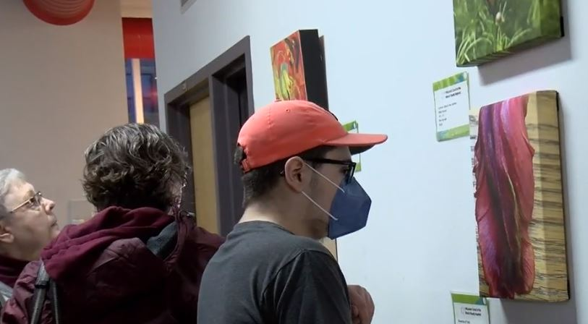
Photo: Three people looking at art pieces hung on a wall.
On November 4 the Council’s office space was transformed into an art gallery. It was all a part of our annual Gallery Night, an opportunity to showcase the work of Wisconsin artists with vision loss. The Council was one of many destinations taking part that evening in a citywide Gallery Night organized by the Madison Museum of Contemporary Art. The Council’s exhibit featured pieces by eight contributors from around the state working in a variety of media. Despite some seriously nasty weather, a steady stream of visitors toured the exhibit, including news crews from two local television stations.
The 2022 Gallery Night was a welcome return to an in-person gathering after two years of virtual-only events due to COVID. That said, if you were unable to come to Gallery Night in November, we invite you to view the artwork that was on display by visiting our Virtual Gallery at https://wcblind.org/events/virtual-gallery/
A full room of patrons gathered in the middle of the event for the artists’ program, where contributors talked about their inspirations, methods and influences.
Ellen Connor, an Oregon, Wisconsin-based photographer, had two pieces featured in the exhibit. “As my vision decreased in the last several years, I began to use photography to enlarge details in nature that I couldn’t see any more without the photograph,” Ellen explained in her artist’s statement. “Modern camera technology does the focusing, since detail is blurry to me at distance. For example, I can see the form of a bird. With the camera, I capture the details and realize he is a nuthatch, or that the wildflower blowing in the wind is lobelia. This method has piqued my interest in color more and more.”
Deb Claire is a painter from Madison. From her artist’s statement:
“My vision started deteriorating in grade school, but I wasn’t diagnosed and found legally blind until age 16 while in driver’s ed. In spite of that, I still sought out art classes in high school, enjoying drawing, watercolors, oils, acrylic, and some 3D art. Even with central vision loss, I was still able to render realistic, detailed images. I continued classes in college, expanding to fiber art and carving. Eventually my vision declined to such an extent, I had to modify how I did it…. My art has become more tactile, using wide brush strokes and finger painting. I believe my expressions are actually more authentic now because they are coming from a more spontaneous inspiration.”
You can read all the artists' statements on the Council website at https://wcblind.org/events/2022-gallery-night-artist-statements/

New Year Brings Changes to Board of Directors
Photo: Chamomile Harrison standing in a yard with a barn or garage in the background.
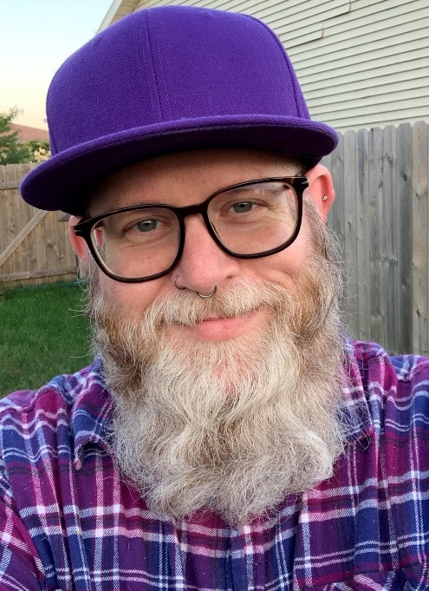
Photo: Nat Tarnoff standing in front of a fence.
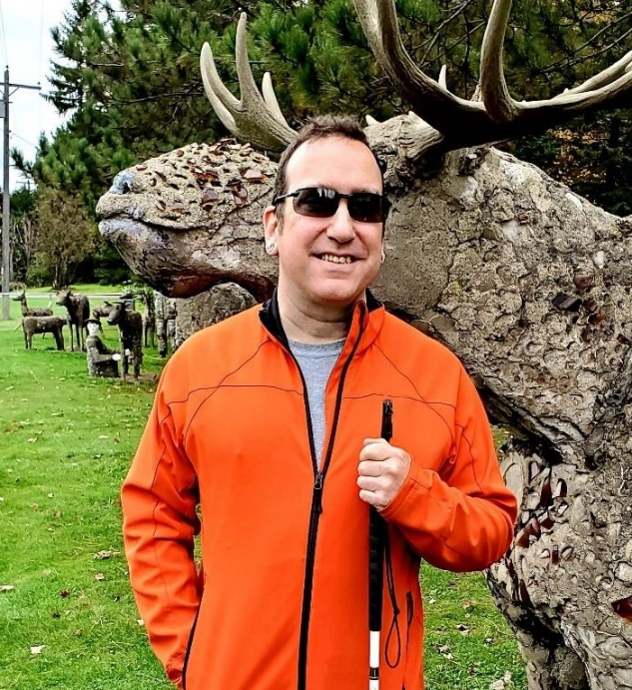
Photo: Brent Goodman standing in front of a sculpture of an antlered animal.
The beginning of 2023 brought several changes to the Council’s Board of Directors.
We said farewell with much gratitude to the departing Chris Richmond. Chris joined the Board in 2012. He served as Board Chair from 2015 to 2021. Along the way Chris says he’s served on all the board’s committees as well as some work groups. His term ended December 31.
“I think my primary motivation for becoming involved with the Council and serving on the Board was paying it forward,” Chris says. “Having been the recipient of the Council’s efforts to ensure more equitable opportunities for blind people in education and employment, it seemed only appropriate to share in advancing the Council’s mission.”
“Chris was an exemplary leader who knew how to honor an organization’s past while embracing the present and guiding it into the future,” says Council Executive Director Denise Jess.
We’re pleased to welcome three new members to the Board. Each represents a different background and brings a unique perspective to the Council.
Madison resident Chamomile Harrison is a 2021 UW-Whitewater graduate who majored in Psychology. While at the University she worked in the Office of Leadership and Career Development as an LGBTQ+ Peer Educator Intern. She’s a former Vice President of the Wisconsin Association of Blind Students. Chamomile is currently a Training Coordinator on the Disability Benefits Team for Disability Rights Wisconsin. “I look forward to being able to serve the blind and disabled communities,” she says. “I’m ready to get to work to start helping people.”
Nat Tarnoff has worked in the corporate setting as a consultant for the past 15 years. The Sun Prairie resident focuses on technical, marketing, design and human resource applications of accessibility. He’s ready to apply his professional skills to the Council’s mission. “Everyone deserves the right to independence,” Nat says. “I work daily with companies of all sizes, from the mom and pop to the Fortune 500, trying to improve their accessibility.”
Nat adds that in addition to lending his expertise to the Board, he plans to “better understand what low vision and blind people really need to be independent.”
New Board member Brent Goodman is from Rhinelander. Brent is a retired creative marketing manager, literary editor and writer. He holds a Master's degree in fine art and poetry from Purdue University and is currently an at-large Wisconsin Poet Laureate Commission member. The white cane advocate lost most of his vision between 2016 and 2018 due to a series of retinal detachments in both eyes. Among other activities, he’s the Northwoods Low Vision Lunch Club co-organizer.
“The Council's work has mattered to me since they issued my first white cane back in March 2018,” Brent says. “The cane has given me confidence to travel independently through my transition into living with low vision.” Brent says he has a special interest in transportation issues, one of the Council’s key policy priority areas.
In addition, incumbent member Chip Kaufman was elected to a new term on the Board. The Middleton resident was first elected to the Board in 2020. He learned of the Council after his cone rod dystrophy diagnosis. He participated in the low vision support group for a number of years and found a like-minded community there. “I found it inspiring to talk with others like me who are losing their vision and to encourage those who were having a rough time,” Chip said as his first term began. “The ability to connect with others who are blind or visually impaired and to make a difference is what drew me to the Council Board.”

Support the Council in a Lasting Way Through Planned Giving
Photo: An adult’s hands passing a small plant into a child’s hands
The Council relies on support that comes in many forms, from small monetary donations to company sponsorships to the talents of our wonderful volunteers. We’d like to invite you to consider giving to the Council in a new, everlasting way: planned giving.
A planned gift is a contribution arranged in the present to be donated at a future date. While not always the case, these gifts are often connected to a will or estate trust. Setting up a planned gift is a simple process. You can find guidance in a newsletter called “Planning With a Purpose” on our website at https://wcblind.org/donate.
There are many ways to plan a gift to the Council. As mentioned, gifts laid out in wills and trusts can continue the giving you began in your lifetime. The Council can be named as a beneficiary in an IRA or other retirement account. Doing this erases the income tax burden family members may owe upon inheriting these assets. IRA owners aged 70-and-a-half and older can also make direct gifts to a charity from their accounts. The gift can take the place of required minimum distributions, again saving income taxes.
In addition, a life insurance policy no longer needed for family security can be given, or the Council can be named as the beneficiary.
A long-time donor from Waukesha County who asked to remain anonymous gets very emotional when talking about how and why she chose to create an account for the Council from her estate. She says individual giving over the years has been a comfort to her, a “fabric of her life.” Her aunt experienced vision loss. “I think about her,” the contributor says. But there was another person from deep in her past whom she also thinks about: An elementary school classmate who was blind made a lasting impression on her. “I sat across from him at lunch,” she remembers. “I never forgot him.” She adds that she’s aware that an aging baby boomer population is increasing the need for vision services and programs. “This is why I started giving. It’s why I give now. And it’s why I included the Council in my estate plans.”
To learn more about planned giving, contact Fund Development Director Lori Werbeckes at 608-237-8114 or LWerbeckes@WCBlind.org.

Upcoming Events
The Big Share
Photo: The Big Share logo
Join the Council on Tuesday, March 7 for The Big Share, a day of online giving hosted by Community Shares of Wisconsin. Mark your calendar for this opportunity to make a difference for people living with vision loss in Wisconsin.
Scholarship applications
Wisconsin students who are blind or visually impaired are invited to apply for a scholarship from the Wisconsin Council of the Blind & Visually Impaired. Scholarships are available for postsecondary students attending a two-year college, technical college, four-year university or graduate program. The application period will open in February, with completed applications due in April.
Advocacy Days
Plan to join us in April for the Council’s 2023 Advocacy Days. Advocacy Days, offered as a hybrid virtual/in-person event this year, will provide opportunities to understand the legislative process, learn how you can help advance the Council’s state budget priorities, and potentially meet with your representative(s) in the State Legislature.

Back Cover:
The Council publishes four monthly e-newsletters: Upcoming Events, Advocacy Update, On Sight and News You Can Use. Each has important information to help empower readers living with vision loss to live vibrant, independent lives. Subscribe to any or all of them at https://wcblind.org/who-we-are/contact/newsletter-signup.
Did you know that the Council Courier is also available in braille and audio formats? To request an alternative format or update your mailing address, call us at 608-255-1166.

Contact Us
754 Williamson St.
Madison, WI 53703
WCBlind.org
Info@WCBlind.org
608-255-1166
800-783-5213

