Wisconsin Council of the Blind and Visually Impaired Council Courier, Spring 2023
In the Spring 2023 issue of the Council Courier:
- O&M Provides the Foundation for a More Independent Life
- Letter from Executive Director Denise Jess
Compelling Data Boosts the Impact of Our Advocacy
- Shining a Light on the Council’s Education Mission
- Focus on Transportation Equity Helped Make The Big Share a Big Success
- New Video Provides Overview of Vision Services Available at the Council
- Upcoming Events
  - Birding by Ear
  - Dining in the Dark
- About Us

O&M Provides the Foundation for a More Independent Life
Photo: Brent Perzentka watching Kim Pickett navigate a hallway using a white cane

Brent Perzentka has a very long job title: Certified Vision Rehabilitation Therapist and Certified Orientation and Mobility (O&M) Specialist. That mouthful reflects the dual role he plays on the Vision Services team, working with clients in both of his specialty areas. O&M is one of the most recent additions to the Council’s menu of vision services. Basically, O&M helps people with vision loss gain skills for getting around independently. That could be navigating one’s own home to move smoothly from the basement laundry room to the second story bedroom, using white cane skills to get to and around a neighborhood store, or using a transit system to get to work on the other side of town.
After completing his academic coursework in O&M, Brent finished his training last summer with over 600 hours of work in an internship at the Blind Rehabilitation Center at Edward Hines, Jr. VA Hospital in Chicago. That was followed by a certification exam.
O&M skills can play a huge part in maintaining a high quality of life. Brent says a person lacking them would “more than likely not be able to maintain their independence. They’d be relying on other people all the time.” Personal safety is also compromised in the absence of these skills, he adds.
One of Brent’s former clients is Kandis Stahmann. The Adams, Wisconsin resident experienced vision loss and eventually blindness in her late 40s.
“Originally, when I first went blind, I was shocked,” Kandis says. “While I noticed the vision was deteriorating, the change was hard.” Kandis became resolved. “I was determined to not let blindness take my freedom, my spot in the world.”
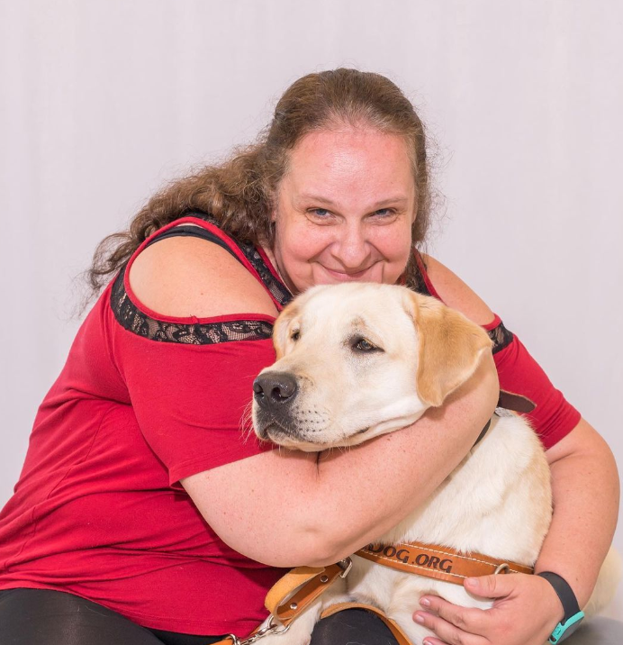
Photo: Kandis Stahmann hugging her guide dog Tim Tam

Kandis contacted her Aging and Disability Resource Center, and they recommended she get in touch with the Council. So began her O&M work with Brent.
Brent remembers Kandis being highly motivated right from the start. “She really wanted to learn O&M skills so that she could be a better mother for her daughter. Which included going to her daughter’s events at her school and being able to navigate the school on her own.”
“I think the most challenging part of it was the unknown,” Kandis says. “Stairs and intersections at first were terrifying.” Kandis says during their time together, Brent shared similar experiences of other people he’d worked with. That also helped Kandis. “Sharing his experiences helped humanize him,” she says.
As Kandis’s comments reveal, the O&M learning process requires trust between teacher and client. Building that trust is Brent’s favorite part of being an O&M Specialist. For the client, finding that trust can be hard. “They’ve just lost their vision. They’re very scared. Their trust in the people who are teaching them is a huge thing. Once you build that rapport with people, they’re ready to start,” Brent says.
“Trust between both sides is a definite need,” says Kandis. “There will be those hard to understand or confusing or scary moments.” These are the moments, Kandis says, when the learner must really believe that what the instructor says is going to work. She also points out that the student must be willing to speak up on their own behalf: “You have to be able to say, ‘ok can we do that again? It was hard.’”
“The moment I knew all the O&M I was learning was going to help was one I won’t forget,” says Kandis. “I had been working hard at the intersections. I finally had done it correctly. The fear of it was gone even though I would constantly be learning more. I even did a short happy dance!”
Now Kandis focuses on the foundation her O&M training provides. “That foundation is used every day--even with my guide dog,” she says. “I have to know how to listen to traffic, know the differences in sidewalks and curbs. If my dog stops and won’t go forward, I have to pull out that white cane to find out why.
“I think without the training, I would still be in my home all the time. I can’t thank Brent enough for helping me find my place in the world.”

Letter from Executive Director Denise Jess
Compelling Data Boosts the Impact of Our Advocacy
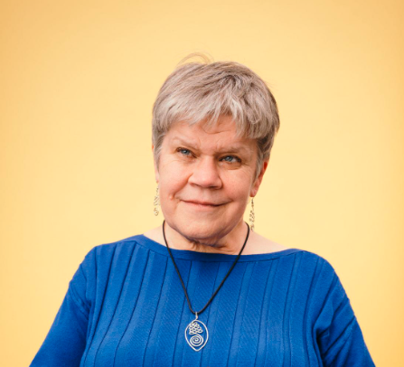
Photo: Executive Director Denise Jess

Since our earliest days, the Council has had a reputation for engaging in productive advocacy with state-level policymakers. We bring a wealth of lived experience to shed light on issues impacting our lives and offer innovative solutions. Missing from many of these narratives, however, has been data to reinforce these experiences, indicating trends and correlating the intersection of our issues with those of other groups.
Knowing that our efforts would be enhanced with the inclusion of data, the Council has been striving to fill in important gaps. Regarding transportation, we’ve worked with the Wisconsin Department of Motor Vehicles to estimate that 31% of Wisconsin residents are non-drivers. The common perception among policymakers and the public is that the non-driving population is relatively small, comprised of people with some disabilities and older adults.
When we share this stunning statistic with people, their jaws drop, and we’ve got their attention for making the case for greater access. Additionally, our advocacy efforts have led the Wisconsin Department of Transportation to develop an ArcGIS, a sophisticated mapping tool that shows where non-drivers live in the state. This tool breaks down the assumption that non-drivers primarily live in urban communities, when in fact they live throughout the state, including in rural areas. This information is critical for engaging more lawmakers from around the state in the discussion of transportation access.
Among my national colleagues, we’ve long recognized the challenges of lack of data about vision loss, knowing that better population information would strengthen our efforts to secure funding and shift policy. VisionServe Alliance, a national consortium of vision loss-focused agencies (of which the Council is a member and I serve on the board of directors) began a state-by-state analysis of older adults experiencing vision loss. In 2022 the Council, along with Vision Forward, Beyond Vision and Industries for the Blind & Visually Impaired, commissioned the Wisconsin study, and the report was published late last year. It is available online at https://visionservealliance.org/reports.
The results indicated what we’d long been observing. The report starts with some baseline facts:
- An estimated 4.2% of older people in Wisconsin report severe vision impairment or blindness.
- Women, who comprise 59% of the older population, are more likely than men to experience vision impairment.
- African Americans report much higher prevalence of vision impairment than their White peers.
- Vision impairment among people 65 and older varies widely across Wisconsin counties, from 3% to 13%.
The report goes on to focus on the impact of these facts, both on individuals and the public at large. It notes that economic well-being is a key social determinant of health, and that lower socio-economic status has been shown to represent a substantial barrier to access to care for those with vision loss.
- Older people with vision impairment have lower levels of education and are poorer than older people without vision loss. Forty percent of older people with vision impairment have not graduated from high school, and 30% have annual incomes below $20,000.
- Older people with vision impairment report higher prevalence of chronic conditions, particularly stroke, arthritis, diabetes, kidney disease and depression. Not surprisingly, 55% of older people with vision impairment in Wisconsin report fair or poor health, compared to 20% of older people without vision impairment.
- 37% of older people with vision impairment report 14 or more days of poor physical health in the past 30 days, compared to 13% of those without vision impairment.
- 13% of people with vision impairment report 14 or more days of poor mental health in the past 30 days, compared to 6% of those without vision loss.
These statistics point to a need for, among other things, greater access to vision services, transportation options and affordable health care.
While these statistics may be hard to read, they give us what we need to enter conversations in more empowered ways. This includes advocating for increased vision services across the state and greater inclusion of the needs of people with vision loss in planning across disciplines. For example, currently attending to the unique needs of older adults with vision loss is not included in the state’s aging plan. It should be.
Over the next months, we’ll be incorporating this data into our state budget advocacy and reaching out to other organizations who serve older adults to build their awareness of our population’s needs. To keep up to date with the Council’s advocacy activities, please subscribe to our advocacy e-newsletter that comes out the second Monday of each month. You can sign up on the Council website at WCBlind.org/news/newsletter-signup.
Going forward, we anticipate again working with our partners in the state and VisionServe Alliance to commission a companion report focused on working-age adults with vision loss. We believe this will give us critical tools for breaking down employment barriers.

Shining a Light on the Council’s Education Mission
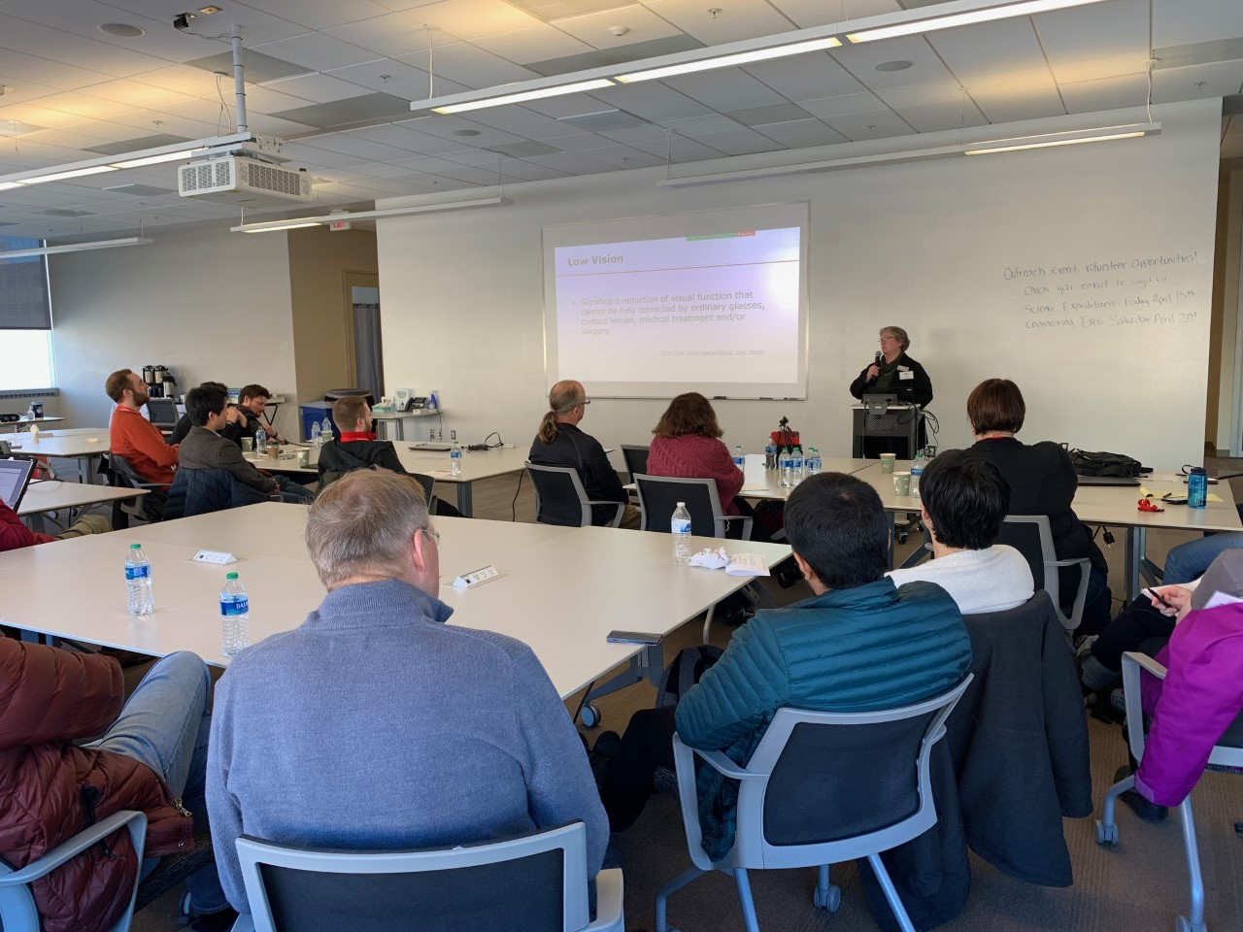
Photo: Education and Vision Services Director Amy Wurf presenting at a Breakthrough Research and Education Workshop (BREW) in the University of Wisconsin Materials Research Science and Engineering Center

The Council’s mission is to promote the dignity and empowerment of the people of Wisconsin who live with vision loss through our three pillar functions—advocacy, vision services and education. Advocacy paves the way for positive change by working with public officials at the local, state and federal levels. We also provide skills and tools to state residents so they can advocate for themselves with government agencies and other institutions. Vision services refers to our direct work with people with vision loss through low vision evaluations, vision rehabilitation, access technology instruction, orientation and mobility training, and braille instruction.
The third pillar of our work, education, is a slightly more elusive concept. Public education and outreach help put issues in context for people with vision loss. Educational outreach also helps the general public better understand the experience of people living with vision loss.
“Education is a key pillar of the Council’s mission because it has the power to open hearts and minds,” says Executive Director Denise Jess. Education is also central to our other core functions. “The foundation of our advocacy work is education, tapping lived experience to enhance understanding of the implications of public policy.”
The Council’s educational efforts take many forms. The annual “Birding by Ear” program is a good example. It’s a blend of community outreach, partnership and learning. And it’s fun! Each spring the Council teams up with Madison Audubon to offer classes that teach techniques for identifying birds by closely listening to their sounds and songs. In the process, participants discover what veteran birders have known all along: that sound is at least as crucial in identifying birds as noticing their coloration or shape.
Folks who are brand new to birding are welcome to enroll, as are people of all visual abilities.
Instructor Kerry Wilcox says, “I view the class as a way to connect more people to birding and the natural world who previously might not have thought it possible or interesting. If you are a person who is visually impaired or blind, there are few birding classes that focus solely on sounds, and fewer still that are geared toward accessible field trips.” Birding by Ear covers both.
Another example of a unique educational experience is Dining in the Dark. It’s a multi-course meal designed to provide diners who are not visually impaired insights into appreciating the dining experience using senses other than vision. To facilitate this, patrons enjoy their meal while blindfolded. The experience is an awakening to restaurant owners and employees as well, as they consider, often for the first time, how to best serve diners with vision loss.
Kari Walker is the chef and co-owner of the Reedsburg restaurant Beastro & Barley, a repeat Dining in the Dark venue. Kari remembers the impression Dining in the Dark had on her the first time. “I got to hear Denise talk about making restaurants more inclusive,” Kari says. “It was a powerful experience for the servers and the participants.”
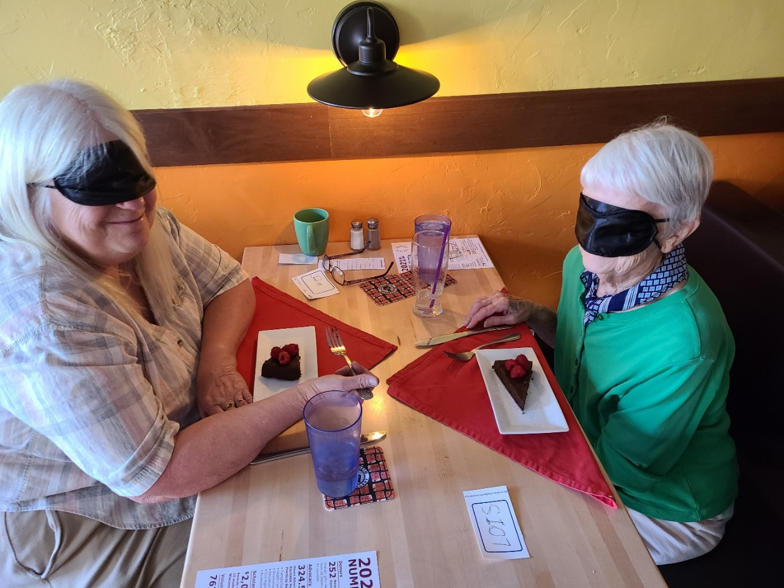
Photo: Diners at last year’s Dining in the Dark event at Beastro & Barley in Reedsburg enjoying their dessert.

While the Council creates many of its own education opportunities, the cornerstone of our public education work is presentations. Denise is frequently asked to speak on transportation issues to city planners, engineers and other groups of professionals.
Vision Services staff are also in regular demand for speaking engagements. For example, Madison-based eye surgery clinic Anderson & Shapiro recently contacted the Council. “We have always referred people over to the Council for low vision needs,” says Anderson & Shapiro Administrator Colin Wyatt. “Our missions cross over.”
But in this case, Anderson & Shapiro wanted to recommend the Council...to themselves. They invited Education and Vision Services Director Amy Wurf to come to the clinic to speak with staff. “I provided a general Council overview, including the variety of vision services, how to make referrals, Sharper Vision store information, and some general information about our advocacy work,” Amy says. “Their team was very engaged with the presentation, and I was very appreciative of the opportunity to speak with them.”
In addition to speaking engagements, this type of outreach often takes place at senior fairs and other community events where there are opportunities to engage with the public and distribute materials about the Council’s work.
Denise says education will always be a powerful way to further the Council’s mission. “For individuals and families experiencing vision loss, education can lessen the fear of the unknown and empower someone to take their next action to support their quality of life.”

Focus on Transportation Equity Helped Make The Big Share a Big Success
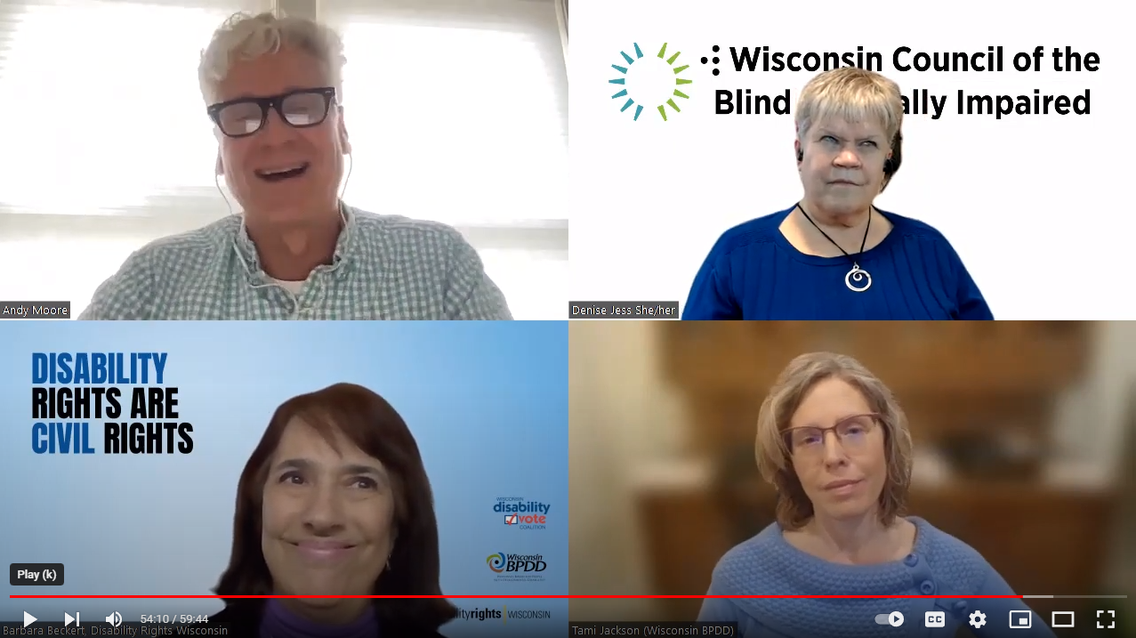
Photo: Screenshot from the panel discussion “Advancing Transportation Equity for Non-Drivers featuring (clockwise from upper left) moderator Andy Moore, Denise Jess of the Wisconsin Council of the Blind & Visually Impaired, Barbara Beckert of Disability Rights Wisconsin, and Tami Jackson of the Wisconsin Board for People with Developmental Disabilities.

The Big Share, an annual one-day fundraising event coordinated by Community Shares of Wisconsin (CSW), was a big success this year, not only for the Council but for many of the other nearly 70 nonprofits that participated. This year’s event, which took place March 7, was the ninth annual Big Share. CSW member organizations work on a range of issues including social and environmental justice, voting rights, healthy food systems, housing access and more. “It’s really a day for our organizations to come together, not to compete,” says Council Fund Development Director Lori Werbeckes. “A chance to share our work all in one place and to raise awareness of all of our missions.”
The Council raised over $10,000 from more than 90 donors during The Big Share this year.
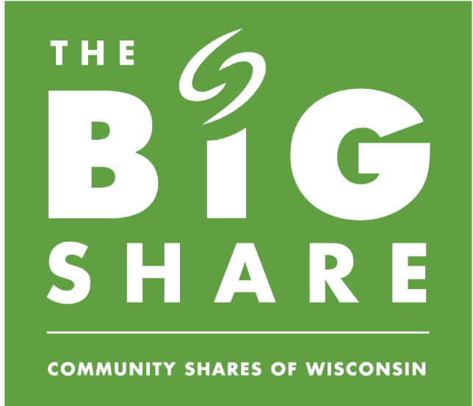
Photo: The Big Share logo

This year, the Council’s work was highlighted during a special online video forum, hosted in collaboration with fellow CSW member Disability Rights Wisconsin. “Advancing Transportation Equity” was also made possible in partnership with the Wisconsin Board for People with Developmental Disabilities.
The hour-long panel discussion was a deep dive into the circumstances and consequences of a transportation system that prioritizes vehicles over people. Non-drivers and their families, supporters, employers and others pay the price for this disconnect. Advancing Transportation Equity panelists included Council Executive Director Denise Jess; Tami Jackson, Public Policy Analyst and Legislative Liaison for the Wisconsin Board for People with Developmental Disabilities; and Barbara Beckert, Director of External Advocacy with Disability Rights Wisconsin.
During the forum Tami Jackson challenged participants who drive to imagine what they would do if they suddenly became non-drivers. “Some of us would be able to cobble together a plan for a few days or a week,” Tami said. “But when you start thinking about that as a permanent thing that you can’t do, most of us have very few options no matter where you live…. There are many places in the state that do not have mass transit like a bus system or a cab system. And even if you do have mass transit in your area, does it go where you want to?”
Some takeaways from the conversation include:
- Transportation inequities impact everyone, not just non-drivers. There are impacts on employment, education, access to healthcare, food security, voting and essentially all aspects of life.
- Non-drivers live in all areas of the state – urban, suburban, small town and rural.
- If you don’t drive or own a car, it’s difficult to impossible to get to where you need to go on your schedule due to limited options, including a lack of pedestrian/bike infrastructure, erosion of services that were previously available, patchwork services that are challenging to navigate and services that end at municipal lines.
- We need to transform our policies and practices to put people, not cars, at the center – create systems for all modes, all users, all abilities, all ages.

You can find a recording of the virtual forum online at https://youtu.be/SsY5N6zhwKE.

New Video Provides Overview of Vision Services Available at the Council
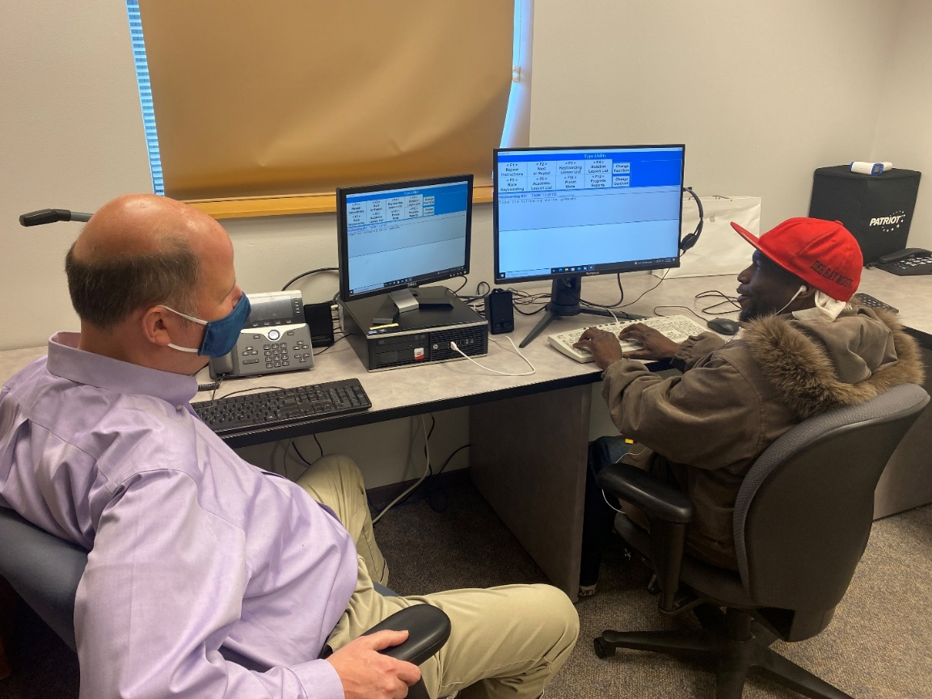
Photo: Access Technology Specialist Jim Denham working with client DJ Moore.

The Council’s vision services team helps clients with low vision evaluations, vision rehabilitation therapy, access technology instruction, orientation and mobility training and braille instruction. Staff members combine special training with a compassionate, respectful, client-centered approach.
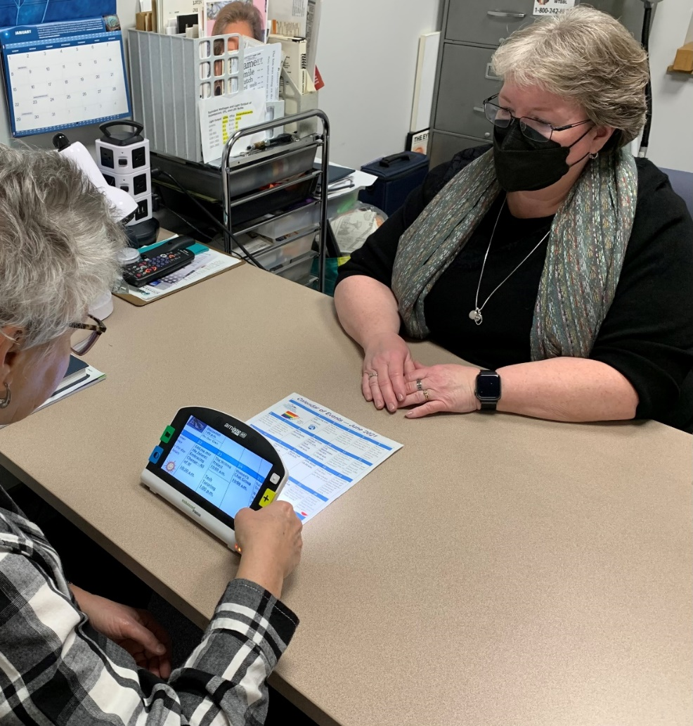
Photo: Vision Services Director and Certified Low Vision Therapist Amy Wurf working with a client

Now you can hear about these services directly from the mouths of our Vision Services staff. Our new video, “Vision Services at the Wisconsin Council of the Blind & Visually Impaired,” provides a detailed overview of our menu of services. We’re grateful to Industries for the Blind and Visually Impaired for providing funding to make the video.
“I’m so excited for people to meet our talented and highly qualified vision services team and learn more about how our services can support them on their journey,” says Council Executive Director Denise Jess.
The video is available via the Council’s YouTube channel at Tinyurl.com/WCBlind-Vision-Services. To talk to Vision Services staff to see if the Council’s services are right for you, call us at 608 255-1166 or use the Vision Services Request Form accessible via the Vision Services page of our website.

Upcoming Events
Birding by Ear
Identifying birds by their sounds is an exciting activity and skill, and any experienced birder will tell you that much of the skill involved in identifying birds has more to do with hearing them than with seeing them. Birding by Ear, hosted in collaboration with Madison Audubon, teaches the techniques for identifying birds by close listening. Participants can attend the class session either in person or virtually on either Thursday, April 27 or Saturday, April 29; and take part in an in-person field trip in Madison on either Saturday, May 6 or Thursday, May 11. For registration information, visit WCBlind.org/council-events/birding-by-ear.
Dining in the Dark
Dining in the Dark is an experiential dinner that challenges attendees to rethink the importance of vision in the dining experience. The Council partners with restaurants across the state to host Dining in the Dark fundraisers. Guests are blindfolded during the multi-course meal. Two Dining in the Dark events are scheduled this spring: Monday, May 1 at Brix Cider in Mount Horeb; and Saturday, June 17 at Beastro & Barley in Reedsburg. For more information, visit WCBlind.org/events/dining-in-the-dark. Note: Dining in the Dark events tend to fill up quickly, so if you are unable to make a reservation for these two events, we are happy to contact you when subsequent events are scheduled.

Back Cover:
The Council publishes four monthly e-newsletters: Upcoming Events, Advocacy Update, On Sight and News You Can Use. Each has important information to help empower readers living with vision loss to live vibrant, independent lives. Subscribe to any or all of them at WCBlind.org/who-we-are/contact/newsletter-signup.
Did you know that the Council Courier is also available in braille and audio formats? To request an alternative format or update your mailing address, call us at 608-255-1166.

Contact Us:
Wisconsin Council of the Blind and Visually Impaired
754 Williamson Street
Madison WI 53703
WCBlind.org
Info@WCBlind.org
608-255-1166
800-783-5213

