Adapting to Low Vision

Adapting to Low Vision
Welcome to this beginning guide to adapting your lifestyle to low vision. Low vision refers to vision changes that cannot be
corrected with eyeglasses, medication or surgery. Low vision may be the result of eye diseases, such as macular degeneration, glaucoma or diabetic retinopathy. It can also occur with brain injuries and neurological conditions, such as stroke or multiple sclerosis. People with low vision have usable vision that can be used in conjunction with other senses, like hearing and touch.
Through vision rehabilitation, they can also learn strategies for safe, healthy and comfortable engagement in daily activities.

This booklet is just a start. Try some of the strategies on your own. We encourage you to consult with vision rehabilitation and orientation and mobility professionals who can assist in
implementing the ideas presented here. These specialists can also teach new strategies to manage everyday tasks, including using access technology. Some of these services can be provided in your own home.

This publication was made possible by a grant from a foundation that prefers to remain anonymous. The Council is deeply grateful for their ongoing support of our mission.

Table of Contents

Tips for Reading 4
Ways to Enhance Vision 9
Managing Medications 14
Accessing Technology 18
Watching Television 20
Travel and Transportation 22
Recreation 24
Resources 27

Tips for Reading
Consider consulting with a low vision optometrist or low vision clinic for advice on the strength of glasses or magniﬁer you need, available options, proper use and posture, and where to ﬁnd the appropriate reading aids.

Talking Books
The Library of Congress’s National Library Service for the Blind and Print Disabled (NLS) offers free talking books to anyone who has difﬁculty reading print due to a visual or physical impairment. The Wisconsin Talking Book and Braille Library (WTBBL), based in Milwaukee, is the state’s NLS outpost.

dpi.wi.gov/TalkingBooks.

A special player is provided to users of the service at no charge. Books on digital cartridge are sent through the mail, with return postage provided.

An audio book app is also available for smartphones and most tablet readers.

The WTBBL application can be found at dpi.wi.gov/TalkingBooks/ apply, or you can call 800-242-8822 for more information. The application must be signed by a professional qualiﬁed to afﬁrm your need.

Your local library has audio books on CD or other digital or app- based formats you can check out. Speak to the librarian to ﬁnd out what is available.

Magniﬁcation
Short reading tasks, such as mail, a menu or a food label, can often be accomplished using a handheld magniﬁer.

Handheld magniﬁer

For longer reading tasks, such as a book or newspaper article, a stand magniﬁer or a digital video magniﬁer can help keep print in focus and well lit.

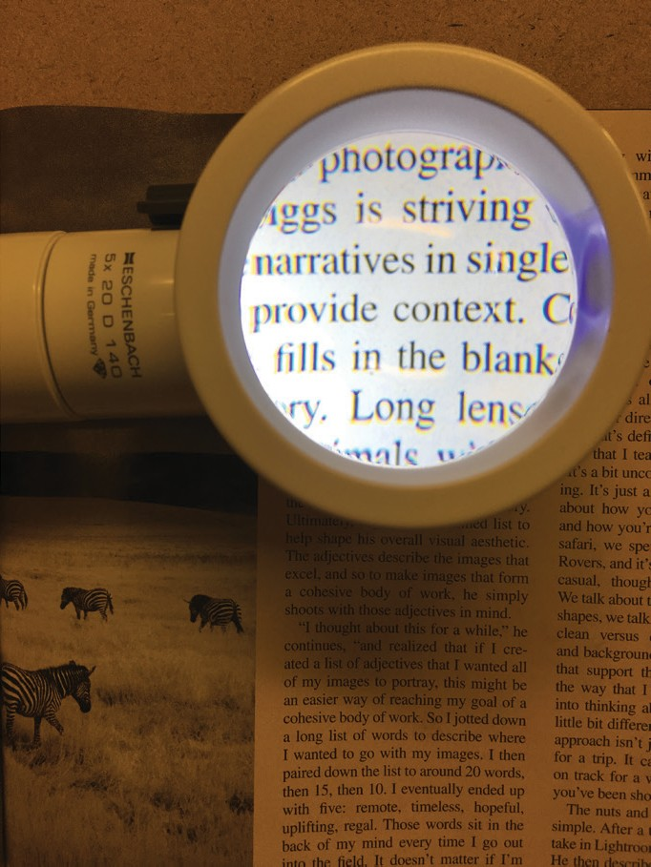
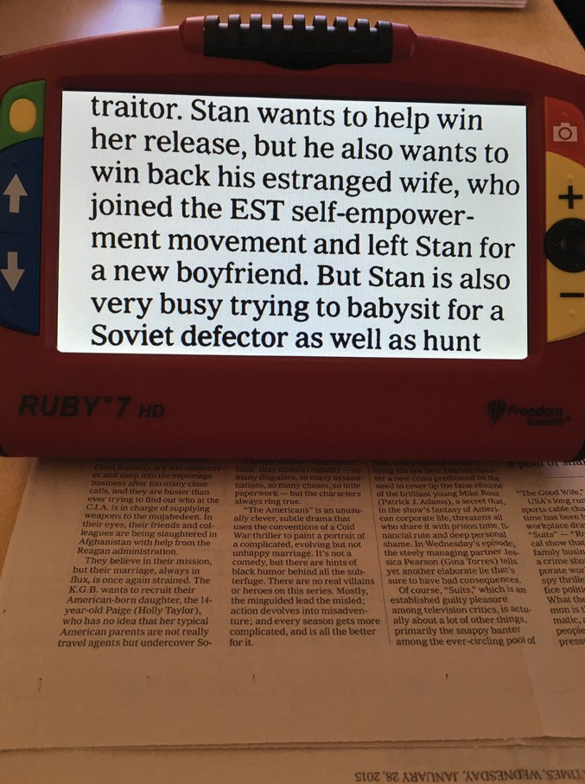

Lighted magniﬁer Portable electronic magniﬁer

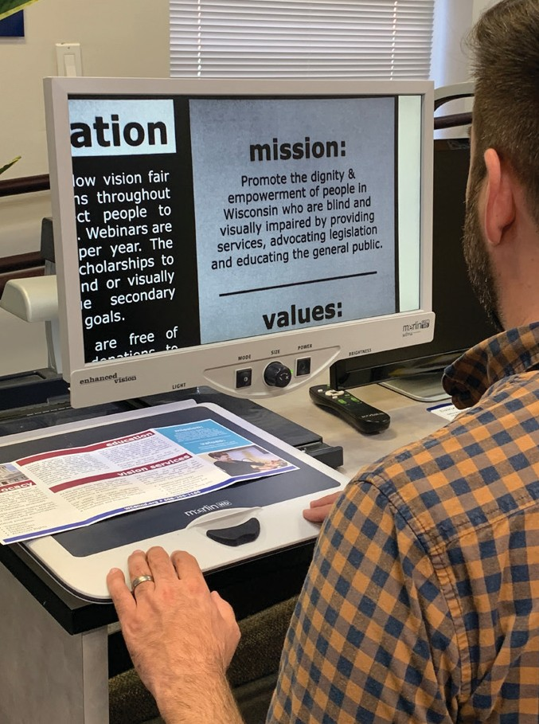

CCTV video magniﬁer

Lighting

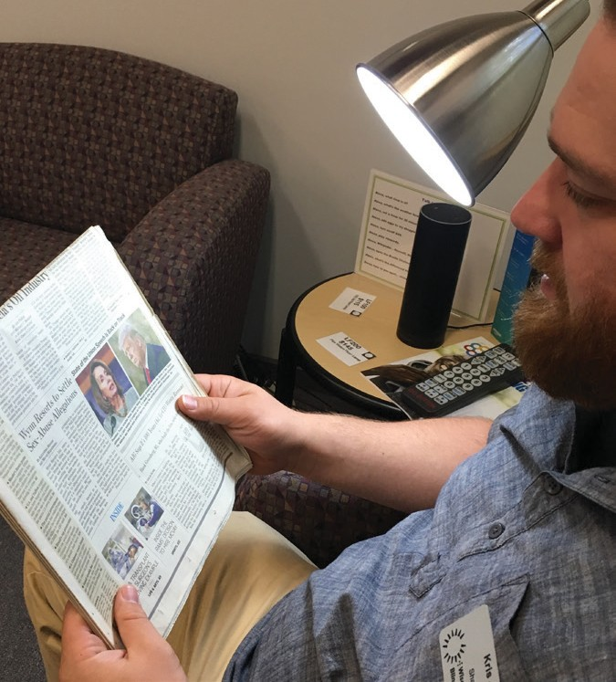
A ﬂexible arm lamp or gooseneck lamp will help direct light toward the page while keeping it out of your eyes.

Preferred position of lamp for reading

Experiment with different types of lightbulbs. Try a daylight, Reveal, cool white or soft white bulbs to ﬁnd the type that provides good contrast and brightness without being too harsh.

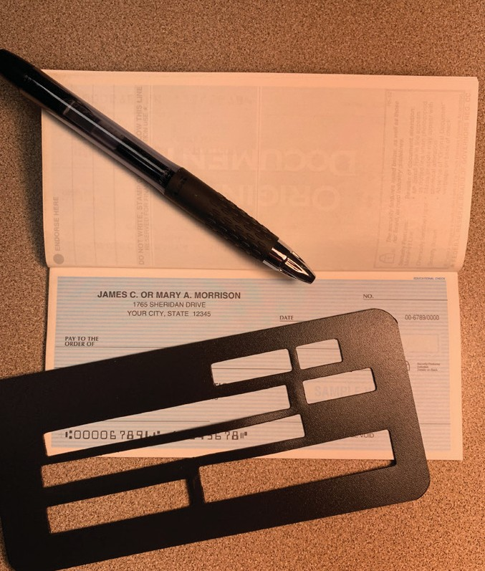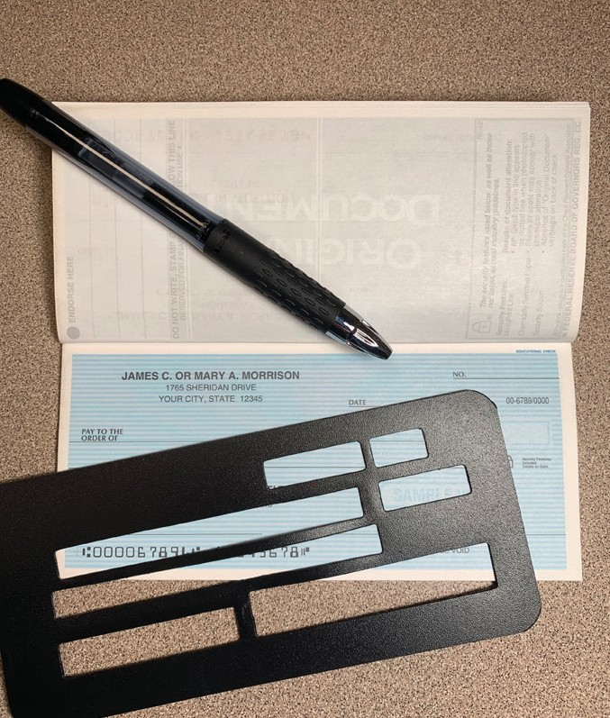

Check, pen and Check, pen and check guide under check guide under warm white light bulb. daylight bulb.

Positioning
The stronger the magniﬁer, the closer your eye must be to the lens to get the best ﬁeld of view. Notice how much more text is seen when you move closer to the lens.
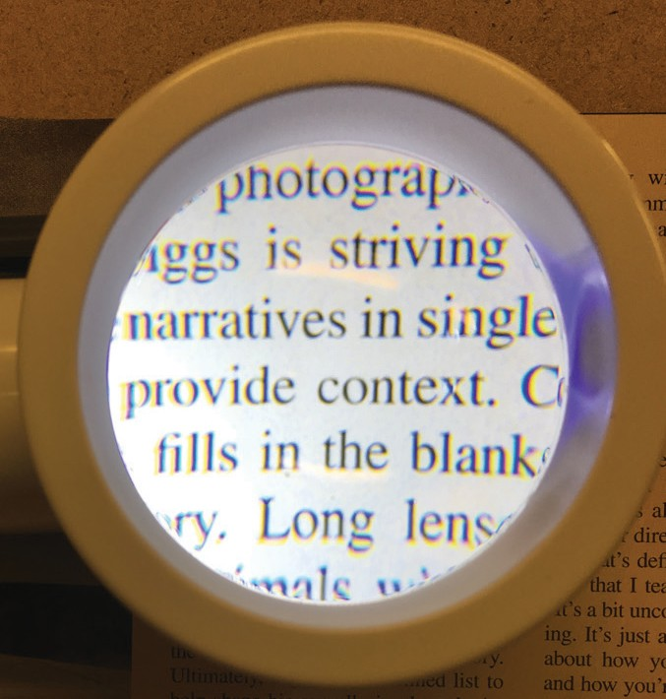
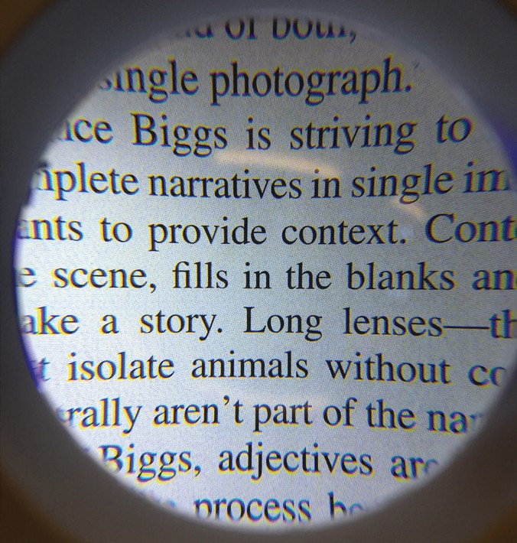

Magniﬁed text with only a few words in view.

The same magniﬁed text with more words in view as the person moves their eye closer to the magniﬁer.

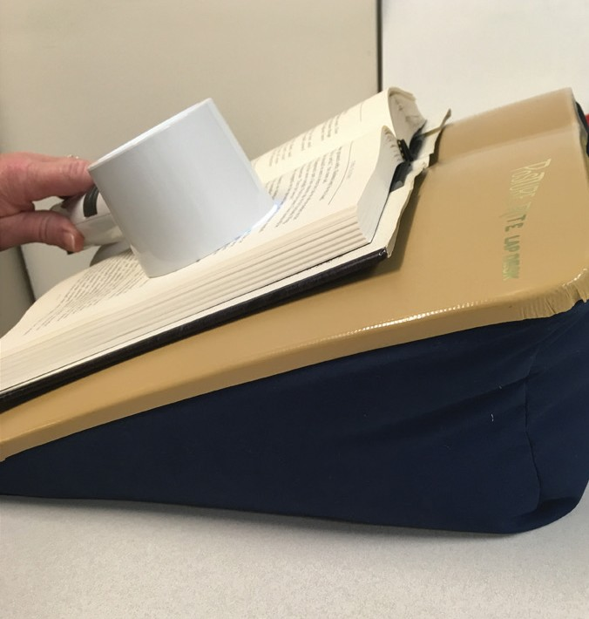
Find a way to prop up your reading material to reduce back and neck strain.
A lap desk or reading stand can be helpful.

Preferred position of

a book on a lap desk when using a magniﬁer to read.

Braille
Braille instruction provides the foundation for those interested in using braille at any level, from a working knowledge sufﬁcient to accomplish daily tasks like reading a recipe card to the
proﬁciency necessary to read a whole book.

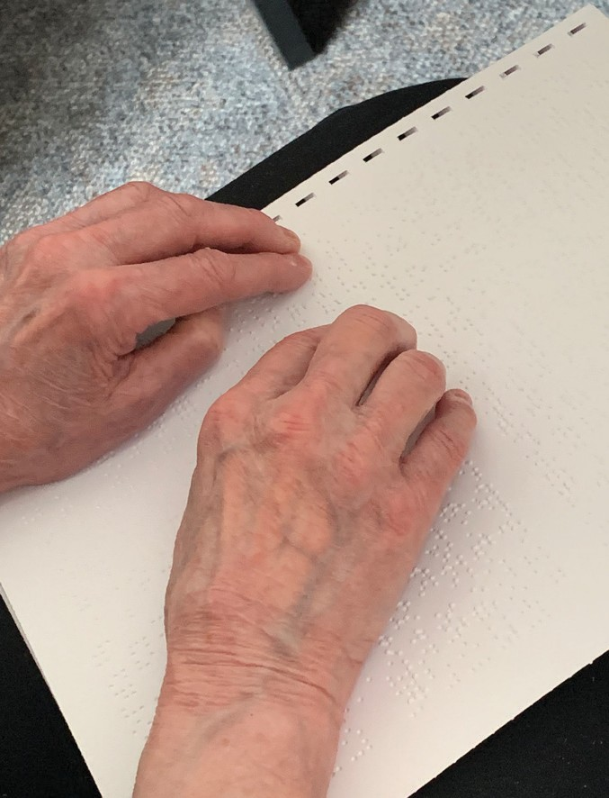

Ways to Enhance Vision

Contrast
Use a contrasting color in the background to ﬁnd items in a cabinet or on a counter more easily. The best solution is to reduce visual clutter by using plain, solid, contrasting colors.

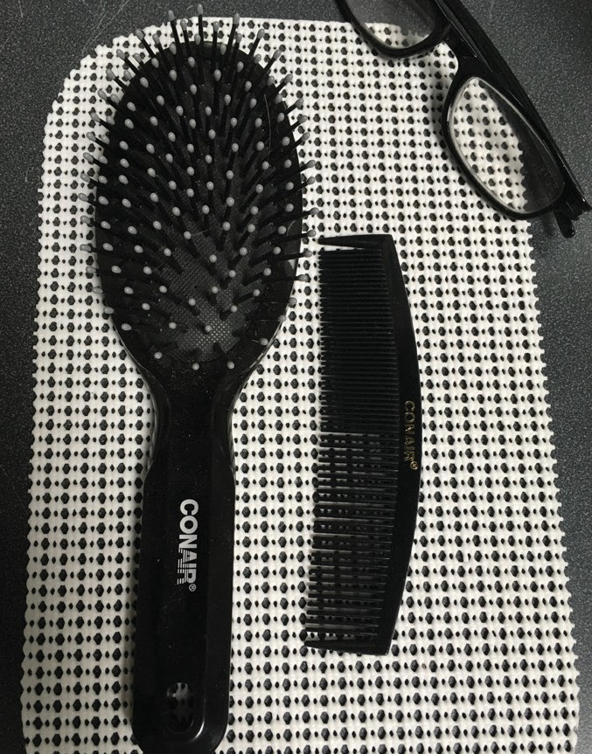

A white bar of soap on a red dish shows good contrast.

A dark comb, hairbrush, and glasses on a white

background shows good contrast.

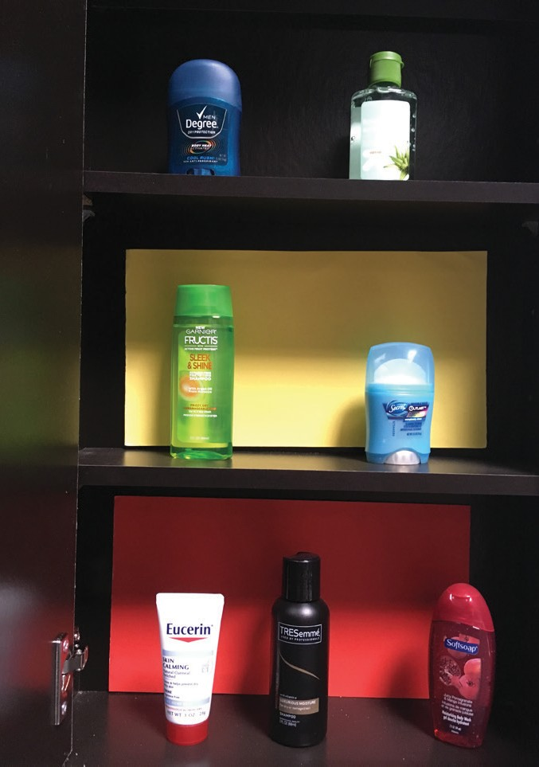
In this photo, notice how the items on the top shelf seem to fade into the dark background, while the items on the lower shelves stand out.

Use contrast to help see medicine bottles and individual pills. Pay attention to the background and keep it simple to help your eyes focus on the bottle.
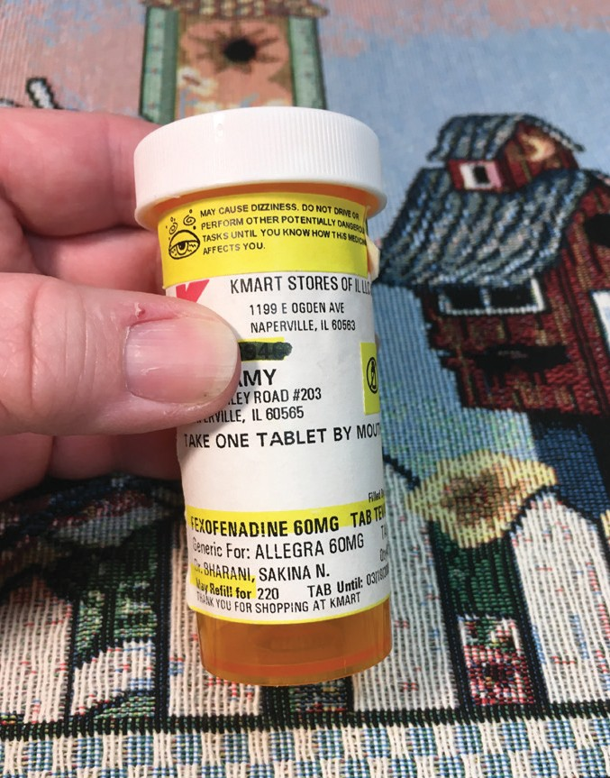
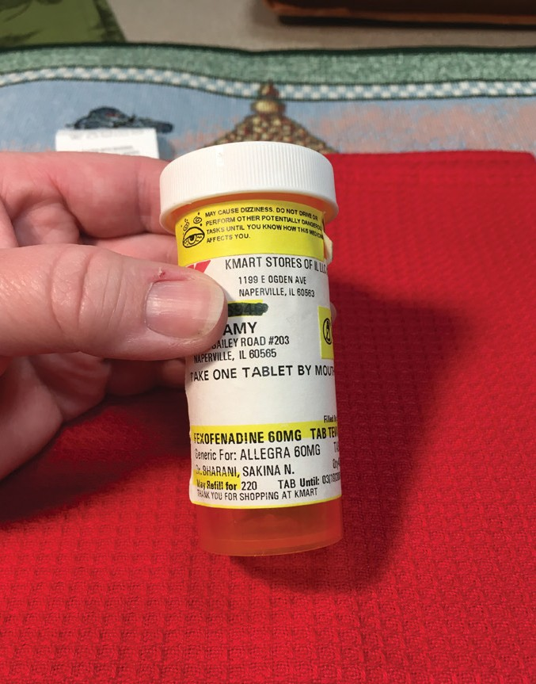

A pill bottle in front of a busy background shows poor contrast.

A pill bottle in front of a solid background shows good contrast.

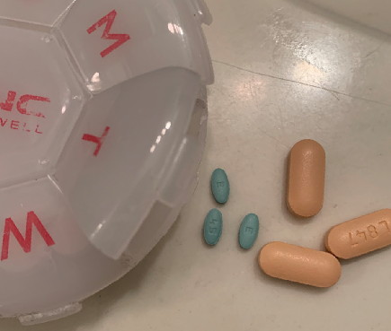

A pill box and pills A pill box and pills on

on bright, reﬂective blue, nonreﬂective surface surface shows poor shows good contrast. contrast.

Try to avoid using plates, placemats and tablecloths that are all the same color.

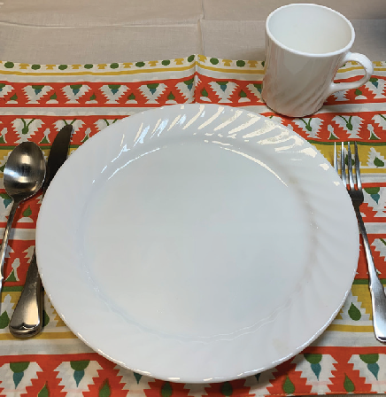
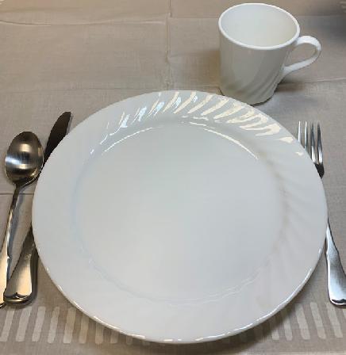
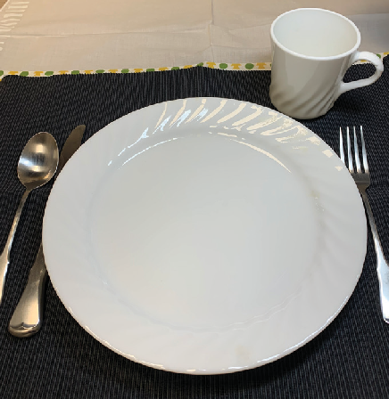

Place setting on busy, multicolored placemat shows poor contrast.

Place setting on plain, white

placemat shows poor contrast.

Place setting on plain, black

placemat shows good contrast.

Labeling and Tactile Markers
In the kitchen or laundry room, put simple, high-contrast, 3-D marks that you can feel on appliance dials. Keep it simple and only mark the most important dials, like the start button on
a microwave or the temperature dial on a washing machine. Marking every button will just make it more confusing! You can use fabric paint, self-adhesive dots, Velcro with a sticky back, or tape in high contrast colors to mark dials and controls.

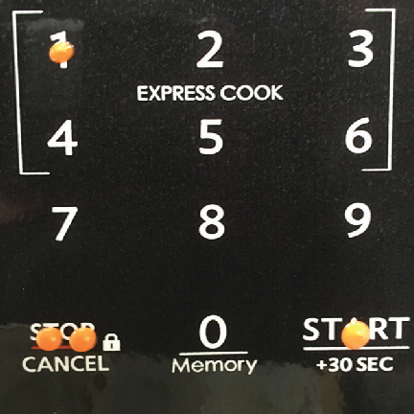
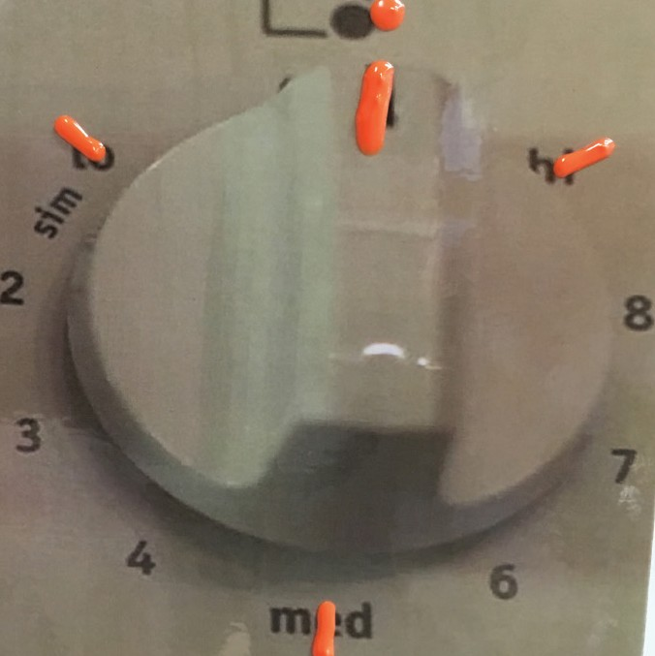

Orange tactile dots Orange puff paint on on a dark microwave an appliance dial. control panel.

Create large-print labels for canned, boxed and frozen foods. Print clearly on a 3x5 card with a bold, permanent marker. Attach the cards with rubber bands. If a card is to be used in the freezer or refrigerator, ﬁrst get it laminated at an ofﬁce supply store.

You can use large index cards to write heating directions for foods you cook often.
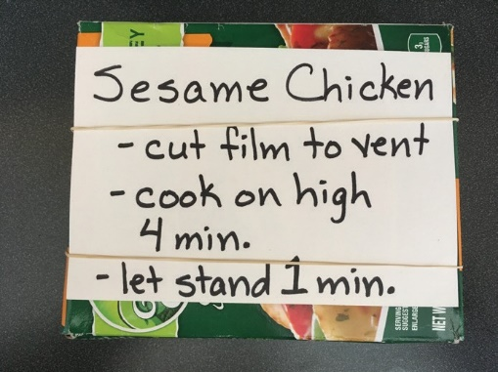

When a food package is empty, remove the label so you can use it over again. You can also use the removed labels to remind you what you need to restock next time you shop for groceries.

Managing Medications

Know Your Medications
Your doctor and your pharmacist may not be aware of your vision loss or how it affects how you best receive information. If you need information about your medications in large print, audio or braille format, let them know. Ask their help in getting to know every detail of your prescriptions – name, dosage, purpose and precautions.

Learn to recognize your medications by size, shape, color, odor or packaging. You can place touch, color or audio labels on prescription bottles to help you recognize them. Here are a few ideas for labeling:

Wrap an index card with large, bold print information around a prescription bottle. Keep the original prescription label secured and uncovered so you can refer to it as needed.

Place colored rubber bands around the bottles, using
a different color for each medication. The number of rubber bands can indicate how many times a day that medication should be taken.
Write the ﬁrst letter or two of the medication’s name on the bottle cap with a bold marker or pen. Put a white label on the cap ﬁrst if that’s easier to write on.

Use a device such as a PenFriend to create a self-adhesive audio label. When the tip of the PenFriend touches the label, it plays the recording of the information on the label.

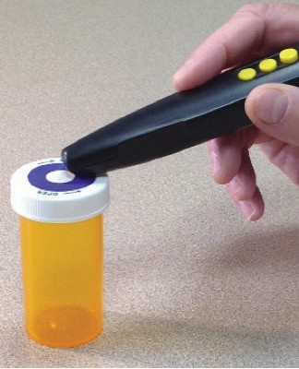
The PenFriend pointing at the top of a pill bottle where the audio label is placed.

Use a pharmacy that offers ScripTalk labels or a similar product. The pharmacy places an audio chip in each medication label.
When you place a bottle on the ScripTalk Reader you have at home, it plays an audio message giving detailed prescription information.

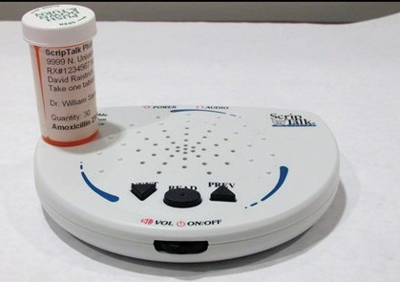
A pill bottle sitting on the ScripTalk prescription reader.

Keep Good Records
Create a reference card that lists your medications, allergies, recent surgeries and emergency medical contact. Include all medications — prescriptions, over-the-counter medications, vitamins and supplements — and their dosages. Take the card with you to all health-related appointments. It’s also a good idea to share the card with a family member. Make the card available to emergency personnel by putting it in an envelope and taping it to the refrigerator. Update the card every six months.

Establish a Medication Routine
It’s important to establish a routine that works for you and stick with it. A pillbox can keep medications organized and remind you of when to take them. Find a box with compartments that are easy to open and labels that are easy to read. The size should be right for your ﬁngers to scoop out the pills.

Fill the box the same day every week and at a time of day when you are focused and alert. Check to see if reﬁlls will be needed before the next week and order them if necessary.

If you are not comfortable ﬁlling your own pill box, ask a family member to help. Check with your pharmacy, as some will prepare weekly or monthly boxes for you.

There are also services that pre-package medications into sorted, organized single-serving, multi-dose packets. The packets may come as a strip of soft plastic bags or in hard plastic blister pack bubbles.

A watch, clock or smart phone app will enable you to set multiple alarms to remind you when to take your medications throughout the day.

Accessing Technology
Access technology can help people with vision loss efﬁciently obtain information. These hardware and software solutions can help individuals reach personal and professional goals at work, school or home.

Some devices, including smart phones (such as an iPhone) and tablets have built in accessibility settings. Other devices, including Windows computers, can be loaded with third-party software to enhance accessibility. Screen reading software uses synthetic speech to translate information on the screen into audio format. Screen magniﬁcation software enhances the
display by magnifying the image. It also allows users to change the color and contrast to make information easier to see.

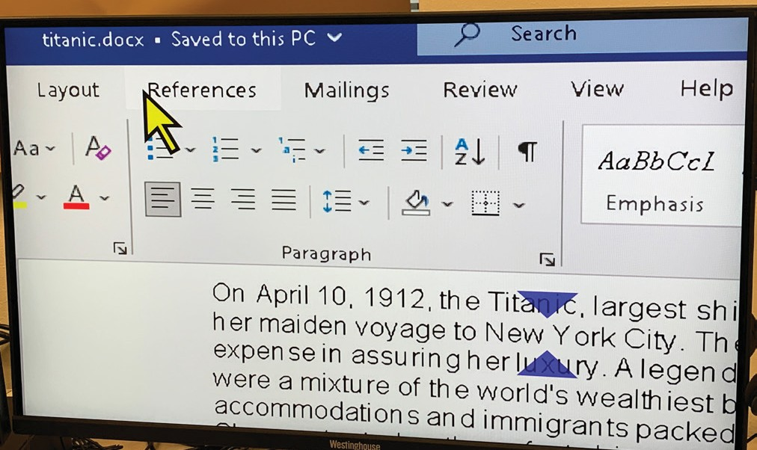
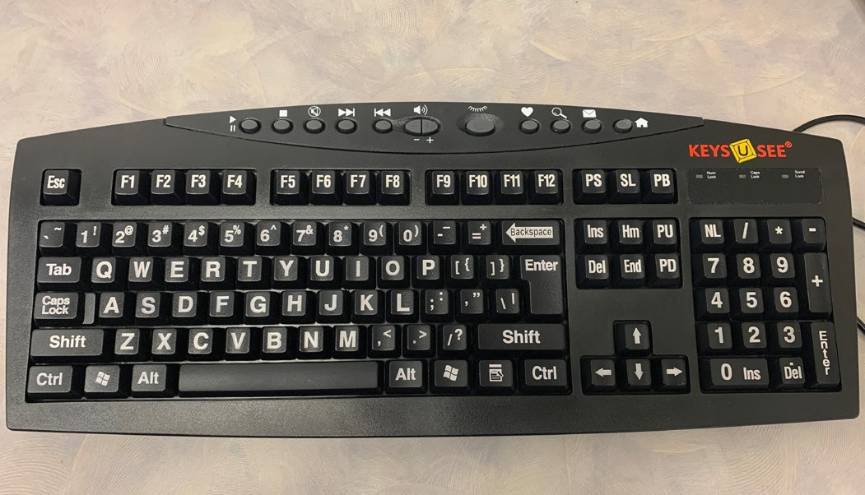
Large print, high contrast computer keyboard.

Computer screen showing enlarged text, mouse pointer and cursor position.

Smart Speakers
A smart speaker looks like a regular small, modern speaker. But when connected to the internet, it can help navigate the web, answer questions and assist with certain tasks just by asking.
Working in tandem with other smart devices, like phones, plugs, bulbs and appliances, they can be extremely useful for people with impaired vision.

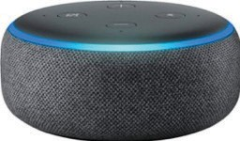
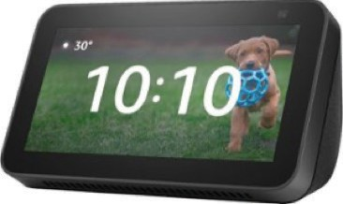

Two examples of smart home assistants.

Watching Television

Evaluate the Environment
Eliminate or reduce lights that may be reﬂecting on the television screen. Try closing drapes or turning off or dimming lights. Sit closer to the screen—don’t worry, it won’t hurt your eyes!

Match Screen Size to Your Needs
Measure your current screen and the distance between the screen and the chair you usually watch from. When you’re at the store, stand the same distance away from the screen as your chair at home. Try out different screen sizes. You can also try adjusting the brightness and sharpness settings.

If you have a narrow ﬁeld of vision, a smaller screen may work better for you than a big screen. You may even prefer accessing television programs on a tablet or smart phone.

Use Optical Aids

to Magnify the Screen
Distance-viewing aids, such as binoculars and monoculars, may be helpful. Often sitting closer is the best solution.

Turn on Audio Description
Audio description is voice narration that describes the action and scenes that are important to the story that you may not see. The narrator does not interrupt the dialog. Use the remote to turn on audio description in the television’s settings menu. Not all programs have audio description, but many do and the number is growing.

Set Up a Favorites List
Using your remote, put frequently watched stations in a favorites list. Move through the list using the remote’s up and down buttons. This reduces the need to use the keypad.

Use an Audio Guide
An audio guide speaks the program title, time and channel. If using cable or satellite TV, check with your provider to learn how to access their audio guide. Streaming services like Roku, Apple TV and Amazon Fire TV have audio guides.

Sports Watching Tip
When watching sports on television, mute the television sound and turn on a radio to hear the play-by-play audio. Radio announcers give more information about the game compared to television announcers.

Travel and Transportation

Orientation and Mobility
Orientation and Mobility (O&M) training provides skills for getting around safely and independently. That could be anything from white cane skills to get to a baseball game across town
to moving safely from the basement to the second-ﬂoor bedroom. An O&M Specialist can provide training to access public transportation, manage a workspace or conﬁdently walk around the block.

Mobility Managers
A mobility manager may be able to help you ﬁnd the most efﬁcient, cost effective or creative way to make essential trips. This is a particularly helpful resource for those in rural areas.

wi-mm.org/Mobility-Manager

Wisconsin Get-Around Guide
The Wisconsin Department of Transportation provides information on intercity and public transportation across the state.

wisconsindot.gov/Documents/Travel/Pub-Transit/Get- Around.pdf

Aging and Disability Resource Centers
Each Wisconsin county has an Aging and Disability Resource Center (ADRC). The ADRC knows the transportation options available in their area for elderly people and people with disabilities. An ADRC may be able to provide information for buses, taxis and volunteer drivers.

dhs.wisconsin.gov/ADRC/Consumer

Local Transit Systems
In some parts of the state, you can contact your local transit system for information about ﬁxed route and paratransit options.

Recreation
There are many great options for recreational opportunities. Here are a few to know about:

National Veterans Sports Programs & Special Events
These specialized rehabilitation programs aim to optimize independence, community engagement, well-being and quality of life for veterans who have disabilities.

va.gov/AdaptiveSports

Wisconsin Department of Natural Resources – Open the Outdoors
Open the Outdoors is a great resource for accessible recreation options for individuals with disabilities.

dnr.wi.gov/topic/OpenOutdoors

Fishing Has No Boundaries
Fishing Has No Boundaries provides recreational ﬁshing opportunities for all anglers with disabilities regardless of their age, race, gender or disability.

FHNBInc.org

Leigh Yawkey Woodson Art Museum
The Woodson Art Museum in Wausau offers diverse and ever- changing exhibitions year-round, as well as a sculpture garden, an Art Park, dynamic programs for all ages and life stages, and a commitment to always-free admission that provides barrier-free access to the visual arts.

LYWAM.org

BOLD (Blind Outdoor Leisure Development)
BOLD is open to all people who are legally blind. Event participation is free. BOLD’s purpose is to allow the blind and visually impaired to experience outdoor sports and leisure activities while developing their social and athletic skills.

WisconsinBold.com

Sailing Education Association of Sheboygan (SEAS)
SEAS is a nonproﬁt dedicated to creating affordable pathways for the community to safely enjoy boating on Lake Michigan.
They provide educational programming and access to boats while removing barriers to participation created by ﬁnancial, physical or cognitive needs.

SEASheboygan.org

Bowling
The American Blind Bowling Association maintains a list of bowling leagues around the county for people with vision loss. Their website lists four leagues in Wisconsin.

abba1951.com/leagues

Hadley Institute
Hadley offers a wide range of learning opportunities related to recreation. Workshop topics include gardening, games, birding, sports and exercise, crafting and sewing.

hadley.edu/learn?topic_id=13

Local Recreation Departments
Check with your local recreation department for adaptive sports, music, language, arts and crafts and other learning opportunities.

Games and Activities
Many popular games can be adapted for people with vision loss. The Sharper Vision Store carries many of these accessible games.

Store.WCBlind.org.

You can ﬁnd even more on the American Foundation for the Blind website.

https://www.AFB.org/node/16207/Games-And-Activities.

Resources

Wisconsin Council of the Blind & Visually Impaired 754 Williamson Street
Madison, WI 53703
800-783-5213

WCBlind.org

Ofﬁce for the Blind and Visually Impaired Wisconsin Department of Health Services
888-879-0017

DHS.Wisconsin.gov/Blind

Vision Forward Association 912 N Hawley Road Milwaukee, WI 53213
855-878-6056

Vision-Forward.org

Center for Deaf-Blind Persons, Inc.
8306 W. Lincoln Ave. West Allis, WI 53219 414-481-7477
Voice/TTY/DBC

Deaf-Blind.org

County Veteran Service Ofﬁcers
Your Wisconsin County Veterans Service Ofﬁcer (CVSO) is the contact for qualiﬁcations and guidance on local, state and federal Veteran’s beneﬁts.
To ﬁnd a local CVSO, call 844-947-2876.

Aging and Disability Resource Centers (ADRC) DHS.Wisconsin.gov/ADRC

Tribal Aging Resource Services DHS.Wisconsin.gov/ADRC/ Consumer/Tribes.htm

Center for Sight and Hearing
8038 MacIntosh Lane
Rockford, IL 61107
888-347-0811

CHSNI.org

Lighthouse Center for Vital Living (Duluth Lighthouse for the Blind)
4505 West Superior St., Suite A Duluth, MN 55807
218-624-4828

LCFVL.org

754 Williamson Street
Madison, WI 53703

608-255-1166
800-783-5213
WCBlind.org

Ofﬁce & Store Hours 8:30 a.m. to 4:30 p.m. Monday through Friday

The Council is a 501(c)3 nonproﬁt organization that relies on donations to fund our operations. Visit WCBlind.org/donate.

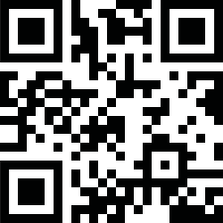
TO VISIT

OUR WEBSITE, SCAN THIS

CODE WITH YOUR SMART PHONE.

