Wisconsin Council of the Blind and Visually Impaired Council Courier, Winter 2024

In the Winter 2024 issue of the Council Courier:
- Beyond Steve’s Law: Next Steps Toward ID Equity
- Letter from Executive Director Denise Jess:
Fostering a Culture That Values Diversity, Equity, Inclusion and Accessibility
- Council Friends: Making an Enormous Difference with Their Generous Support
- Staying Active Safely When the Weather Outside is Frightful
- Spreading the Word about NLS Braille eReader Program
- Upcoming Events
  - The Big Share
  - Scholarship applications
  - Advocacy Days
- About Us

Beyond Steve’s Law: Next Steps Toward ID Equity
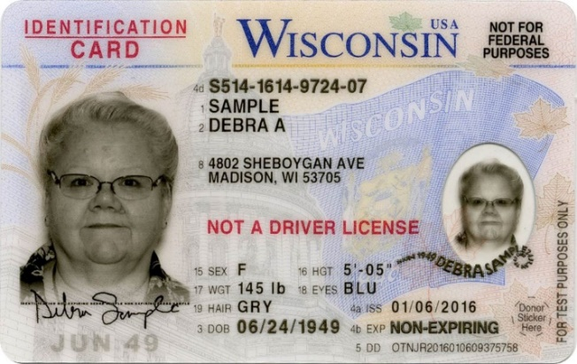
Steve Johnson
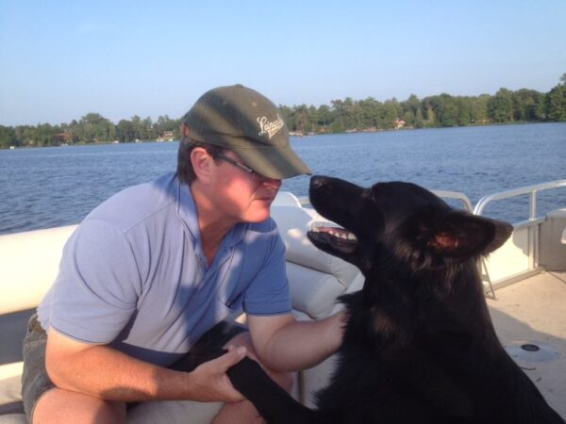
Gary Traynor, another former Council board member and outdoor enthusiast, enjoying a boat outing.

To nondrivers, it’s painfully clear that most of our systems in the U.S. were not designed with them in mind. Our transportation infrastructure prioritizes motor vehicles. A lot of important destinations are hard to reach by public transit, especially in rural areas. Many communities lack safe routes for pedestrians and cyclists. And the default form of personal identification is a driver’s license.
For most identification purposes in Wisconsin, a state ID obtained through the Division of Motor Vehicles (DMV) works as well as a driver’s license. Unfortunately, the car-centric mindset of policymakers has sometimes resulted in laws that unintentionally discriminate against people who hold a state ID card rather than a license. And the very process of obtaining an ID—which requires presenting a birth certificate and other documentation at a DMV office—can be challenging for those who do not drive, particularly in parts of the state where DMV centers are sparse and have limited hours.
Fortunately, a new understanding of ID equity is taking shape at the State Capitol, largely thanks to a bill making its way through the Legislature. Steve’s Law—named after the late Steve Johnson, an avid outdoorsman and former Council board member from La Crosse—would fix a problem with the Wisconsin Department of Natural Resources’ (DNR) online Go Wild system, where you can buy fishing and hunting licenses, register boats and off-road vehicles, and sign up for safety education courses.
The Go Wild system currently requires a driver’s license to establish state residency for the purpose of creating an account. It does not accept state ID cards. This unfair setup denies the 31% of state residents who are nondrivers equal access to state resources. Steve’s Law would allow the DNR to access state ID records the same way they access driver’s license information.
The bill has broad bipartisan support, and we’re hopeful that it will pass and be signed into law this session. But Steve’s Law is just one step toward creating true ID equity for nondrivers. Most state agencies already accept either form of ID in face-to-face situations. The problem is that more and more of these interactions are moving online, and many of the laws pertaining to the digital transfer of data between agencies were written like the one covering the Go Wild system. They allow for driver’s license information, but not state ID data, to be shared digitally. Steve’s Law only fixes the part of the problem related to DNR programs.
“What we need is a blanket bill that says an ID is an ID is an ID,” says Denise Jess, Executive Director of the Wisconsin Council of the Blind & Visually Impaired.
So how do we progress from the great first step that is Steve’s Law toward more complete ID equity? First, a little digging must take place. “We’re working with officials to identify where else in the statutes a driver’s license is specified when a state ID should also be allowed,” Denise says.
There are already good models in place, particularly at the federal level, for streamlining digital transfer of data, a key condition for establishing ID equity. For example, student loan and grant processors can obtain an applicant’s tax materials digitally. The federal government is also making it easier to get a replacement Social Security Card online. The problem here is that the applicant’s state DMV must still be involved in establishing an applicant’s residency, and current state law prohibits the DMV from sending that information out if it’s not a driver’s license.
And access to DMV services remains a barrier in itself. “I don’t mind the DMV being involved, but there are creative alternatives we’ve proposed,” Denise says. “Like a mobile DMV that travels and serves people in downtown Milwaukee or in rural areas.” Denise believes having a DMV satellite office in places where people are already going for other services, such as local Aging and Disability Resource Centers, would be a good idea.
As work toward ID equity continues, Denise asks nondrivers to keep a few things in mind, especially as election season approaches in light of voter ID requirements:
- Check to make sure your ID has not expired. Getting it up to date takes time. Even after going to the DMV, it will take time to receive your ID in the mail. They will give you a temporary ID, but that makes your ballot provisional, requiring follow-up to get your vote counted.
- Plan ahead if you’re voting absentee. You will have to upload your ID into the Elections Commission portal. Plan for this process and take the time to seek help as needed.
- And finally, keep the Council apprised of your challenges and your experiences as you undertake this process. “Let us know if you are running into situations where you can’t get service because you have an ID instead of a driver’s license,” says Denise. Collecting personal examples helps our efforts to advocate for real change. Contact us at 608-255-1166 or Info@WCBlind.org.

Letter from Executive Director Denise Jess: Fostering a Culture That Values Diversity, Equity, Inclusion and Accessibility
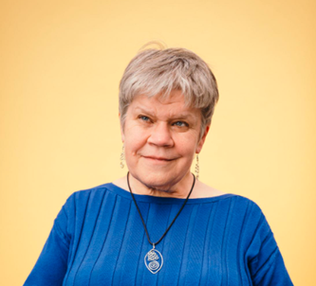

In September I was honored to join a national panel, sponsored by VisionServe Alliance, on fostering cultures of diversity, equity, inclusion and accessibility in our organizations. Inclusion has been a core value at the Council for many years. We know that vision loss impacts people across racial identities, gender, sexual orientation, geographic location and economic statuses. We strive to practice this value of inclusion in active and engaging ways to encourage and support people in connecting with the Council as clients, donors, volunteers, board members and staff. We also know that vision loss and other disabilities are aspects of diversity often overlooked in the bigger diversity, equity and inclusion (DEI) conversation, and have been striving to heighten awareness in our ongoing education efforts.
My remarks during the panel centered on what it takes to nurture a robust culture of inclusion. While I touched on about a dozen points, perhaps the most important is to know your “why.” We know that vision loss can impact anyone, but certain groups are more likely than others to experience it. African Americans are three times more likely to experience vision loss than people who are white, and women are more likely than men to lose their vision. Often these groups face barriers to healthcare information, and may not know about vision rehabilitation services or may be hesitant to reach out. It is therefore imperative for the Council to be thoughtful and strategic in our outreach efforts to build connection and trust among diverse communities. We know first-hand the life-changing impact and improved quality of life that vision rehabilitation, orientation and mobility, low vision and access technology training can bring, and we believe that everyone deserves opportunities to develop these skills.
While ensuring that our services are available to diverse populations, another part of our “why” is ensuring that people with vision loss are included in the many places we visit, work and play, including online. It’s why we’ve added the “A” for accessibility when talking about our diversity, equity, inclusion and access (DEIA) efforts. Through our education and advocacy work, we’ve increased the Council’s “footprint” with more people outside of the blindness community connecting with us. We partner with other organizations on transportation, pedestrian safety and voting access. We advise museums, theaters, nature centers and other community places on modifications to enhance inclusion of visitors with vision loss. And we demonstrate web accessibility with other organizations to encourage them to create access for all.
You can learn more about how we weave our DEIA into our day-to-day work by following our weekly emails. If you are not already subscribed, you can do so on our website at https://wcblind.org/news/newsletter-signup.
We recognize that nurturing a culture of inclusion is a process and will be one that the Council will need to remain engaged with for many years to come.

Council Friends: Making an Enormous Difference with Their Generous Support

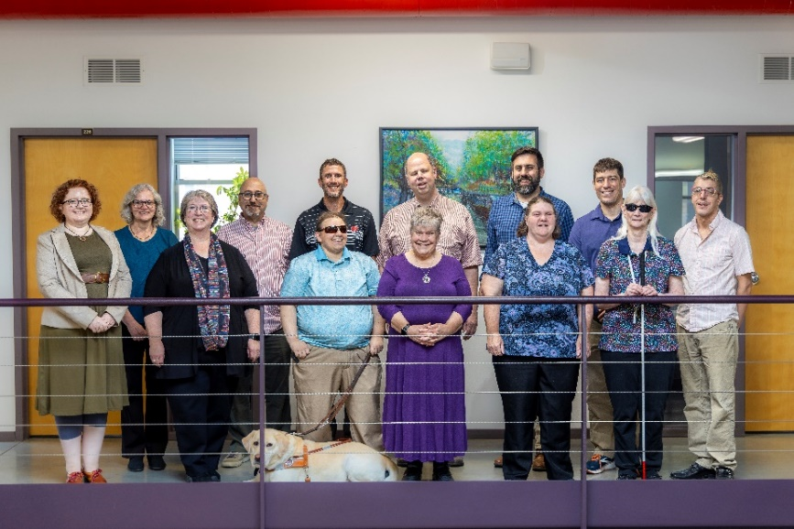
Staff of the Wisconsin Council of the Blind & Visually Impaired

There are many ways your financial gifts help the Council do its work. Donations help provide training sessions with a certified rehabilitation therapist to learn tips for cooking, daily living tasks and home safety. Support dollars also put necessary items like white canes into the hands of clients and even help make Council events like our popular Gallery Night possible.

There are also many ways to give to the Council. Monthly gifts, memorial donations, and different versions of workplace giving to name a few. This month, the Council gives a big shout out to donors who have become Council Friends. Council Friends are supporters who give a total of $500 to the Council in a calendar year. The list of Friends grows every year. Current membership is 62, with many members of this donor recognition club having participated for 15 to 20 years.

“Donors who support the Council consistently are incredible gifts to us,” says Fund Development Director Lori Werbeckes. “We value their financial contributions, of course, and we value their dedication to making vision services and educational resources available to anyone with vision loss.”

For some donors, it’s the Council’s dedicated, highly skilled staff that motivates them to become Friends. “Council staff are so knowledgeable,” says donor and Vision Services client Jeff Williamson. “Talking with people there tended to ease the pain a great deal,” he says. “You’re losing an important part of your life, but there are lots of other things left and they tell you that you can press on.”

The Council’s work caught Waukesha resident John Ladwig‘s attention not long after his diagnosis with Type I diabetes. “I quickly became concerned about my teeth and my eyes,” he says. The first time he laid his hands on Council literature at a booth at the State Fair, he knew he had found an ally. “The more I looked, the more I got involved with reading Council articles and learning,” he remembers. Soon, he began to give to the Council.

“I’ve been able to increase my contributions over time,” John says, adding that he appreciates the Council’s relationship-based approach to fundraising. “They’re not pushy,” he says. But first and foremost, John appreciates the breadth of work the Council does and, he encourages others to join the Council Friends to support that work. “Their money is really going to make a difference,” he says. “It’s applied directly to the people it’s going to help.”

Council Friends can make their gift in a lump sum or cumulatively over the calendar year. To join Jeff, John and other Council Friends, use the enclosed envelope or make your gift online at WCBlind.org/Donate. If you have questions, call Lori Werbeckes at 608-237-8114 or email her at LWerbeckes@WCBlind.org.

Staying Active Safely When the Weather Outside is Frightful
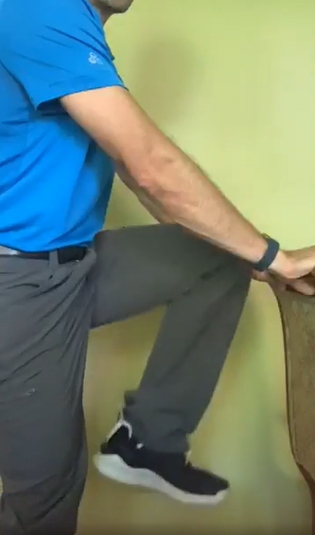
The Council’s Brent Perzentka demonstrates indoor chair exercises.
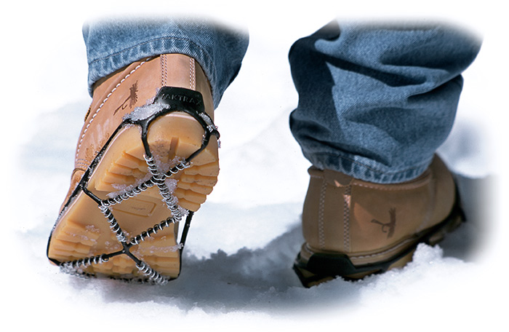
Yaktrax

Winter in the upper Midwest can be a daunting season. Icy sidewalks, freezing temperatures and early darkness are just a few of the factors that can overwhelm a desire to get outside and move. Even a short walk, without the right preparation, can get dicey. In wintertime, “one block can vary greatly from the next,” says Brent Perzentka, Certified Vision Rehabilitation Therapist and Certified Orientation and Mobility Specialist at the Council.
Winter conditions can make it harder for a person with vision loss to keep a straight line. A stretch of sidewalk may be clear in front of one house only to disappear beneath layers of snow and ice in front of the next one. Snowplows sometimes bury crosswalks beneath high piles. Even when a crosswalk is well shoveled, the openings on opposite sides of the street may not be aligned.
All of that said, for all the hazards that accompany the great outdoors in winter, the right kind of preparation can make you feel safe and gain the confidence to head outside and embrace the season. For example, Brent says precipitation, particularly snowfall, dampens the sound vibrations people with vision loss use in dry conditions to maintain their bearings. This requires cane travelers to be more focused sonically. “Snow tends to distort sounds,” Brent says. “For somebody who relies on sound, that’s one effect wet and snow can have.”
Brent recommends that cane users combine tapping with constant contact on the sidewalk during poor winter conditions. “If the snow accumulates, that really throws a wrench into someone’s travel, especially with a cane because you’re losing that tactile information,” he says. “Paths break away and reappear.” To deal with that, Brent recommends using a heavier cane with a smaller tip after snowfall. The heft of the cane combined with the smaller tip can help cut through the snow.
Brent has more tips to help you be prepared:
- Wear layers. While winter clothes keep a person warm, they can also create unsafe walking conditions for a person with vision loss, so choose wisely. A heavy overcoat can limit cane movement. Make sure you can hear well enough through a hat that covers your ears, and be careful that your gloves don’t mute tactile information from your cane tip too much.
- When choosing footwear, grip is essential. The Council’s Sharper Vision Store sells Yaktrax, a product designed to stretch over the bottom of your shoes or boots to provide extra traction when walking on slippery surfaces.
- The store also carries a wide assortment of sunglasses that can help cut winter glare, making it easier to navigate snowy, icy landscapes.
- Take shorter steps in icy conditions, and keep your knees slightly bent to improve balance.
- Plan ahead. Schedule public transit and ride shares early because they may run late due to the weather.
- Stay focused! Brent warns that poor winter walking conditions can narrow attention down to more of a step-by-step level at the expense of general orientation and knowing where one is on their route.
Of course, when the weather is really bad, it’s impossible to spend a lot of time outdoors. Sometimes you need to find ways to stay active inside. Brent recommends finding ways to keep walking indoors. “If you live in an apartment walk the hallways,” he suggests. “Or walk in place at home.” If you can afford one, buying a treadmill, elliptical or stationary bike is a good investment, as can joining a health club if you have access to transportation. And many apartment buildings, condos and senior residences have fitness rooms, so it’s a good idea to check whether there’s a free exercise option just down the hall.
Sun Prairie resident Rachel Iselin has turned her residence into her very own fitness club. “I have an apartment building that’s three floors,” she explains. “Walking all three floors adds up to about a mile.” How does she know? Rachel wears a watch that counts her steps and reminds her when it’s time to get up and move.
Cindy Walsh is another Sun Prairie senior who has great advice for people trying to get started with winter activities. Cindy advises people to connect with resources around them. “There’s so many,” she says. “And move! They don’t have to be big moves.” She says even spending time taking care of houseplants keeps movement in her day. Cindy and her husband George even have a fun ping-pong rivalry going, using a net set up on a downstairs table. Who’s the champion? “We’re actually pretty evenly matched,” Cindy says.

For people who may not have the space at home to walk or exercise, joining a virtual health club or following a fitness website might be an option. For example, Better5.com is an online health destination with a five-point mission: physical health, mental health, purpose, social connections and independence.
Each of those five points is a critical component of overall wellness, and each are harder to take care of during the winter. Staying active is one of the best strategies for keeping your body, mind and soul healthy when the weather outside gets frightful.

Spreading the Word about NLS Braille eReader Program

HumanWare braille eReader

As part of a national network cooperating with the National Library Service for the Blind and Print Disabled (NLS), the Wisconsin Talking Book and Braille Library (WTBBL) provides audiobooks and braille materials to Wisconsin residents who cannot use regular print materials due to temporary or permanent visual or physical limitations. WTBBL also circulates audiobooks and braille materials about Wisconsin or by Wisconsin authors, as well as audio-described DVDs.

In addition to providing materials, WTBBL also sponsors a book club that meets every other month. Access Technology Specialist Jim Denham of the Council is a member of the NLS Reading Technology Advisory Group. This fall, he spoke to the book club about the braille eReaders NLS recently began offering to patrons. In his presentation, Jim provided an overview of the NLS-provided eReader, along with basic information about how to use it with NLS services.

“The NLS braille eReader is a device that’s available on a free, permanent loan basis,” Jim says. “It’s for braille users who want to access braille materials digitally. And it’s really a tremendous program because it puts braille into the hands of people who have been wanting to access braille for a long time.”

In his presentation, Jim emphasized the convenience of braille eReaders compared to mailing physical materials back and forth, the traditional method of accessing NLS materials. He demonstrated how to operate the devices and how to troubleshoot problems. A robust question and answer session followed his talk.

The eReaders are available to any WTBBL patron who is familiar with braille. The Council can provide fee-based training on the device, which Jim says is extremely portable, fitting into a pocket or personal bag with ease.

Jim closed his presentation with a full endorsement of the technology. “I really recommend getting one,” he said. Jim added that NLS has done a lot of work to make the devices widely available. “The fact that we can get a free braille display into our house and use it to access materials is pretty impressive.”

Wisconsin residents can access NLS services through the WTBBL. You can find eligibility and application information online at https://dpi.wi.gov/talkingbooks. You can also learn more about the NLS braille eReader program or sign up for instruction on the device by calling the Council at 608-255-1166 or emailing Jim at JDenham@WCBlind.org.

Upcoming Events

The Big Share, March 5

Join the Council on Tuesday, March 5 for the 10th anniversary of The Big Share, a day of online giving hosted by Community Shares of Wisconsin. Mark your calendar for this opportunity to make a difference for people living with vision loss in Wisconsin.

2024 Council Scholarship Applications

Wisconsin students who are blind or visually impaired are invited to apply for a scholarship from the Wisconsin Council of the Blind & Visually Impaired. Scholarships are available for postsecondary students attending a two-year college, technical college, four-year university or graduate program. The application period will open in February, with completed applications due in mid-March.

Advocacy Days

Plan to join us in April for the Council’s 2024 Advocacy Days. Advocacy Days will provide opportunities to better understand the legislative process and learn how you can help advance the Council’s policy priorities.

Back Page

Did you know that the Council Courier is also available in braille and audio formats? To request an alternative format or update your mailing address, call us at 608-255-1166.

The Council also publishes weekly e-newsletters that include features, helpful tips, advocacy information, upcoming events and more. You can subscribe at WCBlind.org/newsletter-signup.

Contact Us
754 Williamson St.
Madison, WI 53703
WCBlind.org
Info@WCBlind.org
608-255-1166
800-783-5213

