Pedestrian Safety: A Toolkit for Advocates

Introduction
Pedestrian safety is a crucial issue for all Wisconsinites. After all, everybody is a pedestrian some of the time. But for the 31% of state residents who do not drive, including those who are blind or low vision, pedestrian safety is even more critical—it’s literally a matter of life and death.
There are many measures communities can take to become safer and more welcoming for nondrivers and other pedestrians. But sometimes community leaders need a nudge from community members like you to take the necessary steps.
Whether you are new to advocacy or a seasoned veteran, this toolkit will provide you with some of the skills and knowledge you need to take your pedestrian safety advocacy to the next level.

Key Infrastructure Features that Promote
Pedestrian Safety
These are a few of the measures communities can take that have proven impact:

Accessible Pedestrian Signals
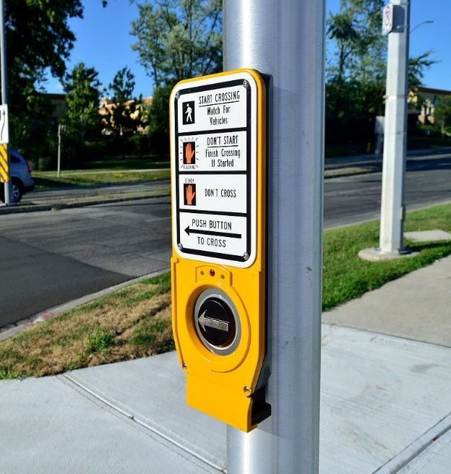
• Crossing the street, especially at unsignalized intersections, is one of the greatest risks travelers with vision loss face.
• Accessible pedestrian signals at intersections with traffic lights give pedestrians audio and tactile guidance informing them that it is their turn to cross. The audio information also includes the street name.
• Blinking signals at intersections without traffic lights provide audio and tactile feedback informing the pedestrian that the signal is activated, while flashing lights alert drivers that somebody is trying to cross the street.
- Another advocacy point is to have the sounds made by the signals be as consistent as possible within a community. Some signals, depending on their style, age, and when they were installed, give verbal information in English and sometimes Spanish, while others may just beep or click.

Curb Ramps

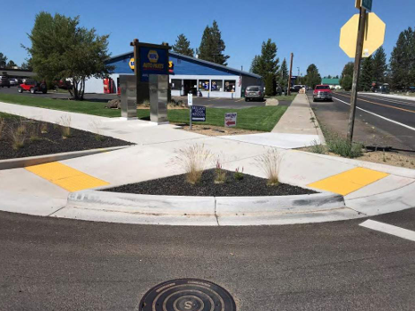

• Curb ramps provide a safe transition from the sidewalk into the street when crossing.
• Correctly placed curb ramps help align the pedestrian with the crosswalk.
• Effective curb ramps contrast in color to the sidewalk and street and are textured to provide tactile feedback. These tactile features, called tactile warning fields, are specially designed for blind and low vision pedestrians to help guide direction of travel.
• Ramps should be in place at all corners of the intersection. There are some allowable exceptions due to space constraints.

Continental Crosswalks
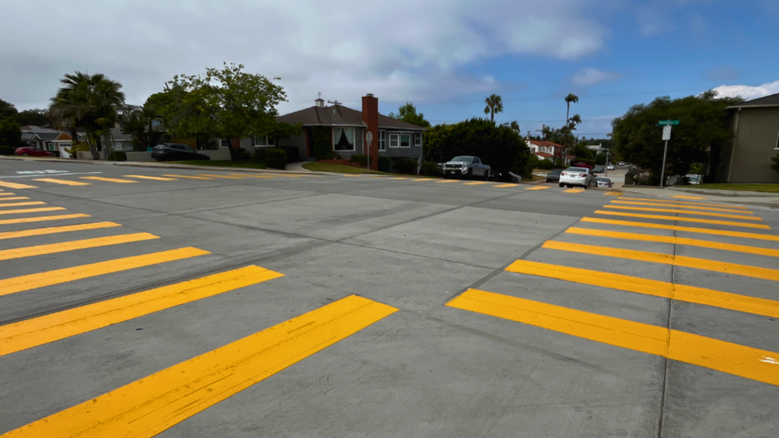
- Sometimes called “zebra striping,” these have stripes painted in the crosswalk that run perpendicular to the standard crosswalk lines.
- This increases visibility for drivers, calling their attention to the crosswalk and increasing the likelihood of a pedestrian being seen.

Bump-Outs
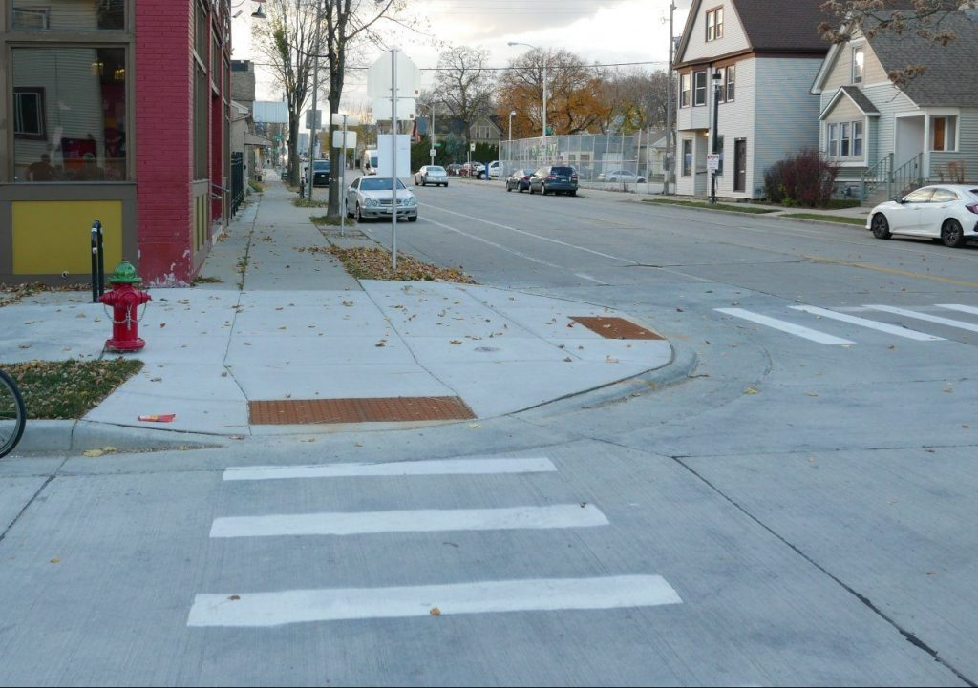
- Bump-outs, also known as bulb-outs or curb extensions, are extension of the sidewalk into the roadway at intersections or mid-block.
- Bump-outs shorten the crossing distance and decrease the time a pedestrian spends in the roadway.
- They enhances the visibility of pedestrians for drivers.

Connected Sidewalk Network
- This concept transforms our thinking about sidewalks from block thinking to a connected network, much like connected roadways.
- Connected sidewalk networks do what their name implies. Someone can use the sidewalk to travel from Point A to Point B without having to walk in the street or cross the street unnecessarily to find a sidewalk
- Connected sidewalks are shown to significantly reduce pedestrian related crashes.

Advocacy Tools

Three-Part Formula for Effective Advocacy
Regardless of the specific issue, this combination of elements has proven to be most effective when urging local decision-makers to take action
- Data and research: This might include things like the number/percentage of nondrivers and/or people with vision loss.
- Compelling story: First-person stories about your lived experience are the strongest. Connect your story to the wider impacted group. If it’s reasonable, you may even be able to connect it to the policymaker you’re talking to.
- Tangible and impactful request: Be concrete and specific. Talk about how your request will bring about positive change. Say what you want, not what you don’t want. It’s okay to offer a bold, innovative solution as long as it is practical

Where to Aim Your Advocacy
It’s not always obvious who you should talk to about the change you are seeking. The first step in advocacy for a safety feature is to find out who owns the roadway in question. Is it a state highway? A county road? A city street? Often the only way to find out is to call the appropriate departments at the various levels of government.

Policymaker Meetings and Phone Calls
While talking to a state legislator or municipal council member can feel intimidating, remember that they are just ordinary people who may even be your neighbors. They are generally happy to have a conversation with a constituent. But it’s important not to waste their time! Be prepared for your meeting or phone call with good information and a strong understanding of the issue you want to discuss.

D. Legal Tools You Can Leverage
- ADA Transition Plan: The Wisconsin Department of Transportation (WisDOT) and municipalities with more than 50 employees are required to develop a plan indicating how they intend to make progress on the transportation goals outlined in the Americans with Disabilities Act (ADA). These plans must be updated each year.
- PROWAG: The Public Right-of-Way Accessibility Guidelines, or PROWAG, are a set of technical guidelines developed by the U.S. Access Board to ensure public streets and sidewalks are accessible to people with disabilities. A new, stronger version of PROWAG has been developed and is awaiting approval from the U.S. Department of Justice

Pedestrian Safety Month
Pedestrian safety is a year-round issue, but October is a particularly good month to advocate for these kinds of changes. That’s because October is recognized across America as Pedestrian Safety Month, so you can coordinate with many other individuals and groups who will be speaking up for pedestrian safety at the same time.
- Proclamations: Ask your local municipal leaders to issue a proclamation recognizing October as Pedestrian Safety Month. Provide them with sample language outlining steps your community can take to promote pedestrian safety

Sample proclamation:

WHEREAS, safe, accessible streets are essential for the well-being of all residents, including children, older adults, and people with disabilities; and
WHEREAS, thousands of Wisconsinites, including over 100,000 with vision loss, rely on sidewalks, curb ramps, accessible pedestrian signals, white canes, and service animals to navigate public spaces safely; and
WHEREAS, Wisconsin’s White Cane Law requires drivers to stop at least 10 feet from pedestrians using a white cane or service animal, reinforcing the need for driver awareness and pedestrian respect; and
WHEREAS, communities can reduce injuries and save lives by investing in proven pedestrian safety infrastructure such as high-visibility crosswalks, traffic calming, and accessible design; and
WHEREAS, raising awareness of pedestrian rights and responsibilities promotes a culture of safety and inclusion for all road users;
NOW, THEREFORE BE IT RESOLVED that, I, Mayor/Village President (NAME), on behalf of the residents of (CITY/VILLAGE) do hereby proclaim October as PEDESTRIAN SAFETY MONTH and (DAY) October 15, (YEAR) as WHITE CANE SAFETY DAY in (CITY/VILLAGE) and call on all residents, leaders, and lawmakers to prioritize safe, accessible streets year-round

(MAYOR/VILLAGE PRESIDENT)
Signed and sealed this (DATE)
at (CITY/VILLAGE) Hall

- Walk and Roll Audits: Find more information below under More Resources
- Media Outreach
Sample op-ed / letter to the editor:
October is a big month for pedestrian safety! The entire month is Pedestrian Safety Month and October 15 is White Cane Safety Day. Nearly a third of Wisconsin residents are nondrivers, and thousands of state residents who are blind or low vision use a white cane or guide dog to get around. Their safety is everyone’s responsibility!
White Cane Safety Day was first proclaimed by President Lyndon Johnson in 1964 as a way of raising awareness of statewide White Cane Laws. Wisconsin’s White Cane Law requires drivers to stop at least 10 feet from any pedestrian who is using a white cane or a guide dog. But it does more than that. By promoting greater driver awareness, the White Cane Law enhances the safety of all pedestrians. Pedestrian Safety Month is newer, established by the National highway Traffic Safety Administration in 2021.
Each year, Gov. Evers and municipal leaders across the state issue proclamations recognizing Pedestrian Safety Month and White Cane Safety Day. Proclamations are great, but there’s so much more that advocates can do. It’s important to urge leaders to put in place specific measures known to improve pedestrian safety. They include accessible pedestrian signals, bump outs, and curb ramps at all intersections. You can learn more about these and other safety features on the Pedestrian Safety Month and White Cane Safety Day page of the Wisconsin Council of the Blind & Visually Impaired website.
There are several ways people can get involved in making their community safer for pedestrians. Here are a few suggestions:
- Reach out to your local elected officials to request a Pedestrian Safety Month and/or White Cane Safety Day proclamation.
- Help your local officials understand your needs as a pedestrian. Some leaders may not be aware that pedestrian safety is a critical issue! You can help them better grasp the importance of good pedestrian infrastructure in enabling nondrivers to go about their daily lives safely.
Thank you for being an advocate for pedestrian safety in your community!

Sample press release:
For immediate release
Your contact information
Leaders Across Wisconsin Proclaim October Pedestrian Safety Month
October is a big month for pedestrian safety! The entire month is Pedestrian Safety Month and October 15 is White Cane Safety Day. Advocates across Wisconsin are taking this opportunity to encourage local leaders to implement changes that will make their community safer and more welcoming for pedestrians.
[Add quote about the impact of good pedestrian infrastructure in your community.]
Nearly a third of Wisconsin residents are nondrivers, and thousands of state residents who are blind or low vision use a white cane or guide dog to get around. Their safety is a shared responsibility.
White Cane Safety Day was first proclaimed by President Lyndon Johnson in 1964 as a way of raising awareness of statewide White Cane Laws. Wisconsin’s White Cane Law requires drivers to stop at least 10 feet from any pedestrian who is using a white cane or a guide dog. But it does more than that. By promoting greater driver awareness, the White Cane Law enhances the safety of all pedestrians. Pedestrian Safety Month is newer, established by the National highway Traffic Safety Administration in 2021. Each year, Gov. Evers and municipal leaders across the state issue proclamations recognizing these observances.
Across the state advocates are taking matters a step farther, urging leaders to put in place concrete measures known to improve pedestrian safety. They include accessible pedestrian signals, bump outs, and curb ramps at all intersections. More about these and other safety features is available on the Pedestrian Safety Month and White Cane Safety Day page of the Wisconsin Council of the Blind & Visually Impaired website.
###

- Social Media
Sample post
October is Pedestrian Safety Month, first launched by the National Highway Traffic Safety Administration in 2020 to promote ways to make our communities safer for non-drivers.
Everyone is a pedestrian some of the time, but for the 31% of Wisconsinites who do not drive, pedestrian safety is especially important.
Pedestrian Safety Month is a great time to talk to local local leaders about ways to make our communities safer and more welcoming for all pedestrians. Learn more at https://wcblind.org/events/pedestrian-safety-month-and-white-cane-safety-day/.

- Use these hashtags when posting about pedestrian safety and Pedestrian Safety Month:
#PedestrianSafety
#PedestrianSafetyMonth
- Follow the Council on social media and share our posts about pedestrian safety:
  - Facebook, Instagram and LinkedIn: @WCBlind
  - YouTube: @WCBlind1

More Resources
- Walk and Roll Audit: A walk and roll audit is an assessment of the walkability of a specific area. Using a free walk audit tool kit from AARP, you can invite local elected officials and other community leaders to accompany you on a walk and roll audit to demonstrate where there are hazards and how pedestrian safety features can improve the lives of non-drivers. https://www.aarp.org/livable-communities/getting-around/aarp-walk-audit-tool-kit-english.html
- America Walks: America Walks equips organizations and individuals from across the country with the resources to create more walkable, safer communities for people of all ages and abilities. Whether it’s assisting a small town in building sidewalks or advocating for changes in highway construction policies, they collaborate with people from all walks of life to enhance their neighborhoods and ensure that everyone benefits. https://americawalks.org
- Strong Towns: Strong Towns seeks to replace America’s post-war pattern of development focusing on suburbs and cars with a pattern of development that is safer, more resilient, more inviting and more livable. https://www.strongtowns.org
- Vision Zero Network: The Vision Zero Network is a collaborative campaign to help communities reach the goal of eliminating all traffic fatalities and severe injuries while increasing safe, healthy, equitable mobility for all. https://visionzeronetwork.org



Founded in 1952, the Wisconsin Council of the Blind & Visually Impaired promotes the dignity and empowerment of people in Wisconsin who are blind or low vision through advocacy, education and vision services. To learn more about the Council, visit WCBlind.org.

Wisconsin Council of the Blind & Visually Impaired
754 Williamson St.
Madison, WI 53703
608-255-1166
Info@WCBlind.org

