Council Courier, Fall 2025

The Illusion of Free Services is Rooted in the History of Vision Rehabilitation
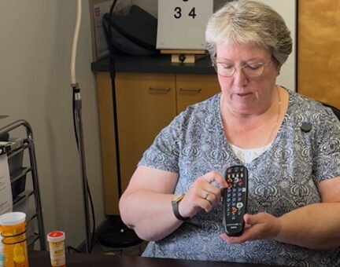
Certified Low Vision Therapist Amy Wurf demonstrating tactile labelling techniques using a television remote

The Council’s highly trained vision rehabilitation professionals empower people who are blind or low vision to live life on their own terms. They help clients gain the skills to navigate safely through their community, use access technology to land a job, use magnification to read prescription labels, and much more.

But throughout its history, vision rehabilitation has been undervalued by society, particularly by the medical establishment. When modern vision services began, this vital work was done for little to no pay, performed mostly by women who were themselves blind or low vision and seen more as mutual aid than as a true profession.

As an unfortunate result, the idea that vision rehab should be a “free” service has persisted to this day in some circles, even as its practitioners have become highly trained professionals with advanced skills and hard-earned credentials.

The Roots of Vision Rehab

Vision rehabilitation as we know it today began in America in 1882 at the Philadelphia School of the Blind. This work was done through “home teaching,” where blind workers, mostly women, would travel to the homes of people with vision loss to teach them how to live independently. There was no textbook or set of standards guiding what was taught. Instead, these skills were passed down from teacher to teacher as a form of mutual aid for other people with vision loss. Home teachers taught everything from braille to daily living skills to crafts, but also took on extra duties similar to those of a social worker, such as case work and counseling.

From the start, this work was severely undervalued. Most women could expect to be paid just $1 a day for their work and had to travel with sighted guides paid for out of their own pockets. It wasn’t until the 1930s, when two member organizations—the American Foundation for the Blind (AFB) and the American Association of Workers for the Blind (AAWB)—met to set nationalized standards for home teachers and vision rehabilitators, marking the beginning of formalized training.

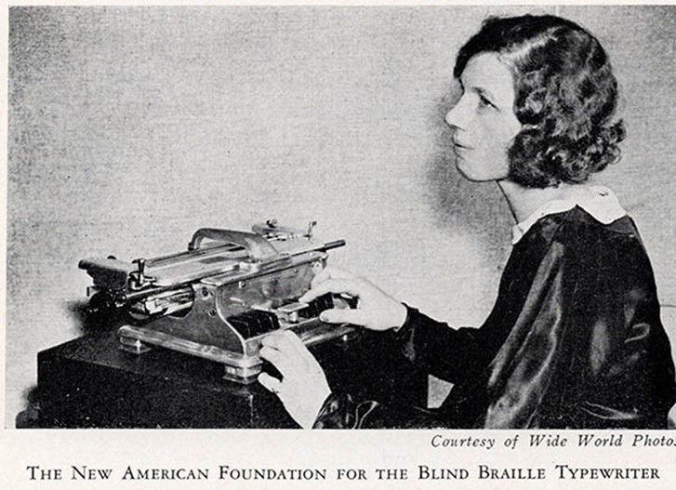
An ad for a braille typewriter designed by AFB to expand employment opportunities.

Standards were first put forward in 1941 and included both two-year and four-year instruction. For the first time, vision rehabilitation specialists had a curriculum to follow to ensure that people were receiving adequate services. Over the following decades, these standards were refined to better serve the needs of people who were blind or low vision across the country.

When veterans began returning home from World War II with vision loss, the federal Veterans Administration (VA) started training their staff in orientation and mobility (O&M) instruction. In 1959 the VA and AFB met to begin establishing university training programs for blind rehabilitation. Western Michigan University (WMU) offered the nation’s first university-based training program in vision rehabilitation in 1963, and soon both Boston College and WMU began the first formal university level O&M training programs. Other universities followed.

More than 50 years later, these certifications are still in use today, though they have gone through countless updates since then. Certifications exist today for many professions in the blind and low vision field, including Certified Low Vision Therapist, Certified Vision Rehabilitation Therapist, Certified Orientation and Mobility Specialist, Certified Assistive Technology Instructional Specialist and Certified Deafblind Intervenor Specialist. Those who graduate from these programs must take a competency exam to establish that they are qualified to provide high-quality service and must engage in continued education and recertification every two to five years, depending on their specialty.

Unfortunate Consequences of History

But this history of undervalued labor brings consequences that we still see today. Vision rehabilitation services provided outside of a medical environment are still not covered by Medicaid, Medicare or most other insurance. Starting wages for new vision rehabilitation specialists remain extremely low, averaging around just $30,000 a year, contributing to a severe shortage of qualified providers. Universities are not offering new programs to train vision rehabilitation professionals, and many people are unaware that these professions exist. As a result, there are not enough new qualified professionals being trained to replace those who retire.

The Hidden Costs of Providing Vision Services

The Council will never turn away a client due to their inability to pay. But the fact that vision services have historically been available at no cost masks the fact that providing these services carries significant expenses. That’s why the Council asks those who are able to pay to do so. While those fees do not cover the full cost of our services, they help enable us to continue serving all clients regardless of their financial situation.

Like for-profit corporations, nonprofits have many overhead expenses. Last year, our total expenses amounted to over $1.6 million! That includes things like building upkeep, utilities, office supplies, staff salaries and everything else an organization needs to operate.
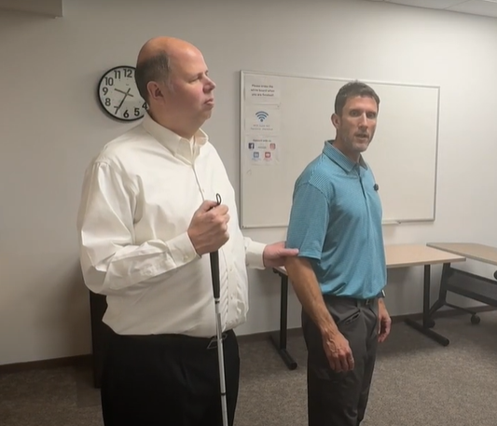
Certified Orientation and Mobility Specialist Brent Perzentka (right) demonstrating human guide technique with the help of Access Technology Specialist Jim Denham.

The vision services professionals at the Council are all highly trained and certified, and acquiring their skills entailed a significant financial investment. Members of our vision services team have all earned a master’s degree or the equivalent, and they must pursue continuing education to retain their certification. The Council honors that investment by offering competitive salaries.

It's also important to recognize that the Council is not just made up of vision services professionals. A robust, wide-ranging organization like the Council requires a full complement of professionals working in tandem to achieve all parts of our mission. Then there are administrative and insurance costs to take care of, and we must maintain reserves to ensure that the Council can stay afloat in the event of unexpected reductions in our revenue.

The state’s Office for the Blind and Visually Impaired (OBVI) does not directly charge their clients for vision services, but they receive funding from the federal government, along with a 10% match from the state, to serve Wisconsin residents. So while clients do not pay OBVI for services, taxpayer dollars are footing the bill. The Council, on the other hand, does not receive government funding. We rely on grants and donations to cover most of our costs, and those funding sources alone are not sufficient to keep our doors open.

The Council works hard to keep our costs down. We use a sliding fee scale to accommodate clients with limited income. In the Sharper Vision Store, we keep our profit margins well below the average for retail stores. The store also carries some used or donated items priced significantly lower than new ones.

We understand that many of the Council’s expenses are invisible to our clients. But obvious or not, providing these services comes with a cost. That’s why the idea that our services are free, rooted in the history of vision services, is an illusion. We appreciate everyone who supports the Council in whatever way that they are able so that we can continue to serve every client who comes our way.

Message from Executive Director Denise Jess
Promoting Pedestrian Safety for All by Building on Our White Cane Safety Day Message

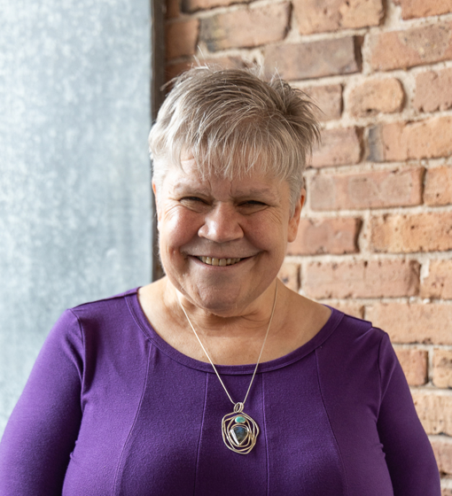

White Cane Safety Day is a hallmark among people who are blind or low vision. Organizations around the country recognize the day to promote the inherent worth of those of us with vision loss, educating our communities about blindness and the importance of the White Cane Law. The Council has been proud to raise awareness in communities around the state by encouraging elected officials to issue White Cane Safety Day proclamations. In 2024, the State of Wisconsin, the County of Milwaukee and thirty-eight municipalities formally proclaimed October 15 White Cane Safety Day. Council board and staff members attended several city council meetings around the state to receive proclamations, taking the opportunity to speak about the importance of the day for blind and low vision pedestrians.

Over the past few years, we have woven a broader message of pedestrian safety into our White Cane Safety Day advocacy. We know that driver adherence to the White Cane Law is critical for our safety, with drivers stopping at least ten feet from a pedestrian using a white cane or a service animal while crossing a roadway. But our safety is dependent on so much more than just that individual driver’s behavior. How our streets and roads are constructed, known as infrastructure, can make a world of difference in promoting pedestrian safety and reminding drivers that others use the roadways too. That includes things like a connected sidewalk network, where we can walk to our destinations without having to walk in the road or make unnecessary street crossings; accessible pedestrian signals to give both auditory and tactile information about when it’s safe to cross the street; curb ramps placed in the direction of travel so that we enter the street lined up to cross within the crosswalk; tactile warning fields at those curb ramps, giving us further directional information; and reducing speed limits to help drivers better maintain control of their vehicles. These street features, and others, promote universal design, with benefit to all pedestrians. They decrease the severity of car vs. pedestrian crashes and reduce the number of deaths and serious injuries.

In 2020 the U.S. Department of Transportation named October as National Pedestrian Safety Month at a time when crashes involving pedestrians and bicyclists were on the rise. Advocacy efforts were ramped up to educate drivers on their responsibilities and encourage public officials to build streets and roads that were accessible and safe for all users. Here at the Council, we saw the declaration of Pedestrian Safety Month as an excellent opportunity to build on our White Cane Safety Day messaging by incorporating other elements of pedestrian safety while still honoring and calling attention to the White Cane Law. While White Cane Safety Day proclamations are a great awareness tool, they are only one of the tools needed to make our roads and streets safe. We need our community leaders to create roads and streets that are safe for all. A wider pedestrian safety message is also more inclusive, inviting other pedestrians to join the effort, strengthening our voices, resources and impact.

This year our Pedestrian Safety Month advocacy includes those White Cane Safety Day proclamations, the creation of a pedestrian safety toolkit for advocates and community leaders, and supporting advocates to reach out to elected officials in their communities to work together to create safer streets for all.

Visit https://wcblind.org/events/pedestrian-safety-month-and-white-cane-safety-day to learn more about how you can get involved.

Monthly Giving is a Subscription to Support People with Vision Loss
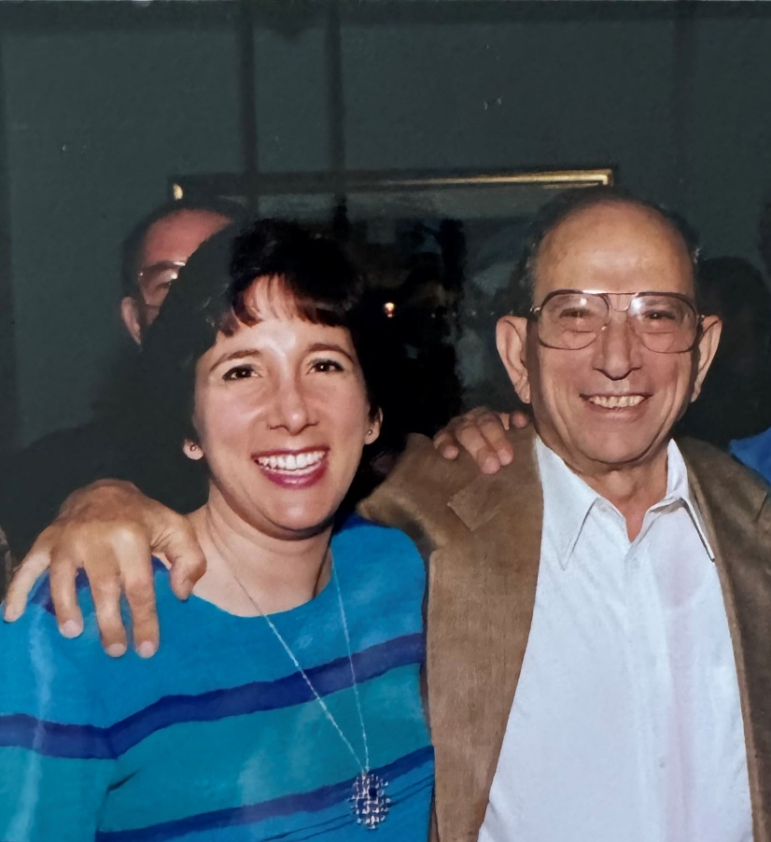
Maria Heide and her father, Pete Papas on Pete’s 70th birthday in 1998.

These days, many of us subscribe to multiple online services like Netflix, Spotify, Audible and others. We pay for these services every month, but we rarely have to think about it because the payments happen automatically. You can do something similar with your support for the Council by joining our White Cane Circle and making monthly gifts to promote the independence and dignity of people across Wisconsin who are blind or low vision.

A recurring gift to the Council is becoming an increasingly popular way for our donors to give. Sustained giving can be automated, making it one of the easiest ways to support our work. Making a smaller gift every month is also easier on your pocketbook while amounting to a larger gift when added up at the end of the year. Monthly donors are also important to the Council because they provide us with income we can count on throughout the year.

No matter the amount, your monthly gift to the Council can help support the Council year-round. A gift of just $10 every month totals $120 by the end of the year, which can help pay for two hour-long access technology classes for someone entering the job market. Giving $20 a month, or $240 for the year, can cover the cost of three orientation and mobility lessons to help someone learn to move safely around their home and community. A gift of $35 per month will enable the Council to provide 12 white canes at no cost to the users over the course of the year. However much you decide to give, you can be confident that your gift is helping bring important services to people in your own community.

People give to the Council for many different reasons. Maria Heide started donating through a workplace giving campaign but has moved to monthly giving in recent years. Maria has known several people with vision loss throughout her life, including her father. “When he was first diagnosed with macular degeneration in the 80s, he didn’t have all of the technology that’s now available to help people with vision loss,” Maria says. “It’s nice to see how things have changed and how the field is growing. The Council is doing great work in enabling people to continue to live their lives after losing their vision.” Maria’s support for the Council also honors her colleague, Neil Ford, who served on our Board of Directors.

The 75th anniversary of the Council’s founding is only two years away, and our goal is to have 75 monthly donors support the Council year-round by that time. If you’d like to join our White Cane Circle, contact Development Director Lori Werbeckes at 608-237-8114 to set up your monthly gift. You can also indicate that you’d like to set up a monthly gift on the envelope enclosed in this issue of the Council Courier newsletter. To give to the Council online, visit WCBlind.org/Donate. Thank you for your support!

Addition of Navigator Role Enhances Council’s Approach to Meeting Client Needs

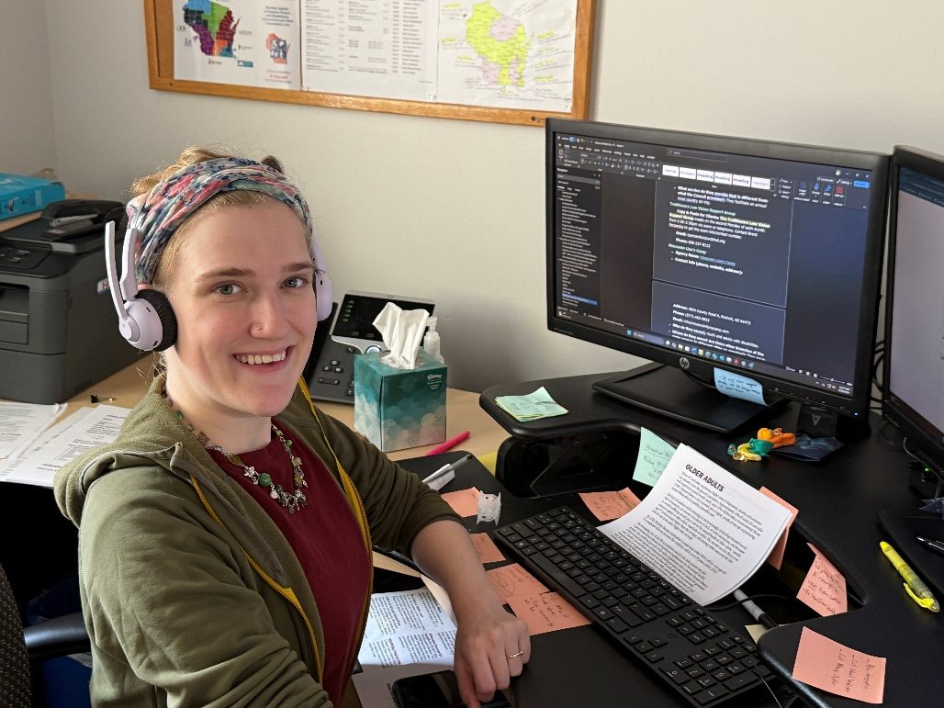
Vision Services Navigator Kate Bleyl-Ericson

For decades, people have been coming to the Council in search of vision services to help them stay as independent as possible. But there are times when our Vision Services team meets with someone and finds they have greater needs than we can address. It’s not uncommon for our team to discover that a client is facing food insecurity, imminent eviction from their home, or other issues we are not properly equipped to help with. People who are blind or low vision have high rates of poverty and unemployment and are more likely to experience negative health outcomes than people without vision loss, which can contribute to those challenges.

To address these unmet needs, the Council hired Kate Bleyl-Ericson earlier this year to fill the newly created position of vision services navigator. The navigator provides a more person-centered experience for those reaching out to the Council, enabling our team to gain a fuller understanding of how we can best support the individual.

“The navigator position is really a broadening and deepening of our services,” says Education & Vision Services Director Amy Wurf. “New clients and some existing clients go through an intake process so we can better understand the needs of the entire person.”

While we had a short intake process before, our intakes are now more comprehensive and explore the entire lives of our clients. The process begins with questions about vision, but also includes demographic questions and more general questions about the client’s quality of life. If the client has additional needs that the Council cannot address adequately, Kate can help them find the right services for their needs. Kate has developed a comprehensive directory of resources and organizations available for a variety of needs the client may have. Using this directory, Kate can pick the best options available to address the client’s needs. When Kate is not conducting intakes, they’re talking with these organizations to create connections and build a deeper knowledge of how their services can help our clients.

So far, Kate says that outside of vision services, the biggest needs that come up are food insecurity, isolation and transportation. “It can be hard to know what you need when you’re facing more than one hardship at one time,” Kate says. “My job is to help people identify what they need and to point them toward the resources they need to address those needs, whether that’s within or outside the Council.”

Kate is also gathering important demographic information to help us better understand the population we serve and which communities we need to work harder to reach. This data includes things like the client’s age, gender, racial and ethnic backgrounds and income levels.

The addition of the navigator role is also benefitting other members of the Vision Services team, who no longer have to conduct intakes themselves and can focus more of their attention on providing the services they specialize in. “We aren’t really trained to know exactly how to help people facing things like food insecurity,” Amy says. “Kate is trained in knowing where someone should go to get services. Now, we can get right to providing training to people to help them live their lives safely and independently.”

Most importantly, the navigator is making a major difference in the lives of our clients. Madison resident Dawn Rhodes originally reached out to the Council to inquire about magnifiers but was also interested in vision rehabilitation therapy to live more independently in her home. During the intake process, Kate discovered that Dawn could also benefit from other services available in Dane County. Kate worked with Dawn to connect her with a food pantry that can deliver food directly to her door. Dawn was also made aware of other local disability advocacy groups. “Kate’s been very good about showing me all these different programs,” Dawn says. “Kate has helped me find new ways to be proactive in the community. They’ve been fantastic and have a great attitude!”

We are excited to see how the addition of the navigator role continues to improve our ability to address our clients’ needs as comprehensively as possible.

2025 Council Scholarship Recipients Include Both New and Returning Faces

For much of the Council’s history, we have provided scholarships to students who are blind or low vision to support their postsecondary education and career goals. This year we awarded $2,000 scholarships to four students from all corners of Wisconsin. Our 2025 recipients included both new faces who are just beginning their college journey and returning students completing master’s degree programs.

Living in Pleasant Prairie and unable to get a driver’s license because of her low vision, Alyson Dahl says she has had to rely on family to get her to where she needs to go most of the time. That motivated her to apply for college somewhere more friendly to pedestrians than the suburbs, and there are few places better suited for nondrivers than New York City. Alyson is attending New York University (NYU) this fall with the intention of getting on the school’s pre-med track.

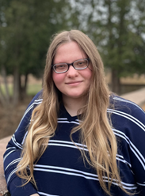
Alyson Dahl

Alyson’s goal is to eventually make it to medical school to study adolescent medicine. As someone who has experienced health issues herself throughout high school, she says joining NYU’s prestigious medical program felt personal. “It took a while for them to diagnose my condition, and that whole experience was so draining,” Alyson says. “It made me really think about ways I could help other people who were in my shoes feel less stranded.”

Jasmine Bertschy is starting her second year at UW-Whitewater at Rock County, pursuing a degree in Psychology. Jasmine hopes to become a mental health counselor after finishing her undergraduate study and completing a master’s degree. As a young teen, Jasmine wanted to be a pediatrician. But after losing her vision, she decided on a different way to help kids. “I like being able to meet people one on one and help just by talking with them,” Jasmine says. “It’s encouraging to me that people can be helped in ways other than with x-rays and other medical tests.”

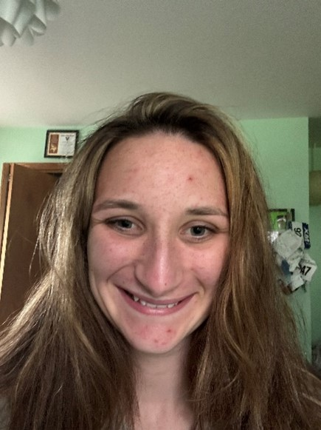
Jasmine Bertschy

Beyond getting good grades in her first year, Jasmine says she’s also gained confidence in herself. “When I lost my vision at 15, I didn’t think I would be able to do things on my own,” Jasmine says. “Realizing I can pursue a college degree and do things independently has really boosted my confidence.”

UW-Green Bay student Kaylee Mueller received her undergraduate degree in the spring and is staying in Green Bay this fall to work on a master’s in social work. While she’s certainly excited to start the next step in her education, she calls starting her master’s program both thrilling and terrifying. “I feel like I’ve crossed over to the next level of really being an adult,” Kaylee says. “I’m no longer someone they’re just helping out. Now I’m being seen as a real equal to the people I work with.”


Kaylee Mueller

As part of her master’s program, Kaylee will be working in the Student Access & Success office, where she’ll help new students cross the hurdle of finishing their first year of college. While she worked as a peer mentor as an undergrad, Kaylee will be taking on more responsibility this fall, overseeing those undergraduate peer mentors.


Mia Zutter

Mia Zutter is finishing her last semester at Northern Illinois University, where she’s earning a master’s degree in special education for visual disabilities. Mia plans to become a teacher of the visually impaired (TVI). Mia is wrapping up her education with some field experience at the Wisconsin School for the Blind and Visually Impaired in Janesville. “Growing up with vision loss and working so closely with my TVI, I sort of felt called to work within the blind and low vision community,” Mia says. “I had some trepidation about working around vision loss when I was young, because my life itself is tied up around vision loss. But I feel like I can use that experience to make a real difference.”

Mia’s first year at Northern Illinois University was not without trials. From apartment issues to trouble with her teaching placement, Mia realized she needed to ask for a little help. “My vision loss has made me a bit hyper-independent, because I need to rely on people for things like transportation all the time,” Mia says. “So learning when I need to ask for help has been a great thing for me.”

Congratulations to all of this year’s Council Scholarship recipients!

Wisconsin Talking Book and Braille Library to Roll Out New Talking Book Players

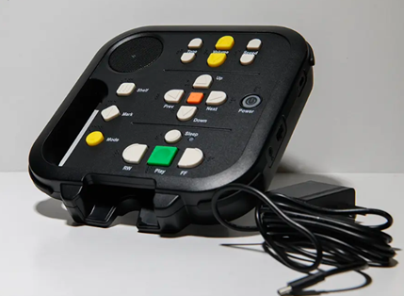

This fall, the Wisconsin Talking Book and Braille Library (WTBBL) is rolling out a new talking book machine. The Digital Advanced Player 2 (DA2) will still play the classic talking book cartridges, but they will also connect to the internet so you can download books directly from BARD to your device. The National Library Service for the Blind and Print Disabled (NLS) is sending the machines to WTBBL, which will then distribute them to Wisconsin program members. WTBBL will slowly phase out the old machines, but they will not take away your older model if you prefer to continue using that.

In addition to the ability to download books directly to your device, the DA2 has a few other new features. While they will still have a headphone jack, their on-board speaker is louder than that of the old machines. The buttons on the new machine will still have braille and high contrast labeling, but they have been rearranged in a way that should be more logical for users. Because you will need to log in to your BARD account if you want to download books from the internet, the DA2 has a port where you can plug in a computer keyboard so you can easily type in your account information.

While you can still use the cartridges mailed to you by WTBBL, downloading books allows you to listen to them right away instead of waiting for a cartridge to arrive in the mail. To download a book, turn on the DA2 and press the “Mode” button until you get to “NLS Collection.” From there, you can either search through their library on the machine or you can select a book from your wish list. Searching for a book through the machine itself can be cumbersome, so we recommend adding books to your wish list on your computer and then downloading them from the list on your machine.

WTBBL will have a limited number of DA2 machines to begin the rollout and will be getting more to replace the older models over the next year. If you have questions about the DA2, contact Certified Access Technology Specialist Jim Denham at JDenham@WCBlind.org or visit the WTBBL website at DPI.wi.gov/TalkingBooks.

Board Members Gather for Annual Retreat

In late August, our Board of Directors gathered at the Council offices in Madison for their annual retreat. Members spent the day discussing the Council's Plan of Work, the financial health of the organization, and various other governance and oversight topics. Our board is made up of people from across Wisconsin, both with and without vision loss, all of whom have a close connection to the blind and low vision community. It was great to have almost the entire board together in the building! We're grateful for their ongoing service and commitment to the Council's mission!

Upcoming Events

Pedestrian Safety Month/White Cane Safety Day

Throughout October, we celebrate Pedestrian Safety Month, an opportunity to promote the many measures communities can adopt to become safer and more welcoming to those who get around on foot. White Cane Safety Day, October 15, is an opportunity to raise awareness of White Cane laws that require drivers to stop for pedestrians using a white cane or guide dog.

Gallery Night
Our annual Gallery Night event showcases the work of artists with vision loss from around Wisconsin. This year’s event takes place Friday, November 7.

Fall 2025 Sharper Vision Store Featured Items
Be the talk of the water cooler with these adaptive office supplies!

Olympus Voice Recorder
With large, highly visible buttons and a front speaker for easy listening, this one-touch recorder allows you to power on and record in one motion. You’re ready to record in an instant! #CR440
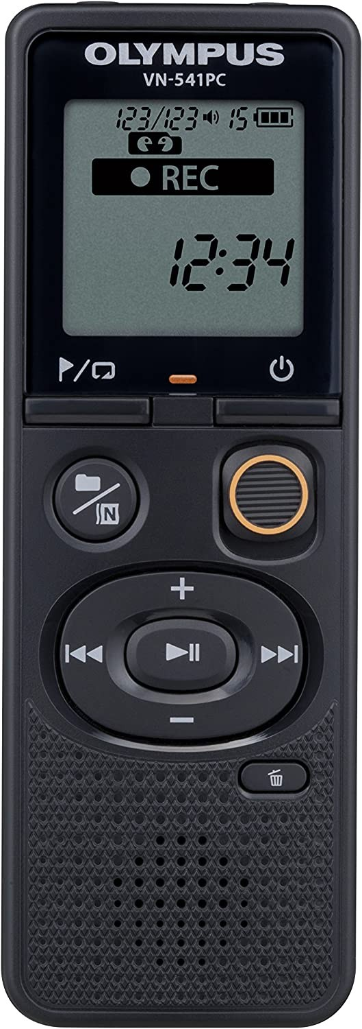

Wilson Digital Recorder
The Wilson™ Recorder is a simple to use digital recorder which can store up to 12 hours of recordings based on the selected recording quality. The buttons are on the front of the recorder. Users can pause while recording. #CR430
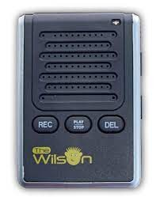
MULTI MEMO
The Multi Memo Voice Recorder Dictaphone offers six minutes of recording time. Ideal for speaking and listening activities and memory aid for independent living. #CR460
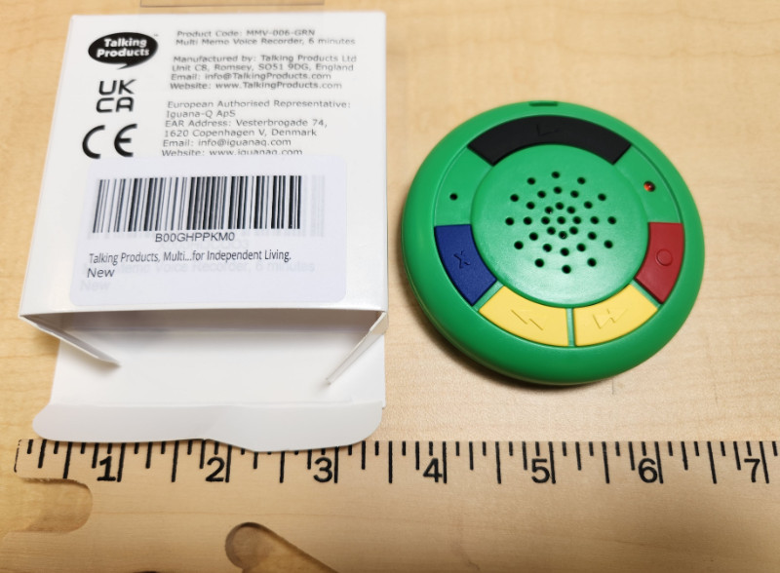

Talking Tile
Record and playback 80 seconds using the built-in microphone and speaker. Re-record as many times as you wish. Re-use time and time again. The large size and robust housing are ideal for those with visual impairments. #CR465


Check Writing Guide
This plastic stencil fits standard sized checks to help individuals who are blind or visually impaired fill out their checks and stay within the lines. A handy tool that will fit in your checkbook. #WG415
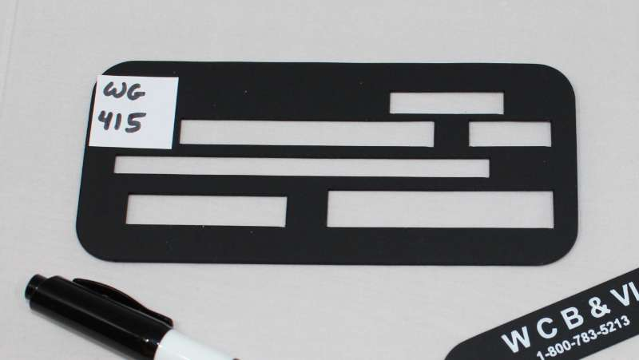

Letter Guide
This writing guide is made of durable plastic with 13 openings. This guide measures 8-1/2 x 11 inches and fits standard line spacing. #WG103


Envelope Writing Guide
This durable plastic envelope guide fits on top of standard #10 (business) envelopes. It is black, providing high contrast. #WG201


Signature Guide
This signature guide is made of durable plastic and is sized to fit a standard signature area. It measures 3-3/8 by 2-1/8 inches. #WG616
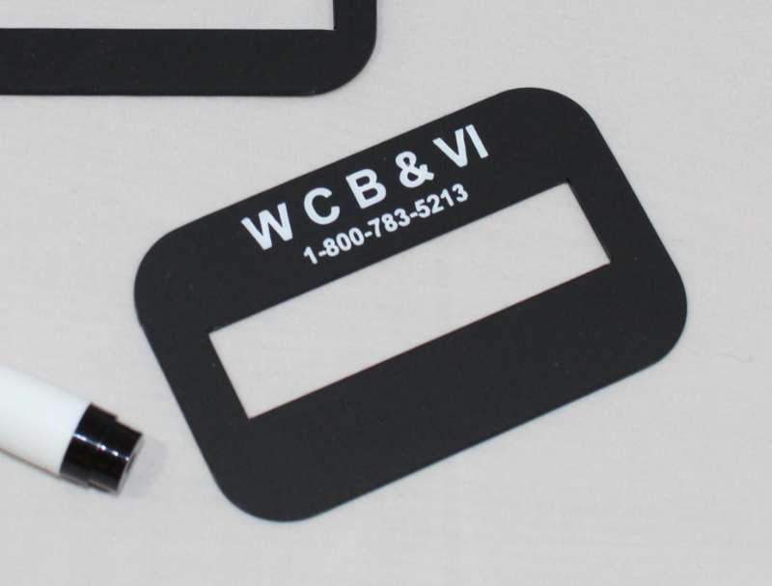

20/20 Slimline Pen
Writes lines in dark black that are 1 mm wide. Ink dries quickly and does not bleed through the paper. #WG700
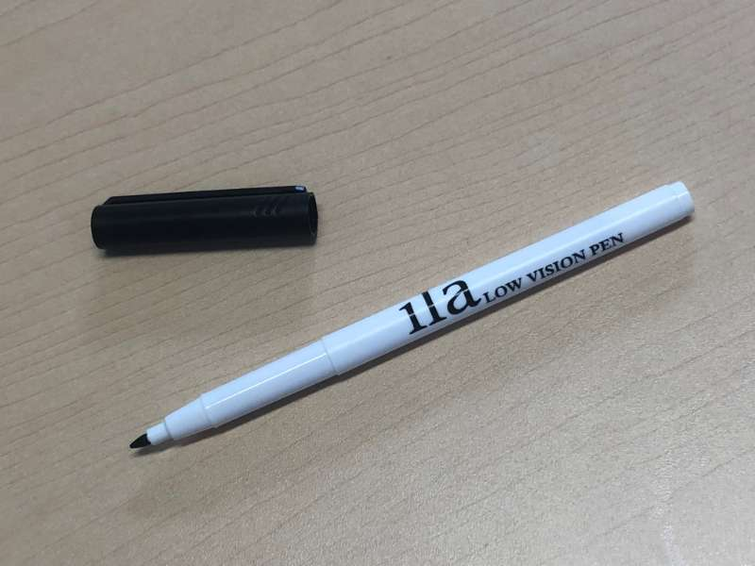

Sharpie Click Pen
Sharpie Click Pen – Black #WG730
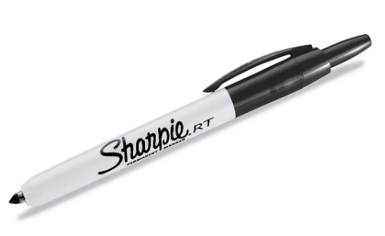

Sharpie Gel Pen
This intensely bold gel pen with no smear or bleed technology
offers vivid writing with a medium point (0.7mm). #WG745
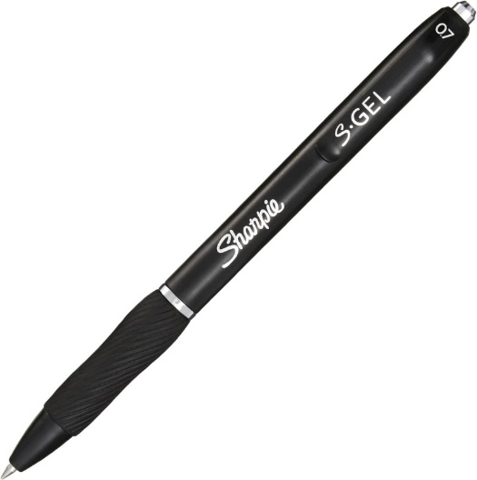

20/20 Pen BOLD
This pen writes lines in dark black that are 1 millimeter wide. The ink does not bleed through the paper and dries quickly after you write. #WG728
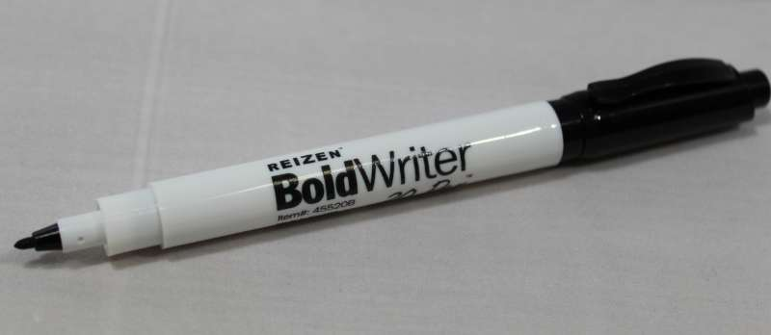

Big Print Address Book
The lines of this big print address book are spaced 1/2 inch apart to provide ample room for large handwriting and easy reading. This book contains three name listings per page and over 500 total individual listing spaces. Measures 7-1/2 x 9-1/2 inches with spiral binding and alphabetical tabs. #WG307
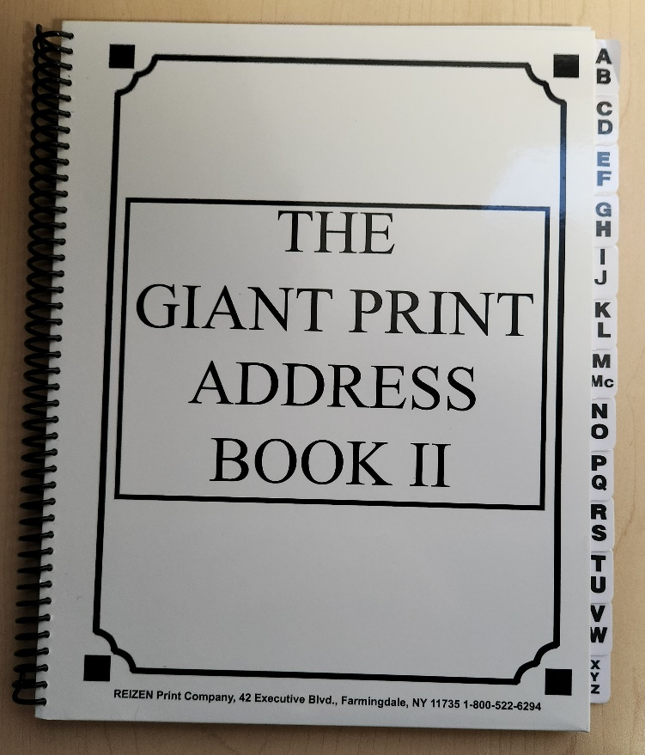

Large Print Check and Deposit Register
Use this super large easy-to-see check and deposit register to maintain a record at home of all your check transactions. Each 8 x 11 inch page is designed for 12 entries. 50 pages provide space for a total of 600 entries in the register. #WG505


3M Labeler with Braille Dial
This braille labeler is perfect for reorganizing belongings. This labeler has a tactile dial with both braille as well as print letters. The dial has the complete alphabet, as well as number signs, commonly used contractions, and punctuation marks. #HL150


Clear Dymo Labelling Tape 1/2" X 144"
This clear tape fits into a braille label maker or slate and stylus, and makes labeling appliances easy, so they can be used by those with or without sight. #HL155


Back Page:

Did you know that the Council Courier is also available in braille and audio formats? To request an alternative format or update your mailing address, call us at 608-255-1166.

The Council also publishes weekly e-newsletters that include features, helpful tips, advocacy information, upcoming events and more. You can subscribe at WCBlind.org/newsletter-signup.

