Council Courier, Winter 2026

Header: 2025 Was Another Year of Hard Work and Growing Relationships

2025 has come to a close, bringing an end to another fantastic year at the Council. “I’m proud of our work to promote the dignity and inherent worth of Wisconsinites who are blind and low vision throughout the state,” says Council Executive Director Denise Jess. “It’s exciting to witness the Council’s spheres of influence grow wider and deeper, from legislators and judges to other human service providers and the broader public through a variety of events.”
We started the year with the creation of our Advocacy Discussion Group. Meeting every other month, this group serves as a space for people who are blind or low vision across the entire state to grow as advocates at both the local and state levels. Since its launch in January, the group has developed a dedicated group of participants who support each other in their advocacy journeys.
During the first half of the year, state lawmakers crafted the 2025-27 biennial state budget. As in past budget years, the Council worked tirelessly with lawmakers to advocate for programs that benefit people who are blind or low vision. Our advocacy didn’t just address the budget, however, as we also weighed in on a variety of proposed legislation throughout the year that affects people with vision loss.
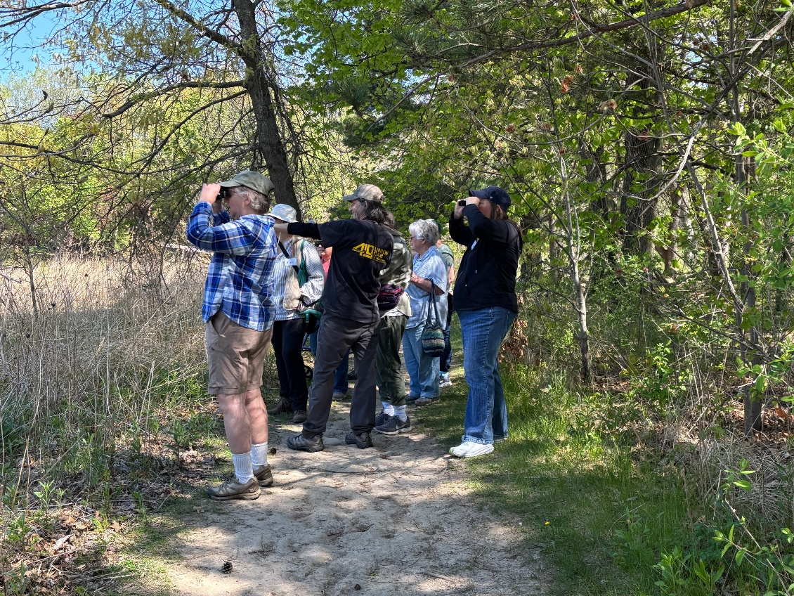
Caption: Birding by Ear
The Council continued many of its longstanding events in 2025. We once again hosted Advocacy Days in May, returning to the state Capitol to give participants the opportunity to meet with their state representatives to discuss issues important to the blind and low vision community. Also in May, we collaborated with the Southern Wisconsin Bird Alliance and the Aldo Leopold Nature Center in Monona for Birding by Ear, where a diverse group of participants identified over 50 species of birds by sound instead of by sight. And over the course of the year, we held four Dining in the Dark events, offering participants in Reedsburg, Cross Plains, Mt. Horeb and Madison the opportunity to focus on senses other than sight as they appreciated the dining experience.
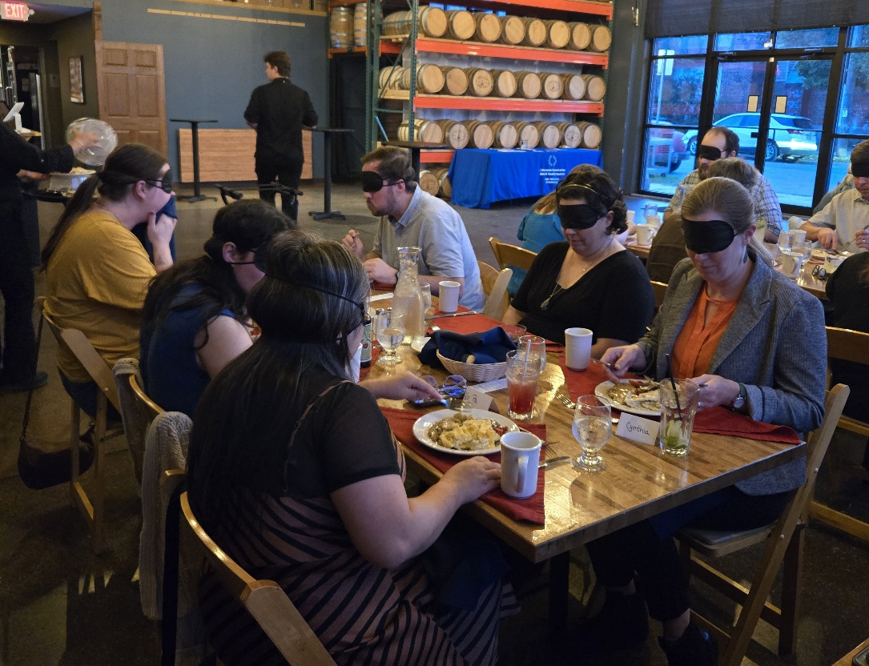
Caption: Dining in the Dark

As summer approached, we announced our 2025 Council Scholarship recipients. We awarded $2,000 scholarships to four young women from across the state, each at a different stage in their postsecondary journey. Congratulations to all of our 2025 recipients!
Summer also brought the arrival of Kate Bleyl-Ericson as the newest member of the Council’s Vision Services Team, filling the newly created position of vision services navigator. Recognizing that people who are blind or low vision often have unmet needs outside the scope of what the Council can provide, the Council added this role to help our clients connect with other community services to address such issues as food insecurity, isolation and transportation access. Having Kate on board has enabled us to support the whole person rather than focus narrowly on their vision services needs.
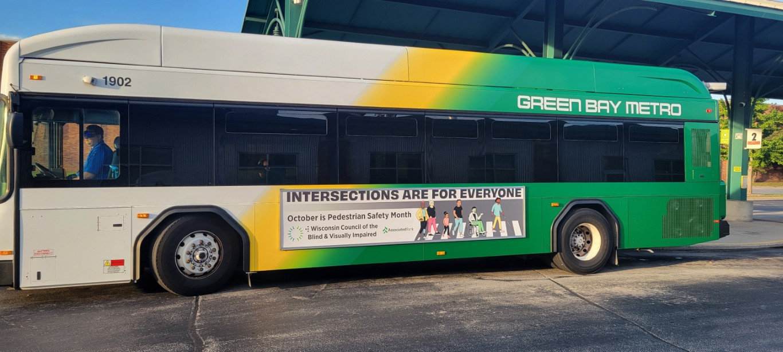
Caption: Pedestrian Safety Month bus ad

October marked two important and interlocking events: Pedestrian Safety Month and White Cane Safety Day. The Council continued to advocate for safer streets for all pedestrians across the state, with 42 local governments and the State of Wisconsin issuing proclamations formally recognizing October as Pedestrian Safety Month and the 15th as White Cane Safety Day. The Council also ran bus ads in La Crosse, Waukesha and Green Bay. While our bus ads have highlighted White Cane Safety Day in the past, this year our ads had a broader Pedestrian Safety Month focus featuring the theme of “Intersections Are for Everyone.”
In November we opened our doors to the public for our annual Gallery Night event. This year, we featured the work of eleven Wisconsin artists who are blind or low vision. Their work included paintings, drawings, photography, ceramics, fiber arts and even artisanal chainmail jewelry. Gallery Night 2025 was one of our most successful ever, with over 100 visitors stopping by to appreciate the art while learning more about the Council.
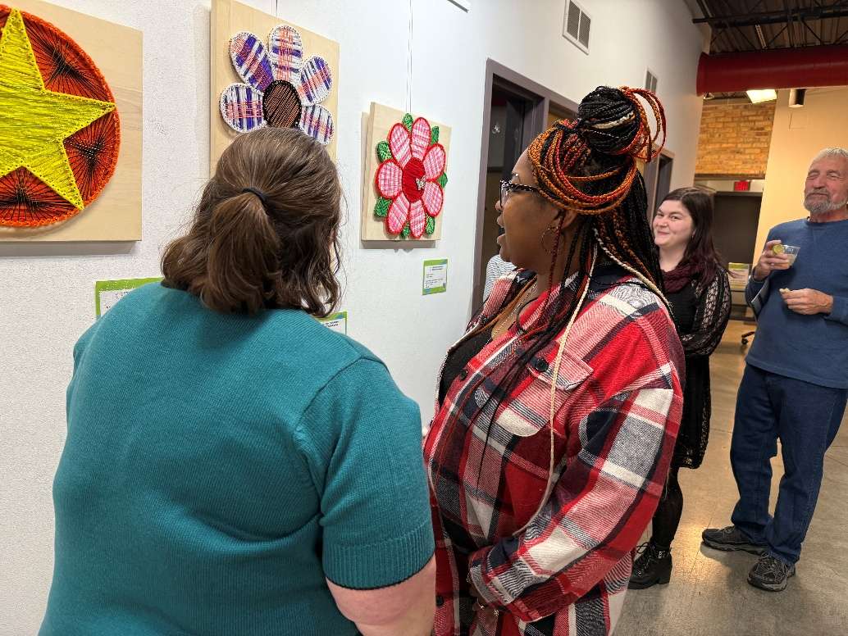
Caption: Gallery Night

Toward the end of the year, we released a new video, “Exceptional, Welcoming Services for Blind and Low Vision Transportation Users.” The purpose of the video is to help specialized transportation drivers better understand how to provide a safe, comfortable and accessible ride to passengers with vision loss, empowering them to stay engaged in the community. The video was made in partnership with Clouds North Films with funding from an anonymous foundation. Janesville Transit was also instrumental in bringing the video to life. You can find the video on our YouTube channel.
Throughout the year, the Council reached out into the community at a variety of educational events. As usual, we tabled or presented at many health fairs and senior centers. But 2025 saw the Council reach out to a more diverse array of audiences than ever before. For example, staff spoke at the Wisconsin Judicial Conference on the importance of accessible and welcoming courtrooms; at the UW College of Engineering on empowering the blind and low vision community on campus; and in staff trainings for the state’s Office for the Blind and Visually Impaired on access technology and the role of the vision services navigator.
Thank you to the many individuals, service organizations, funders and businesses who supported the Council financially throughout the year. Those gifts allowed us to advocate on critical issues, put on numerous successful educational events, and provide vision services to every client regardless of their ability to pay. We’re excited to continue this work into 2026.

Message from Executive Director Denise Jess
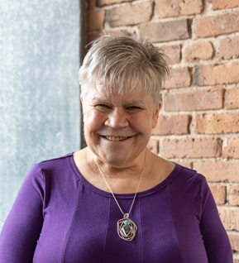

2027 marks the Council’s 75th anniversary. As we gear up to celebrate, we reflect on our rich history, our present environment, the opportunities and challenges in front of us, and our desired organizational future. These reflections have led us to an exciting endeavor to seek a new organizational name and logo, approved by our Board of Directors in 2024 as part of our 2025-27 Strategic Plan. Throughout this year we’ll engage in a robust process to “rebrand” the Council in a way that honors our legacy and 75 years of promoting the dignity of people who are blind and low vision while embracing a future with increasing diversity and life experiences of people experiencing vision loss.
These are some of the compelling factors that led to this decision.
  - Our current name causes a lot of confusion. It is very similar to the Office for the Blind and Visually Impaired, a state agency that offers some of the same services we do. We get calls intended for them all the time. It is also very similar to the Wisconsin Center for the Blind and Visually Impaired, the school in Janesville. We even have the same initials, WCBVI. For those new to vision loss and their families and caregivers, this leads to uncertainty about where to turn.
  - Our current name is too long and cumbersome. People get it wrong quite often. It doesn’t even fit into the space allowed on many online forms we must fill out. Having people recognize our name and note it correctly strengthens our organizational identity.
  - Our current name does not reflect how we have evolved over time. We are not really a “council.” This term often leads people to believe we are a governmental agency. Also, we have moved beyond the language of “impairment,” which suggests there is something “wrong” with people who are blind or low vision.
We recognize those in the Council’s orbit may have a host of feelings about the change, ranging from excitement to grief. We’re giving ourselves a year and working with a top-notch Madison-based marketing firm to engage key voices in the renaming process. We also hold true to our mission to promote the dignity, independence and empowerment of people who are blind or low vision, and our lasting commitment to our values of inclusion, integrity and uncompromising respect.
Stay tuned as this process moves forward. We’ll formally announce the changes in early 2027.

Warmly,
Denise

Header: Retiring Development Director Lori Werbeckes Reflects on Evolution of Council’s Approach to Fundraising
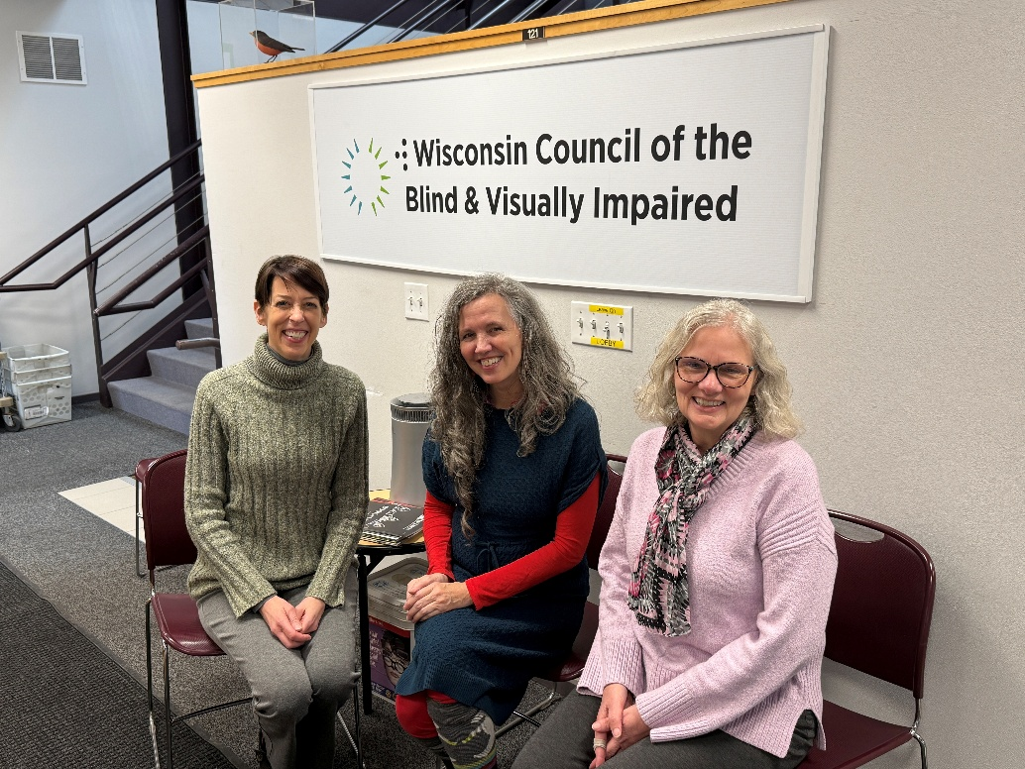
Caption: From left: Jodi Nachtwey, Debbie Rasmussen, Lori Werbeckes

In December, Lori Werbeckes’ tenure as Development Director at the Council came to an end as she began her well-deserved retirement. Lori joined the Council in August 2013, and for a dozen years helped shape the way the Council raises money to support the services and advocacy we provide. Congratulations on 12 great years and the beginning of your next phase in life, Lori!
“I am truly grateful for all Lori has done to uplift the importance and value of fund development at the Council, particularly with establishing and nurturing long-term relationships with our donors,” said Executive Director Denise Jess. “Her warmth and genuine kindness along with her expertise and skill have been such a gift.”
Over the years, donations have increased thanks to the support of everyone who believes in the Council’s mission to promote the dignity and empowerment of people who are blind or low vision in Wisconsin. With donor support, the Council has been able to grow in all our core areas—advocacy, vision services and education.
Throughout her time at the Council, Lori has set the tone in how we show our appreciation to our loyal donors. Along the way, Lori created several recognition clubs. The Legacy Circle recognizes those who have named the Council in their will or as a beneficiary. Friends of the Council give $500 or more annually. White Cane Circle members make monthly gifts. Council Visionaries are those who have contributed $20,000 or more over their lifetime. This recognition highlights the many different ways people give to the Council and encourages others to give.
How we thank and interact with our donors has evolved during Lori’s time with the Council, with a growing emphasis on building relationships. Over the past decade, we have added personal greetings in every thank you letter we send. We also began writing personalized notes to our regular supporters during our annual White Cane appeal, and started reaching out to donors in some form nearly every month.
Lori says adding new ways to communicate with our donors has helped us build better relationships with those interested in the Council. “It’s a privilege to connect someone who wants to give with an organization that is serving a cause the donor is passionate about,” Lori says. “For many people, making a gift is personal, so their action deserves to be acknowledged with the same amount of thought. The result is a donor base that knows how their gifts are being used, which then translates into our donors feeling informed and involved in the Council.”
The way our development team works to grow our donor base has also seen big changes over the past 12 years. When we reach out to the community, we do so to educate the public about the services the Council provides. We’ve grown our Dining in the Dark events, which serve as both an educational experience for the public and a fundraiser for the Council, to eight different venues in different parts of Wisconsin. We’ve offered sponsorship opportunities for events like Gallery Night and The Big Share to build connections with local businesses.
Speaking of The Big Share—an annual fundraising event orchestrated by Community Shares of Wisconsin (CSW)—we grew our emphasis on peer-to-peer fundraising and delivered collaborative presentations with other CSW organizations.
Along the way, we began sending letters to Lions Clubs across Wisconsin to foster new and continuing relationships. We’ve grown internal support by building workplace giving campaigns around fun contests like chili cookoffs and mocktail contests, and encouraged all members of our Board of Directors to become donors.
Change is constantly happening at the Council, and we are excited to see how our development strategy continues to evolve in the years to come. As Lori moves on to the next stage in her life, debbie rasmussen, a member of the Council’s development team since 2022, has been named Development Director. Congratulations, Lori, and thank you for 12 wonderful years of helping the Council grow!

Header: Board Member Kole Torres Speaks Up on Pedestrian Safety Issue in Her Community
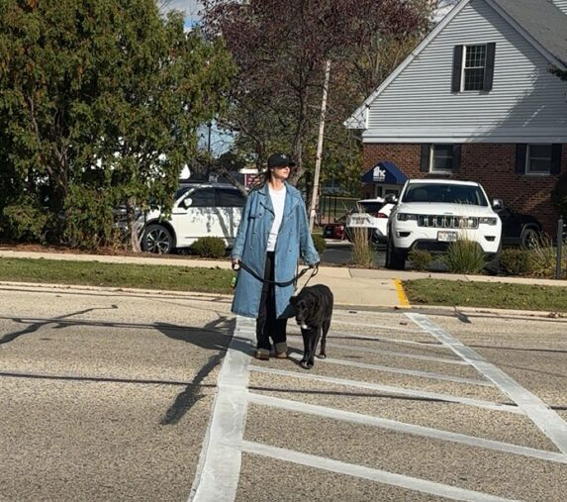
Council Board Member Kole Torres first moved to Menomonee Falls several years ago and has been in her current apartment on a busy three-lane road for about two years. Kole has two dogs, one of whom is old and walks slowly due to arthritis. That’s a problem, Kole says, as the only place for her dogs to do their business is across this busy road.
While the road in front of Kole’s apartment building has a crosswalk, it is not signalized, and drivers often fail to stop when she is trying to cross. After a particularly close call, Kole decided it was time to speak up.
“I waited until the cars were over 100 yards away, they saw me from a long distance, and yet they didn’t stop,” Kole says. “We were in the road, and the car never even slowed down. I walk ahead of my dog because he’s so slow, and I was almost hit by this speeding car. Then the car behind them honked at me! I wondered if I was in the wrong, but I did everything right.” From her experience working with the Council, Kole knew she had to do something.
Kole did some digging and decided to reach out to her local police department to let them know about the incident. To her surprise, they got back to her right away. State law says that drivers must yield to pedestrians in a crosswalk, but as Kole found out, drivers will often try to speed through the intersection instead, putting the safety of the pedestrian at risk. The local police said that while they could not force every driver to obey the law, they could use their resources to make the crosswalk a little safer for pedestrians. “Not even an hour after I got off the phone with them, an officer was at the crosswalk,” Cole says. “It was such a pleasant experience. They told me that they were going to try to place a safety officer to watch the intersection and help pedestrians cross the street safely for a few hours every day.”
While the road has already been made safer thanks to the presence of the safety officer, they still cannot do much until after a driver breaks the law. Kole says her advocacy journey is not done, and she is getting ready to talk with her local and county officials about other ways to make the intersection safer.
Kole saw a tragedy waiting to happen, and instead of just hoping for the best, she decided to speak up and advocate for her own safety. Thanks to her role with the Council, she says she had the resources she needed to bring tangible change to her own neighborhood. “I started my advocacy journey just before October, which I knew was Pedestrian Safety Month, to give myself a little encouragement and momentum,” Kole says. “I used that momentum and the Pedestrian Safety Toolkit from the Council to really inform how I spoke with my local officials. Anyone can do what I did. You just need to have a little patience. Don’t get too discouraged if things don’t move as quickly as you’d like. Find someone who believes in you and your voice to uplift you. Find your allies!”
With a little support and the willingness to tell your own story, anyone can be an advocate in their own community. If you want to advocate for pedestrian safety in your neighborhood but don’t know where to start, visit the Advocacy page on our website at WCBlind.org/Advocacy for some ideas.

Header: Addressing the Needs of the Whole Person
Georgette Stack says her vision loss started in just one night. After waking up seeing through a white fog, she went to her doctor, who informed her she had a vitreous hemorrhage in one eye. A year later, a change in medication caused her to lose most of the vision in her other eye. “I went through the emotional rollercoaster of realizing my vision was gone,” Georgette says. “I decided to go to the Council just to see what could be done.”
Georgette started with Vision Services Navigator Kate Bleyl-Ericson, who led her through an extended intake process. The purpose of intake is to get to know the client and determine what she needed to continue living life on her own terms. Georgette then met with Education & Vision Services Director Amy Wurf for low vision therapy. Amy worked with Georgette to find magnifiers that helped her to read again, albeit very slowly given how little functional vision she has.
Next, she worked with Access Technology Specialist Jim Denham to help her relearn how to use her phone without vision. Jim helped her get a phone that allows her to use voice controls to make calls. Orientation and Mobility Specialist Brent Perzentka helped Georgette obtain a white cane and begin learning how to use it. Now with an upgraded titanium cane, she says she uses it to safely navigate unfamiliar places and is even going for walks around her neighborhood.
Georgette also spends time investigating the Sharper Vision Store with the help of Customer Care Specialist Greg Schmidt. “I always like to explore and see what I can see in the store,” Georgette says. “Greg has been so great at showing me new things!”
In addition to the services our vision services team provides directly, they bring a well of information on how to improve every aspect of a client’s life and wellbeing. “The intake and training are not solely about what is happening with the eyes, but about the whole person, mind and body,” Amy says. “Each of us listens to our clients to pick up clues to other concerns or needs that might not have been expressed initially. We keep all the training areas in mind and how they might be important for our client to explore. In addition, we provide referrals to other professionals and agencies who might be more appropriate to meet some of their needs. We don’t need to be experts in all things, but we listen and help guide our clients to other reliable and trusted providers when appropriate.”
“It’s become obvious that my vision isn’t coming back,” Georgette says. “But instead, they are finding ways to help me in my everyday life to make things easier every day. Without these services, I would probably have shied away from people. With their encouragement, I feel I have a positive future.”
As she continues along her vision loss journey, Georgette says she looks forward to returning to some of her favorite places in Madison, such as the UW Madison Arboretum to experience the lilacs again with her new skills. “I was starting to get a little reclusive,” Georgette says. “But the Council is helping open up my world again.”

Header: Welcome Jodi Nachtwey to the Council Team
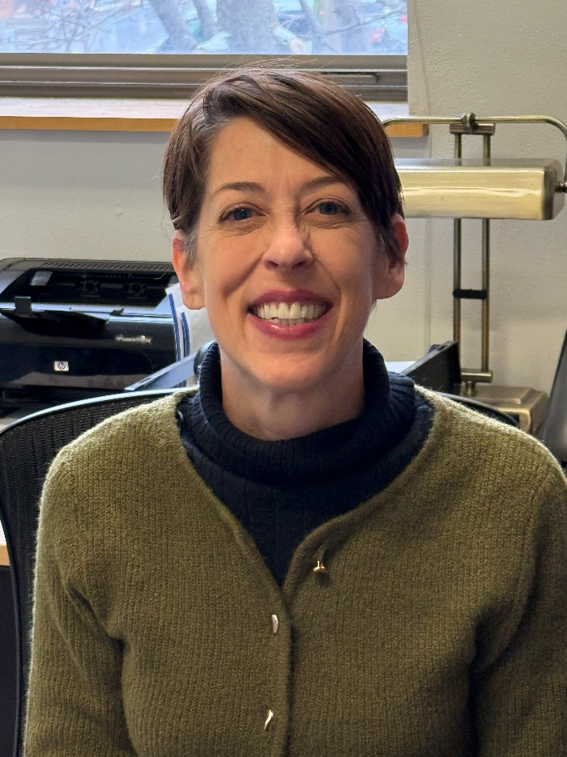

We are pleased to welcome Jodi Nachtwey as the newest member of the Council staff. Jodi joined the team on November 10 as Development Specialist. In this position, Jodi will play a vital role in maintaining donor records, securing grants, and assisting with other projects as a member of the development team.
Jodi comes to the Council after nearly two decades working as a social scientist and research analyst, specializing in international public opinion research. Searching for something new, Jodi was encouraged to apply by her neighbor, who had received services from the Council in the past. Outside of work, Jodi is a pianist and loves to work in her native plant garden.
“I’m so excited to work with the Council as a Development Specialist,” Jodi says. “I look forward to working with a nonprofit organization that has relationships with other groups across the state that are making a difference.”

Welcome to the team, Jodi!

Header: Welcome Jim Unger to Council Board of Directors
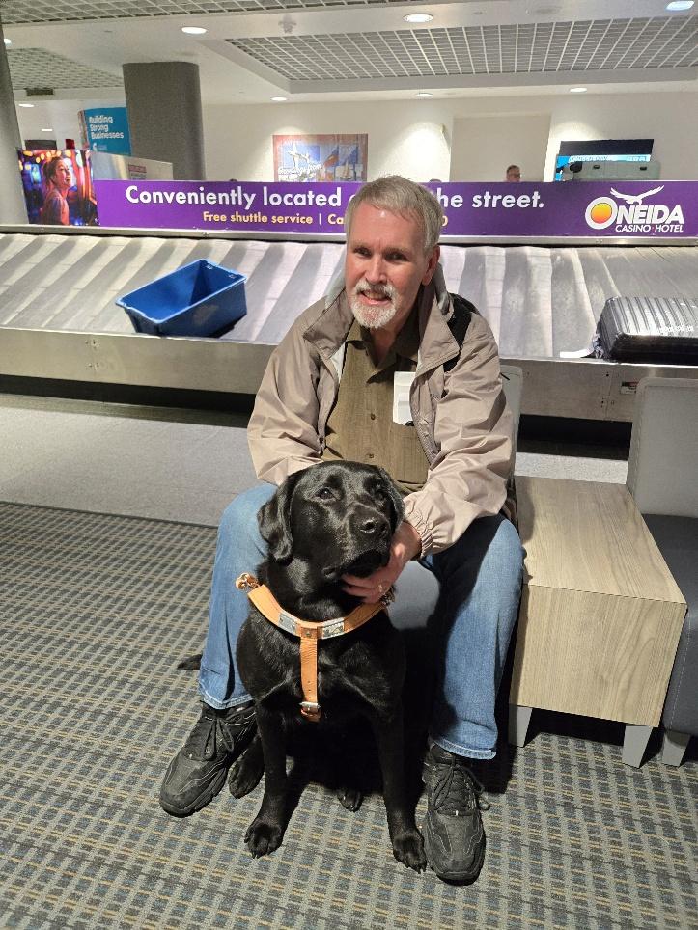

We are pleased to welcome Jim Unger as the newest member of the Council’s Board of Directors.
Jim, who lives in Rhinelander, has over 40 years of experience in the blind and low vision rehabilitation field. Most recently, he worked for the Office for the Blind and Visually Impaired (OBVI) as a vision rehabilitation therapist until his retirement in 2019. Since then, Jim has continued to provide access technology training on a contractual basis to clients around the area.
Jim has atypical retinitis pigmentosa, which has progressed slowly over his entire life. He is a guide dog user, having gotten his first dog in 2013. Jim co-facilitates the Rhinelander Low Vision Support Group, and says members of the group encouraged him to apply to join the board.
“It means a lot to me to be a board member,” Jim says. “I’ve been around the Council for basically my entire professional life, and know the value of their work to make life better for people with vision loss. I’ve already been promoting the Council any chance I get, because they’re such an important resource to people across Wisconsin.”
Welcome to the Board, Jim!

Council Scholarships
Each year, the Council provides postsecondary scholarships to students who are blind or low vision. The application period for 2026 Council Scholarships opens in February. For more information and to access the application materials, visit https://WCBlind.org/Events/Scholarships/.

Header: Winter 2026 Sharper Vision Store Featured Items
Subhead: Stay in top shape with these adaptive health products!

5X / 10X Zoom Mirror on Gooseneck
Two powerful 5-3/4-inch mirrors with 5X and 10X magnification. 9-inch flexible gooseneck adjusts to any angle. Comes with wall mount and slide on suction cup mounting bracket. #MX905


5X Hand Mirror with Vanity Stand
This 7X magnification hand mirror comes with a detachable vanity stand that makes it great for those “finishing touches.” When held by the handle or used with the detachable vanity stand, it's a perfect mirror for home or travel. The mirror is mounted in a 7-inch diameter, clear acrylic beveled frame. #MX907


10X Lighted LED Mirror
This mirror provides crisp, bright LED light and 10x magnification to help you see yourself and get ready. The mirror pivots so you can adjust the angle, and the backside is a mirror with no magnification. Battery powered with 4 AA batteries (included). #MX960


LED Mirror 5X
This mirror provides crisp, bright LED light and 5x magnification to help you see yourself and get ready. The mirror pivots so you can adjust the angle, and the backside is a mirror with no magnification. Battery powered with 4 AA batteries (included). #MX950


Autodrop Eyedrop Guide
The Eyedrop Guide holds the eye open so a drop can be placed in. The guide provides easy control so less medication will be wasted. #HM601
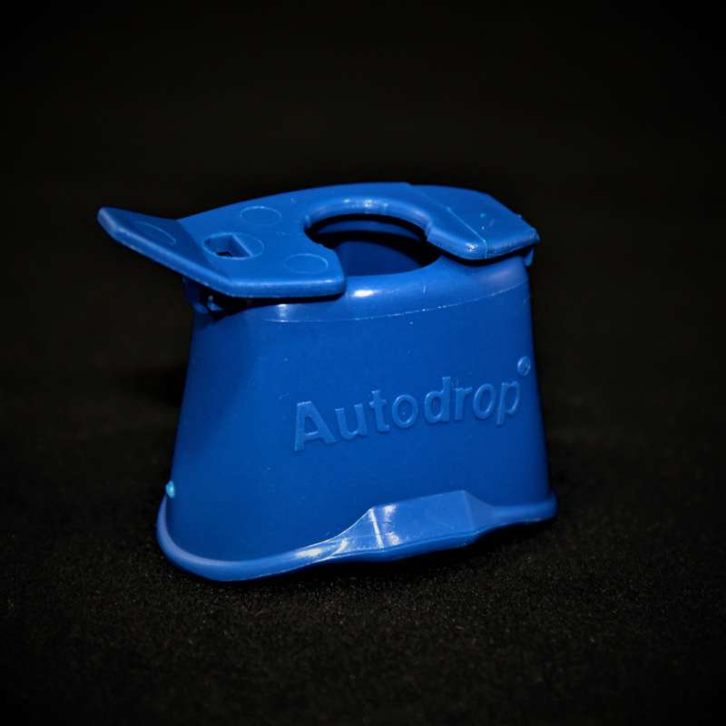

Lighted Nail Clip with Magnifier
Lighted Nail Clip with Magnifier. #HM610
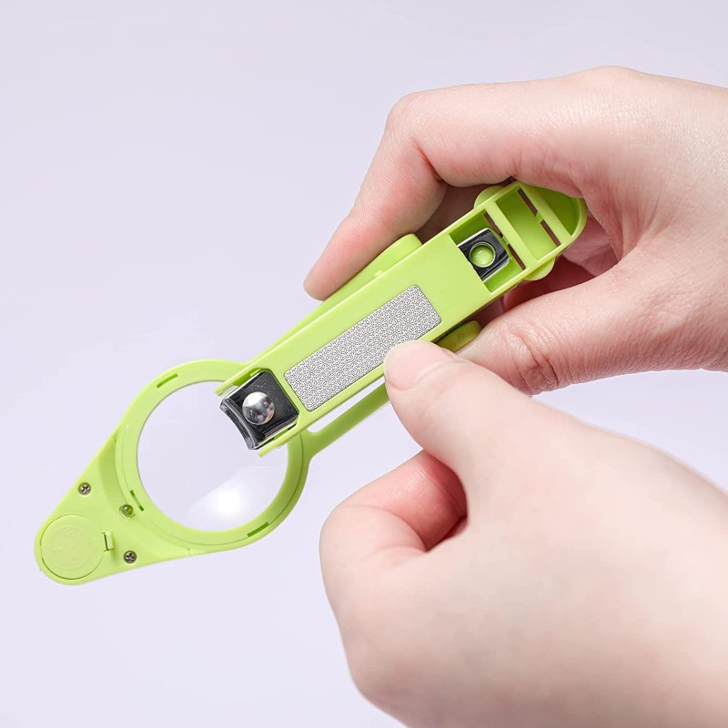

No-Contact Talking Thermometer
This no-contact infrared thermometer can measure temperature when held 2-4 inches from the forehead or behind the earlobe. It can remember up to 32 temperature readings. Speaks temperature in both English and Spanish and can also be used for room temperature. #HM245
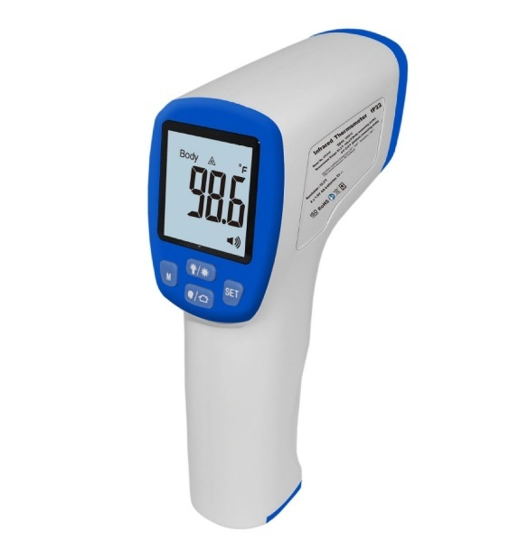

Pill Organizer 7 Day
This colorful pill box has sections for dosages four times a day, seven days a week. This organizer is great for people on multiple medications each day. It features color-coded day and time compartments, so you don’t miss a dose and to reduce medication misuse. #HM101
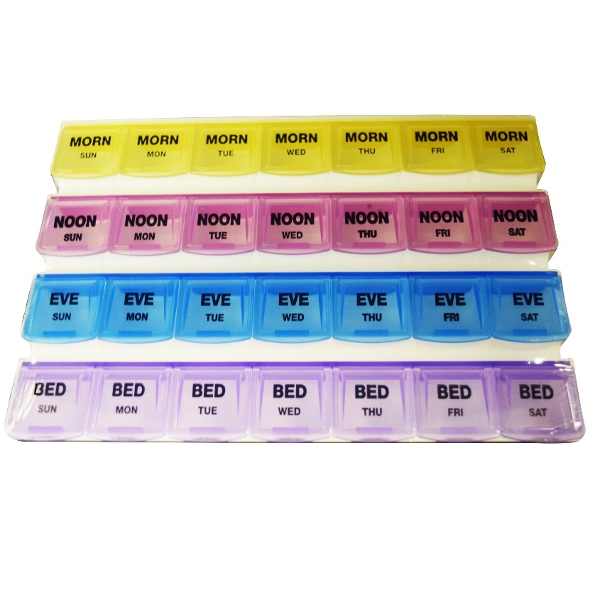

Recordable Talking Alarm Clock - Pill Reminder
The Your Minder Recordable Talking Alarm Clock has speakers on both sides of the clock and can be programmed for six daily alarms. The LCD display has a bold, easy-to-see font to show the time and date and color-coded buttons located on the top. This clock can also act as an electronic pill reminder by individually recording messages to play at each alarm. #HM801
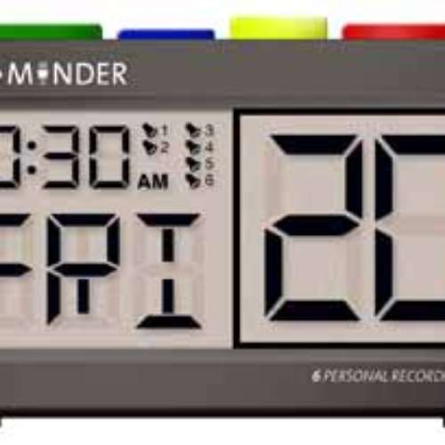

Small Braille Pill Box
Seven individual pill compartments in a single compact plastic container. Marked in Braille and standard alphabet for each day of the week. #HM102
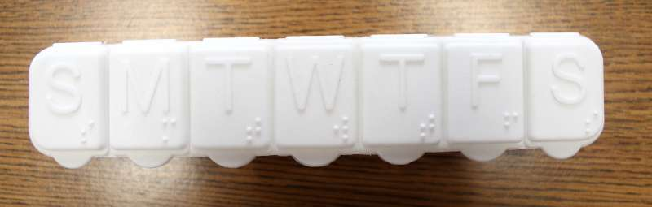

Superior Talking Scale XL-550 lbs.
The Superior Talking Scale is accurate to within 1% of actual weight up to 550 pounds. The platform measures 14-1/2 x 11 inches and is textured to indicate foot placement. It speaks in English or Spanish in a female voice and operates on 4-AA batteries (included). Voice can be turned off. #HM400XL
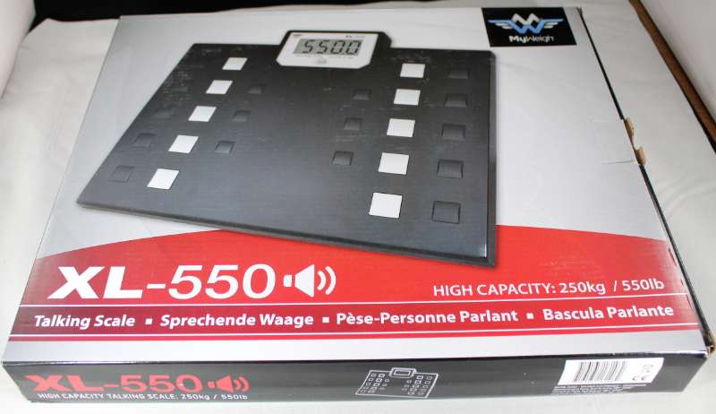

Talking Blood Glucose Monitor
The Prodigy Voice is a talking blood glucose monitoring system that provides accuracy with just a small sample of blood. Results are announced clearly and records can be stored with the date and time. #HM232
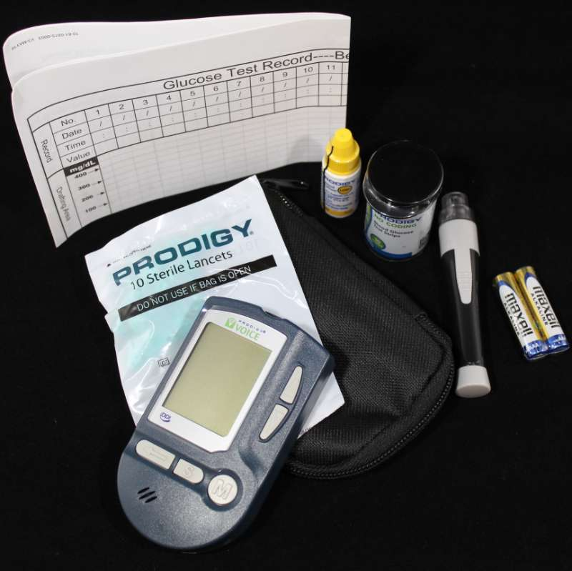

Talking Blood Pressure Meter
This talking blood pressure monitor gives the average of three consecutive readings. The monitor has a 90-reading memory recall, irregular heartbeat detection, time and date stamping, and a pressure rating indicator. Verbal readings are available in English and Spanish. An AC adapter, carrying case and batteries are included. The cuff is 9 to 14.6 inches. #HM272
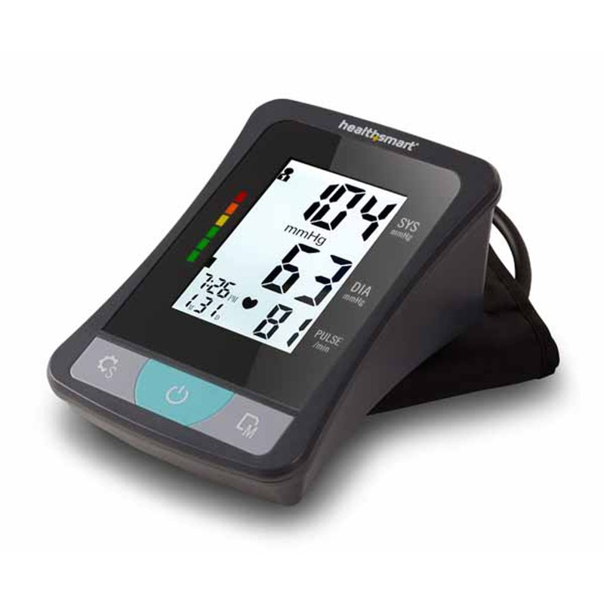

Talking Blood Pressure Meter, Wrist Style
Talking blood pressure monitor offers a clear speaking voice and ease of use. It has one-touch operation, irregular heartbeat detection, 2-person memory storage with 90 measurements each, LCD displays with 3 color backlighting, and averaging of last 3 measurements. #HM705
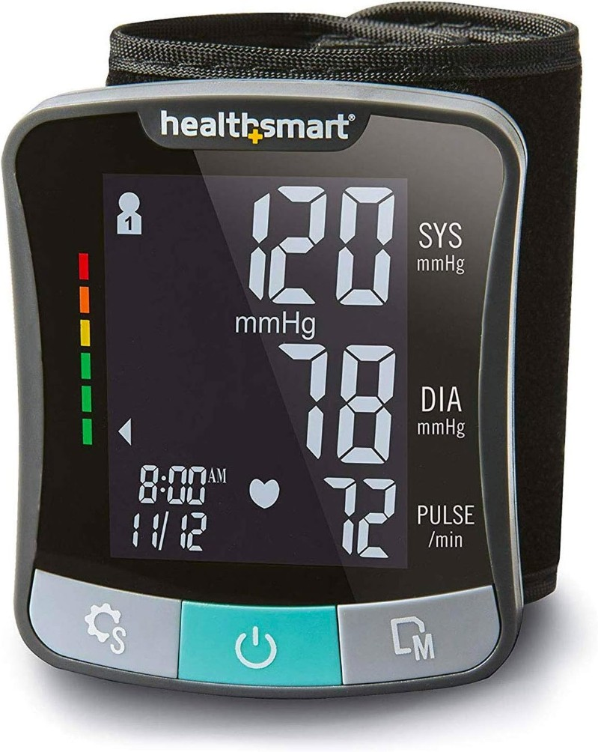

Talking Clinical Thermometer
This talking thermometer works for oral or underarm use and responds quickly to your body temperature. Accuracy is within 0.2 degrees Fahrenheit or 0.1 degrees Celsius. It has six language settings. Battery powered (battery included). #HM246
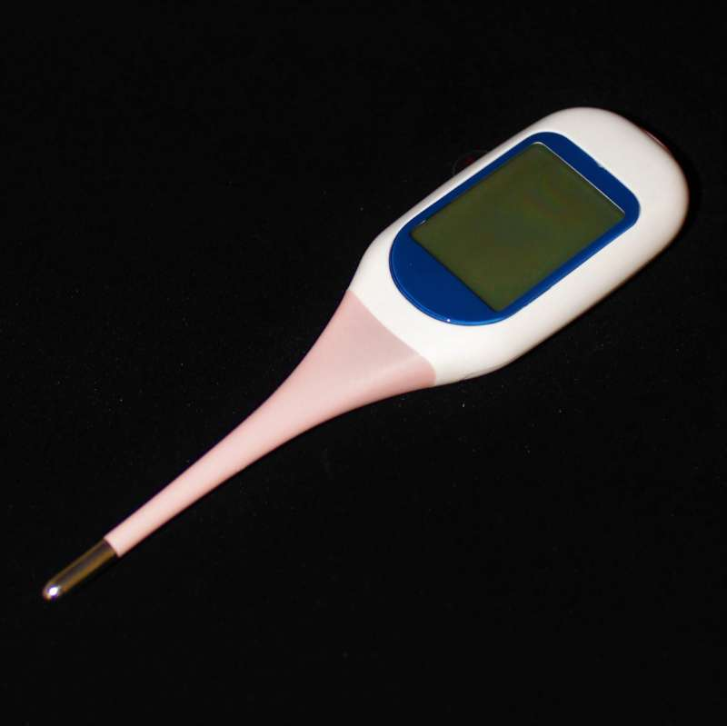

Talking Pedometer
A little exercise every day can help you stay healthy. This talking pedometer measures and announces steps, calories, distance, and total activity time. It can also announce the current time and has a seven-day memory. The pause function allows you to stop and resume measurement as needed. #HM500
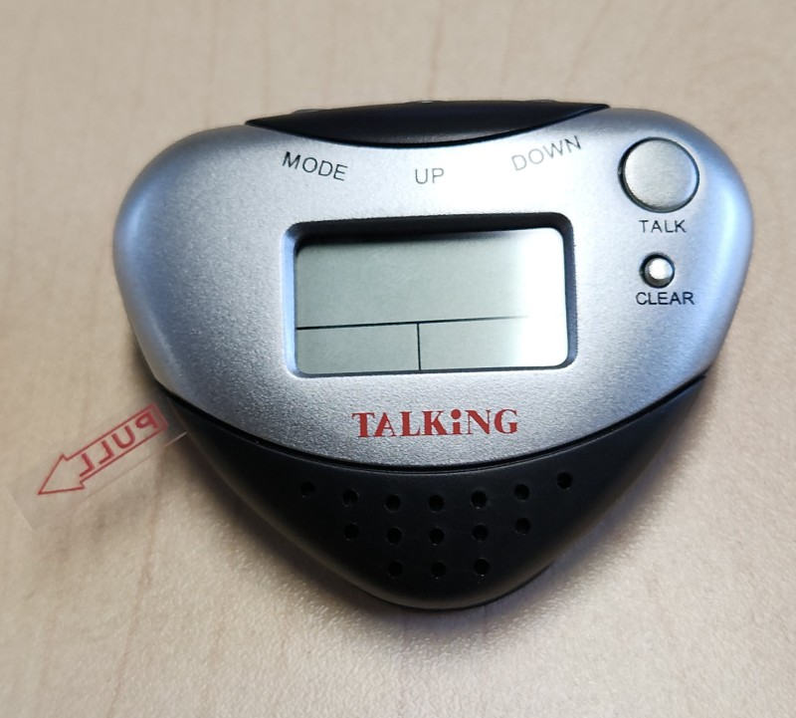
Back Page:

Did you know that the Council Courier is also available in braille and audio formats? To request an alternative format or update your mailing address, call us at 608-255-1166.

The Council also publishes weekly e-newsletters that include features, helpful tips, advocacy information, upcoming events and more. You can subscribe at WCBlind.org/newsletter-signup.

