Council Courier, Spring 2026

Header: Take Steps to Reduce Social Isolation After Losing Your Vision
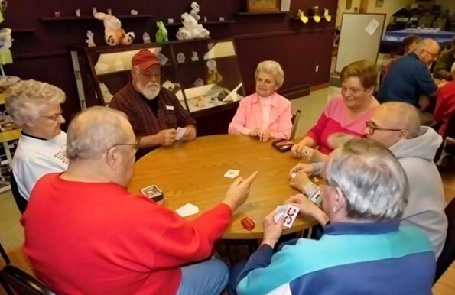
Caption: Senior Centers are a great option for finding opportunities to stay socially active in many communities.
It can be easy to feel as if you are alone after losing your vision. According to a study from the National Institutes of Health, people with disabilities experience loneliness and social isolation at significantly higher rates than people without a disability. But it’s important to remember that you are not alone. You can still be active in your community, and there are many steps you can take to reduce your social isolation.
“There can be a lot of reasons why someone who is blind or low vision may feel isolated,” says Education & Vision Services Director Amy Wurf. “Transportation barriers, a lack of accessible information about activities, and self-consciousness can all keep someone from going out into their community. Reaching outside of yourself and finding a way to focus on something you enjoy rather than focusing on what you feel you cannot do is so important for your mental health.”
There are probably many structured social events happening in your community all the time. Most towns have a public library, and they often host book clubs and discussions, as well as other events like craft clubs and volunteer opportunities. The library can also help you get an audio version of the book being discussed if you are not yet set up with the Wisconsin Talking Book & Braille Library. Libraries are often in a central location, meaning it may be easier to find transportation to and from the event.
If your community has a senior center, they will also hold regular events for older adults, and many offer transportation options to make it easier to participate.
If you live in the Madison area, the nonprofit organization Arts for All holds art, music and dance classes specifically designed for people with disabilities. In the Milwaukee area, Blind Outdoor Leisure Development (BOLD) holds free events for people with vision loss to get outdoors while meeting new people.
There are a number of online structured social events happening regularly as well. The American Council of the Blind hosts dozens of online events every week. These groups cover everything from sports to cooking to religious events to birding. Hadley is another national organization that regularly hosts online meetups on a wide variety of topics. You can learn more about Hadley’s online discussion groups at HadleyHelps.org/Discussion-Groups.
If you feel more comfortable in less structured, casual social settings, there are plenty of options available for you as well. Simply going for a walk in your community can help you get out and about and can be a great way to meet your neighbors. There may also be a more organized walking group in your community. Starting a card game group is a great way to stay connected with family and friends. The Sharper Vision Store has a number of accessible card and board games appropriate for various levels of vision loss. If your family and friends do not live with you, a computer, tablet or smartphone with FaceTime or WhatsApp can help you stay connected.
Speaking of technology, a smart speaker that uses Alexa or Google Home can help keep you company. For example, you can simply ask it for trivia questions or to play a podcast or audiobook. If you are signed up with the Wisconsin Talking Book & Braille Library, you’ll have access to the NFB-NEWSLINE, a free audio news service available to anyone who is blind, low vision or otherwise print disabled offering audio editions of many local and national newspapers.
In addition to helping you feel less isolated, getting out into the world benefits the entire blind and low vision community. A lot of the sighted population still clings to the myth that people with vision loss cannot live alone, travel or hold a job. “We strive to break that stereotype and educate people all the time in our work at the Council,” Amy says. “The perceptions of what people with vision loss can do, which is what anyone can do with adaptations, can be changed when someone is out there just living their life and going about their business. By getting out into the community, people act as ambassadors by reminding everyone that they exist and are part of society.”
If you need assistance in building the skills you need to feel comfortable in your community, the Council may be able to help. Contact our vision services team at Info@WCBlind.org or fill out the Vision Services Request form at WCBlind.org/Vision-Services/Vision-Services-Requests.

Header: Message from Executive Director Denise Jess
Subhead: Partnering with Eye Doctors to Build a Comprehensive Continuum of Care
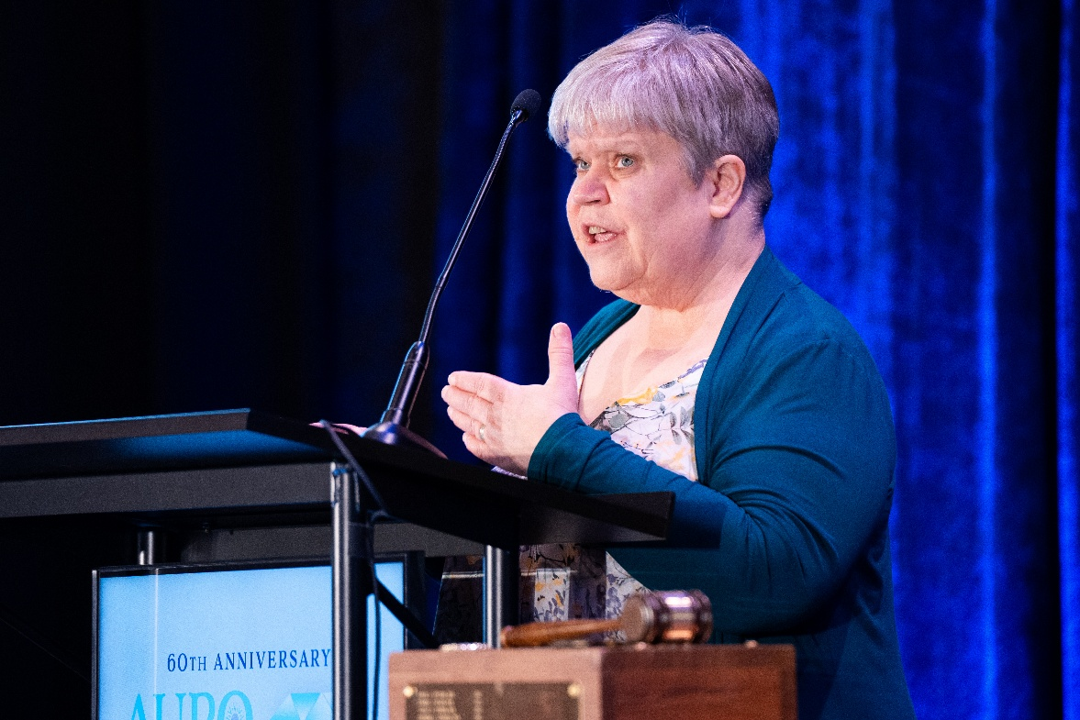
Caption: Denise Jess presenting at the annual meeting of the Association of University Professors of Ophthalmology
Earlier this year I was invited to speak at the Association of University Professors of Ophthalmology’s (AUPO) annual meeting to advocate for vision rehabilitation services, like those provided at the Council, in the continuum of care. It was a great opportunity to meet with over 600 of the country’s leaders in both clinical practice and the education of future doctors about people who are blind and have low vision, beyond our medical eye conditions. We discussed the interconnectedness of vision loss with other health concerns, including depression, anxiety and suicide risk; barriers to employment; transportation and economic stability. Their engagement was heartening, and many follow-up discussions took place. I want to thank Council board member Dr. Terri Young, who currently chairs both AUPO and the UW-Madison Department of Ophthalmology and Visual Sciences, for her insight for including this advocacy in the conference planning.
For many years, we have understood how important it is to develop a strong continuum of care between eye doctors and vision rehabilitation professionals. Optometrists and ophthalmologists are often the first to discover and diagnose eye conditions that can lead to loss of vision, but they may not refer their patients for vision rehabilitation. Consequently, the individual does not know where to turn for support and skill-building. Organizations like the Council, Vision Forward and our partners across the country have been reaching out to the medical community to bring these issues forward. Sometimes this outreach is met with interest and an open door, other times not. In 2016 the American Association of Ophthalmologists issued a statement to its members stating that referring for vision rehabilitation services was the appropriate standard of care, along with continued medical care for the eye condition itself. But progress towards a cohesive continuum of care has been slow and there remains much room for further growth.
Sadly, some people still hear comments from their doctors like “There’s nothing more I can do for you.” Or they are told that organizations like the Council are “hospice centers for the eyes,” or “You aren’t bad enough off yet to go to the Council.” Messages like these often lead to people waiting too long to seek vision rehabilitation services like learning to use magnifiers, color and shading contrast, appropriate lighting, developing white cane skills, or using access technologies like screen readers or magnification to operate their phones and computers. Or they end up never seeking these services.
We applaud our medical community partners who have taken the lead in connecting patients with organizations like the Council. Some have even added low vision optometry and occupational therapy to their services, addressing some of the needs of their patients with eye conditions that lead to vision loss. We want to see this positive momentum continue to grow, and I am hopeful that planting seeds like I was able to do earlier this winter will continue to sprout into comprehensive services for people who are blind and low vision.
We know the number of people with significant vision loss will continue to grow, and we are already unable to meet the needs of our current population, with less than 3% of people receiving vision rehabilitation services. Bringing more skilled and dedicated professionals into the continuum of care increases our ability to create a better world for people who are blind and low vision.
If you see an ophthalmologist for your eye care, take a moment during your next visit to talk with them about the value of vision rehabilitation in your life. Consider bringing this issue of the Courier for them to read, learn and grow.

Header: Advocacy Rules for 501(c)(3) Nonprofits Align with Council’s Mission
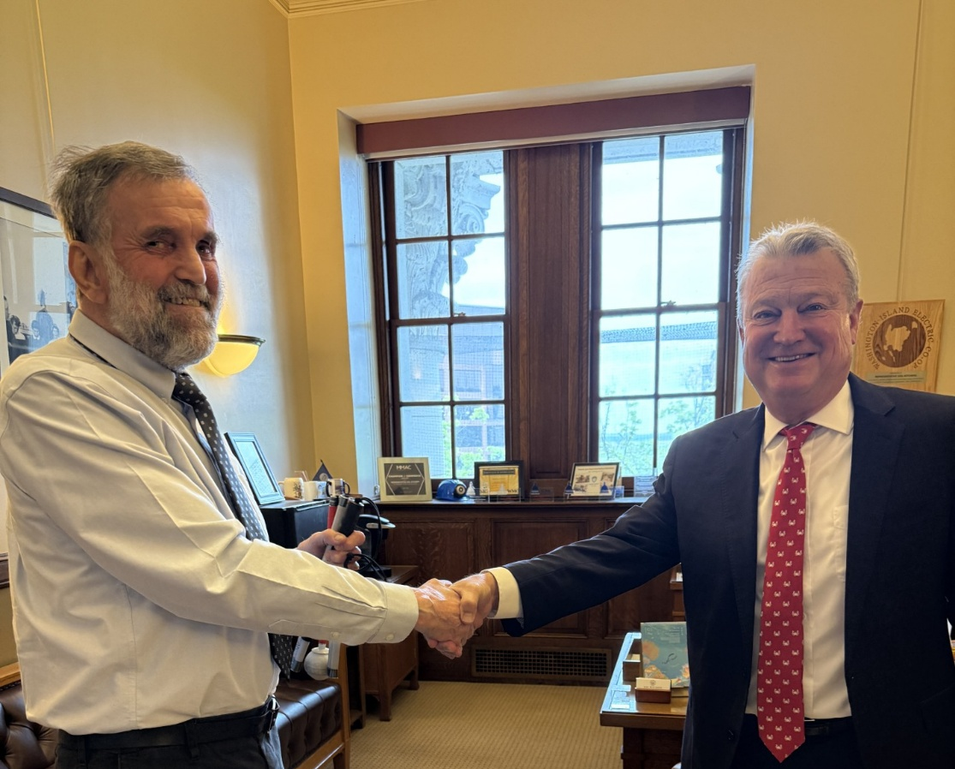
Caption: Peter Sherrill of Door County (left) met with his legislative representatives, including Rep. Joel Kitchens (right), during the Council’s 2025 Advocacy Days to help educate them about the Council’s policy priorities.
Since our founding in 1952, public policy advocacy has been a core component of the Council’s mission. As a 501(c)(3) nonprofit organization, we are bound by strict rules about how we go about lobbying and advocacy. Abiding by these rules keeps the Council in compliance with the law and protects our nonprofit status, but it also helps guide us in our work.
“When we think about our key pillars of education and advocacy, along with our mission of promoting dignity and empowerment, the guardrails in place are central to our mission,” says Executive Director Denise Jess. “We represent all Wisconsinites with vision loss, no matter their political leaning. So when we advocate for legislation, we work with those who are making the big decisions, regardless of their party affiliation, in a way that both follows the law and gives us a seat at the table.”
The rules about how much advocacy nonprofits can engage in without jeopardizing their nonprofit status have always been murky. But a bill passed by Congress in the mid-1970s clarified the matter a bit, spelling out how much of our budget we can spend on advocacy activities. The limits on lobbying lawmakers directly remain somewhat vague—we cannot dedicate a “substantial” amount of time to it—but like most other organizations, we track our advocacy time carefully throughout the year and stay comfortably within those boundaries.
Even if it’s not for a “substantial” amount of time, there are still limits on our advocacy. The purpose of these guardrails is to ensure that we do not become a partisan organization. So while we can advocate for or against pieces of legislation, we cannot publicly support or oppose political candidates. For example, we can meet with policymakers to educate them about the issues surrounding certain legislation, testify at public hearings, and talk about policies we support or oppose, but we cannot raise funds for or make campaign contributions to candidates running for office. And we are not allowed to compare the Council’s position on an issue to that of someone running for office. The National Association for the Education of Young Children provides a great list of advocacy dos and don’ts for nonprofits on their website. As a statewide nonpartisan organization representing all Wisconsinites who are blind or low vision, we easily follow these rules simply by living our mission.
Advocacy means more than just lobbying. The Council dedicates much of our work toward educating lawmakers and the public instead of working as lobbyists. Our advocacy happens on a continuum, where we start by educating people on the issues, then advocate on those issues, and then directly lobby for or against specific legislation. The Council does not actively litigate legislation in court.
“We’ve shifted our strategy over time to focus more on education and less on direct lobbying,” Denise says. “When we educate people about the issues instead of directly lobbying, we tend to have a bigger overall impact while making new allies in the Legislature who might not have listened to us if we only talked to them when we wanted them to vote a certain way. The issues that we work on aren’t going to be solved overnight; we have to be persistent in continuing to work with lawmakers and building relationships with them.”
Being perceived as partners rather than lobbyists helps us build credibility and further influence policy related to our mission. The guardrails that keep us from becoming a partisan entity also help form the basis of how we can be most effective as advocates.
To learn more about the Council’s advocacy and about our legislative priorities, visit the Advocacy page on our website at WCBlind.org/Advocacy.

Header: There are Many Ways to Give to the Council

People support the Council for many reasons. Maybe they received services from us in the past, or perhaps a family member was blind or low vision. Maybe they have benefitted from our advocacy or simply want to help us advance our mission. Whatever their reasons, we’re grateful to everyone who supports our work. We offer a wide variety of different ways to give.
Probably the easiest and fastest way to give is through an immediate cash gift. A gift in the form of a check or credit card can quickly provide support for all our programs and services. The Council accepts MasterCard, Visa and Discover, and donations can be made securely online through PayPal whether or not you have a PayPal account.
You can spread out your gift over the entire year by becoming a monthly donor. Instead of making one large gift, you can give a smaller amount each month. Monthly giving provides the Council with predictable, stable income that helps sustain our work throughout the year while allowing you to make a big impact a little bit at a time. We recognize our monthly donors collectively as our White Cane Circle.
If you are 70½ or older, you can make a qualified charitable distribution (QCD) directly out of your IRA. This allows you to give up to $100,000 tax-free every year, and your gift counts toward your required minimum distribution. To make a QCD, contact your IRA provider and request a direct transfer to the Council.
Another tax-advantaged way to give is through a donor advised fund (DAF). After setting up a DAF with your financial institution or community foundation, you can add funds to it whenever you like. When you’re ready to make a gift, talk with your fund holder and request a donation be made.
Eligible Thrivent members can direct Choice Dollars to the Council through the Thrivent Choice program. These funds come at no personal cost to you and allow you to help decide where Thrivent will distribute its funding. If you are eligible, talk to your agent or go to Thrivent.com/Thrivent-Choice to direct charitable funding to the Council.
You may have opportunities to support the Council in your workplace. Many employers offer workplace giving campaigns through organizations like Community Shares of Wisconsin (CSW) to give employees an easy way to support organizations they care about. In most cases, you can either make a gift in one lump sum payment or through smaller deductions taken out of each paycheck. 100% of the designated proceeds through CSW workplace giving campaigns go to the organizations you choose.
A memorial gift is a way to honor someone’s legacy after they have passed. To direct memorial donations to the Council, include this phrase in the obituary: “Memorial gifts may be made to the Wisconsin Council of the Blind & Visually Impaired, 754 Williamson Street, Madison, WI 53703 or online at WCBlind.org.” Similarly, a tribute gift is made in honor or memory of a friend or loved one. When making either a memorial or tribute gift, please include your name and address when you set up the fundraiser so we can notify you when gifts are made.
If the Council has had a significant impact on your life, consider a planned gift to create a legacy that will bring lasting change for generations to come. Being named as a beneficiary in a will or life insurance policy is a high honor for the Council, as it demonstrates the true impact we have had on somebody’s life. The Council can also be named as a beneficiary of an IRA or other retirement account. Doing this avoids the income tax burden family members may owe upon inheriting these assets.
The Council also accepts in-kind donations in the form of donated low vision tools and equipment in good condition. Common types of used equipment we accept include magnifiers, flat-screen closed circuit TVs (CCTVs), adaptive kitchen products, and clocks. We are only able to accept used equipment that is clean and in full working order with all original parts present, including power cables. For electronic devices, such as CCTVs, we can only accept equipment made within the last 15 years.
There are even ways to support the Council without direct financial or monetary value. Reach out to us to share how the Council has had a positive impact on your life so we can share it with our community. Subscribe to and share our On Sight e-newsletter. Follow us on social media and share our posts. Helping to spread the word about the Council far and wide can make a lasting impact on both us and people with vision loss across Wisconsin.
Learn more about all the ways you can give to the Council by contacting Development Director Debbie Rasmussen at DRasmussen@WCBlind.org or 608-237-8113.

Header: Sharper Vision Store is the Best Choice for the Adaptive Products You Need
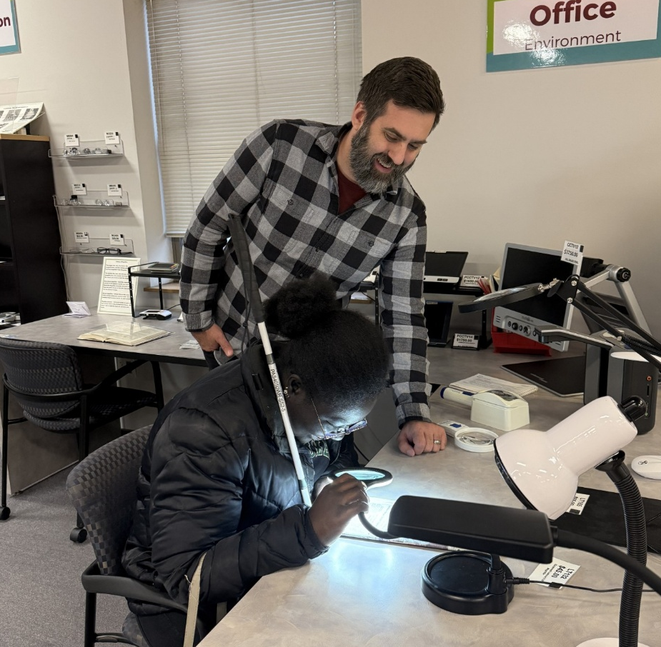
Caption: Customer Care Specialist Greg Schmidt helps a store customer choose the right magnifier for her needs.
For over 50 years, the Council has operated a store stocked with adaptive products to help people who are blind or low vision continue living their lives with dignity and greater independence. The Sharper Vision Store has everything from magnifiers to kitchen equipment to sunglasses to bump dots, all curated and tested by our Vision Services team.
When buying from the Sharper Vision Store, our highly trained staff can help you to find the products that you need. All too often, we hear from clients who have bought something they believed would work for them from a large online retailer, only to find that it was not right for them. When you buy from the Sharper Vision Store, you can be confident that our staff will help guide you toward the most suitable items for your individual needs. We test products before they are placed on the showroom floor to ensure that they meet the highest standards and that we understand their benefits and limitations. And as a nonprofit, we keep our margins significantly lower than most other retailers so that our customers get the best price on the best products.
There are three ways to shop at the Sharper Vision Store. You can visit our physical storefront at 754 Williamson Street in Madison, where our customer care specialist can help you find the perfect item for your needs. You can also visit our online store at Store.WCBlind.org and see everything we sell from the comfort of your home. And if you already know what you need, you can call us at 608-255-1166 and purchase from the Sharper Vision Store over the phone.

Box at end of store article:
Effective May 4, 2026, the Sharper Vision Store will be closed for walk-in shopping on Mondays. You are still welcome to place orders online at Store.WCBlind.org or over the phone by calling 608-255-1166 or 800-783-5213.

Header: Upcoming Events
Birding by Ear
Learn to identify birds by sound rather than sight. On Saturday, May 2, we’re teaming up once again with Southern Wisconsin Bird Alliance and Aldo Leopold Nature Center to present this unique educational opportunity. Open to birders of all experience levels and physical abilities. Learn more and register at https://swibirds.org/all-events/2025/5/10/birding-by-ear.
Dining in the Dark
Dining in the Dark is an experiential dinner that challenges attendees to rethink the role of vision in the dining experience. The Council partners with restaurants across the state to host Dining in the Dark fundraisers. Guests are blindfolded during the multi-course meal. The next Dining in the Dark event is scheduled for Monday, May 18 at Brix Cider in Mount Horeb. Visit https://WCBlind.org/events/dining-in-the-dark for more information and to make reservations.

Back Page:

Did you know that the Council Courier is also available in braille and audio formats? To request an alternative format or update your mailing address, call us at 608-255-1166.

The Council also publishes weekly e-newsletters that include features, helpful tips, advocacy information, upcoming events and more. You can subscribe at WCBlind.org/newsletter-signup.

