Wisconsin Council of the Blind & Visually Impaired
2025 Annual Report
A Year of Progress and Impact

Mission & Values
Mission: To promote the dignity and empowerment of the people of Wisconsin who are blind or low vision through advocacy, education and vision services.

Values: Inclusivity, integrity and uncompromising respect are the core values that guide the Wisconsin Council of the Blind & Visually Impaired in fulfilling our mission. We foster long-term relationships grounded in these values with our partners, clients, sister organizations, donors, policymakers and the public.

Message from the Executive Director and the Board Chair

A New Identity on the Horizon
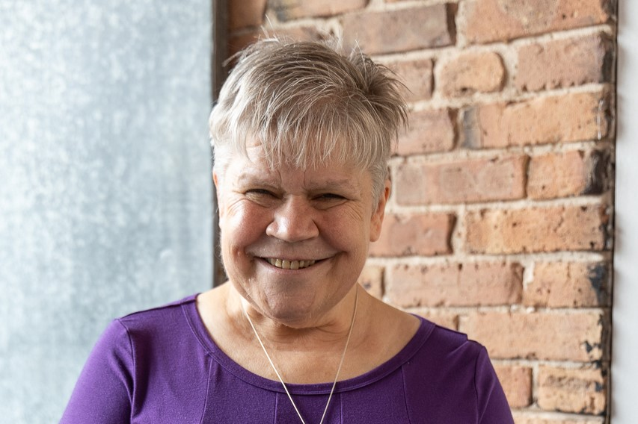
Caption: Denise Jess
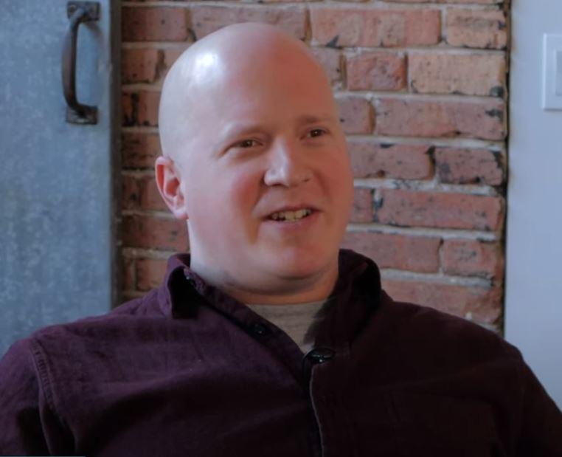
Caption: Nick Sinram
An annual report is mainly about what an organization accomplished during the previous year. But it’s also an opportunity to look forward at our plans for the year ahead. When we completed our 2025-27 strategic plan back in 2024, it included a full-blown rebrand, with a new identity to be unveiled in 2027 to coincide with our organization’s 75th anniversary. In 2025 our Board of Directors approved a 2026 budget that included significant resources to support the rebranding project. That work, which will eventually result in a new name, new logo and new website, is taking place throughout 2026.
This is a major undertaking that we are committing an enormous amount of energy to getting right. We are making sure to honor the Council’s 75-year history while embracing a future of greater diversity and life experiences among people experiencing vision loss. Our process involves gathering input from a wide range of stakeholders that includes clients, donors, staff and board members, fellow advocates and community partners. We’ve enlisted the help of a top-notch Madison-based marketing firm to translate all that information into a new brand and image that captures the Council’s essence powerfully and succinctly.
These are some of the key considerations that led to our decision to rebrand:
• Our current name causes a lot of confusion. It is very similar to the Office for the Blind and Visually Impaired, a state agency that offers some of the same services we do. We get calls intended for them all the time. It is also very similar to the Wisconsin Center for the Blind and Visually Impaired, the school in Janesville. We even have the same initials, WCBVI. For those new to vision loss and their families and caregivers, this leads to uncertainty about where to turn to have their needs addressed.
• Our current name is too long and cumbersome. People get it wrong quite often. It doesn’t even fit into the space allowed on many online forms we must fill out. Having people recognize our name and use it correctly strengthens our organizational identity.
• Our current name does not reflect how we have evolved over time. We are not really a “council” anymore. We have also moved beyond the language of “impairment,” which suggests there is something “wrong” with people who are blind or low vision.
We recognize that a change this big can spark a range of strong feelings. No matter what new name we land on, it’s inevitable that some people in our orbit will love it while others, possibly even some within the organization, may experience grief or disappointment. But as challenging as this project is, it’s also incredibly exciting. It has the potential to strengthen our organization and help us build a more powerful identity that will ultimately enhance our impact. Stay tuned as this exciting process moves forward and a new chapter in the Council’s story approaches!

Vision Services Impact: Gaining a Better Understanding of Client Needs
In May of 2025, Kate Bleyl-Ericson joined the Council’s vision services team in the newly created role of vision services navigator. The navigator serves as the first point of contact for new clients, conducting intakes to better connect people with the services they need, both inside and outside the Council. Kate has already had a huge impact on the lives of the people we serve, as well as helping the Council gain a better understanding of the folks who come to the Council and the challenges they face.
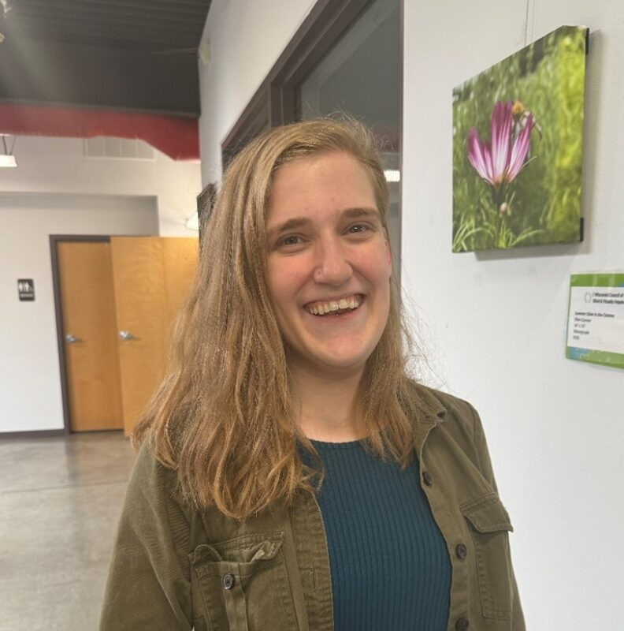
Caption: Kate Bleyl-Ericson
When our vision services team meets with clients in their homes or in the community, it’s not unusual for us to discover that they have needs beyond what we can provide directly. Food insecurity, imminent eviction from their home and problems accessing transportation are common situations. People who are blind or low vision face high rates of poverty and unemployment and are more likely than others to experience negative health outcomes, which in turn contributes to these challenges. Our navigator helps us better identify these needs and connect clients with resources in their communities that can help address them.
During a comprehensive intake process, Kate asks new clients about any needs in their lives that are not being met. Kate then determines who on our vision services team can assist in their vision loss journey while identifying needs that we may not be able to address. Kate has developed a comprehensive directory of resources and organizations that can assist with a range of challenges the client may have. When not conducting intakes, Kate is talking with these organizations to establish connections and build a deeper knowledge of how their services can help our clients.
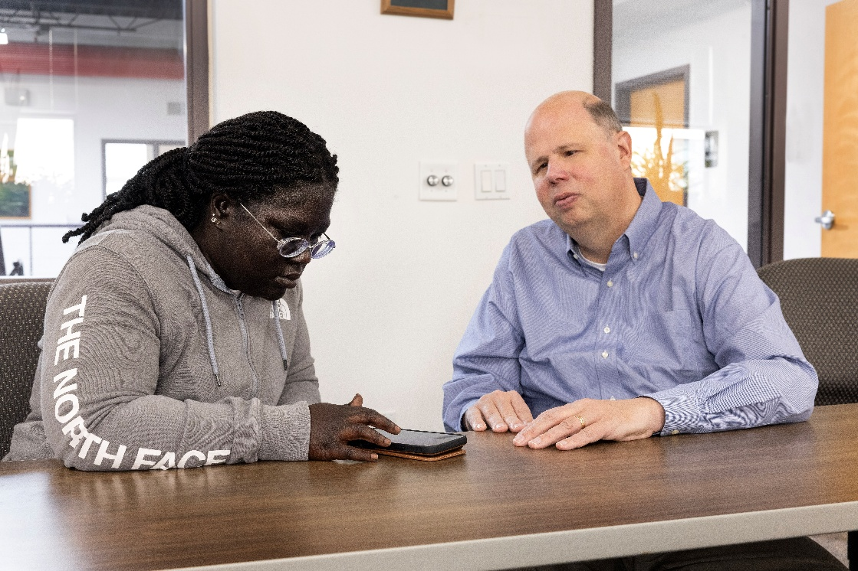
Caption: Access Technology Specialist Jim Denham instructing client Mikayla Mobley on smart phone accessibility features

Lynn first came to the Council looking for access technology instruction. She did an intake with Kate, who connected her with the Council’s access technology specialist Jim Denham. Kate also connected her with several other resources, including the state Division of Vocational Rehabilitation, part of the Wisconsin Department of Workforce Development, for help in her workplace. Today, Lynn says she uses access technology at her job every day and was recently approved to use Meta smart glasses to further help her at work.
“Kate was absolutely wonderful to work with,” Lynn says. “It was so great to be able to bounce ideas around with someone who really understands. I’ll admit I was hesitant to reach out to the Council because it can be hard to ask for help. But I really appreciate the kindness shown to me by everyone, especially Kate, and all the different resource options they gave me. Like throwing a stone in a pond, it’s created a ripple where people are now turning to me as a resource. I’ll help them when I can, but I also know that I can send them to Kate, who is perfectly suited to help them.”
The impact of the navigator is also being felt at the Council. Through the intake process, Kate gathers demographic information about the people who come to the Council for services. This data includes the usual information like the client’s age and gender, but also information about their vision loss and whether they’ve received vision services in the past. This data is extremely valuable to the Council and informs decisions across all pillars of our organization. We can provide this data to lawmakers when advocating at the Capitol, use it to apply for demographic-specific grants, or follow the data to better focus our education and outreach efforts. It would be easy to assume we are serving only a specific population segment with our services, but our data can show our vision services team that they are regularly working with diverse communities.
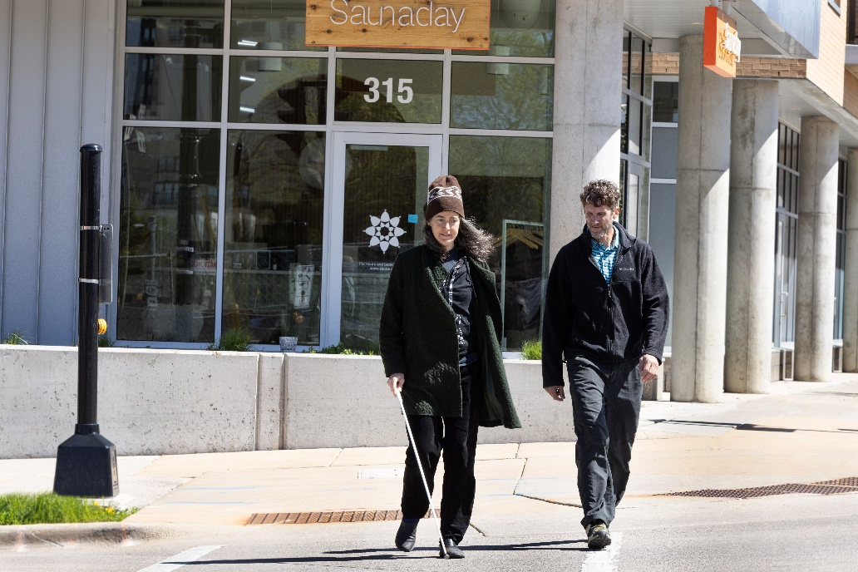
Caption: Certified Orientation & Mobility Specialist Brent Perzentka instructing client Sarah Evans on navigating the streets of Madison

“In addition to just being good practice, this data is really helping affirm some of the statistics we see at the national level,” says Education and Vision Services Director Amy Wurf. “Our navigator can provide as much time as our clients need to share their story and gather the information we need to be better providers for both this specific client and everyone else we serve.”
“The whole purpose of the navigator is right there in the name,” Amy says. “They help people navigate both their vision loss journey and their life in general. Everything we do in life is impacted by our vision. If someone doesn’t have access to healthy food or a job, is that a byproduct of their vision loss? Working with the navigator, they can better connect those dots, and we can better serve all of our clients’ needs.”

Box:
Vision Services in 2025
- 303 Access Technology Appointments
- 255 Low Vision Evaluations
- 229 Orientation & Mobility Visits
- 220 Navigator Contacts
- 454 canes provided to clients in 48 counties

Advocacy Impact: Taking Our Message to the Court System
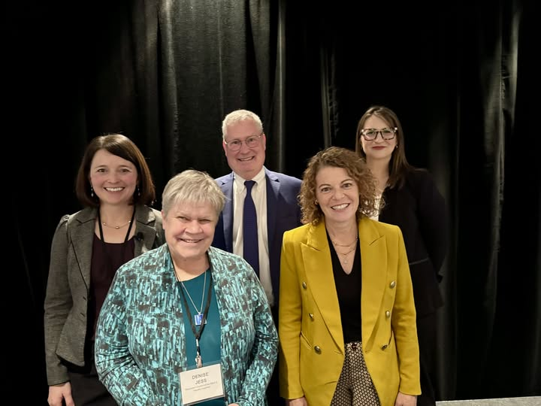
Caption: Denise at the annual Wisconsin Judicial Conference in November. Back row left to right: Amber Peterson, District 5 Court Administrator; Charles Petrof, Access Living; and Hannah Balder, Disability Rights Wisconsin. Front left to right: Denise Jess and Wisconsin Supreme Court Justice Rebecca Dallet.
Since our founding nearly 75 years ago, advocacy has been one of the Council’s top priorities. We regularly advocate on the local, state and federal levels for policy initiatives that promote the dignity and empowerment of Wisconsinites who are blind or low vision. In addition to working with lawmakers on specific legislation, we are always looking for new ways to educate them about ways they can make a meaningful difference in the lives of the people we serve.
In 2025, we had the opportunity to do important work within the judicial system. In the second half of the year, we were able to connect with judges at multiple levels, including municipal courts, state circuit courts, and even some Supreme Court justices, along with circuit court clerks. At events across the state, Council staff spoke about the importance of creating welcoming courtrooms for people with disabilities, and why they should go beyond what is required by the Americans with Disabilities Act (ADA). When people with disabilities are treated with respect and dignity, they will be more likely to have a fair and just experience with the courts.
While these judges are aware of the rules mandated by the ADA, the value of having those rules reinforced by people with lived experience is immeasurable. People with disabilities are more likely to face bias and misperceptions in the courtroom, which can lead to higher rates of incarceration. According to a report from the Bureau of Justice Statistics, nearly two in five people in state or federal prisons had at least one disability. But when courtrooms are made into safe spaces for people with disabilities through open hearts and minds, the system becomes fairer, with more equitable outcomes.
In November, Executive Director Denise Jess had the honor of speaking before judges from across the state at the annual Wisconsin Judicial Conference, where she talked about the importance of creating welcoming, compassionate, ADA-compliant courtrooms that serve people with disabilities equitably. “These talks were very successful, with judges asking meaningful questions and having valuable conversations throughout the conference,” Denise said. “My hope is that when anyone has to go to court, their disability status doesn’t unfairly disadvantage their outcome.”
Court officers do not generally make their courtrooms inaccessible intentionally. The problem is a lack of knowledge about the barriers people with disabilities face in the judicial system. Judges and clerks shouldn’t ask for specific information about an individual’s diagnosis. Instead, they should ask directly for more information about the barriers the person is experiencing. By providing reasonable accommodations, such as large print or brailled documents, and treating the person requesting those accommodations with respect, courtrooms can become genuinely fair and inclusive.
“We were honored to partner with Denise and the Wisconsin Council of the Blind & Visually Impaired to provide a number of trainings to Wisconsin circuit court judges, municipal court judges, and clerks of circuit court on effectively working with people with disabilities,” says Amber Peterson, Deputy Director of State Courts for the Office of Court Operations. “Providing these trainings to court professionals is essential to ensuring equal access to justice. When judges and clerks understand the barriers individuals with disabilities may face and the accommodations that support full participation in the court process, they are better equipped to ensure procedural fairness and strengthen trust in the courts.”
“While it is essential that judges understand the legal requirements of the ADA, it is equally important that they recognize the profound personal impact (of the rights) those laws are designed to protect for litigants that come to our courts,” said Wisconsin Supreme Court Justice Rebecca Dallet. “It was so powerful to have Denise share her unique perspective with the Wisconsin judiciary to help build this awareness. When judges pair legal knowledge with compassion, they ensure that people with disabilities are seen, heard, and able to meaningfully participate in the court process.”

Education and Outreach Impact: Growing Footprint Connects Us with New Clients
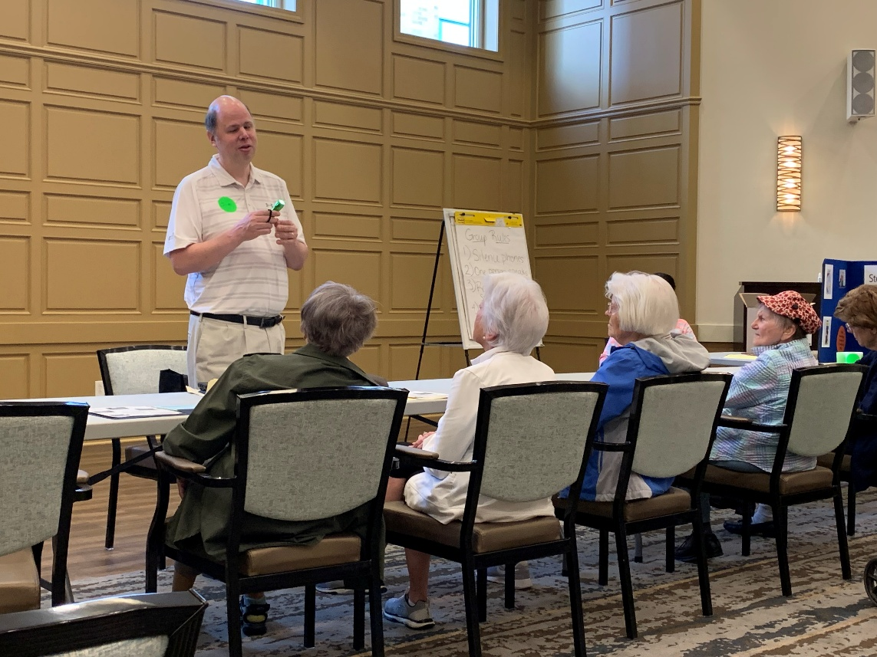
Caption: Jim Denham presenting at a Stepping On event

Education and outreach are a pillar of the Council’s mission. We meet the community where they are to teach them about living with vision loss and the services we can provide at the Council. In 2025, we attended 65 events across the state where we connected with over 3,100 people of all different backgrounds. We’ve broadened our outreach strategy in recent years, focusing on the entire spectrum of vision loss with attention to specific audiences or eye diseases. This new strategy has brought the Council before new groups, expanding our footprint in communities across Wisconsin while strengthening our services and our mission.
“We’ve become really intentional with where we’re reaching out and what kind of information we are providing to people,” says Education and Vision Services Director Amy Wurf. “When we can focus on the entire field of eye health and vision rehabilitation, we can get before agencies and organizations that may not have reached out to us in the past. It’s so important that we make these new connections so that we can spread the word about everything that we do among people who may not have heard about us before.”
We may know that another organization exists, and vice versa, but it can be hard to see ways we can work together if we haven’t formally communicated with each other at some event. By broadening our outreach efforts, we can begin to share with each other the scope of our work. Once these formal introductions have been made, it can become easier to find pathways to collaborate and better serve a wider audience while promoting each other’s work.
Stepping On is a worldwide initiative that promotes fall prevention through workshops in local communities. Here in Wisconsin, the Council has attended many of these workshops to talk about the role vision plays in avoiding falls. We join other experts in our communities, such as public safety officers, occupational therapists and pharmacists, to help people stay safe and on their feet while generating new relationships with both clients and organizations we may not have had opportunities to work with in the past.
“Our partnership with the Council has really strengthened over the past few years,” says Ashley Hillman, director of program partnership with Safe Communities, the organization that coordinates Stepping On in Dane County. “The value of having someone like the Council come in to act as an external expert on vision is immeasurable. Vision is one important part of falls prevention and can influence other risk factors. The Council works in tandem with our other experts to address every root cause of why people fall. It’s like a big puzzle, and the Council is one very important piece. They’re such a wonderful partner in our mission.”
As we broaden our footprint across the state, we are able to serve new clients who may not have been aware of our services in the past. We know that only a relatively small portion of people with vision loss in Wisconsin are accessing the vision services they can benefit from. Some of those people have more complex health concerns and already work with a team of physical and occupational therapists to help them live independent lives. By connecting with providers in fields outside of vision services, we can let them know about our services and how we can join their team to address their needs more fully.
We recently connected with an organization providing services for people with developmental disabilities living in group homes, some of whom are also blind or low vision but are not receiving the kinds of vision services the Council provides. They referred some of their clients to us, and now those clients have multiple certified specialists trained to address a specific need instead of having just one or two people trying to take on all of their complex challenges.
Joining this team of service providers has a trickle-down effect. When we teach these clients skills to gain independence, often family members and other staff at the facility will learn these skills too. “When the people around the client are watching and taking notes, they learn how to better care for both this specific client and other clients who may have vision loss,” Amy says. “It’s great to be able to spread that information; working with these service providers is a great way to get information about what we do out to as many people as possible. That can only happen when we go out into the community and connect with these people and organizations.”

Box:
Education & Outreach in 2025
We reached 3,150 participants through 65 presentations and outreach events.

Donors Find Many Reasons to Continue Supporting the Council
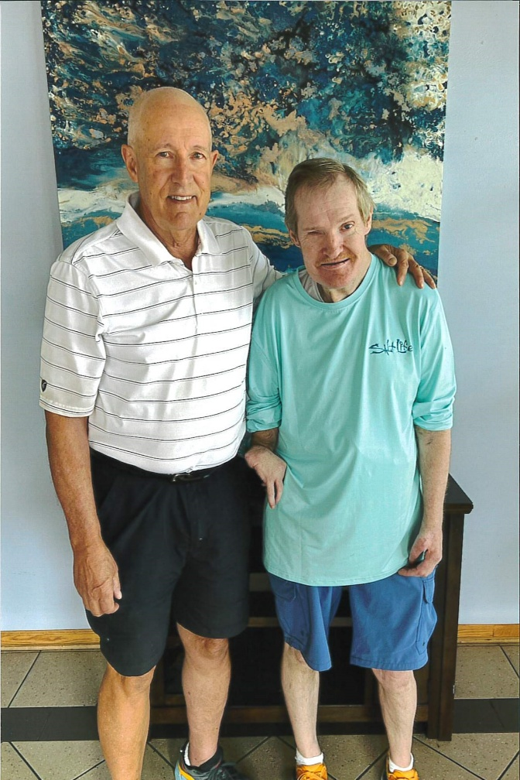
Caption: Steve Bentin with his son Mike
The work of the Council, from education to advocacy to vision services, would not be possible without the generous support of the hundreds of donors who give to us every year. The Council means something different to each supporter, but they all share one thing in common: a belief in our mission to promote the dignity and empowerment of people who are blind or low vision.
Steve Bentin of Madison has been giving to the Council for over 40 years. Steve’s adopted son was born with multiple disabilities, including no vision in his right eye. While his son, who has since passed away, did not receive vision services from the Council, Steve says he was still motivated to support us in order to help others who have lost their vision. “All these years later, it’s still important to me to help out the Council however I can,” Steve says. “I never knew if my son would need services from the Council, but it made me realize that he very well could have. It just stayed so important to be able to do whatever I could. Whoever is out here helping people maintain their dignity is alright by my book.”
Dave Ackmann of Waukesha has been giving to the Council for nearly 30 years. Retinitis pigmentosa runs in his family, he says, and today his vision is less than it once was. “I read the newsletters the Council puts out, and I’m always so impressed by everything the organization does,” Dave says. “On one side of my family, just about everyone lost their vision eventually, so I continue to give to the Council today in their honor.”
Whether someone has been giving to the Council for decades or are making their very first gift, we are grateful to everyone who supports the Council. You can join Steve and Dave in supporting our work by visiting our website at WCBlind.org/Donate, or by contacting Development Director Debbie Rasmussen at DRasmussen@WCBlind.org or 608-237-8113.

Box:
Support for the Council in 2025
We received 1,427 gifts from 59 WI counties and 24 states and welcomed 223 new donors in 2025.

2025 Donors
Donors
Thank you to our generous donors. Find a complete list of donors on our website at WCBlind.org/donate/donors
Friends of the Council gave $500 or more throughout the year:
Carol Adams
Moses Altsech
Anonymous
Anonymous
Mike & Susan Archer
Anonymous
Joyce Bates
Priscilla & Anthony Beadell
Margaret Beatty
Berlin Lions Club
William Bethke
Bonita Campbell
Paul & Sandra Christianson
Anonymous
Computer & Networking Solutions
David Cooley
Edgerton Lions Club
Jean Espanshade
Don & Irene Golembiewski
Patricia Graupner
Nona Graves & Dennis Ameden
Greenville Lioness Lion Club
Anonymous
Loretta Himmelsbach
William & Michele Holcomb
Anonymous
Hortonville Lions Club
Carole Hughes
David Jenneke
Tom & Judy Jensen
Denise Jess & Jani Koester
Chip & Christy Kaufman
Robert Kivela
Anonymous
Marlyn & Jo Ann Klongland
Candice Koehn
Mel & Brian Kolstad
La Crosse Lions Club
John & Terry Ladwig
Lake Wisconsin Lions Club
Anonymous
Marvin Levy
Bryan Lilly
Barbara Lockwood
Lomira Lions Club
Constance Malak
Middleton Lions Club
Sanbrita Mondal
Gail Morton
David Mueller
David Nelson
Neshkoro Lions Club
Barbara Nilsson
Anonymous
Plymouth Lions Club
Kevin & Lori Purcell
Timothy Radelet
James Roberts
Jim & Phyllis Rood
Evelyn Safeblade
Sandra Schild
Joan Schmit
Tracy Schoenrock
Jean Schott-Wagner
Patricia Schroeder
Carolyn Schultz
Pat & Jay Smith
Karen Steffen
Judith Stolper
Marvin Strehlow
Catherine & George Tesar
Philip Tyrrell
Jeffrey & Christine Rushton
David G. & Nancy B. Walsh Family Foundation Ltd
Lori & Mark Werbeckes
Williams Bay Lions Club
Jeffrey Williamson
Barbra Winter
Karin & Geoffrey Woie
Betty Wray
Mary & Conrad Wrzesinski
Terri Young, MD
John & Roslyn Zeltins

These individuals have been supporting the Council for 10 or more consecutive years:
David Ackmann
Carol Adams
Nurudeen Amusa
Carol Anderson
Virgene Anderson
Anonymous
Carolyn Arndt
Richard Ayres
Alice & Eric Bannier
James Bardenwerper
Steven & Susan Baudo
Priscilla & Anthony Beadell
Cherri Becker
Bruce Bender
Steve Bentin
Michael & Luann Berns
Amy Bigna
Charles & Luann Boie
Nannette Boinski
Richard & Marilyn Borree
Stewart Brown
William & Denise Buenzli
Kathleen Burr
Bonita Campbell
Ruth Chalmers
Richard & Tracy Clark
Anonymous
Computer & Networking Solutions
Sue & Don Cowan
Anonymous
Wallace Cutler
Mary Daniel
Amy Dee
Claire Dick
Wallace & Margaret Douma
Sally Drew
Shelly & Peter Eisch
Phyllis Ermer
Rebecca Feldt
Don & Marlyn Fenhaus
Joyce Fiel
Cheryl Fine
Robert & Susan Flemming
James & Karen Fletcher
James Fowler
Elmer Frank
Linda Froehlich
Connie Gabrilska
Frances Gasper
Rachel & Daniel Golla
Rosemary Goodrich
Nona Graves & Dennis Ameden
Greenville Lioness Club
Jeffrey Gurriell
Mary Jean Hale
Susan Hansen
Karen & Dave Heesen
Anonymous
Dean & Barbara Hekel
Loretta Himmelsbach
Magdalen Hirst
William & Michele Holcomb
James & Lucille Hornung
Thomas & Jeanine Houtevelde
Marilyn & Neil Howell
John Hughes
Denise Jess & Jani Koester
Jean Kalscheur
Gary Karl
Anonymous
Rebecca & Michael Kneer
Anonymous
Candice Koehn
Warren & Janet Konopacki
Peter & Mary Kopp
Richard Krenzke
Jack & Linda Kuschel
John & Terry Ladwig
Allen & Jeanne Lamers
Anonymous
Marvin Levy
Lomira Lions Club
Arthur & Sandra Luedeke
Stewart Macaulay
Silvan Maly
Kenneth & Kay Mauk
Aleda McArdle
Dan Meyer
Debby & Dan Meyer
William Michels
Nyla Musser
Patricia Nelson
Barbara Nilsson
Jay & Linda Olson
Randal & Anne Orlikowski
Phyllis Orsburne
Brent Perzentka
Dan & Judy Peterson
Derek Peterson & Beth Esser
Anna Mae Petrusha
Ronald & Judy Phillips
Lee Pondrom
Sarah Potts
Anne Putnam Smith
Christopher Rapp
Mary Rebhan
Jennifer & Greg Rice
Chris Richmond
Gerald Ring
Delores Robillard
Mary & Robert Roenneburg
Doug & Carla Salmon
Gladys Schaefer
Anthony Scherer
Anonymous
Tracy Schoenrock
Kathleen Schuster
Charles Schwarting
Raymond & Kathi Smerz
Michael Smith
Anthony Smorynski
Margaret Sommers
Kathy Southard
Rhonda Staats
Maurice & Lois Stecklein
Karen Steffen
Jon & Rebecca Stellmacher
Michael & Takako Sterr
Kim Stien
Judith Stolper & Gene Haug
Audrey Studrawa
Emma Thieme
Douglas Thorp
Gary Utterberg
Carol & Richard Van Boxtel
Lee Vermilyea
Bill Vielgut
The Vogel Foundation
Eunice Wagner
Anita Waterbury
Lester Watters
Wenthe-Davidson Engineering Co.
Lori & Mark Werbeckes
Elizabeth & Phillip Willems
Margaret Williams
Barbra Winter
Gary & Sandra Yakes
John & Roslyn Zeltins
Lon & Linda Ziehm

Council Visionaries have contributed $20,000 or more over their lifetime:
Carol Adams
Anonymous
Loretta Himmelsbach
Rosemary Himmelsbach
Robert Holloway
James Roberts
Marvin Strehlow
Catherine & George Tesar
David G. & Nancy B. Walsh Family Foundation
Margaret Williams

Items and services valued at $200+ were received from:
4Imprint
American Printing Company
Stanton Davis
W. Lee Hansen
Merriel Kruse
Sara Lenz
Barbara McClellan
Sonja Penner

2025-26 Council Staff
Jaxon Baker, Program Associate
Kate Bleyl-Ericson, Vision Services Navigator
Susan Bosques, Administrative Assistant
Mitch Brey, Operations Manager
Heather Buggs, Administrative Assistant
Kathleen Callen, Education and Outreach Coordinator
Jim Denham, Access Technology Specialist
Bob Jacobson, Communications Director
Denise Jess, Executive Director
Jodi Nachtwey, Development Specialist
Brent Perzentka, Certified Vision Rehabilitation Therapist, Certified Orientation & Mobility Specialist
Debbie Rasmussen, Fund Development Coordinator / Development Director
Greg Schmidt, Store Customer Care Specialist
Nate Wegehaupt, Communications Coordinator
Lori Werbeckes, Development Director
Amy Wurf, Education & Vision Services Director, Certified Low Vision Therapist

2025 Board of Directors

Executive Director
Denise Jess, Madison

Chair
Nick Sinram, Milwaukee

Vice Chair
Melanie Ramey, Madison

Secretary
Brent Goodman, Rhinelander

Treasurer
Renee Peterson, Horicon

Liz Fryseth, La Crosse
Maggie Groshan, Stoughton
Chip Kaufman, Middleton
Mikyla Mobley, Madison
Sanbrita Mondal, Middleton
Kole Torres, Menomonee Falls
Terri Young, Madison

The Wisconsin Council of the Blind & Visually Impaired is a 501(c)(3) nonprofit that derives revenue through individual donations, bequests, foundation and corporate grants, event sponsorships, client services, retail purchases and returns on investments. Copies of this and previous Annual Reports are available for download via our website at WCBlind.org.

Financials
2025 Revenue
Contributions .................. $489,853
Bequests ............................ $5,605
Store Sales (net)............. $216,696
Vision Services.................. $34,925
Rent ................................ $15,600
Investments ................... $872,050
Miscellaneous.................... $13,129
TOTAL REVENUE ....... $1,647,858

2025 Expenses
Low Vision Services .......... $591,350
Community Education ....... $385,004
Fund Development............ $190,010
Management & General ..... $441,082
Cost of Goods Sold ........... $187,513
TOTAL EXPENSES ...... $1,794,959
Back Cover:

Council logo
754 Williamson St., Madison, WI 53703
800-783-5213
info@WCBlind.org
WCBlind.org

The Council is a 501(c)(3) nonprofit organization that relies on donations to fund our operations. Visit WCBlind.org/donate or use this QR code to give via our website.
