Council Courier, Fall 2026

Header: Council Connects with Community at Spring and Summer Events
The Council regularly connects with the community through educational events both in our backyard in Dane County and across Wisconsin. Over the spring and summer months, we’ve been hard at work spreading the word about our mission and affirming that with the right adaptations, people who are blind or low vision can do almost anything they put their mind to.
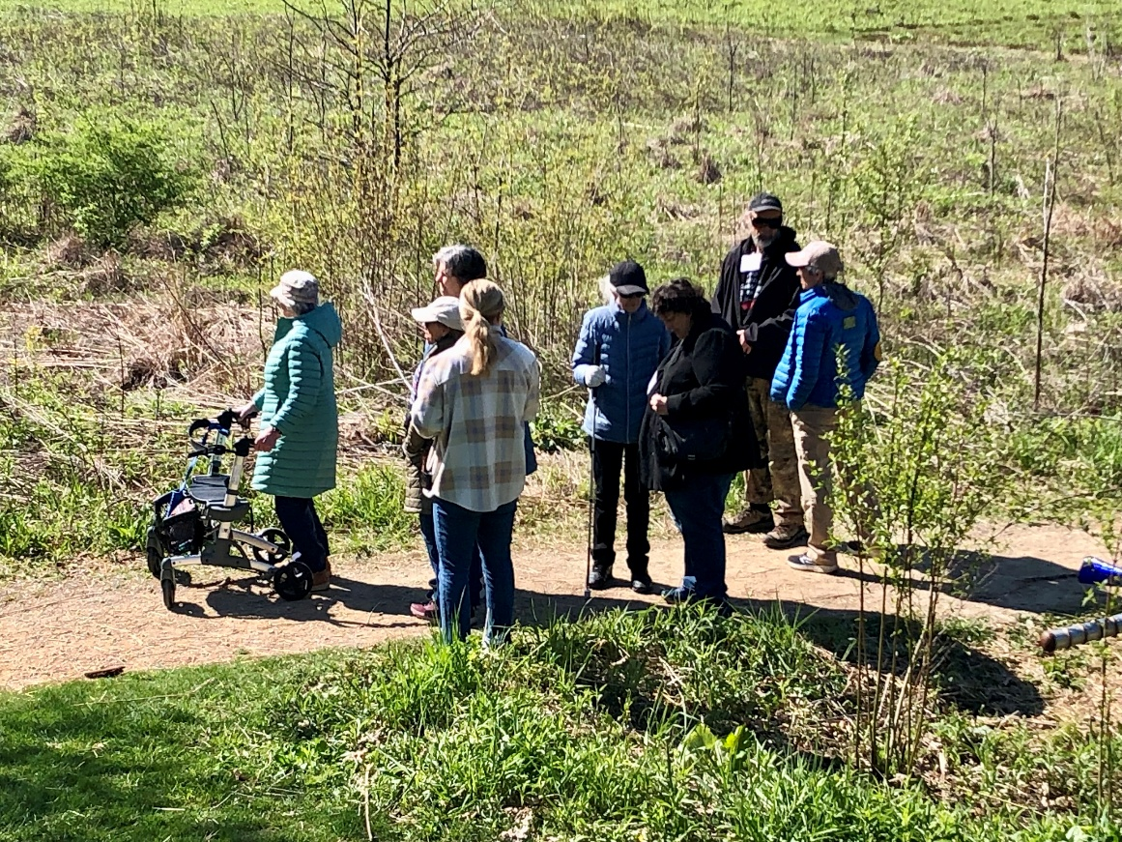
Image: Eight people in a field listening for birds
We welcomed the return of warm weather in May with Birding by Ear. Organized in collaboration with the Southern Wisconsin Bird Alliance and Aldo Leopold Nature Center in Monona (which also hosted the event), Birding by Ear is a prime example of an outdoor activity extremely well suited for people with vision loss. People from across the vision spectrum and with all levels of birding experience met to learn to identify birds by their sounds rather than by their shapes or colors, while exploring the trails of the nature center. In addition to our partner organizations, we would like to thank our skilled guides for once again helping make this event a resounding success.
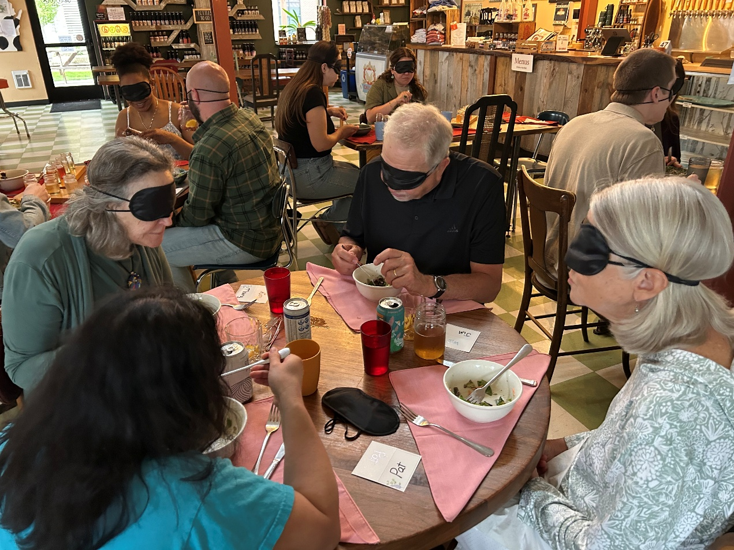
Image: A group of people sitting at tables eating a meal while blindfolded

Also in May, the Council visited Mount Horeb to host Dining in the Dark at Brix Cider. This unique culinary experience had participants don blindfolds to focus on senses other than sight to appreciate their meal and dining companions. After the meal, Council staff led a discussion about the role of vision in the dining experience. This discussion was especially impactful for Richard and Krista Ralston of Madison, who joined us for their second Dining in the Dark event.
“It was really gratifying to hear from everyone else in the room about what they encountered during the meal, especially from the people who are blind or low vision describing how they manage the dining experience every day,” Richard says. “I feel like Dining in the Dark is such a great event to help people become better caregivers or spouses or just more understanding members of the general community.”
In June, we awarded scholarships to eight Wisconsin students who are blind or low vision attending postsecondary education in the fall. The Council has been awarding scholarships for most of its history, and the program continues to make an impact today. Unlike other scholarships, we allow students to use the funds however they see fit. We know that students with vision loss take on additional financial burdens for things like access technology and transportation costs. Past recipients say their Council scholarship helped them to spend less time worrying about working a part-time job and more time focusing on their studies.
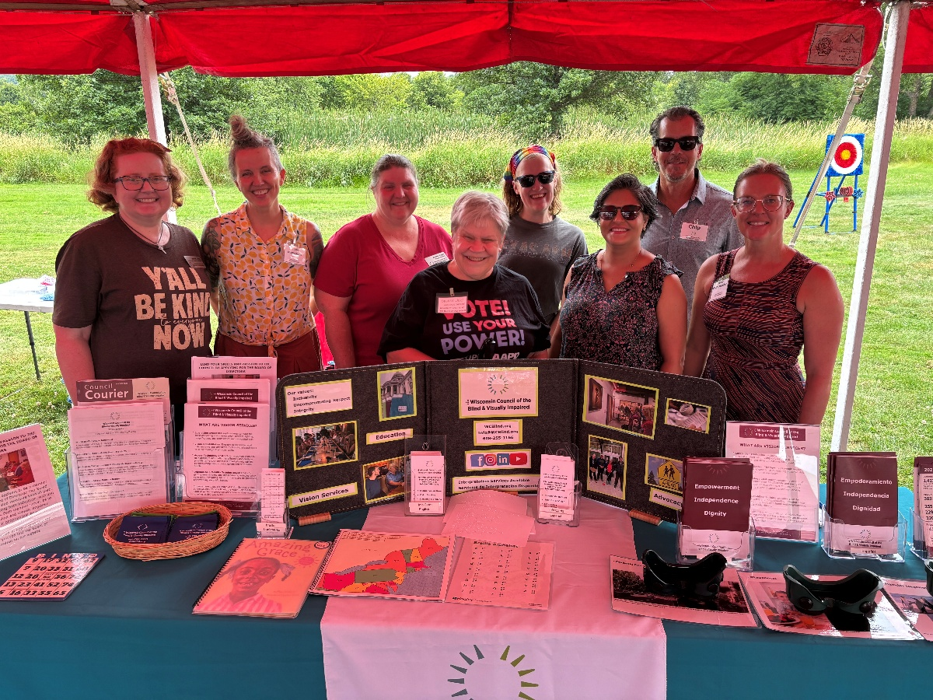
Image: Eight Council staff and board members standing behind a display table containing promotional materials

In addition to our big tentpole events, the Council went out into the community to meet our neighbors where they are and educate the public about our work. At events like the Madison Disability Pride Festival and the Madison Gospel Run/Walk and Health Fair in July, we connect with both new and old friends as well as with other organizations doing important work across Dane County and the entire state. These tabling events are a great opportunity to reach people who may not know who we are but could benefit from services we offer.
“These are really great events because they allow us to showcase all of the work we do at the Council,” says Education & Outreach Coordinator Kathleen Callen. “It feels good when other organizations come to us at these events to ask about how they can improve their services or create a new partnership. Whether they’re looking to become clients or have questions about accessibility in social media, the Council becomes a trusted resource when we put in the time and effort to reach into the community in these ways.”

Header: Message from Executive Director Denise Jess
Subhead: Dismantling Ableism
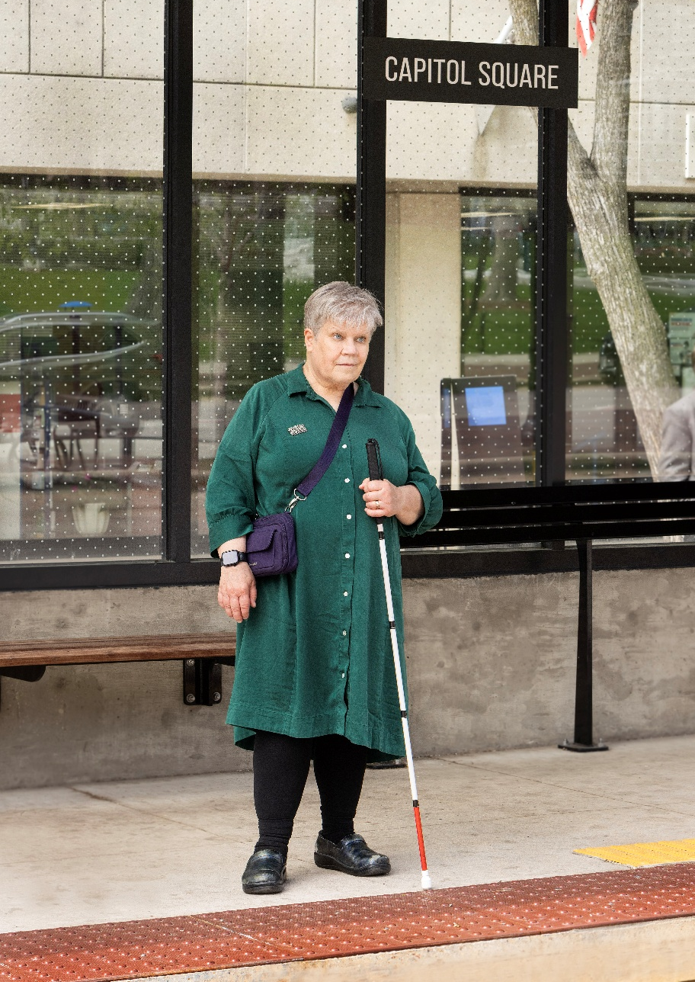
Image: A light-skinned woman holding a white cane standing at a bus stop

Throughout my life I’ve encountered people who have perceptions about me as a blind person—what I can, can’t, should or shouldn’t do. These perceptions can be frustrating, confusing and sometimes painful. I’ve had situations where I felt others were putting parameters on my life that didn’t make sense and weren’t in my best interest. Over the years, I’ve heard so many others share similar experiences, whether they are teens or older adults, in or out of the workforce, new to vision loss or visually impaired all or most of their lives.
We encounter these perceptions from strangers in our communities, service providers, caregivers and even from coworkers, family members and friends. Sometimes people will be overly protective or try to do things for us without asking or giving us the chance to do it ourselves. Or we aren’t given access to the same opportunities as our sighted friends, relatives or coworkers. We may be overlooked for a job or promotion or not invited into an activity, not based on our skills and talents but on assumptions about living with vision loss.
Those with these perceptions may not even be fully aware of what they are doing or saying. They are often trying to be helpful and do not intend to be unkind. But in many cases, people have gotten the message over the years that having a disability is somehow a bad thing, that it makes us less “whole” and reliant on someone’s charity. This messaging starts when we are little, continues throughout our lives, and is reinforced in many ways through the media and what influential people say about disabilities. The result is a society rife with biases, often unconscious, about vision loss and disabilities. We can even hold these biases against ourselves, believing that we are less worthy, less capable or even less lovable.
These biases sometimes carry over into the decisions made in our families, communities, businesses and public institutions. These unrecognized biases lead to barriers like poor lighting in apartment buildings and senior living facilities; inaccessible restaurant menus; health care and legal forms that can’t be completed by someone without sight; inaccessible websites; lack of public transportation; unsafe pedestrian access; and lack of funding for services like vision rehabilitation. These institutional barriers create even more limitations for those of us who are blind and low vision. We are left to figure out how to navigate these barriers. That means we have to put more energy than our sighted friends, family members, coworkers and neighbors into striving for the things we want.
What I’ve described is often referred to as ableism—a belief, whether conscious or not, that people with disabling conditions, including vision loss, are somehow inferior to non-disabled people. I often say that my world isn’t made smaller by my blindness, but rather by the barriers I face constantly in a world not built for people with vision loss.
Every day here at the Council, we work to break down ableism. We know that people with sight limitations still have inherent worth, and they matter as human beings deserving of equality and access.
When our Vision Services team teaches somebody a life skill, such as traveling with a white cane, using access technology to send an email, using a magnifier to see a photo of their grandchildren, or using adaptive kitchen tools to make dinner, old biases about our lack of capabilities are challenged.
When we award scholarships for postsecondary students and they arrive on campus ready to take on the world, they show us a way forward to greater access and equality by debunking assumptions and paving their own paths forward.
When we engage with the community at resource fairs and speaking engagements, we serve as role models of what we can achieve.
Our events, like Gallery Night and Birding by Ear, showcase the incredible talent, curiosity and human potential that we bring to our communities as blind and visually impaired individuals.
Through our public policy work, we consistently strive to break down systemic barriers around non-driver transportation and pedestrian safety, voting, and access to the digital world.
Thank you to the many generations of staff, board members, donors, volunteers, clients, store customers and community partners who have contributed in small and large ways—sometimes without even knowing you did something important—to the dismantling of the barriers of ableism and creation of a better world for people with vision loss. I am truly grateful.

Header: Know the Different Types of Vision Professionals on Your Team
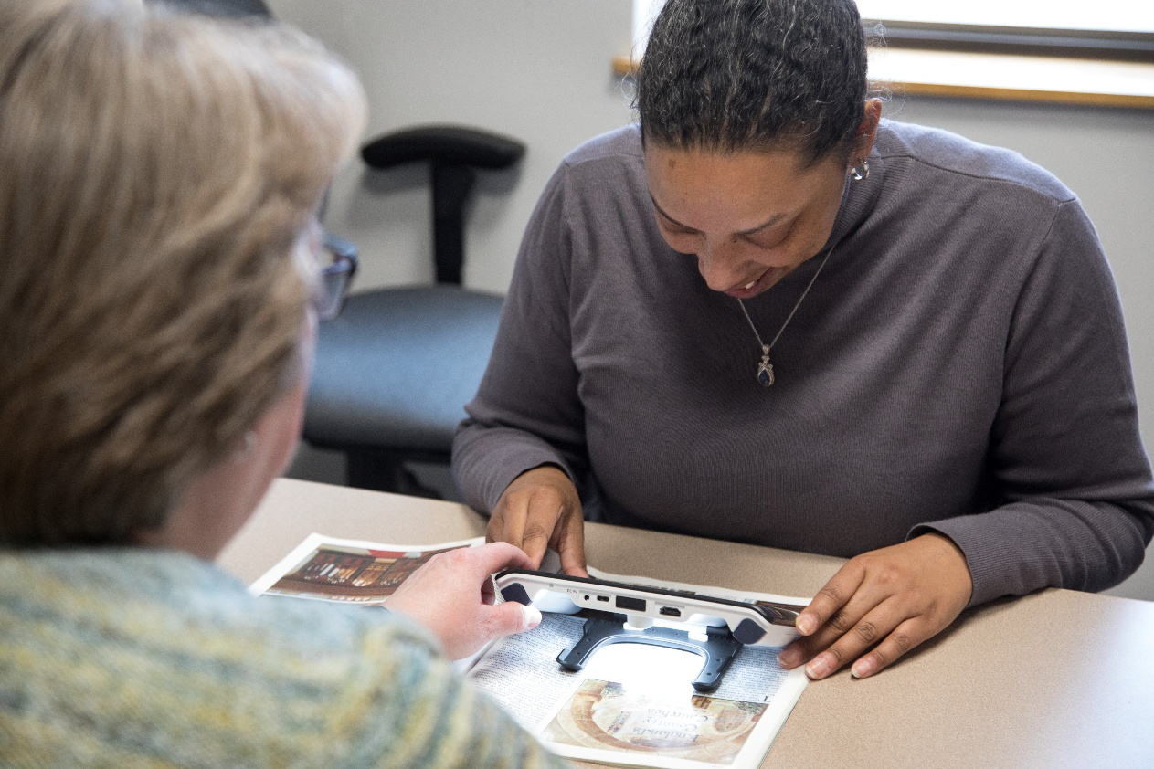
Image: A low vision therapist working with a client using a small digital magnifier

As you begin to experience vision loss, it’s important to have a team of vision experts to best meet your needs. There are professionals who specialize in each aspect of vision and adapting to its loss. Knowing who to go to and when to go to them is vital to maintaining your eye health and fully addressing your vision needs.
One of the first people you will likely talk to about your vision is an eye doctor, who may be either an optometrist or an ophthalmologist. Often working together in the same office, optometrists and ophthalmologists can work as a team to address the medical needs of someone’s vision.
An optometrist is a professional with a doctorate degree in optometry. While they are usually referred to as eye doctors, they do not hold medical degrees. They are often the best choice for routine eye and vision care. An optometrist gives primary vision care through eye exams and vision tests and can prescribe corrective glasses and lenses. They can also detect some basic abnormalities in your eyes; however, if you have more complex vision needs, you should visit an ophthalmologist.
An ophthalmologist is a medical doctor with years of medical training in diagnosing and treating a wide range of eye diseases. They can even perform many types of eye surgery. Some ophthalmologists will specialize in specific diseases or areas, such as glaucoma or pediatric eye diseases. As medical doctors, they may be able to recognize other health conditions that aren’t directly related to the eye and refer those patients to the correct type of specialist for further treatment.
There are also specialists trained in helping people with vision loss continue to live as independently as possible. A low vision optometrist is a professional who in addition to regular optometry training has also received special training to learn the skills and tools to better serve people with low vision. Low vision optometrists can give a more accurate examination for people with vision loss and determine what prescription would be most beneficial. They can guide some low vision rehabilitation, but only within a clinical setting. They will provide a rehabilitation plan based on the patient’s level of vision loss and their goals and then refer the patient to the appropriate specialist or therapist for additional training.
A low vision therapist, such as ours at the Council, is also a trained specialist who helps people make the best use of their remaining vision. Major focuses include effective use of magnification and lighting. Low vision therapists earn a national certification to ensure they are applying the best practices to help people continue living as independently as possible after losing vision. A low vision therapist works outside of a health care setting and can meet clients in their home or workplace to find practical adaptations that work with their lifestyle.
A low vision therapist can evaluate their client’s actual home environment and help put the low vision optometrist’s recommendations into practice. They can also provide their own low vision evaluation to determine how to best address the client’s vision rehabilitation goals. For example, a low vision therapist can work with a client in their kitchen to assess where bump dots may be useful on an appliance or on food packages. They may assess the medicine cabinet to recommend the best way to label medication containers. Because they can conduct their own evaluation, a client doesn’t have to see a low vision optometrist before seeing a low vision therapist, though we do recommend it so that they can benefit from every resource that may be available to them.
Finally, occupational therapists (OTs) are professionals with specialized graduate degrees trained to help people with a variety of disabilities. OTs can then complete additional training and certification to provide services similar to those of vision rehabilitation therapists (VRTs), who specialize in teaching people with vision loss daily living skills. While OTs don’t have a medical degree, they often work in a clinic setting, and their services may be covered by insurance. In contrast, vision rehab takes place outside of the medical sphere and is therefore not usually covered by insurance.
When you work with all the vision professionals who can assist in your vision loss journey, their combined care can ensure that the full range of your vision needs are met so you can continue living your life with dignity and independence.

Header: Staff Changes at the Council: A Welcome and a Farewell
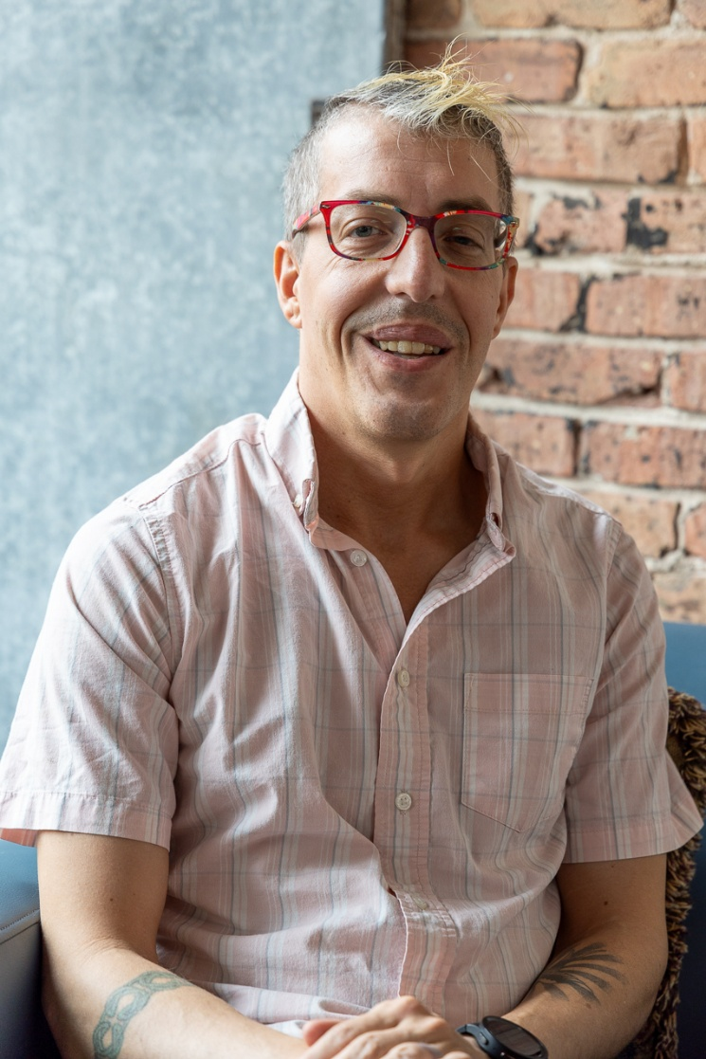
Image: Jaxon Baker sitting in front of a metal and brick wall

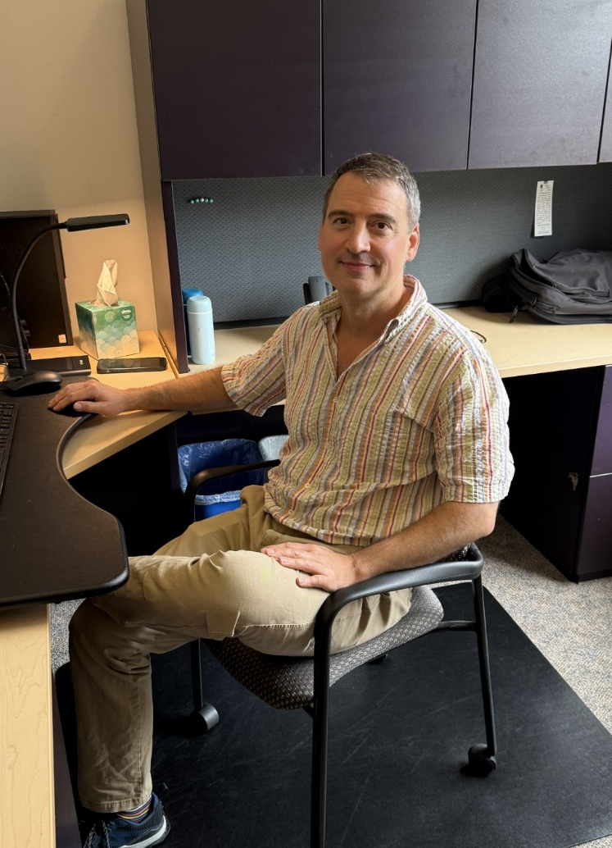
Image: Dan Neff sitting at his desk

This summer was a time of change for the Council staff, as we bid farewell to one staff member and welcomed another.
In July, Program Associate Jaxon Baker left the Council staff as he took the next step in his career. Jaxon wore several hats at the Council performing much of the vital behind-the-scenes work that helps the organization run smoothly. He had been a member of the team since 2022.
Jaxon’s role at the Council fluctuated over the years, including at various times working on our website and e-newsletters, helping clients and customers at the front desk and in the Sharper Vision Store, and making sure our building is safe and clean. Jaxon brought a smile to the faces of visitors and coworkers every day, and his presence will be missed. We’re grateful to Jaxon for everything he has done for the Council and wish him the best in his future endeavors.
Also in July, we welcomed Dan Neff as the newest member of the Council staff. Dan joined the team as executive assistant. In this position, Dan provides critical administrative and organizational support for our executive director.
A Madison resident for over 20 years, Dan comes to the Council after two decades with the phone captioning company CapTel. After hearing about the position and spending some time on the Council website, Dan says he saw the job as a great fit.
“I found myself very aligned with the Council’s mission and everything the Council is doing,” Dan says. “I’m excited to work here and am looking forward to learning new skills while applying my prior experiences to this work.”
Welcome to the team, Dan!

Header: Monthly Giving Helps the Council Budget for Success Throughout the Year

Image: Graphic of a calendar page with a dollar sign in the corner
Every month, people across Wisconsin who are blind or low vision rely on the Council for services, resources, advocacy and opportunities to build skills and independence. Monthly donors help make that work possible year-round. That reliable support is especially important when planning for the future.
Just as families must create a budget to determine how much they can spend and save based on their income, the Council must constantly monitor how much funding we’ve taken in through grants, one-time donations and, most reliably, our monthly donors in order to plan our work. Monthly donors provide the Council with steady income that we can count on throughout the year to help us sustain and grow all of our core operations. Whether we are enhancing our approach to vision services, pursuing a new advocacy goal, or looking for new educational events to spread the word about the Council, this predictable income enables us to pursue our mission ambitiously. No matter the amount, your monthly gift will add up over the year and make a meaningful impact.
The Council will reach an important milestone next year: the 75th anniversary of our founding in 1952. To celebrate, we are working toward a meaningful goal: 75 monthly donors to sustain our work all year long. We’re already more than halfway to that goal, having welcomed several new monthly donors over the past year. Kate Hawk is one of them.
Kate started volunteering at the Council in the summer of 2025, working to keep our Sensory Gardens beautiful and weed-free. Kate, a student working toward becoming an occupational therapist, says she doesn’t have time this year to work in our garden but wants to continue to support the Council any way she can. So instead of contributing her time, Kate became a monthly donor earlier this year.
“Even if I don’t have time to volunteer at the moment, I really love all of the services the Council provides,” Kate says. “It’s a great mix of services, from the White Cane Program to vision services to educational events. When I worked at a rehab clinic here in Madison, I would often point people experiencing vision loss toward the Council. I want to keep helping the Council in any way that I can. I truly appreciate everything they do.”
Please consider joining Kate and helping us budget for the future by becoming a monthly donor. We recently made it easier than ever through the new Monthly Giving page on our website at WCBlind.org/donate/donate-monthly. If you have any questions, contact Development Director Debbie Rasmussen at DRasmussen@WCBlind.org or 608-237-8113.

Header: Remembering Council Board Member Melanie Ramey
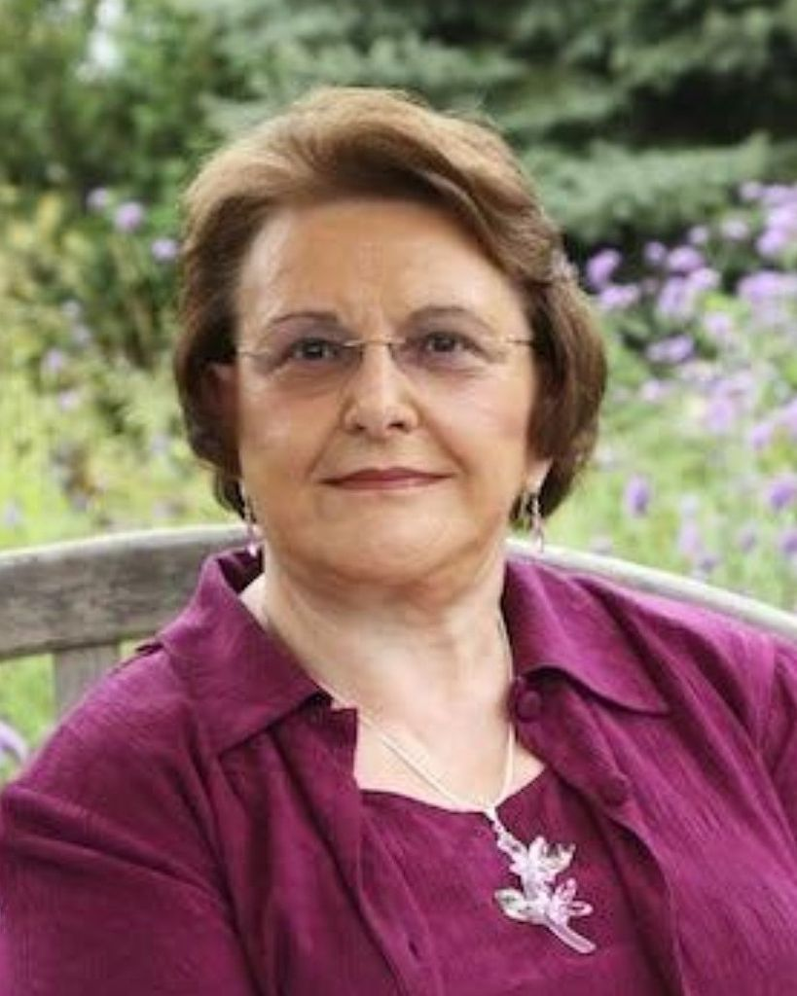
Image: Photo of Melanie Ramey
We’re saddened to announce that Melanie Ramey, Vice Chair of the Council’s Board of Directors, passed away in June at the age of 87. A long-time Madison resident, Melanie was born in Fort Smith, Arkansas and lived a life of advocacy, leadership, mentorship and service to others.
A Freedom Rider during the Civil Rights Movement, Melanie later moved to Madison and played a major role in community organizing for decades as Executive Director of the YWCA, CEO of Hospice Organizations and Palliative Experts of Wisconsin, and president of the Rotary Club of Madison and of the League of Women Voters of Wisconsin.
Melanie first got involved with the Council in 2020, when a routine visit with her eye doctor revealed that her vision had deteriorated due to macular degeneration, enough that she could no longer drive safely. Melanie took that advice seriously and asked a friend to pick her up. On their way home, they passed the Council’s offices in downtown Madison and Melanie decided to take action right away. Just a short time after her diagnosis, she was learning daily living and access technology skills from our Vision Services team to help her continue to live life on her own terms. A few months later, she saw her chance to put the skills she had gained throughout her life toward helping advance the Council’s mission by applying to join our Board of Directors.
Melanie’s ample leadership experience was an extremely valuable asset to the board. As the Council has evolved alongside the increasingly complex nonprofit world, Melanie’s leadership helped her fellow board members grow and build on their own leadership skills. This ongoing professionalization of the board has been vital to the Council’s success. As someone who was new to vision loss, Melanie also brought an important perspective to the board’s work. Melanie was able to process her own vision loss while helping other Wisconsinites who are blind or low vision gain the tools and skills to improve their own lives.
“It was truly a privilege to work with Melanie,” says Executive Director Denise Jess. “Her passion for equality and justice shone through in everything she did. I also delighted in her life stories and quick wit. She will be missed.”
We encourage you to read Melanie’s full obituary online at CressFuneralService.com/Obituaries/Melanie-Ramey.

Header: Upcoming Events
Pedestrian Safety Month (Throughout October) and White Cane Safety Day (October 15)
Pedestrian Safety Month is a time for advocates to call attention to a wide range of policies and practices to make our communities safer and more welcoming for all. White Cane Safety Day, observed on October 15, is an opportunity to educate the public about White Cane laws that protect individuals who use a white cane or service animal to get around.
Learn more about Pedestrian Safety Month and White Cane Safety Day on our website at WCBlind.org/events/pedestrian-safety-month-and-white-cane-safety-day.

Gallery Night
Join us on Friday, November 6 for Gallery Night. Since our first Gallery Night event in 2011, the Council has invited the public to experience the work of Wisconsin artists who are blind or low vision. Over the years, we have displayed work in a variety of media, including paint, photography, ceramics, woodworking, digital images, fiber arts and more.
Learn more and check out last year’s virtual exhibit at WCBlind.org/events/gallery-night.

Did you know that the Council Courier is also available in braille and audio formats? To request an alternative format or update your mailing address, call us at 608-255-1166.

The Council also publishes weekly e-newsletters that include features, helpful tips, advocacy information, upcoming events and more. You can subscribe at WCBlind.org/newsletter-signup.

